#$K Systems Overview

Your MEDLOG® clinical data system consists of many specialized components that allow you to enter, store, manipulate, analyze and present medical data. To best understand what MEDLOG can do for you, you first need some information about its overall design and how its components operate on your data. The various MEDLOG components are called programs. These programs do not operate separately, but share information in a coordinated manner. Each program performs a unique, major function, and this manual is organized with a chapter for each program. This chapter provides a brief explanation of the ways in which MEDLOG's programs relate to each other and to your data.

Your use of MEDLOG will begin with your determining which data will be collected. MEDLOG will use your data for all of its analysis and reports. It does not come with any built-in data.

Before you begin collecting medical data you must determine what will be collected and how it will be recorded. You may want to design paper forms to record data, or you may decide to input data directly from medical records. In either case you must tell MEDLOG such things as the names of the selected data items (called variables), their units of measurement, and their ranges of permissible values. The DEFINE program stores this information in the data dictionary so it can be used by other MEDLOG programs. With DEFINE you can add new variables, change the specifications of existing variables, and delete variables. We recommend that you conduct careful and thoughtful planning before any data are collected, since changes made later could involve considerable time and effort.

MEDLOG lets you establish several different files of medical data (called databanks) on your computer. Each databank is identified by a unique three-letter combination that must be specified when you use MEDLOG. Separate databanks are usually established for different medical specialties, for different classes of medical problems, or for different research studies, such as clinical trials. Generally speaking, each databank exists as if it were on its own separate computer.

MEDLOG terminology assumes that your data are associated with entities called patients. You can, however, use MEDLOG to collect data on laboratory animals or to keep track of other information. Except for a few predefined variables (for example, name and birth date) there are no operational assumptions about the subject matter. Even these predefined variables can be left blank if you so desire.

The predefined variables are also called built-in variables. Each patient will have one or more occasions when values are recorded for the variables. These occasions (called encounters) can be of various types: clinic visits, hospitalizations, surgical procedures, laboratory tests, etc. Encounters may occur at irregular intervals, and the numbers of encounters may vary widely between patients. At each encounter values are recorded for some, but typically not all, of the variables. Those not recorded are marked as “missing”. Missing has many interpretations: not observed, not obtainable, not requested, not applicable, etc. MEDLOG is capable of efficiently processing databanks containing a large proportion of missing values .

When you first establish a databank you will be asked whether patients will have multiple encounters or not. For most long term projects, many measurements and procedures will be repeated. In order to organize these efficiently, MEDLOG uses the concept of an “encounter”. An encounter is always associated with a particular date (time of day is optional). For example if WBC is a variable standing for White Blood Count, then it could be measured at each office visit. The same variable WBC would have different values at the various time points (encounters), and could be “missing” if not measured at some time points. Many features in MEDLOG are especially designed to access and analyze “time variant” variables such as WBC.

If you say that patients will have only a single encounter, this disables the encounter features of MEDLOG. This is appropriate for some types of “one shot” clinical trials. This simplifies some activities, but makes the databank less flexible. Discuss this with a consultant before choosing the single encounter mode.

The data collected at a medical encounter frequently are values of a set of related variables. For example, the administration of an EKG may result in the recording of not one, but perhaps a dozen variables. To facilitate data entry you can design entry screens that look like the paper forms you may be using. You can use the FORM EDITOR program to create and modify the entry screens to fit your application requirements.

DEFINE FORM EDITOR
To set up a MEDLOG databank, you must decide which data variables will be used and define the value ranges you will accept for them. The DEFINE program stores this information in the dictionary. Then you will use the FORM EDITOR program to layout screens to fit your entry requirements.

variable
dictionary

data entry forms

FORM
DATA ENTRY

(stored data)

entry files

Data Types
Most data you enter will fall into two categories: Text data (for example, street address) and numeric data. The latter include encoded data, that is, data whose values are a list of numbered responses. Male and female are the alternatives for the variable sex and could be encoded as 0 and 1 respectively. Numeric data can be used for statistical and analysis purposes. Text data are used mainly for reports. Data can be further subdivided into two categories: time-variant and time-invariant. For a particular patient a time-variant variable may assume different values at different encounters and MEDLOG will store all of those values. A time-invariant variable has only one value for a particular patient and that value applies to all encounters. The date of first presentation of a particular symptom is an example of a time-invariant variable. Once it is correctly recorded, it will never change, or if it is changed, we do not need to remember what it was before. Whether a variable is text or numeric, and whether it is time-variant or time-invariant, is specified in the data dictionary by means of the DEFINE program.

Data Storage
The range of permissible values of a variable is determined by restrictions you put in the data dictionary by using the DEFINE program. There are three "sizes" of numeric variables corresponding roughly to 2, 4 or 6 digits of accuracy. For optimal performance, you should choose the smallest size that will suit the variable's requirements.

The position of the decimal point is called the variable’s scale factor. A scale of .1 allows measurements in tenths.

When you choose a variable type, size and scale in DEFINE, you will see the possible range of values before you finalize your selection.

Entering Data
You will normally enter data by first specifying the appropriate entry form. The FORM program then allows you to enter, examine, or change the values for all the variables on that form.

FORM-DATA ENTRY

entry files

CHART

When a new patient is entered, MEDLOG expects a few facts like name and medical record number. These will usually be on the first form you will create. If your databank allows a patient to have more than one encounter, you will be asked to supply the encounter date, if it is not already on the current form.

MEDLOG allows for an undated encounter, which we call "encounter zero". It can be used to record events that occurred before the first dated encounter. This is discussed in the DATABANK OPTIONS program. Most applications of MEDLOG do not need to use encounter zero, so its use is currently discouraged.

Encounters may occur as close together as one day, on the same day, or as far apart as years. A patient may have as many as 1000 encounters or as few as one.

You may use the FORM program to change data that has already been entered. To delete an erroneous encounter, delete a patient, or change an encounter date, you must use the REMOVE program.

The MEDLOG system has another data entry program, ENTER. It uses lists of variables called “panels” to control the entry process. Most remarks concerning the form program apply also to Enter.

Once you have established a dictionary and designed your entry forms, you can begin to enter data. The FORM program lets you establish a new patient record or add information to an existing record. The information recorded with the FORM program is stored in the entry files for use in other MEDLOG programs. For example, you can list patient data from the entry files with the CHART program.

The Transpose File
In many clinical applications, the data entry process is never complete. New patients are continually added, and present patients will have new encounters. MEDLOG freezes the data for analysis by making a copy of them in a format more efficient for rapid retrieval and analysis. This allows data entry to proceed while the data you are analyzing are held in a stable state. The copy process, called a file transposition, is performed by the CREATE program, which copies the data from the entry file into a file known as the transpose file. The analysis programs always use data from the transpose file, but other programs such as CHART, REPORT and LETTER can give you direct access to the entry files.

When you want to add newly entered data to your analysis data set, you simply run the CREATE program again to update the transpose file. The most important benefit of the file transposition process is that it allows you to quickly retrieve and manipulate data for analysis while you are sitting at the computer. Without the transpose file, retrieval and analysis could take too long with a large databank.

Derived Variables
Once the transpose file is created, you are ready to search, transform, combine, and statistically analyze your data. The next program that you are likely to use is the COMPUTE program. It computes new variables.

The COMPUTE program forms new variables by combining or manipulating the observed variables. As a simple example, a patient's age at a particular encounter can be calculated as age=(date-birthday)/365.25, where date is the built-in variable for encounter date. Other computed variables may require more complex expressions involving several variables, square roots, logarithms, etc. COMPUTE allows you to use any of the common mathematical operators and functions. If you are familiar with computing languages, you will find using COMPUTE similar to using an assignment statement in FORTRAN, BASIC or Pascal. If you have no computer experience, you will find it similar to writing an ordinary equation.

Because you will use some computed variables repeatedly, the COMPUTE program lets you store the definitions of up to 512 different computed variables. This means that you can generate all of your frequently used computed variables by giving the computer a few simple commands. Once a computed variable is processed, you can use it in the same way as an observed variable. You can use it, for example, in an expression for another computed variable.

Patient Groups
The GROUP program is one of the most complex programs in the MEDLOG system. It is used to define the characteristics of patients who should be grouped together for purposes of analysis or reporting. A group can consist of as few as zero patients (none met the qualifications) or as many as all patients (all met the qualifications). Furthermore, a group specification can identify not only certain patients, but it can also identify particular encounters belonging to those patients. Groups can be formed from other groups by several methods, the simplest being to apply a new qualification to the patients in an existing group. Another method of forming new groups from existing groups is to use the logical operations of union and intersection. The union of two groups consists of those patients belonging to either group. The intersection of two groups is those patients belonging to both.

The concept of a group is so important to the processing of your data, particularly time-oriented data, that a few more words on the subject are justified. Consider for a moment a comparison of two groups of patients. The first received drug X following a certain medical procedure. The second group received drug Y. We would like to compare the two groups using statistical methods. The first step is to specify exactly who qualifies for inclusion in each of these groups. You may want to exclude certain patients, for example, those over 70 years old at time of first dose. It may be important that the patient had not previously received either of the drugs. You may want to limit the comparison to patients with symptoms of a particular level of severity. Lastly, it may be important that the drug administration and subsequent evaluation take place within a limited time period. As you can see, the process of specifying who belongs to a group can be quite involved. The GROUP program allows great flexibility in forming such groups, and group specifications can be very simple or very complex.

The SELECT program is a companion of the GROUP program. It performs the task of taking the group specification and identifying the patients who belong to the group. We call this forming the group. When you make a new group or change group specifications, the SELECT program is automatically used to find which patient belongs to the group.

Since group specifications are routinely stored for repeated use, SELECT can be used apart from GROUP to update many groups at once. This is convenient when a new transpose file is created (by the CREATE program) since all previously formed groups must be reevaluated in light of the new data.

Note that the ability to store the specifications of groups and use them repeatedly is very similar to the storing of computed variable expressions for use when new data are ready for analysis. This similarity is not coincidental. MEDLOG is designed to save any information, which is likely to be used more than once. This feature increases MEDLOG's effectiveness to the researcher and minimizes the chances for error.

To use the stored data for analytical purposes, you must first run the CREATE program to make or update he transpose file. You can then manipulate the transpose file without fear of altering the original data.

You can derive new variables from the data in the transpose file by using the COMPUTE program. COMPUTE lets you write mathematical and logical expressions combining or manipulating existing variables. No programming is necessary. The statements are stored so that you can apply them to other data as needed.

MEDLOG’s GROUP program allows you to specify criteria for defining subsets of the patient population for analysis. The SELECT program accompanies GROUP, applying the group specifications to the patient date in the transpose file. The definitions of those patient groupings are store for repeated use as new data is added to your databank.
entry
files
compute
statement
file

COMPUTE
CREATE

SELECT
GROUP
transpose
file

patient group files

Data Extraction
The EXTRACT program performs a simple task: it extracts from the transpose file certain data for each patient in a group and places those data in what is called an extraction file which is similar to a spread sheet file. An extraction file is used by a variety of statistical programs to do scatter-plots, linear regression, contingency tables, etc. While the concept is simple, there are many options available in EXTRACT, which make it very flexible. Before discussing these options, it will be helpful to review quickly what you have just learned about the MEDLOG system.

The data stored in the transpose file consist of values of variables recorded on the patients under study. In addition, we may have added some derived variables by using the COMPUTE program. With the GROUP and SELECT programs we have described some groups of patients and selected patients who meet the group specifications. Now we want to look at some data belonging to patients in the various groups. As a simple example, consider the comparison of two groups of patients on a diet to reduce serum triglycerides. For each patient we may want two values, the beginning triglyceride level and the ending level. Or we may want to look at average triglyceride level, or the maximum, etc. Note that in these examples we are extracting one or two values from a series of measurements of triglyceride levels made over time.

The EXTRACT program provides many ready-made solutions to the problem of analyzing time-variant data. It can extract the minimum, maximum, first, last, and average value, as well as values at encounters identified by the GROUP program. Other options are the value recorded at a particular encounter, the date of the maximum value, and the encounter number of the last encounter. A total of over sixty built-in extraction options offer all the flexibility you are likely to need in analyzing your data.

Instead of one observation (that is, set of variable values) per patient, EXTRACT can also produce a data file consisting of one observation per encounter, or of one observation per event, such as fracture or episode of infection.

You can extract data from as many as 8 different groups of patients at the same time. This lets you easily use the statistical analysis programs to compare data from two or more groups. Extraction files may be named and saved for later analysis. The extract program can also transform data and make new computed data. It allows for a direct connection to the Excel spread sheet product.

The EXTRACT program pulls out specified information for the patients of a particular group and stores it in an extraction file, where it can be used by any of MEDLOG’s statistical and data listing programs. EXTRACT uses the information stored by SELECT to determine which patients are needed.

EXTRACT offers many options such as finding the minimum, maximum, first, last, and average values, date of the maximum value, and the value recorded for a particular encounter. It can also compute new variables from the extracted data in the same way that COMPUTE works on the transpose file data.

transpose file
EXTRACTT

group files

extract
extraction file

Statistical Programs
SCATTER, MEANS, SURVIVE,
BARGRAPH, CROSSTABS,
CORRELATE, FREQUENCY

The extract program also you generate new variables from the extracted data, much as the COMPUTE program does for the entry data. For example, a transform statement could be used to calculate the ratio of maximum body weight to minimum body weight.

Statistical Programs
Once the EXTRACT program forms an extraction file, you are ready to run any of the programs for statistical analysis or data listing. We will only mention them here - complete descriptions are given in the pertinent chapters of this manual.

The MEANS program calculates descriptive statistics on any variables in an extraction file. It produces means, standard deviations, minimums, maximums, etc. for up to 8 groups. It also performs t-tests and one-way analyses of variance.

The SCATTER program produces scatter plots of one variable versus another. It calculates linear regressions, plots residuals, calculates confidence intervals, etc.

Survival analysis (Kaplan-Meier) is performed by the SURVIVE program. It calculates survival probabilities and produces plots of the survival curves. Different survival curves can be statistically compared with the Mantel-Haenszel test.

CROSSTABS will cross-tabulate values of two variables. It will also tabulate one variable in two or more groups. Column, row and total percentages can be printed. Chi-square and Fisher exact tests of significance are performed.

WHISKER produces a summary plot according to a method advocated by Tukey. The other statistical programs are BARGRAPH, CORRELATE, FREQUENCY, NONPAR, WHISKER, COXREG, LOGREG, and LINREG. The last three are advanced statistical programs for survival analysis and regression analysis.

It should be mentioned that it is very easy to go from one statistical program to another, since the work of extracting appropriate data is done once by EXTRACT, and these data are saved for use by any of the statistical programs.

Any of the plots and other information displayed on the computer screen by the statistical programs can be printed on paper. Also, a graphic manipulation program is available to change the look of the standard graphics and use a variety of output devices.

Listing Data and Utility Programs
MEDLOG has five programs that can display the data you have collected.
- The CHART program lists the data records for individual patients, displaying the data as a series of columns, each column representing an encounter. This time-oriented format, advocated by Fries, is very useful when you are looking for trends or other changes over time.
- The report program is used to generate reports according to your specification. It can be used to summarize date, make various list, and other purposes too numerous to mention. The report program is a very powerful and flexible component of MEDLOG.
- The LETTER program can produce form letters, clinical summaries and other reports that pertain to individual patients. Like REPORT, it has many uses.
- The MEMBERS program lists the values of selected extracted and time-invariant data for all members of a group. You will find it useful for determining who is in a particular group and why.
- The PATPLOT program provides a graphical display of the value of selected variables for each patient. It can also display graphical information on group averages.

Several programs are available for “housekeeping” purposes.
- The DATABANK OPTIONS and the ENVIRONMENT programs allow you to choose options such as data formats.
- The REMOVE program is used to delete a patient or an encounter from the files.
- The CONTENTS program can list the variable dictionary, list the available groups, and provide other information about the overall content of a databank.
- QCTOOLS program provides useful information concerning the data that has been collected and the relationship of variables to forms.
- BUILD, COPIER and MERGE are programs are used to combine or split databanks or combine data for analysis. REMOTE is used to transfer data from remote data entry locations.
- IMPORT and EXPORT are used to transfer data from MEDLOG to another computer system, and vice versa. EXPORT also lets you format your data for statistical packages such as BMDP and SAS or for spreadsheets such as Excel.

File Organization
It is helpful, but not essential, to understand where MEDLOG stores your data on the hard disk. It will assist you in copying or backing up files.

The MEDLOG programs are usually stored in a folder named MED. The main program has the name medlog2k.exe. Some components are in a sub-folder name mwlib. Icons and bitmaps are stored in the sub-folder mwicons. The sub-folder mwhelp contains help files for the programs. The special file menupz.exe contains your unique installation information.

Each databank resides in a separate sub-folder whose name matches the databank ID. These sub-folders are further divided into sub-folders for various purposes. The two most important sub-folders for a databank are Defines and Entry. This is where the data is stored. The other sub-folders that may be present are: Forms, Letter, Reports, Extract, Compute, Trans, Commun, Groups, Print, Command, Remote and Graphics. In addition each databank has a small file called databank.cfg which holds various option settings.

Each databank also has user initialization files that are used to “remember” previous use and settings. These files are named userxxx.ini where xxx is the user’s initials.

In this discussion we have assumed that all of your data resides on a single disk drive. The file organization used by MEDLOG allows you to assign subdirectories to other drives and it allows different databanks to share the same files. In the example shown in the previous figure, it would be possible to have both databanks share the same sub-directories for forms and report templates. For a more detailed look at this topic see Chapter 54, File Organization.

Hot Keys
There are five “function” keys that can activate special functions from any spot within MEDLOG. The F1 key “pops up” the chapter of the MEDLOG manual corresponding to the topic on the screen. The F2 key opens the print options window. See Chapter 46, Print Options.
The F3 key is used to select a Command file. See Chapter 49, Command Files. The F4 key is used to activate the patient locator function. See Chapter 43, Locate. The F5 key is used to open the Information Utility feature. See Chapter 44, Information Utility.

The MEDLOG main menu (see Figure 1-1) provides access to the functions and components of the MEDLOG system. The various functions are grouped on this main menu under the broad categories of Setup, Entry, Prepare, View, Analyze, Tools, Options and Help. Under each functional category the individual programs can be chosen from drop down lists. Frequently used programs can also be accessed directly by placing them on the Speedbar. This will be discussed later. Also, shortcut keys (usually an alphabetical key with the ALT key held down at the same time) can be used to navigate menus and make selections. Shortcut keys correspond to an underlined letter in a menu or button name.
Figure 1-1. Main MEDLOG Menu
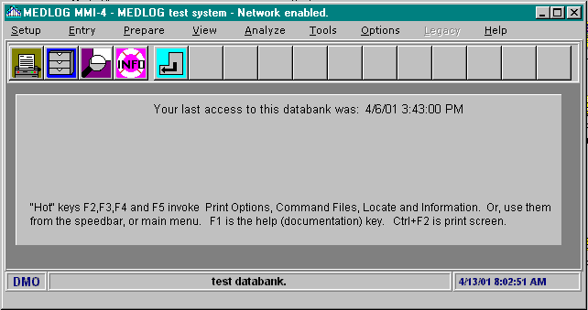
{bml 01-01.bmp}
The main MEDLOG menu will also display start up messages and will always show the current databank name as well as the time of day. Since each program returns to the main menu when it is completed, you will soon be very familiar with the main menu screen.

Conclusion
We have completed our tour of the programs that comprise the MEDLOG system. Since it was our intention to be brief, you may wish to read this chapter again after looking at some of the other chapters. By then you will realize that MEDLOG has many virtues and features which have been passed over here for the sake of simplicity. If you understand programming or database design, and want more technical detail, you may want to read Chapter 48, Technical Overview. Otherwise skip it - you should not need it.
%PageBreak.

#$K System Environment

The ENVIRONMENT program provides for the different Date, Time, and Identity formats used throughout the world. The environment selections apply to all databanks.

From the main MEDLOG menu, click on the Options menu and select the Environment program to open the dialog box shown below.
Figure 2-1. Environment menu
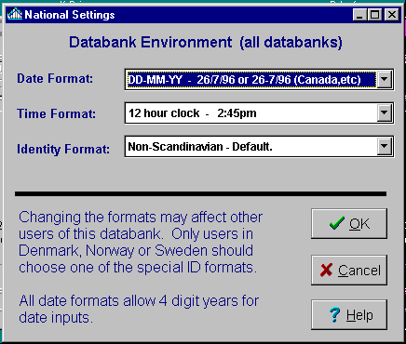 {bml 02-01.bmp}
The Environment program sets three options:

Date Format
Time Format
Identify Format

DATE
Note: Dates may be displayed with either two digit years or four digit years. An option on the Environment menu controls this action. Date inputs can always be either two digits years or all four digits. When a two digit year is entered, the date century will be chosen so that the date will not be more than one year in the future. For example, the year 98 will be 1998 because 2098 would be more than one year in the future. When data is exported, the date format can be specified.

The drop down list provides for the following formats:

MM/YY/DD this is the format commonly used in the USA (11/23/99)
DD-MM-YY common international (23-11-99)
DDMMMYY military and international (23Nov99)
YYMMDD Sweden (991123)
DDMMYY Denmark and Norway (231199)

During data entry, the separator characters shown above as slashes (/) or dashes (-) can be any other punctuation character such as a period (.). After entry the data will be reformatted according to the date format you have chosen.

Date formats may be changed at any time since the actual date is stored as a number and is formatted as needed. When dates are entered with a two-digit year, the current century is assumed unless the date would appear to be more than one year in the future. Thus, year 01 is 2001 while year 98 is 1998. Again, four digit years can be used to override this assumption.

TIME
A twelve hour clock which uses a.m. and p.m. and the 24-hour clocks are available.

IDENTITY FORMAT
This option only concerns the Scandinavian countries that have national identity numbers. It is covered in the Chapter 51, Special Versions of MEDLOG.

#K Change Databank
From the main menu under Setup menu, select the Change Databank. The CHANGE DATABANK dialog show below will appear.
Figure 3-4. Change Databank
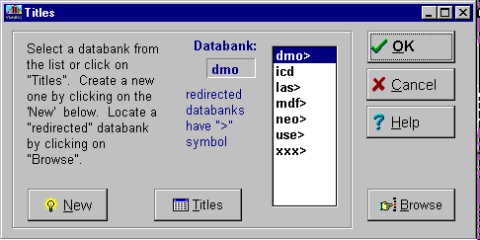
{bml 03-04.bmp}

The dialog box should be familiar, as it is the same one that appears when MEDLOG is opened and the change databank button is pressed. There are four options: create a new databank; select an existing databank; browse to locate an existing databank; and search the existing databank titles.

Create a new databank
As the title implies, you wish to create a new databank. Clicking on the New button will open a dialog box that requires the new databank's 3-letter identifier.

Select an existing databank
Select a databank from the drop-down list and click on it to highlight it. Then click on the OK button to open the databank.

Browse
This is the standard Windows browse procedure. You can search the available storage devices and if the databank is available, open it. If the databank is not currently in the folder where you have MEDLOG installed, MEDLOG will remember the location and in the future redirect the system to the location. Redirected databanks are indicated on the drop down list by the greater than (>) symbol.

Titles
If the Titles button is clicked, the system will open with a list of the databanks and information relevant to the databank. See Figure 3-5.

Information available: databank name, long title, directory path. If the databank path is the same as the MEDLOG program, then only the databank initials are shown under Path.

Figure 3-5. Databank information
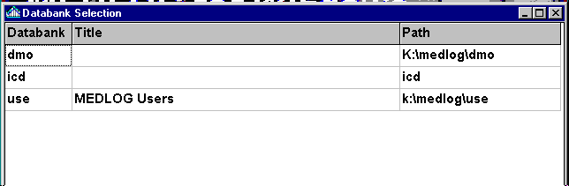

%PageBreak.

#$K Databank Options

The DATABANK OPTIONS program is located on the main MEDLOG menu under Options. The program provides various options, chosen to best fit your operational needs.

The options selected apply to the databank you are currently using. The options may be changed at any time.
Figure 3-1. Databank Options
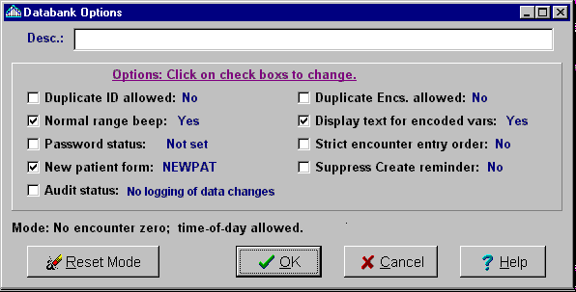
{bml 03-01.bmp}

Desc (Description)
A Databank is identified by a unique three letter or number combination. In addition to this required identifier, the databank should have a text description. This description will be displayed on the main MEDLOG menu screen and can be placed on printed pages.

Duplicate ID allowed
The primary patient identifier is a built-in variable called MRNO (medical record number). You are encouraged to use MRNO to uniquely identify patients, and this will make some MEDLOG functions easier to use. If two patients have the same MRNO or if the MRNO is missing, this usually indicated a data entry error. To prevent such errors, the standard action is to prevent such an entry. However, there are conditions where a duplicate MRNO might be valid, such as when a patient is allowed to reenter a study as a new case. Other examples exist but they must be considered carefully. The option to allow duplicates is normally set to No.

Normal range beep
When set, this causes a beep whenever a value is entered and it falls outside the normal range set by DEFINE.

#K Password Status (Security Settings)
Clicking on the Password Status option box will open the Databank Password dialog box show below. A master password must be entered. Only the person with the master password may set the other passwords and permissions.

Passwords are used to limit the access which an individual may have to the databank. The initials are optional and are used to make sure that the operator initials match the password given to that operator. For example, if password FIDO had permissions EVL with initials RWK, then after operator RWK entered his initials to start up MEDLOG, the password FIDO would be required. After that point operator RWK could enter data and list data but would not be able to change variable definitions or delete patients.

Passwords may have an expiration period which may by set from 1 to 999 days. A warning will be given if a password is used within two days of its expiration. After expiration, it will not work. If the master password expires, it will continue to work - otherwise there would be no way to change passwords or reset the expiration periods.

Figure 3-2. Password options
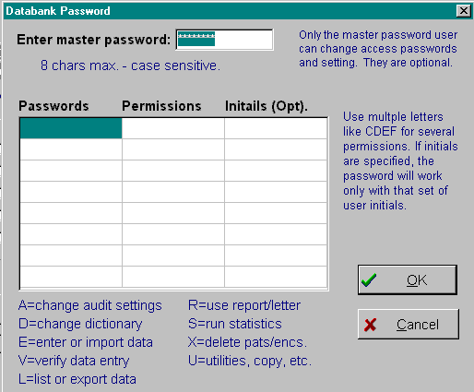
{bml 03-02.bmp}
To determine the current operator’s permissions, go to the Help menu and select the Security Settings menu item.

Another method to limit the use of MEDLOG, is to disable some of the programs which can be used at a particular installation. To do this, a special program named disable.exe is required. The program is not included in the standard installation, but it may be requested, free or charge, by an authorized person at your institution. The Disable program can be kept on a floppy disk for security purposes. It is very easy to use, and no instruction is needed.

Another security measure is to set a timeout value which will disable MEDLOG if there is no computer activity for a given number of minutes. Any activity which involves operator intervention, whether in MEDLOG or another application, will reset the clock. The minimum timeout is 5 minutes, but a value of 60 would be more reasonable. Two minutes before the timeout, a message will appear giving you a chance to show some activity. After the timeout occurs, the MEDOG system will be put into a sleep state and must be restarted in order to do anything.

The log of databank access, if enabled, will record the date-time and user initials of anyone who logs into the databank. The resulting file (access.med) is contained in the root folder of the databank. It will also include any unsuccessful attempts to access a databank which is password protected. The word “failed” will appear next to the log entry for any unsuccessful attempts.

In the situation where many databanks have the same security administrator, the log of unsuccessful attempts to access any databank can be consolidated into a single file. This file named noaccess.med is located in the root folder of the MEDLOG system (containing the file medlog2k.exe). The file must be created manually (an empty NotePad file will do). If it exists, the unsuccessful logins will be recorded there and not in the access.med files.

NewPat Form
The FORM data entry program has a check box for you to indicate that you are establishing a new patient. When this is checked, the program will automatically use a default form to collect the basic information for a new patient. The name of the default form is NEWPAT, but you may change the name by using this option.

Audit status
This topic is covered in Chapter 8, “VERIFY and AUDIT LOGS”.

Duplicate Encs. allowed
Normally, a patient can have only unique dates/times for his encounters. There are situations where patients are evaluated or treated more than once at the same encounter. This is an unusual situation and this option will allow for it. You should discuss this option with a MEDLOG consultant before using it, since it seldom needed.

Display text for encoded vars
Display programs such as CHART and REPORT will display the text values for encoded variables when this option is chosen. If you want to see the numeric values instead, you may remove the check from this option. This option may be changed back and forth without changing any patient data.

Strict encounter order
This seldom used option will make it difficult to establish encounters for a patient which are not in strict chronological order. If this option is set and it discovered that a patient had an encounter which falls between two existing encounters, then the REMOVE program must be used to establish the encounter before data entry is resumed. It is unlikely that you will want this option.

Suppress Create reminder
After you have entered new patient data, and prior to running an analysis program or making a new group, you should run the CREATE program in order to update all the necessary files. Since it is easy to forget to do this, MEDLOG will give you a reminder message. This message will be given only once in a session, and it may be ignored. If you do not want to receive this reminder at all, you may suppress it with this option.

%PageBreak.

#$K Define Variable

Purpose of DEFINE
The DEFINE program is used for establishing and changing specifications of the dictionary. The dictionary is the foundation of the databank because it defines what can be stored as coded variables in the databank. DEFINE sets the specifications of each variable.

Who should use DEFINE
DEFINE should be used only by or under the supervision of the person responsible for deciding which data are to be collected and the characteristics of those data. This person could be called a database administrator. Before data entry begins, the administrator establishes the names and other factors for each variable. Proper specification of the data dictionary is critical for the proper operation of a clinical databank. Uncontrolled input and invalid changes to the dictionary can corrupt data and invalidate any analysis.

When to use DEFINE
DEFINE must be used to create the data dictionary before any data can be entered into a databank. Even after the dictionary is established, and data entry is begun, DEFINE, can be used to add or delete variables, or to change the specifications of variables.

How to use DEFINE
DEFINE establishes the name and the description of variables in a databank. If you have another databank, definitions of selected variables can be copied into your new databank.

To use the DEFINE program, go to the main MEDLOG menu, select Setup on the MEDLOG menu, and invoke Define Variable which will start by opening the window in Figure 4-1.
Figure 4-1. Define Program
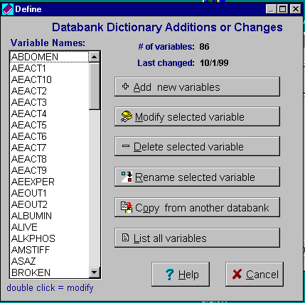
{bml 04-01.bmp}
If you are establishing a new databank, click on the Add new variables button to open the “Add a new variable dialog” shown in Figure 4-2.

Add new variable
Creating a new variable starts with entering the New Variable Name.

Figure 4-2. Add new variable
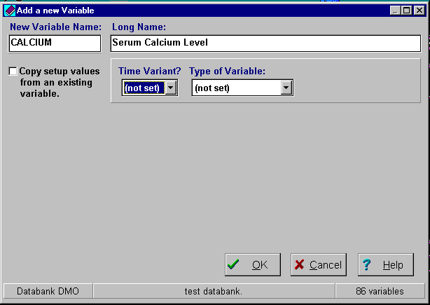
{bml 04-023.bmp}

New variables can be added by:
- Creating an entirely new variable, or
- Copying the variable details from an existing variable in the same databank or a variable in another databank.

The variable name is associated with a measurement or question that is recorded in the data files. For example, systolic blood pressure might be named SYSBP.

Variable names are limited to 8 characters, so some abbreviation is usually required. The variable name must begin with a letter of the alphabet, but elsewhere in the name you can use letters, digits 0 to 9, and the following six special characters: % @ $ # & _ (underscore). No other characters or embedded blanks are allowed. The case of letters is unimportant since the DEFINE program translates them into upper case letters.

You may define your variables in any order, since MEDLOG makes no use of the ordering of variables in the dictionary. When lists of variables are displayed, they are normally sorted alphabetically to make selection easier.

There are some variables that are automatically defined in every databank. They are called built-in variables. Since they are predefined, their definitions cannot be modified and the DEFINE program will prevent the use of their names as user variables. The most important built-in variables are:

NAME reserved for output only and refers to the combination of variables: FIRSTNAM, MINITIAL, and LASTNAME
FIRSTNAM maximum 20 characters.
MINITIAL middle initial.
LASTNAME maximum 22 characters.
BIRTHDAY Error! Bookmark not defined.the patient's date of birth.
MRNO the medical record number.
A maximum of 9 characters. It should be used as the primary patient identifier wherever possible.
DATE and TIME reserved for the time point of an encounter.

The following reserved names have more specialized purposes that will be explained in other chapters: CHANGED, ENTERED, SPLITNUM, ENCOUNTR, NUMENC, LASTENC, STATUS, and PATKEY.

There other reserved names are used only in the Scandinavian countries: IDNO, SCANDNO, and SCANDSEX. They replace MRNO in Scandinavia.

Long name
Following the entry of a valid variable name, DEFINE searches the dictionary to see if the variable is already there. If the variable name was not found in the dictionary, the cursor will move to the next field, Long Name as shown in figure 4-2.

The Long Name is optional. Since a variable name is limited to eight characters, it is necessarily cryptic. In order to help you remember what this variable really is, you may have a long name. A maximum of 40 characters can be used.

The Long Name, if supplied, is used in listing of the dictionary by the HELP facility and on the output of some programs. It is a good idea to supply a long name whenever the variable name is not self-explanatory.

Time Variance
An important determination is whether the new variable is “Time Variant”.

(Yes) variables are time variant if they can have different recorded values at each encounter. Good examples are weight and blood pressure that may change each time a patient is seen.

(No) variables are time invariant when values do not change between encounters. For example, sex of the patient, or date of diagnosis are values not likely to change. Time invariant also includes variables which can change, but for which only the latest value is retained. Examples are street address or physician’s name.

(Not Set) indicates that you have not yet chosen a proper "yes" or "no" response.

Note: databanks that allow only a single encounter per patient will not have the time variant question. All variables in such a databank are time invariant and have a single value.

Type of Variable
There is no default setting for the type of variable. A selection from one of the nine types must be made from the drop-down list
Figure 4-3. Variable types
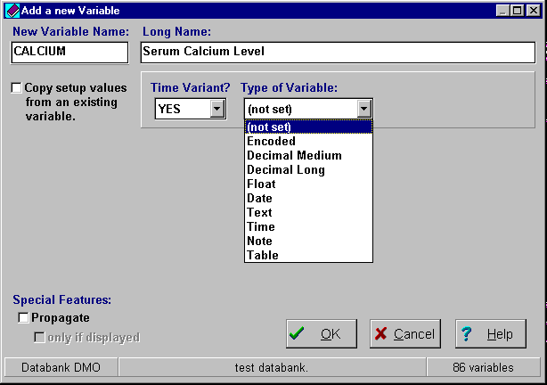
{bml 04-04.bmp}

Variable Types

Encoded A list of alternatives is specified. No/Yes are typical.

Decimal Medium Two significant digits used for small numbers.

Decimal LongF our significant digits that can be negative.

Float No fixed decimal point. Six digit accuracy.
Use this type only when decimal long cannot be used.

Date Allows dates between the years 1874 and 2049.

Time A time of day, either am/p.m. or 24 hour format.

Text A maximum of 80 characters.

Note A note variable can hold many lines of text.
It cannot be searched.

Table Values will be chosen and entered from a table.
Tables may include graphic images.

Encoded
This is the usual type for "yes/no" questions and other question that can be answered with a short list of alternatives. The values must be established in DEFINE. New values can be added after data entry has begun, but the order of the existing list of alternatives should not be changed.

The total number of characters used by all alternatives cannot exceed 512 characters. If each alternative averages six characters, a total of 72 alternatives are possible. If this limit is exceeded, text or table variables can be used.

Providing for a missing value (0 = missing, 1 = yes, 2 = no) is not necessary and not advisable. MEDLOG recognizes a blank field or a question mark (?) as "no data entered". Also, the standard convention of using the value 0 (zero) = "no" and 1 = "yes" is preferred as 0 is more closely associated with a negative response.

Decimal
These numeric types have a fixed decimal point. You specify where the decimal point, if any, goes, and it remains fixed thereafter.

Decimal Medium
As a measurement variable, this format can handle two digit values (actually 0-253) and can use a scale factor to place the decimal point. Many measurement questionnaire responses can be handled with this format.

Decimal Long
This is format that has 4 decimal places of accuracy (actually -32,760 to +32,760). The values can be negative which is not possible with the decimal medium type. Most medical measurements can be handled with this type.

Float
The float format provides an infinitely wide range of values (10 ⁻³⁵ to 10 ⁺³⁵) with 6 digits of accuracy, but it occupies the most storage (4 bytes). Float should be considered when a decimal long format with an appropriate scale multiplier will not accommodate the accuracy or range required.

Date
This format is reserved exclusively for calendar dates. The possible range is any date between the years 1874 and 2049. Dates are entered and displayed according to the date format set with the ENVIRONMENT program. Dates are internally stored as the number of days since January 1, 1960. You do not need to be aware of this detail since MEDLOG will always converts your input/output correctly.

Time
This format is reserved exclusively for the time of day entries. The range is from midnight (12:00 am or 00:00) at the start of a day to the last minute of the day (11:59) p.m. or 23:59). Noon is 12:00 p.m. or 12:00. Times are internally stored as the minutes from noon, but MEDLOG always converts your input/output according to the time format specified by the ENVIRONMENT program.

Text
Text variables may be up to 80 characters long. This variable format is typically used for street addresses, names of referring doctors, and most anything else which will not fit into convenient categories or numbers. They are not, however, very useful in analysis.

Note
This variable holds free-form notes concerning treatments, observations, etc. They may be considered an extension of the text variable format. They are very good for capturing comments or other text that will exceed a single line. A note can occupy several thousand characters but have only limited search capabilities.

Table
Tables are really compound variables. Each table has columns that MEDLOG calls elements. The rows of a table are the "values" of the table that can be assigned to a table variable. For example, a table variable called STATE could have elements called NAME, CAPITAL, LAND_AREA, FLOWER, BIRD, and ADMIT_DATE.

The table associated with the variable, STATE, would hold information about each state, including the capital city, state flower, etc. During data entry, the "value" of STATE is assigned by picking the appropriate row in the table. This would then associate all the table elements such as capital city and flower to the patient.

New rows can be added to a table during the data entry process. Thus, tables can grow as more data is entered.

Some databanks use no tables, while others use many. Tables are frequently used to hold information concerning drugs. For example, GENERIC, TRADE and CARDIO_TOX that correspond to the generic drug name, its trade name and a measure of cardio-toxicity. Other variables would be used to record dosage and frequency information.

A useful table is the ICD-9 number and the diagnosis description. A public domain version of the ICD-9 table is included with MEDLOG.

Table variables have many special features.
- A table can have up to 250 elements that are equivalent to sub-variables
- Table values may be displayed in sorted order.
- Data entry usually involves clicking on to the correct table value and selecting it.
- Extensive use of tables may slow MEDLOG responses because of the complexity of processing table variables.

Variable Types, Storage Sizes and Ranges
Type Storage Size Range
Encoded Byte
Decimal Medium Byte 0 to 253*
Decimal Long Two bytes -32760 to 32760*
Float Four bytes Floating point (-1.0 E⁺³⁵ to 1.0 E⁺³⁵) 6 digits
Date Two bytes Date (1874--2050)
Time Two bytes Time 12:00 am to 11:59 p.m. or 24 hour.
Text Two bytes** 1-80 characters
Note Four bytes** no limit
Table Four bytes** n/a
* A decimal point can be specified with a scale factor
** A separate storage files are used with Text, Note and Table types.

Scale Factor
(applies to decimal variables)
Figure 4-4. Scale factor
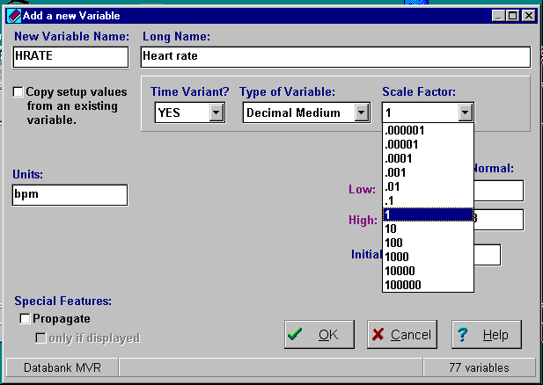
{bml 04-05.bmp}

If the variable type is Decimal Medium or Decimal Long, the decimal point must be positioned depending on the scale factor selected.

If the data for this variable is recorded in whole numbers, leave the scale multiplier at 1. If the data is recorded to the near 1/10th, use a scale multiplier of (.1). If the data are recorded with two places of accuracy (e.g., 4.27), then the scale multiplier must be .01 and so forth. Scale multipliers greater than 1 are less common.

Range Values
(applies to decimal and float variables)
Figure 4-5. Range and initial values
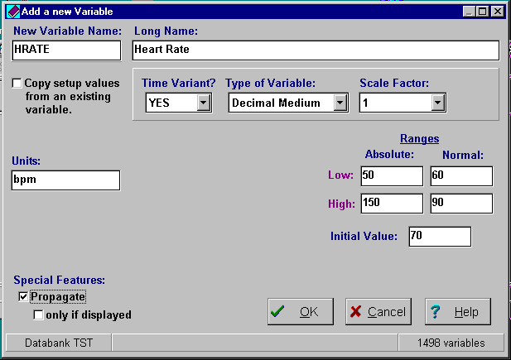
{bml 04-067.bmp}

In the example, Figure 4-5, the low absolute value is 50 and the high absolute value is 150. The normal range can not exceed the absolute range.

Absolute and Normal Ranges
Once a scale factor is chosen for a decimal type variable, the DEFINE program will display the Absolute and the Normal ranges. The default is the greatest range possible for the variable type and scale. If the default range is too small for the intended application, go back and change either the type of variable or the scale factor.

You may set the absolute range to 0-100 by setting the absolute low to 0 and the high to 100. In this case, values less than 0 or more than 100 cannot be entered for a patient.

The normal range can be used to provide a warning during data entry of a possible error. The normal range can also be used to provide guidance when the variable's attributes are displayed during data entry. The normal range must be within the absolute range.

If data is entered with FORM or ENTER, and the data is outside the normal range, the computer will beep. The beep may be enabled or disabled by setting an option in the DATABANK options program.

Initial value
If an initial value is set, it will be used only when encounter number one is established. It is probably best not to specify an initial value unless you really have a good reason.

Units
The units of measure are optional. If the variable is measured in milligram or milliliters, set the units to "mg/ml". By supplying proper units, you are documenting the databank, and removing confusion about what the number really represents.

Propagation
In the example shown in figure 4-5, the Propagate box is checked

“Propagation” means that values will be copied automatically from one encounter to the next. The copying takes place when a new encounter is established, and before any data entry is begun.

In effect, propagate assumes that the value of a variable will not change from on encounter to the next unless there is manual intervention. During the data entry process, the value of a propagated variable will be displayed, and it is up to the data entry operator, if necessary, to change the value.

Propagate is rarely used in controlled clinical trials because it makes assumptions (copies data) without operator action. Propagate is used in clinical practice when much of the data may be assumed to remain constant unless specifically changed. An example is marital status.

Current practice is to avoid the use of propagate, unless a specific need for this capability is found. If propagate is selected, the propagation action can be further limited by the "only if displayed" option.

"only if displayed" option
If this option is selected, the value for the variable will be propagated only if the variable appears on the current data entry form. This means that propagation will only take place when there is an opportunity to change the value. If this option is not selected, the variable will be propagated for that patient when a new encounter for the patient is established, whether or not a form containing the variable is used.

Text Variable Specifications
Figure 4-6. Text variables
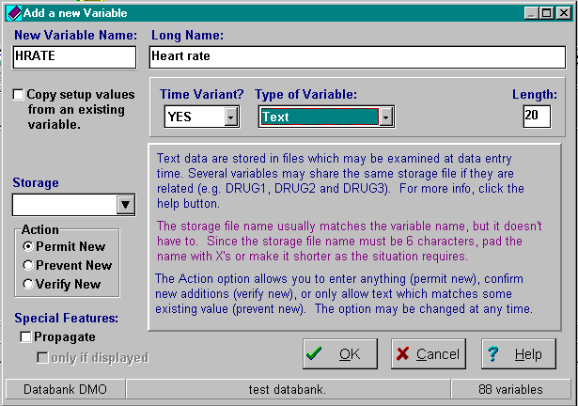
{bml 04-08.bmp}

Length
The length specification will limit the number of characters that can be entered for a value. The number may be from 1 to 80.

Storage
File encoded text values are placed in a pair of files. You must supply a 6-character name that will be used to form the file names.

Newcomers to MEDLOG are usually confused about specifying the storage files. Each file encoded text variable can use a different storage file. If, however, you have several related variables such as COMP1, COMP2, and COMP3 for complaints #1, #2, and #3, it would be best to use the same storage file for all three. There are several reasons for this:
- programs run faster;
- ensures that all complaint variables use the same names to describe the same complaints;
- helps to look at the complaints as a collection rather than three separate variables.

If the databank is large (>1000 patients) do not put too many variables together in the same storage file, especially if the variables have many unique values; e.g., birthplace. Each storage file can hold a maximum of 65,000 different text values. When variables share a storage file, it is just like sharing the same list that has a maximum of 65,000 lines on it.

Avoid using more than 20 text storage files, but 20 files are not an absolute limit. Feel free to discuss this issue with a MEDLOG technical consultant if you are not sure how to use storage files.

Once the storage file names have been established, do not change them.

Action
When the FORM or ENTER programs add data for a text variable, the text file is searched to see if that text already has been used before. What happens next will depend on the option you choose.

Prevent New
No new text values may be entered. An error message will be issued if you attempt to enter text that does not match a previously entered value in the same file. The file/TEXT/table Utility program may then be used to enter new values into the text file.

Permit New
Automatically adds all new values. If the value has not previous been used, it will be added.

Verify New
Verify new entries. If the value entered is not already in the text file, a warning will be given and you are asked to confirm the entry. If you indicate the entry is valid, it will be added.

Action may be changed with DEFINE at any time. It might be prudent to begin by allowing all values (Permit New) and then switch to verifying new entries (Verify New) when the databank is mature.

Table variable specifications
Figure 4-7. Table variable
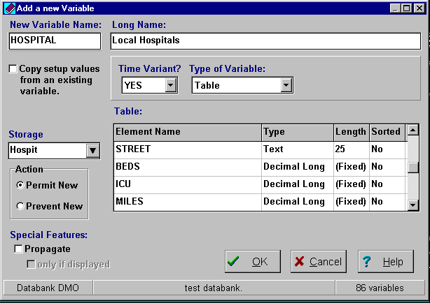
{bml 04-09.bmp}

Table variables are more complex to define than other variable types because they can have up to 250 elements that have separate names and types of their own. For example, a table variable hospital can have elements called name, street, beds, icu and miles. The elements are components of the variable hospital.

TABLE HOSPITAL

NAME STREET BEDS ICU MILES
1. Country Gen. East 4th 400 1 2.5
2. Doctors 2700 Lakeshore 100 0 2.1
3. Presbyterian 24 Elmwood 200 1 7.5

During data entry, a hospital would be selected by placing the cursor on the appropriate table row. If no appropriate row exists a new one could be inserted. A big advantage of a table is its ability to assign all of the element values to a patient with a single step. It helps standardize coding and selection of drugs, adverse reactions, operative procedures, etc.

The elements of a table may be text, decimal long, float, date, image or ext_image. A decimal long element type cannot have a decimal point, so all fractional numbers must use the float element type.

A storage name where the table data will be stored must be created. Several table variables may have the same storage file that means that they will have the same table of choices to work with. This might be appropriate, for example, if we have two symptom variables called SYMPTOM1 and SYMPTOM2. The same storage file for symptoms would be appropriate for both variables.

Table elements

To add an element, e.g. after miles, (see figure 4-7) to an existing table, use the Modify selected variable option. When the variable’s specifications appear, move the cursor to the first empty box on the drop-down Element Name list, click on it and then on the Edit button. Enter the element Name, Type, Length, and Sorted information.

Element names can be up to 25 characters long, but you should use short names so that your entire table can be displayed. Use the remove button to delete elements

Images stored in Tables

A table variable may be used to store a graphical image internal to the table, or externally with a path/filename the graphical image file. A stored graphical image may be loaded during data entry from another file or from the clipboard. The image is stored in the table in jpeg format. External images which are stored by reference (path and file name) and may be in .bmp, jpg or dcm formats. Images may be displayed on the data entry form or used in the LETTER and REPORT programs. While the image type of table element may be used in conjunction with other elements of the table, it is common to use a table variable with only one element (an image type). If this is done, then the table editor (used in data entry) will skip directly to the image editor or the file locator, in the case of the external files.

Remember that images can occupy a lot of storage space. It is typical for a single jpeg format image to occupy 90K bytes. The space occupied in the table for external images is only 256 bytes. Before entering a lot of image data, discuss your application with a MEDLOG technical consutant.

Technical note:
The table data is stored in files formatted for the Paradox relational database system. The tables may be processed directly by Paradox if you have this software package. It is not necessary for you to have any Paradox products to use the table features. The table files are in the defines subdirectory and have file extensions of db, px, xnn and ynn.

Modify Selected Variable
On the Define program option selection dialog box, select a variable, and click on the Modify selected variable button.
Figure 4-8. Modify variable
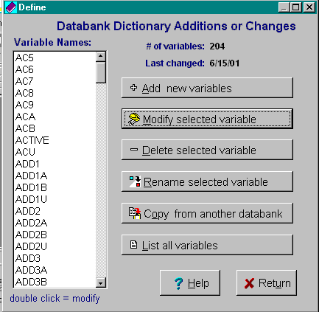
{bml 04-11.bmp}
Or, just double click on the variable you wish to modify.

The following modifications cannot be done once data entry has begun:
- Change numeric data to text data and vice versa
- Change date, time, table or text data to another data type.

If such changes are required, the data must be exported, the variable deleted, and then defined again. After that, the old data can be imported if that is appropriate.

Changing the type and scale of a decimal value is never a problem if the range of permissible values is increased. For example, changing from decimal medium with multiplier .1 to decimal long with multiplier .01 is fine since the permissible range is increased. Making the change in the other direction would cause a problem if negative valued data had been collected for the variable being changed.

Rename Selected Variable
Highlight the variable to be renamed, then click on the Rename selected variable button.
Figure 4-9. Rename selected variable
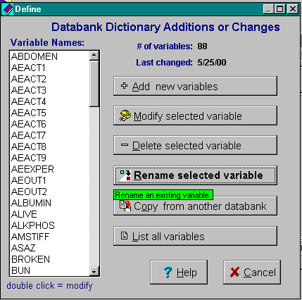
{bml 04-12.bmp}

Enter the New Variable Name and an optional Long Name for the new variable. See page 4-3 for name restrictions.

Verify the new variable names to ensure the data is correct. If everything is correct, click on the OK button to process the change.

Export dictionary to Excel
Clicking on this button will cause an Excel spreadsheet to be created and displayed. It will show the entire contents of the dictionary. Excel cannot be used to import or change the dictionary.
{bml 04-12.bmp}
%PageBreak.

#$K Form Designer-Editor
MEDLOG requires that templates (forms) be designed prior to actual data entry. This is done with form editor-designer or any text editor such as Word. The section, Designing and Creating New Forms, beginning on page 5-4, describes the layout and features you can use to design custom forms. Using the FORM EDITOR-DESIGNER program, you can make data entry screens that look like your paper forms. You also have the capability for computing, enforcing entry rules and controlling the cursor position on a form.

Purpose of form designer-EDITOR
It is used to make data entry screens (forms) that are used by the FORM and VERIFY programs.

Who should use FORM DESIGNER-EDITOR
It should be used by persons authorized to set up or modify the data entry portion of MEDLOG.

When to use FORM DESIGNER-EDITOR
It can be used after you have established a dictionary for a databank (using DEFINE).

Users installing MEDLOG for the first time:
Every databank must have a form that is used to register a new patient. The default name for this form is newpat, but you can give it a different name if you wish (See the databank options program).

Form Design
Figure 5-1. Form EditorDesigner
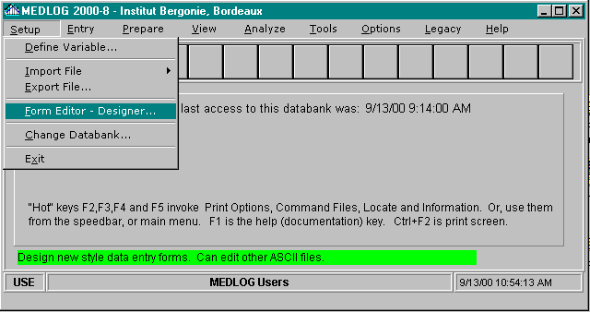
To create a basic newpat form, select Setup from the main MEDLOG menu and invoke the Forms Editor - Designer program.

{bml 05-01.bmp}
If you are using MEDLOG for the first time, FORM EDITOR-DESIGNER will first show a blank form.

Then you can use Figure 5-2 as an example to create a newpat (new patient) form that uses only MEDLOG built-in variables.

Figure 5-2. Form design example
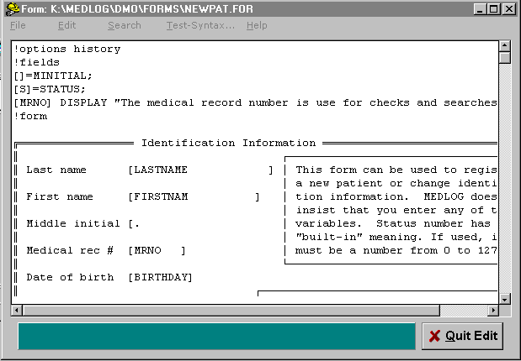
{bml 05-02.bmp}
The first line !options history is used to declare that this forms contains only time-invariant data. Therefore, it will not be necessary to set an encounter date prior to using this form.

The next line is the !fields command which must start in column 1. The !fields section describes processing, rules and naming conventions for the form.

The actual form begins with the !form command. Variables for data input are identified with left and right brackets ([ ]) and the field name must begin immediately after the left bracket. The field on line 14 with the “ [.“ is an exception to be explained later.

The form must end with !end. After saving the file, the form is available for data entry using the FORM program. That is all there is to designing a simple form.

In the next sections, the form rules are given in detail.

Form Requirements

General
A form consists of a fields section and a form section.
- The fields section begins with a line: !FIELDS
- The form section begins with the line: !form
- The form is terminated with an end line, or a continuation line !END

Each of the preceding command instructions must begin in the first column and be the only command on the line.

The contents of the new form depend on the data required.

The name of the form must be a unique, 1-40 character (alphanumeric) name. It is recommended that form names be 15 characters or less in order to display properly in some places.

A form may begin with a line !options xxx,xxx where xxx is a special option. The options are HISTORY, AUTOENTER, AUTODUP, ABORTOPT, CHANGESOPT and GOTOENDOPT. These options are discussed in appropriate places later in this chapter and the next chapter.

The !FIELDS Section
Each entry in this section begins with the name of a field, enclosed in square brackets [ ]. The name corresponds to a name in [brackets] that appears in the !FORM section that follows. You may use upper or lower case for field names.

The purpose for the !FIELDS section is to specify special processing rules for a field when data is entered into that field or when the cursor reaches that field on the form. These rules might specify calculations, required conditions, branching to other parts of the form depending on the value entered, etc.

There are many attributes and actions that may be defined for a field. A complete list begins on page 5-6. Note that a semi-colon terminates every field definition.

In the newpat example, the !FIELDS section is used to provide substitute names for two variables whose names were too long to fit between the brackets in the !FORM section. The second variable, MINITIAL, is given an empty name and will be matched with the first empty name on the form - in this case, "[." See the reference to line 14, Figure 5-2.

You may also specify actions to take at the completion of a form by using a [!END] field specification. This field will be processed after the last field on the form, or whenever the form is completed by any other action. It is useful for performing any over-all checks on the form.

Form Limits
Characters per form line 300
Lines per form 1600
Fields on all forms active at the same time 1400
Forms active at the same time 12
Lines for all forms active at the same time 2400
Variables on all forms active at the same time 1800

Linking Forms Together
If there are several forms which are always processed in sequence, they can be processed automatically by using a !CONTINUE command to end of a form. For example, if forms A, B and C are always used together, the last line of form A would be !CONTINUE B. Likewise, form B concludes with !CONTINUE C.

It is also possible to “nest” forms - see the following paragraph on GOTO statements.

Designing and Creating a New Form

Fields Section Options

Substitution
Sometimes the length of the variable name is longer than the spaced required for data entry on the form. For example, a lab value of 12.1 for a variable called labvalx requires only four spaces, but the field on the form for [labvalx] provides for nine spaces. Substituting a shorter name for labvalx can solve this problem.

By creating a substitute name, [x]= labvalx, in the !fields section, you can use [X], only three spaces long, in the !form section. Note that the brackets count as part of the data entry space when they appear on the form (!form section).

GOTO
The GOTO command directs the input cursor to go directly to the field named. Unless a GOTO rule is given, the next field to be processed will follow the normal direction of reading a printed page (left to right, top to bottom). The GOTO changes this sequence.

Example of GOTO: [symptom] GOTO [headache];
Example of GOTO and SUBSTITUTION: [x]=diastpm GOTO [next];

If you do not want to substitute names, add goto's or use other features, you do not need to mention that field. In fact, you might not need to put anything at all in the field section of a simple form. Example: !FIELDS
!FORM
beginning of form
!END

Very short fields require special attention. Here is an example of a one line form which has 3 adjacent fields, each two characters wide.
!fields
[x]=drug1;
[y]=drug2;
[z]=drug3;
!form
Enter 3 drug numbers [x[y[z next to each other
!end

A special feature allows you to have single character fields that have no identifying name. In this case the !fields section must identify the fields in the same order they will appear on the form.

Example: !fields
[]=drug1;
[]=drug2;
[]=drug3;
!form
Enter 3 drug numbers [[[ next to each other
!end
If it is necessary to refer to a specific unnamed field, you can give it a “reference only” name. This name could be used in another field's GOTO. The reference name is enclosed in parentheses.

Example: [x]=drug1 GOTO [skip];
[(skip)]=treatmnt;
The right and left brackets are special characters that cannot be used as display text on your form.

Description of Field Commands and Attributes
Each field described in the field section of a form may use the features below:

BEFORE causes action to occur before prompting
AFTER causes action to occur after prompting (default)
IF ... THEN...; ELSE... conditional processing.
BEGIN...END for grouping statements (usually follows IF)
GOTO [fieldname] causes a change in the order fields are processed.
COMPUTED( expression) computes a value for the field.
FIXED declares that the field does not prompt for data entry.
HIDDEN makes the field value invisible on the form.
BUTTON(value) makes the field into a button icon.
TIME declares field input to be time-of-day format.
HOUR display field as elapsed hours and minutes (hh:mm)
NUMERIC display numeric value of encoded variables.
NOVERIFY causes the VERIFY program to display a value and skip verification.
AUTOENTER eliminates use of the Enter/Tab key when field is filled.
DISPLAY "message" causes message to be displayed on data entry screen.
TABLE(var,"element") causes selects a particular table element to be displayed.
IMAGE (max-height-aspect) display the table image. If aspect = 0 use picture aspect.

Before studying each feature in detail, you should examine an example of a complex field definition shown below.

[lab] = labtest3;
BEFORE If age>50 BEGIN;
labtest3=?;
GOTO [lab2];
END;
AFTER If labtest3~=SUM(test1,test2,test3) BEGIN;
DISPLAY "Sum DOES not check. Re-enter.";
GOTO [lab];
END;
ELSE GOTO [test4];

In this field specification, a test will be performed before the data entry prompt will be made. If the patient is over 50 years old, the value of labtest3 will be set to missing, no prompt will be made, and the cursor will move to the field labeled lab2. If the patient is not over 50, a value must be entered from the keyboard. It will then be tested to see if it matches the sum of three previously entered values. If it does not match, an error message is printed and the entire field is reprocessed. If it does match, the form continues with field test4.

Commands in this example were written with upper-case letters, but you can use lower-case letters just as well.

Keywords
The keywords that can be used in a field definition are explained further:

- BEFORE
A prefix which may be used in front of GOTO, IF, DISPLAY, BEGIN and any assignment statement. It will cause the action to occur before a value can be entered. Only the DISPLAY operates before entry by default. The other statements would be performed after the field is completed unless the BEFORE prefix is used.

- AFTER
Like BEFORE, except the action will occur after entry is completed for a field.

- IF expression THEN statement; ELSE statement.
The actions you want to perform may depend on the values of data entered. The IF statement is the way to make decisions. The value of the expression is evaluated and the statement following THEN will be performed if the evaluated expression is non-zero. (Note: the relational operators >, <= etc., will return 1 if the relation is true and 0 otherwise). If the expression is not true, the statement following ELSE will be performed. The use of ELSE and its statement are optional. Also, the word THEN can be omitted, if that is your style. The statement following the THEN or ELSE can be another IF statement. Such compound IF constructions may be up to 20 “levels” deep.
Example: IF sex=1 THEN GOTO [gyn];

For text variables, use double quotes around any text constants.
Example: IF drugname="prendisone" GOTO [steroids];

As has been illustrated previously, this statement will cause the cursor to jump to the field named steroids.. In the absence of a BEFORE or AFTER condition, the jump will take place after the data is entered for the field.

The statement GOTO [!END]; will cause the current form to terminate. You may think of [!END] as a special field at the end of every form which signals that the form is complete. It is the same action as clicking the complete icon or pressing Alt-E. When a form is completed, you will normally see a pop-up message asking if any changes are desired. This message can be suppressed when GOTO [!END] is used to complete the form by putting GOTOENDOPT on the !OPTIONS line of the form.

The GOTO statement may also jump to a different form. To do this, the name of the form is specified after the field name.
Example: [test] IF sex=0 THEN GOTO [q1]:followup;

If a GOTO activates a form, control will return to the field containing the GOTO after the “nested” form is completed. If you do not want to return to the previous form, you may use GOTO [!ENDALL] to return to the patient selection menu.

- COMPUTED ( expression).
The field will derive its value from the computed expression. If the computed variable is in your databank dictionary, you must specify FIXED to avoid an input prompt after the calculation. The computed value will be displayed on the screen (unless HIDDEN is specified). The expression may involve previously entered variables, whether on this form or not. It can use the numeric operators and all of the standard numeric functions.
Example: [bsx] COMPUTED(height*1.564+weight/233.5);

- FIXED
This specifies that the field will not prompt for an input value. This is useful for a field that is computed or only used for display purposes.

- HIDDEN
The value of the field will not be displayed, only blanks will be shown. It is used principally for a field that performs checks or calculations, but does not need to display anything.

- Button(value)
This turns the input field into a button icon. The input actions are accomplished by clicking on the button or pressing the Enter key when the button is activated. This will toggle the off-on state of the button. When the button toggled on, the value specified will be assigned to the variable associated with this field. When toggled off, the missing value is assigned.

- NUMERIC
This specifies that the numeric value of the variable will be displayed, not the encoded value. This is applicable only to variable type “encoded ”.

- NOVERIFY
When the VERIFY program comes to a field with this attribute, it will display the value and proceed to the next field.

- AUTOENTER.
It is sometimes faster to enter data if the need to press the Enter or Tab key after every response is eliminated. AUTOENTER will automatically supply the Enter/Tab key press when the field is filled. This action applies only to fields that do not yet have a recorded value. Example:
!fields
[m] AUTOENTER
[y] AUTOENTER
[opdate] COMPUTED(sasdate(15,m,y)) HIDDEN;
!form
Enter month and year of operation [m[y. [opdate]

If you want AUTOENTER to apply to all fields on your form, you can put this option on the !options line. Example: !OPTIONS AUTOENTER.

- DISPLAY "message".
The message will be displayed on the screen. The message might contain additional instructions, entry alternatives, etc. You specify the message by enclosing it in double quotes (").
Example: [hrate] DISPLAY "Enter greatest value observed.";

If the message text begins with the tilde (~) character, it will cause the computer to beep and the message will be displayed without the tilde (~) character.

- POPUP "message".
A popup window will show your message. You must click on the OK button or press Enter to continue processing the form. The computer will also beep..
Example: [cat] if cat=1 & sex=1 then popup "SEX conflict";

- Assignment statement.
An assignment statement has the form: variable = expression; The expressions are the same as those allowed with COMPUTE. The variable will be one you have defined for your databank or one of MEDLOG's built-in variables. It is also possible to compute variables which are only used within the form (if such variables are text, their names must begin with a dollar sign).
Example: [x] DISPLAY "Negative values treated as zero";
IF x<0 then x=0;

- TABLE (variable,”element”)
When table variables are used on a form, the value of the first element will be shown in the field for the variable. When the Insert key is pressed, the complete table will appear. If you would like to have a different element's value appear on the form, you may override the default with this keyword.
Example: [bds] TABLE(hospital,"beds")

TABLE may also be used in computations to get the value of an element.
Example:
[RA]COMPUTED(TABLE(hospital,”beds”)/TABLE(hospital,"rns"));
Note that the element names are enclosed in quotes.

- IMAGE (aspect)
If a table variable contains an image element, use this function to display it on the form. It is only used with a table variable. If the image element is not the first element in the table, you must also use a TABLE statement to specify it. The aspect is the ratio percent of height to width of the graphic. An aspect of 50 would be twice as wide as high. An aspect of 300 would be three times longer than wide. The aspect range is 10 to 1000. A value of zero will use the actual picture aspect and this is the normal choice. Use aspect to make an image shorter than normal. If the aspect is greater than the actual picture aspect, it is not used. The width of the displayed image is determined by the width between the brackets where the variable appears on the form.
Example:
!FIELDS
[PHOTO] TABLE(PHOTOVAR,”TUMOR”) IMAGE(0)
!form
---.
photograph: [PHOTO ]
. (blank lines left for image)

- LINK "program parms".
Link will cause another program to begin. MEDLOG will not continue until the other program completes. If the program is not in the current directory, or standard search path, you should specify a complete path as part of the program name.
Example: [DOSE] LINK "DOSECALC.EXE NORMAL";

- AUDIT
This specifies that an entry will be made in the audit file for any changes made to this variable. See Chapter 8 for a discussion of the audit log.

- TIME
The entry value must be a valid time of day. This is used mainly with computed times which otherwise would be displayed as a number.

- Hour
The resulting value will be displayed as hours:minutes and is generally used with a computation of elapsed time in minutes.

Additional rules for !fields section
- Each field definition is automatically continued until a line is reached which starts with a [ or ! which signals the start of a new field or a new section, respectively.

- Statements within a field definition may be continued by placing a backslash (“\”) character at the end of the line. Example:
[rate] computed(type1*83.4+type2*81.7+type3*78.1\
+type4*75.5);
- Often it is useful to perform some tests or processing when a form is completed. The special field name [!end] can be used for this purpose. Example:
[!END] IF BP = ? THEN BEGIN;
DISPLAY(“BP is a required field”);
GOTO [BP];
END;
Processing of the [!END] field takes place before the “Any changes” message.

Available Functions
The functions that can be used in a computed expression are also described in Chapter 19 of this manual
ABS(x) Absolute value of x
ALOG10(x) Common base 10 logarithm of x
ATAN(x) Arctangent of x
CLOSEST(x1,x2,y) Closest (of x1, x2, etc. to being equal to last argument y.
CONCAT(s1,s2,..) Concatenates two or more text values. The result is text.
COS(x) Cosine of x
DAY(x) Day of the month. The range is 1-31
ENCODED(x) Text value of an encoded variable x
EXP(x) Value of e raised to the power x
INT(x) Integer (whole number), value of x
JULIAN (x) Julian day (1-366) of date value
LAG(x) Value of x from the previous dated encounter
LENGTH(s) Character length of text, value s
LOG(x) Natural logarithm of x
LOG10(x) Base 10 logarithm of a number x
LOOKUP(x1,x2,...y) The last argument y is tested to see if it equals any of the preceding arguments. If it does, the position of the first matching argument is returned and the positions begin with 1. If there is no match, the function returns the missing value
MAX(x1,x2...) Maximum value of the arguments, missing values excluded
MEAN(x1,x2,…) Arithmetic average of the arguments, missing values excluded
MIN(x1,x2,…) Minimum value of the arguments, missing values excluded
MONTH(x) Month of date value x. Returns 1 to 12.
NOT(x) 1 if x = 0, otherwise 0
NOW(0) The current time of the day
NUMERIC(s) The numeric value contained in string s
NUMMISS(x1,x2,x3,…) Number of arguments with missing values
NUMPOS(x1,x2,…) Number of arguments with values greater than zero
NUMREC(x1,x2,...) Number of arguments with non-missing values
PICK(x1,x2...,y) All but the last argument is possible values of the function. The last argument y is the position of the function value to be returned.
POS(s,s2) Position of string s in string s2. The first position is 1.
RAND(x) Uniformly distributed pseudo-random number on an interval 0.....x
SASDATE(d,m,y) Converts d=day, m=month, y=year into date value
SETMISS(x) If x= -1, then the missing value is returned, otherwise the value of x is returned
SIN(x) Sine of x
SQRT(x) Square root of x
STRPICK(s1,s2...n) Like PICK, except for string values
SUBSTR(s,n,l) Substring of s from position n, length l. . The first position is 1.
SUM(x1,x2,...) Sum of the arguments, missing values excluded
TABLE(var,"elem") Returns the value of element for table variables
TBLNDXN("tablename","elem",numval) Returns the index of a numeric value for a given non-text field. tablename is the storage file name.
TBLNDXT("tablename”,"elem", textval) Returns the index of a text value for a text field
TAN(x) Tangent of x
TRUNC(x) Truncate number. Same as INT
WEEKDAY(x) Day of week, Value 1-7, Sunday = 1
YEAR(x) Year of date x
ZERO(x) Value of x at encounter 0 (zero)

Variables
Variables may be used in “if” expressions. If the variable is encoded, its numeric value (internal representation) will be used (See ENCODED function). Text variables may be tested for equality and alphabetical order. If you make up variables to be used only within the form (local variables) they must follow the same naming conventions as defined variables. If a local variable is used to hold text values, its name must begin with a dollar sign.

The built-in variables that you can use as field names are:
LASTNAME
FIRSTNAM
MINITIAL
BIRTHDAY
STATUS
MRNO
PATKEY

There are several other built-in variables that can be used in computed expressions:
DATE Current encounter date.
TIME Current encounter time.
ENCOUNTR Current encounter number.
CHANGED Date patient was last changed.
ENTERED Date patient was first entered in MEDLOG.

The !FORM section
The section of your form beginning with !FORM is the visual area. Everything in this area will appear at data entry time exactly as you designed, except for the field names. The field names, indicated by bracketed ([ ]) names, are replaced at data entry time by a blue line indicating that it is a data entry location.

The names of the fields in your visual area can match a dictionary variable or can match a field name in the !FIELDS section. Duplicate field names are not allowed on the same form.

A left bracket ( [ ) must precede the field names in the visual area. The field names, except for unnamed fields, must begin immediately after the bracket. The width of the field, including the brackets, will determine the maximum input length. For example, [lastname ] will allow 18 characters during data entry. If the field needs to be shorter than the field name and brackets allow, you can use a substitute name as explained later.

Normally a right bracket ( ] ) indicates the end of a field. However, any character that cannot be part of a field name, such as a period or a left bracket, will signal that the field was completed at the previous character position.

MEDLOG forms can be designed with colors and different fonts. Colors and fonts have no effect in the !FIELDS section, and it is suggested that you use a single font and color for it.

Because some fonts (like Arial or Times Roman) have proportionally spaced characters, the effect of using spaces to control the data input width of a field is not as simple as with a mono spaced font like MS Linedraw. The FORM program counts the field width (the brackets, the name length and any spaces) to determine the permissible field width. The size and font style of the data entry field will be determined by the size and font of the bracket character which begins the field.

Colors can be used to make the form more appealing. When data is displayed for a field, it will be displayed in black. If you enter new data, it will be displayed in bolded maroon. This makes it easy to see what has just been entered. If the form is printed (usually without color), the bolding makes it easy to see what was entered.

Tabs can be used to position items on the form. Tab position are set in the ruler at the top of the Form Editor screen and may be changed from line to line. However, do not use tabs between the brackets used for data entry because this will cause strange results..

Editing Forms
Figure 5-3. Open a form
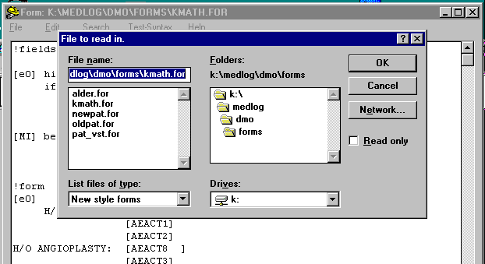ml 05-03.bmp}

To edit a form, browse and select the file and folder containing the form. Click on the form to open the file for editing.

.

Forms can be edited with WordPad, Word, or any editor which can load and save Rich Text Format (RTF) files. However, only MEDLOG’s FORM EDITOR program has a syntax checking capability and other assists. Because FORM EDITOR is very similar to WordPad, no special instruction should be needed to use it

Create new form
Figure 5-4. New form
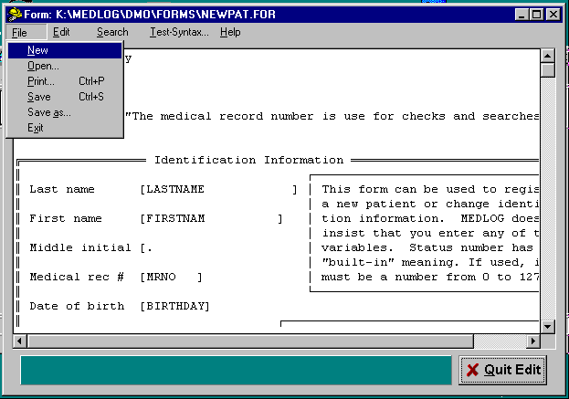{bml 05-04.bmp}%PageBreak.
To design and create a new form, invoke the New option on the File program.

A blank screen will appear which can be used to start a new form.

Image Style Forms
Figure 5-5. An image form used for data entry
.
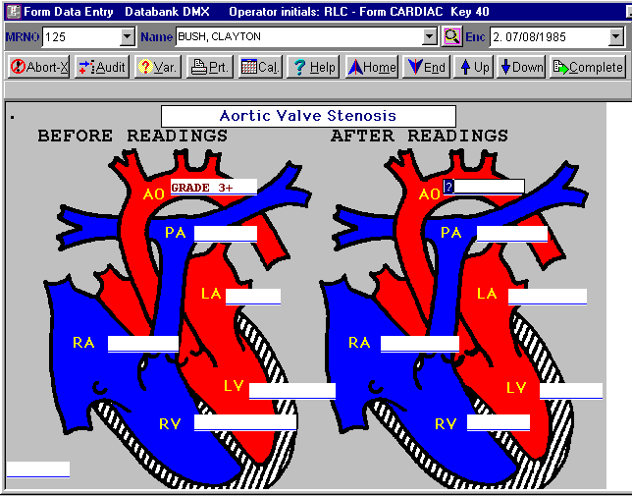
{bml 05-05.bmp}%PageBreak.
Image forms work just like other forms, except they have a background image which may be a picture, a diagram, or any bitmap graphic. In the example above, the two heart diagrams are a bitmap image. The white boxes are the data entry fields. Any part of the image which is underneath the data entry fields is always hidden.

The first step is to get the background image ready. The source of the image may be a scanned page, a file copied from elsewhere or a drawing you made with Paint or some other product. It must be saved as a bitmap (.bmp). Save your bitmap in the FORMS directory of the databank. MEDLOG will not manipulate the image, so it is best to get the image touched-up before you proceed to add the data entry fields on top.

Before you put your image on a form, you must create a new form with at least the !fields, !form and !end lines. Then use the menu selection Format, and click on Background. A dialog box will appear for the image selection. If you choose a valid image, the Form Editor will then split into two windows. One window will hold the image and will be the place where you add the data entry fields. The other window will hold the field statements. Note that when so separated, the lines with !fields and !form are hidden, and you should not try to add them back.

Using the same placement techniques as with any other form, put the bracketed data entry fields on the form. The placement may be a little tricky since the positioning is done by lines of text and not by point and click. You may use tabs to move across the image to get to the correct positions. To move down, add lines with the Enter key as needed. Because placement can be critical, it is suggested that you put a period at the upper left corner of the form. This seems to act as an anchor and helps align the image during data entry. You can see the period in the example above.

You may use the test-syntax to look for errors, just as with any other form. However, because two windows are involved in the Form Editor, errors may not be as easy to understand or locate. Therefore, start with only simple or no field statements. If there are no syntax errors proceed to add more to the fields section as required.

When you are finished putting the fields on the image and finished with the fields statements, you may save the form. When you save the form, the two windows are combined into a single .rtf file. The bitmap must continue to reside in the forms directory, so do not delete it. If you examine the .rtf file in Word, you will see that the image location is on the !form line.

It is not clear how useful image forms will prove to be. Initially, we suggest you use them sparingly. Use them where ordinary text does not illustrate the data entry form well. It is quite possible, however, to scan blank case report forms and use them as image forms for all data entry. A typical bitmap may occupy up to a megabyte of storage, but most computers have ample disk space for many bitmaps.

#$K Form (Data Entry)
The FORM program requires that template forms must be already designed prior to data entry. Use FORM Designer-Editor or a text editor for modifying the form.

Purpose of FORM
The advantage of using the FORM program is that the entry process can mimic on the screen the paper forms that are used for data collection. It has other capabilities for computing, enforcing entry rules and controlling the cursor position on a form. The companion program, VERIFY, can be used for double entry verification.

FORM is used to enter, display, and edit your data.

Who should use FORM
FORM should be used by persons authorized to enter or change data in the MEDLOG system.

When to use FORM
FORM can be used after you have established a dictionary for your databank using Define, and after you have designed suitable entry screens using FORM Editor- Designer.

How to use FORM
Figure 6-1. Main MEDLOG menu
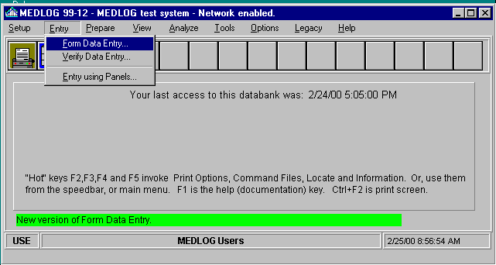
{bml 06-01.bmp}

Select Entry from the main MEDLOG menu and then invoke Form Data Entry.

Users who have previously entered data with FORM will have the last form used appear in the window. The last patient accessed will also appear on the form.
If a different form is needed, click on the drop-down button and select the desired form.
Figure 6-2. Newpat example
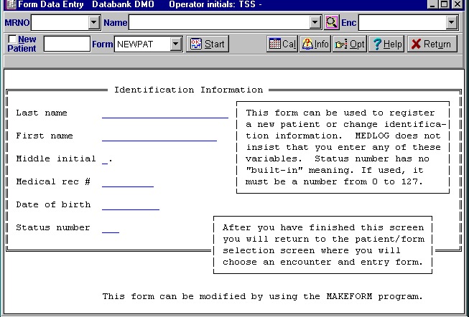
{bml 06-02.bmp}

New MEDLOG databanks
If no forms have been created, the system will open a blank screen and there will be no forms available for selection. Go to the FORM Editor-Design program and make a newpat form, an example of which is in shown in figure 5-4.

Patient selection
The following dialogue boxes on the top of the form are common to all forms. Before you can "Start" data entry, you must select a patient (mrno, name, or key), select an encounter, and select a form. If this is a new patient, click on the New Patient box. The current newpat data entry form will appear and must be completed in order to continue.

mrno If the Medical Record Number is known, enter it or select it from the mrno drop-down list. This action will fill in the name and patient key.
name If the name is known, you may select a patient by name. This will also fill in the mrno and key.
key This box is unlabeled and next to the New patient check box. . A unique key is assigned to each patient beginning with zero. Enter a key number, then press the Tab key. The name and mrno will be filled in.

enc Select the desired encounter date. For a new encounter, select ..New..

form Choose a form the drop-down list.

Retrieving Existing Patients’ Records

Using the Patient Key
Figure 6-3. Select Key
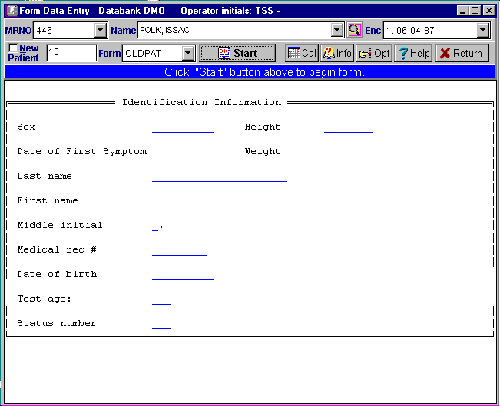
Selection of a patient by patient key
is a one method to find the patient's record. The key for the last patient you processed will appear in the unlabeled key edit box. In this figure the key number is 10. Replace the previous key with the key desired and press Tab. If the number is valid, the corresponding last Name and MRNO fields are automatically filled in.
{bml 06-03.bmp}
If the patient key is not known, either the Name or MRNO can be used to find a patient.

Name and MRNO selection:

Select the drop down list by:
- Scrolling through the list and clicking on the desired name. The corresponding MRNO or Name and key should appear in the appropriate boxes and should be checked for accuracy.
- Typing in the first series of letters in the patient's last name; e.g. "cla" for Clay. The drop down list will then jump to the position in the list where the letters "cla" begin. Scroll through the list to select the desired patient.

After a patient is chosen, an encounter must be selected.

Encounter
Before any data entry can proceed, an encounter must be designated. A new encounter will require a date and, if required by the project, a time-of-day. If the form contains no time-variant variables and the form has !OPTIONS HISTORY specified, then no encounter need be specified to begin data entry. This is useful for registering new patients.

Technical note: databanks that use the encounter zero option will always have "0 (history)" in the encounter list because encounter zero is always considered to exist.

Figure 6-4. Select an Encounter
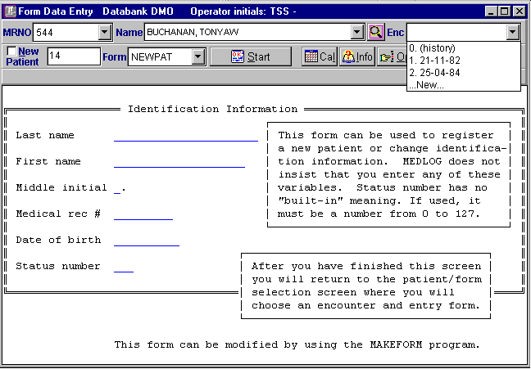
Click on the Enc drop-down list dialog box. A list of encounters and their dates will be displayed in the window with the most recent encounter first.
{bml 06-06.bmp}

Selecting an entry form
Figure 6-5. Select data entry form
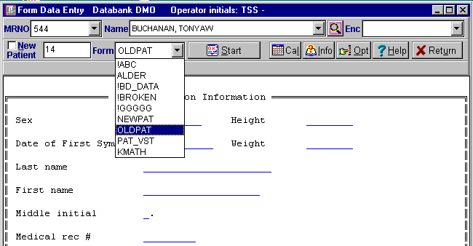
Once a patient and encounter are selected, only the form remains to be selected. The last form used will appear by default.

A list of forms will appear by clicking on the Form drop-down box.

{bml 06-07.bmp}

Changing patient, encounter, or form
When a form is completed, the system will return to the selection menu automatically. To change patient, encounter or form, simply move the cursor to the field and make the change.

Entering a new patient
To begin processing a new patient, click the New Patient dialog box. This automatically brings up the form newpat unless a different default was set in the databank options.

Start Data Entry {bmc BStart.bmp}
Click on the Start button.

Other options
Other options available prior to beginning data entry:

The Info button {bmc BInfo.bmp}
This button will display more information on the currently selected patient. This can also include the display the values of a variable at the various encounters. This list is also useful in finding a particular encounter for a patient with many encounters.

The Opt button {bmc BOpt.bmp}
This button can select or change the variable that is used in conjunction with the Info button.

The Cal button {bmc BCal.bmp}
This button invokes a calendar. This button is also available during data entry.

The Return button {bmc BReturn.bmp}
This button is used to exit data entry and return to the main menu.

The Locator button {bmc BLocator.bmp}
This icon following the Name field is used to invoke the Patient Locator function that is the same as the F4 key. This function is useful in selecting patients by something other than Name or MRNO.

Beginning data entry
Once you click on the Start button, the form values, if any, are filled and the cursor moves to the first entry field. You may also use the mouse to move the cursor directly to any field and then click on the mouse to edit the field.
Click on the Complete button to exit the form. {bmc BComplete.bmp}

During data entry
The menu bar above the form will activate the following actions.

{bml BmenuBar.bmp}

Abort (shortcut Alt-X)
Suspends processing of the form. There are three courses of action:

Click on the Yes button to save any entered data before leaving the from. Click on No to leave without saving any data. Click on Cancel to continue doing data entry. Note: if the form has !OPTIONS ABORTOPT specified, then you will not have the choice to save entered data.

If you click on the Audit button, Figure 6-6 will appear.
Figure 6-6. Audit log
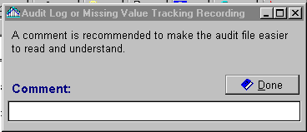
Comments regarding the data being captured can be entered. The audit log provides a record of any unusual situation.
More information on the audit log is found under the topic Audit Log in chapter 8.
{bml 06-08.bmp}

Var (shortcut Alt-V)
Figure 6-7. Variable information
Depending on which variable is being entered, clicking on the Var button displays information from the dictionary.

The same display is given if you right click on a data field during data entry.
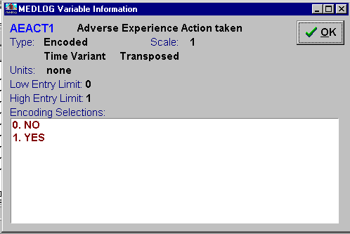
{bml 06-09.bmp}

Prt (shortcut Alt-P)
Figure 6-8. Printer button
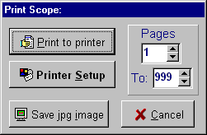
The options are: print a screen, print all lines in the event the lines extend below or above the screen, and change any of the available printer options
Note: The “Save jpg” will copy the form listing to a file. This can later be used in a graphics program or attached to an email.:
06-10.bmp}

Cal (shortcut Alt-L)
Figure 6-9. Calendar
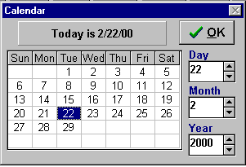
Clicking on the Cal button opens a calendar for the current date

The Calendar can be changed by using the Month, Day, Year scroll buttons on the right of the calendar.
{bml 06-11.bmp}

Help (shortcut Alt-H or F1 key)
Pressing the F1 key or the combination of Alt + H keys opens the Help function.
Figure 6-10. Help
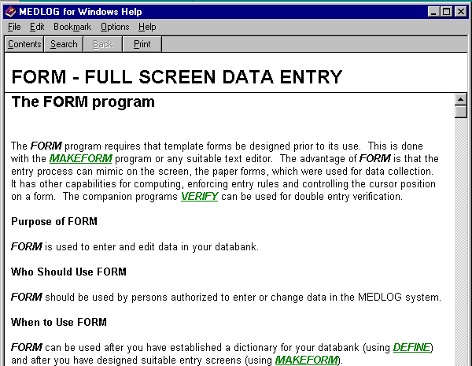
{bml 06-12.bmp}

Home (shortcut Alt-M)
Clicking on the button moves the cursor to the top of the form.

End (shortcut Alt-E)
Clicking on the button moves the cursor to the end of the form.

Down
Moves the cursor to the entry field one line down. Same as pressing the down arrow key.

Up
Moves the cursor up one line (compare with the Shift-Tab keys).
It is the same as pressing the up arrow key.

Complete (shortcut Alt-E)
Clicking the Complete button effectively
jumps to the end of the form and brings
up a yes/no dialog. If you reply Yes,
then data entry continues with this form.

Figure 6-11. Complete?
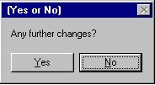

Note: if the form has the option CHANGESOPT specified, the message above will read “Are you finished?” and the roles of yes-no are reversed.6and13.bmp}

Beginning Data Entry
- Initially, the cursor will be positioned at the first field on the form:
To move to the next field, press the Tab or Enter key.
To move to the previous field, use the Shift-Tab keys simultaneously or move the cursor over the field and left click on the mouse;
The PgUp or PgDn keys will move the cursor about one screen up or down.
The Left, Right, Home and End keys are used only to position the cursor while editing a data field.

- When the cursor is positioned at a field for data entry:
a value can be entered.
a question mark can be entered to erase a value;
a special key can be used to enter a value (discussed below);
no action (just Tab or Enter) leaves the field unchanged.

Data Values
To enter a value for the variable, just type it, then press the Tab or Enter key.
To remove a previously entered value (make it missing), type a question mark.

Comments on data entry for the different types of variables.

Decimal variables
The only allowable characters in the value of a decimal variable are the digits (0-9), the decimal point(.), and the minus sign(-) which must be the first character. Embedded blanks are not allowed. A plus sign (+) as the first character is accepted but is unnecessary.

The allowable range is determined by the variable type and scale multiplier, or by its absolute range, if specified in the dictionary. Type, scale multiplier, and absolute range are specified in the data dictionary and are explained in detail in the Define program. Clicking on the ?Var button will display the dictionary information for the variable.

The scale multiplier that is specified in the data dictionary determines the allowable precision. For example, if the scale multiplier is .1, the maximum precision is tenths, so FORM will truncate a value such as 3.21 to 3.2.The maximum precision is visible in the range displayed by clicking on the ?Var button. The number of digits displayed after the decimal point in indicates the maximum precision is fractional. For example, if the allowable range is 1.00 to 25.00, the maximum precision is hundredths.

If the value entered is outside the normal range specified for the variable in the dictionary, a beep occurs (an action which can be disabled in DataBaNK options).

Encoded variables
A value for an encoded variable can be entered in one of three ways: as a character string, as the numeric code for the string, or as a selection from the drop-down list.

For example, if the values for an encoded variable are: ABSENT, MILD, MODERATE, SEVERE, with corresponding codes 0, 1, 2, and 3, then the second value could be entered as MILD or as 1. If the letters MI are entered, FORM will then redisplay the value as “MILD. Note that only enough letters to uniquely identify the value-need to be entered. In this example, MI stands for MILD, S for SEVERE, etc. If sufficient letters for unique identification are not entered, FORM will return the message “Ambiguous encoded value”.

To choose a response from the list of permissible alternatives, click on the drop-down icon or press the Insert key.

Date variables
Values of date variables must be entered in the form MM/DD/YY when using the U.S. format. Other formats are discussed under Databank Options. If the date is 03/27/99 it can be entered as 3/27/99, 3-2-99, 3.2.99, 3/27/99, or 03/27/99. MEDLOG uses a rule that distinguishes between 1900 and 2000 dates, but you can use 4 digit years if you wish. Today’s date an be entered by typing the single letter D.

Text variables
Values of a text variable can contain any character, except that the first character cannot be a question mark (?). Lower case characters are translated into upper case. A text variable has a maximum length. If more than the maximum number of characters is entered, the computer will beep and the cursor will not move forward.

Text values may also be selected from a drop-down list of previously entered values. To do this, click on the drop down icon or press the Insert key.

Note variables
Press on the Insert key or click on the note icon to bring up the note editor. The cursor keys move around the note window. Standard text editing routines using the Backspace, Delete, and Space keys , and the cursor are used to modify the text.

Table variables
Clicking the table icon or pressing the Insert key will bring up a table. See Figure 6-15.

Use the scroll capabilities or the Search option to position the table on a sorted table element. If you surround your search with astrerisks like *SOM* then only those selections containing SOM will be shown. If you use #SOM#, selections containing SOM in any text element will be shown.

After highlighting a row, Click on the Save and Exit button to make an assignment from the table. New entries can be added to the table by clicking the Insert icon or pressing the Alt-I shortcut key.
Figure 6-12. Table variable
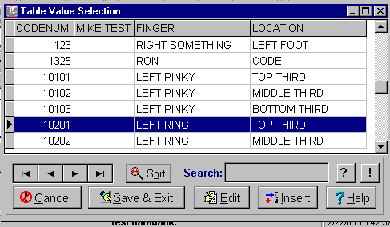
{bml 06-14.bmp}

Special Entry keys

? (Question mark)
The question mark key will delete a previously recorded value without substituting another value. This sets the value back to missing which will display as blank. The same thing happens if you erase completely a value with the backspace or delete keys.

! (Exclamation point)
The exclamation point (!) is an alternative missing value. It is used to distinguish a missing value that requires further action. For example, a missing value for a blood test which is expected to arrive and not remain missing forever. See the VERIFY and Audit Log chapters for a complete discussion.
D and T keys
D can be used to enter today’s date when a date is required. After pressing Tab or Enter, the real date will appear. T is used for the current time of day.
Esc (escape) key
This key aborts entry and asks if you want to continue.
Ins (insert) key
This key will copy the value from the previous field, but only if the option DUPKEY is specified for the field or the entire form (!OPTIONS DUPKEY).

Inserting Comments in the Audit Log
During data entry you can click on the Audit button to put a comment into the databank audit log. See the Audit Log, Chapter 8, for a further discussion.

Error Messages
WARNING - Disk x is over 95% full.
Make frequent backups. Your disk drive is nearly full.

ERROR Could not find !FORM line.
Each form must have a !FORM line to begin the visual part of the form. If this is an RTF form (new style), the problem may be caused by using imbedded tabs instead of returns at the end of lines. Such problems can be seen and fixed in Word by displaying the formatting symbols.

Ambiguous encoded response.
Too few characters were entered to uniquely identify an encoded value.

Invalid.
An incorrect response was made to the patient notes prompt.

Invalid date.
An erroneous month or day was entered. Examples: 15/7/80, 8/34/79, and 23jly84.

Invalid encoded response.
A character string was entered, as the value for an encoded variable, which isn't one of the valid alternatives.

Too late.
A birth date was entered which is in the future.

Too low.
A number less than the allowable minimum was entered, such as a variable value lower than the absolute range.

Too much precision.
A number was entered with more precision than the scale multiplier allows for this variable.
Examples:
If the scale multiplier is l, the maximum precision is units, so 10.3 is not allowed.
If the scale multiplier is .1, the maximum precision is tenths, so 10.31 is not allowed.
If the scale multiplier is 10, the maximum precision is tens, so 103 is not allowed.

Use form MM/DD/YY (or other format).
A date was entered in other than the required format. The ENVIRONMENT program may change the date format.

A linkage error has occurred.
The entry file has been damaged, possibly because of a power failure or a hardware problem. Restore the files from your backup media, and if the problem persists ask a MEDLOG consultant for assistance. The COPIER program can be used to salvage a damaged databank.
%PageBreak.

#$K Enter (using Panels)

Purpose of ENTER
The ENTER program is used to enter and edit data in a databank. It is an alternative or an adjunct to the Form program. It is recommended that FORM be used for most of your data entry since it has capabilities for checking and processing that are not in Enter.

Who should use ENTER
Only persons authorized to enter or change data in the MEDLOG system should use this program.

When to use ENTER
ENTER can be used as soon as a dictionary for a databank has been established using DEFINE.
Data entry can commence immediately or whenever it is most convenient.

How to use ENTER
Go to the Main MEDLOG menu window and choose Entry using Panels program under the Entry menu. The dialog box shown in Figure 7-1 will begin.

Tabular Data Entry
Figure 7-1. Tabular data entry

The window is divided up into several related sections.

Dictionary
All variables in the dictionary are displayed in alphabetical order.

The variables can be selected for the entry list by double clicking on them or using the directional pointer to move it.

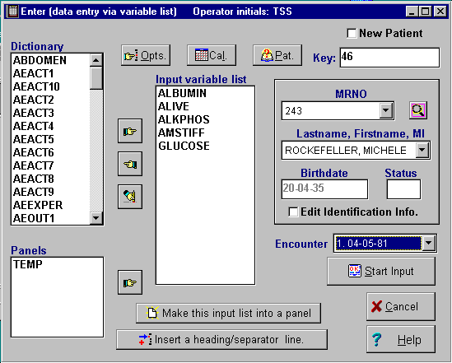{bml 07-01.bmp}

Panels
Panels are lists of dictionary variables and separator lines. Clicking on an existing panel and then clicking on the right pointer will effectively combine that panel with the current panel (i.e., the variables from the chosen panel will be added to the input list).

Clicking on the Edit Identification Info button allows modification of the patient identification.

Insert a heading/separator line
{bml Binsert.bmp}

Figure 7-2. Patient separator line
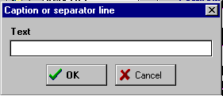
Clicking on the Insert button provides
a window that accepts either a blank line or a text line. The response will then be inserted in the Input variable list. This provides a separator line in the data input list

{bml 07-02.bmp}

Make this input list into a Panel
Clicking on this button invokes a dialog box for a new panel name
{bml BMakePanel.bmp}
Figure 7-3. Create panel
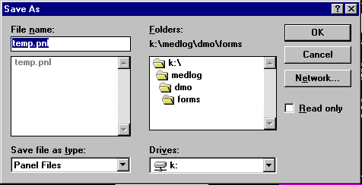
.
Change "temp" under File name to a new 1 to 8 character panel name, then click on OK.

Make sure the extension remains .pnl
{bml 07-03.bmp}

Opt button
Clicking on the Opt button will open Figure 7-4. {bmc BOpt.bmp}

Use the F5 key to get a list of variables. Type in the name of a time-variant variable. The values of this variable will be displayed when the PatInfo button is pressed.

Figure 7-4. Select a variable
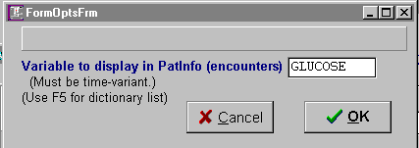
{bml 07-04.bmp}

Cal button
Clicking on the Cal button will open the Calendar display. {bmc BCal.bmp}

Figure 7-5. Calendar
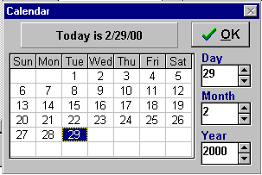
{bml 07-05.bmp}

Data Entry using Panels

Selecting a Patient
Before a panel can be used, an existing patient must be selected or a new patient created. There are several options for calling up a patient already in the databank. To establish a new patient, see the instructions in the following New Patient section.

Select patient by system Key
MEDLOG assigns each new patient a number, called the system key. It uses the key to identify the patient's records in the entry file. The first patient entered is assigned key 0 and subsequent patients are assigned key numbers sequentially.

The patient key is displayed on the screen when data is entered for the patient. If the patient's system key is known, it can be entered and the system will respond with the patient's base record. Specifying the system key is the fastest way of calling up a patient's record. The time taken by the other search methods depends on the number of patients in the databank.

Select patient by MRNO
If the patient's MRNO is known, it may be selected from the drop-down list. By entering the first few characters, the system will position the list according to the characters.

Select patient by Lastname, Firstname, MI
If the patient's name is known, it may be selected from the drop-down list of all patient names.
Figure 7-6. Patient selection
{bml 07-06.bmp}

Once a patient has been selected, the birthday and status will also be displayed. Additional information is available by clicking on the Pat button.
{bmc BPat.bmp}

Figure 7-7. Patient information
Relevant information concerning the selected patient, in this case ROCKEFELLER.

Also, and the values of a selected variable (See figure 7-4), GLUCOSE, appear, providing an easy way to identify an encounter of interest.

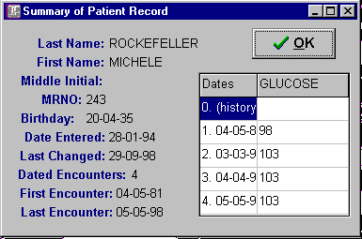
{bml 07-07.bmp}

Selecting an Encounter
When the patient has been selected, enter an encounter number or choose one from the drop-down list. See Figure 7-8. Or you may choose by selection a date from the Pat button list as shown above.
Figure 7-8. Encounter selection
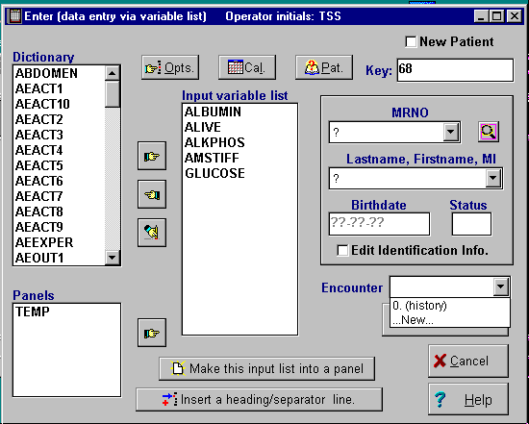
If your databank uses encounter zero (see databank options), it will always appear on the encounter list.

New always appears so that you can create a new encounter date for the patient.

{bml 07-08.bmp}

Start Input
Clicking on the Start Input button will load the appropriate patient date and begin the data entry procedure.
 {bml BStartInput.bmp}

The rules for data entry are essentially the same as in the Form program. See the form program, Chapter 6, for more information.

New Patient
To establish a new patient, click on the New Patient selection box.
Figure 7-9. New patient
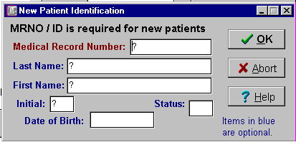
{bml 07-09.bmp}

Click on the OK button when complete and proceed to the variable in your input list.

Note: The question marks (?) indicates a blank or "information not entered" field. Any information entered will replace the question mark.

All of the items on the New Patient Identification dialog box, Figure 7-9, are builtin MEDLOG variables. If your databank options specify that a unique MRNO (Medical Record Number) must exist, then this item is required. All the others are optional.

The Medical Record Number (MRNO) is a maximum of 9 characters. Last name and First Name allow 22 and 20 characters respectively. Initial is a single character and Status may be a number from 0 to 127.

Note that the Enter program provides a handy place to make corrections to a patients name, birthday or MRNO, even if that is the only use you make of it.
%PageBreak.

#$K Verify and Audit Logs

Background
Audit logs are records that keep track of changes or additions to your databank. They are especially useful in controlled clinical trials when it is necessary to determine who changed "what" and "why?". The audit log file contains information about the date of the change, the initials of the person making the change, the identification of the patient being changed, the new data value and the old data value. The exact format of the audit log will be discussed later in this chapter. The audit log can be printed, transferred to Excel, or it can be processed by other non-MEDLOG programs to produce reports.

Verify facilities are used to enter data twice and test for any discrepancies. Good practices dictate that a different person enter the data the second time so that the same errors are unlikely to be repeated. For example, the number 7, when written carelessly, can be misread as a 1. A second observer can help eliminate such errors or, at least, identify ambiguous data. The VERIFY program is nearly identical to the form program except that it is only used to check the data. It produces entries in the audit log whenever a value is changed.

The audit log features are controlled by options that are set in the DATABANK OPTIONS program. These are discussed in this chapter.

The Verify Program

Purpose of VERIFY
VERIFY is used to enter data a second time in order to detect keystroke errors. It is used routinely with databanks where an extremely high degree of confidence in the accuracy of the data is required.

Who should use VERIFY
VERIFY should be used by a different person than the one who entered the data using FORM. The reason for this is to prevent the same errors from being repeated.

When to use VERIFY
VERIFY can be used as soon as data has been entered into the MEDLOG system.

How to use Verify
VERIFY is very similar to form. So much so, in fact, that it is necessary only to speak of the differences in this chapter. You should be familiar with the form program before attempting to use VERIFY.

Invoke the Verify program by clicking on Entry and Verify Data Entry.
Figure 8-1. Main MEDLOG menu
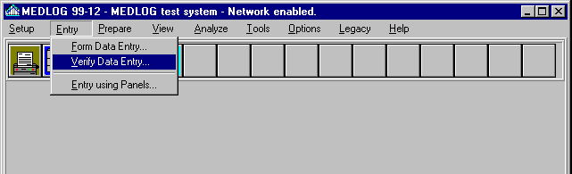
{bml 08-01.bmp}

If the audit log options are currently set for No Logging, you will be asked if changes should be recorded in the audit log. For any other audit log option, you will not be asked, and the changes will be automatically recorded.
Figure 8-2. Start Verify
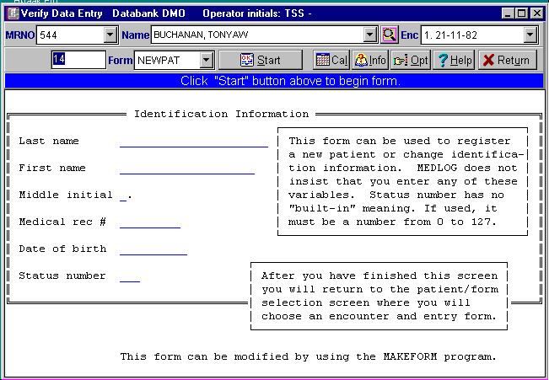
TThe form last used by the Form or VERIFy program will open.

Proceed just like form, to choose a form, patient, and encounter. You may note that the ability to create a new patient or encounter is removed since VERIFY's purpose is to check the accuracy of existing data.

l 08-02.bmp}

Even though a value may already be assigned to a variable, the VERIFY program does not display it. In this way, you will not be influenced to type the same response as before. This is true for numeric variables, encoded variables, and text variables. Note variables will be displayed since this type of data is best verified by visual inspection rather than blinded reentry.
If you enter data which does not agree with the data already in the databank, you will be asked if you wish to change the existing data. If you reply yes, the old data will be overwritten and a record of the change will be made in the audit log file.

In Verify there is, of course, no way to establish a new patient or a new encounter.

The rest of VERIFY is operationally identical to form.

Audit Logs

Setting the Audit Log Options

The VERIFY program will always record any changes in the audit log. Other programs, such as FORM, can also make entries, depending on the audit log control settings. The default condition is to produce no audit log entries, except, possibly, when VERIFY is used.

Figure 8-3. Databank options
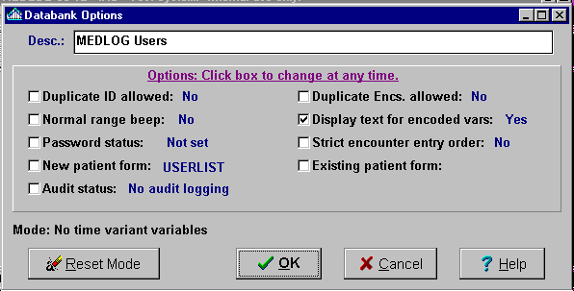
Click on the Audit status selection box to activate audit options.

{bml 08-04.bmp}

If you click on the Audit status box to activate the option, the following Audit action selection list will appear in the following dialog display. In addition to the list of logging options, there is a check which prevents or allows the logging of data when the old value was missing.
Figure 8-4. Audit log options
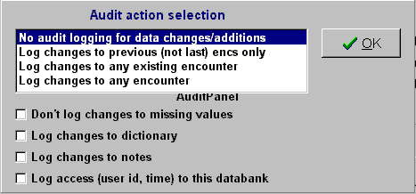
{bml 08-05.bmp}

Remember that audit log activity will slow down data entry in form because the operator may be asked to supply a comment for each audit log entry. Make your logging selections based on your needs; the selection may be changed later.

Following are examples of possible audit logging selections

- No audit logging: This the default condition, and should be changed for FDA trials.
- Log changes to previous (not last): Changes or additions will be logged, but not to the last encounter (most current) encounter of a patient. This option is used to prevent logging of information which may be added at different sessions from looking like separate entry operations. In fact, it is not frequently used.
- Log changes to existing encs: If data is added or changed, with the exception of a new encounter, audit log entries will be made. This is a common option for a clinical trial.
- Log changes to any encounter: This is the most extreme logging activity. Unless the databank is considered to be “complete”, this option should only be used if the box Don’t log changes to missing values is checked. Otherwise, the audit log will grow unmanageably large.

If you are mainly interested in documenting changes made to “old” data, you will probably choose Log changes to any existing encounter option and check the box Don't log changes to missing data option. If a databank is considered “complete”, you may want to change the to Log changes to any encounter and remove the check on Don’t log changes to missing data.

The check box for dictionary changes enables or disables entries in a file for any changes to the databank dictionary. Any FDA clinical trial should log the dictionary changes, once the dictionary has been established and prior to entering any patient data.

The check box for access logging will cause a file to be written whenever the databank is opened. This is a recommended option for FDA clinical trials.

After you have chosen the log options, they will be in effect for the form and VERIFY programs and any other programs which can change the data. The form program will produce audit log entries according to the rules you have chosen. The VERIFY program will produce audit log entries as long as any logging is in effect. The VERIFY program will not record changes if No audit logging is in effect and the operator specifies that no entries should be made in the audit log.

Format of the Audit Log
The audit log is an ASCII file named \MED\xxx\AUDIT.MED where xxx is your databank ID. Each line can be up to 126 characters long, but typically will be much shorter. There are three types of lines: Patient identifier line.
Data change line.
Blank line between patients.

Patient identifier lines
Column Description
Column 1 “F” if generated by FORM, V=VERIFY, X=REMOVE
Column 2 blank
Columns 3-10 date of change
Column 11 blank
Columns 12-16 time of change hh:mm (24 hour)
Column 17 blank
Columns 18-20 operator initials
Column 21 blank
Columns 23-25 the word “Key”
Column 25 blank
Columns 27-31 patient key number, left justified
Column 32 blank
Column 33 ”(”
Columns 33-42 medical record number
Column 43 ”)”
Columns 44-45 blank
Columns 46-48 the word “Enc”
Column 49 blank
Columns 50-52 encounter number
Column 53 blank
Column 54 ”(”
Columns 55-70 encounter date/time
Column 71 “)”
Column 72 blank
Columns 73+ patient name (last-name, first-name, middle-initial)

Scandinavia Only: the Scandinavian identity number replaces the mrno in column 33. ”Enc” is eliminated to provide sufficient room for the identity number.

Data change line
Column 1-2 blank (column 2 is a minus sign if entry is a comment)
Column 3+ variable name, blank, equal sign, blank, old value, space,
minus sign, greater than sign, new value.
(if there is a comment, the new value is followed by a space,colon,
space, then the comment)

Note: Text values are in single quotes ('). The missing value is represented by a single question mark (?).

The audit log file will grow as new entries are added to it. You may periodically edit this file, copy it to other files or erase it when you no longer have a need for it.

The file created for dictionary changes is found in the DEFINES folder and is called DEFAUDIT.MED. The file created for access records is found the databank folder and is called ACCESS.MED. These files make be examined with WordPad, and their format should be obvious.

On network systems, the audit files may be set to “write only” for additional security. Of course, they must be set back to “read/write” in order to examine them.

If a databank is password protected, unsuccessful attempts to gain access will also be recorded in the ACCESS.MED file with the word “FAILED” attached. In order to centralize the unsuccessful attempts of all databases, a file named NOACCESS.MED may be created and placed in the same directory as the MEdlog2k.exe program file. If this file exists, the unsuccessful access attempts will be recorded there and not in the ACCESS.MED file of the individual databanks.

#KLog tracking to Excel
Figure 8-5 shows a partial listing of an audit log file. As you can see, the format of the file has been chosen to make it easy to visually examine the entries. You can examine this file with a text editor such as Word or WordPad. It may be transferred directly into Excel with the LOG TRacking to EXCEL program (under the Tools menu ).
Figure 8-5. Audit log file
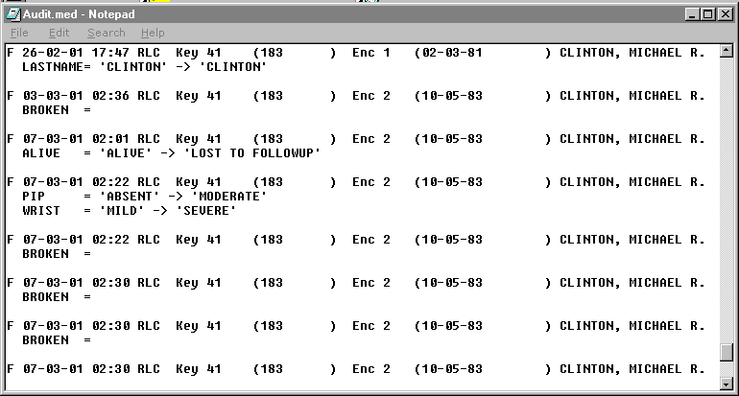
{bml 08-06.bmp}

The audit options also allow you to record the changes that are made to the databank dictionary. If the dictionary option is set, any changes to variable definitions will be written to a file named defaudit.med in the DEFINES subdirectory. The format of the file is:
Variable XXXXX changed by XXX on 7/8/01 at 1:05 PM
Change--item 1
Change--item 2
The change-items will depend on the actual changes made. An example is:
Units: 'POUNDS' to 'LBS'.
This file may be examined with a text editor such as Word or WordPad.

Missing Value Tracking
When the exclamation key ! is used in FORM or enter to set a variable to missing, a record is also made in a special table for the purpose of keeping track of missing data. If the variable is later changed to any value except !, this fact will also be recorded in the missing value table.

The table created for tracking missing data has the name missing! It is stored in the DEFINES directory. The element names of the table are:

Element name Description

id Patient key, encounter date-time, variable name.
Example: 00001-881001-1200-PULSE is patient key 1; encounter October 1, 1988 at 12:00, variable PULSE.
missdate The date the special missing value was set. (i.e. the entry date).
misscomment A comment entered at the time the missing value was set. (optional)
valdate The date the special missing value was changed to another value.
valcomment A comment entered at the time the value was changed. (optional)
mrno Medical record number identifier.

Several programs have facilities to list or search for special missing values. These include GROUP and the F4 Patient Locator function. Listing programs such as CHART will display “!” for special missing values.

The missing value tracking table can be viewed in Excel or in Paradox. The LOG TRACKING TO EXCEL program on the Tools menu can transfer the tracking information directly into Excel.
%PageBreak.

#$K Chart

Purpose of CHART
The CHART program lets you display all or part of the patient data recorded in the MEDLOG files. You can display the records of individual patients or of groups of patients, and you can restrict the encounters and variables displayed.

Who should use CHART
CHART should be used by anyone requiring a listing of entered and computed patient data.

When to use CHART
You can use CHART at any time to display entered data. You must run the CREATE and COMPUTE programs before using CHART to display computed data.

How to use CHARt
Figure 9-1. Chart program
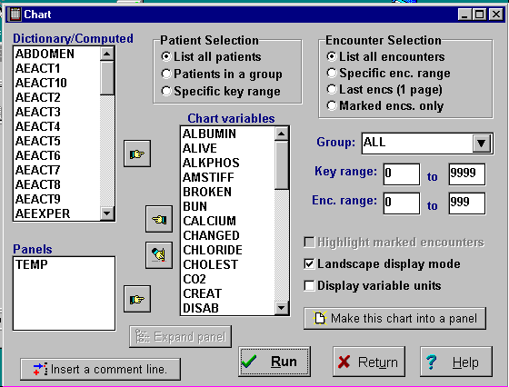
You can choose variables from the Dictionary/Computed list or Panels of variables. The variables will be displayed on the Chart variables list in the order you select them. It is possible to drag and drop the variables to change the order.

Encoded variables are ordinarily displayed as text in the chart listings, but the numeric values will be shown if this option is selected in Databank Options.
{bml 09-01.bmp}

To improve readability, you can insert separators in the form of headings and blank lines in the listing. To insert a comment line, click on the Insert a comment line button.

Patient Selection
- List all patients.
- All patients represented in a group.
If you choose this option, you should also select the appropriate group.
- Specific patient numbers.
If you select this option, you should enter the key ranges of the patients you want.
Encounter Selection

List all encounters

Specific enc. Range: Enter the desired range in the dialog box. See Figure 9-1.

Last encs (1 page)

Marked encs. Only: Applies only to the patient selection, Patients in a group. This results in only the marked encounters of the group being displayed.

After all of the relevant selections are made, press the Run button to produce the Chart.

Patient Chart display
Figure 9-2. Chart display
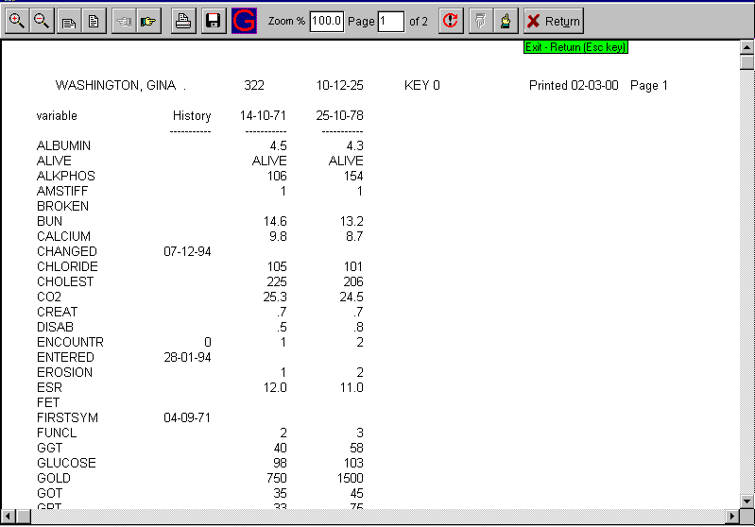
{bml 09-02.bmp}

If there are too many data items to fit on one screen, the listing is continued on subsequent screens. If there are more encounters than will fit across the screen, the additional encounters are shown below the first set of encounters or on subsequent screens, if necessary. Note that in this case the time-invariant variables are not displayed for the additional encounters since they would be the same as on the first encounter displayed. Each patient's data begins on a new page.

Click on the move up or down buttons (looks like hands) to move to the next or previous patient. If a patient uses more than one page, the move right and left buttons will move between the pages belonging to the same patient.
%PageBreak

#$K Import Data
Three programs, COMMA, ASCII and FASTLOAD can accomplish data importation. FASTLOAD is used to import data that was generated for this purpose by the export program. The COMMA program can read comma delimited files, and is used to load data from most other software products. The ASCII program is also used import data from other sources, but it follows a specific format that must be specified prior to its use. Each program is discussed separately.

#KComma or Tab Delimited

Figure 10-1. Comma Program
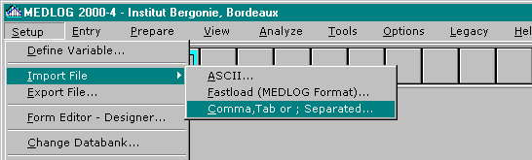
Choose the third import choice, Comma or Tab Delimited.

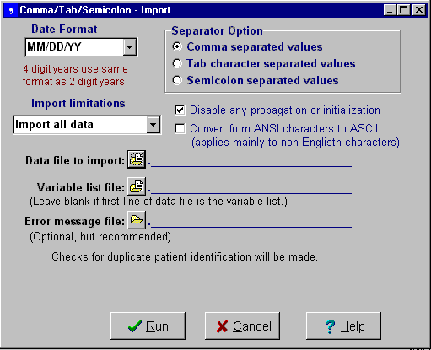
The file to import must have data values delimited by Commas, Tabs or semi-colons.

The variable names can either be on the first line of the data file, or in a separate file (variable list file).
{bml 10-02.bmp}

Figure 10-2. Comma delimited file example displayed in Excel.
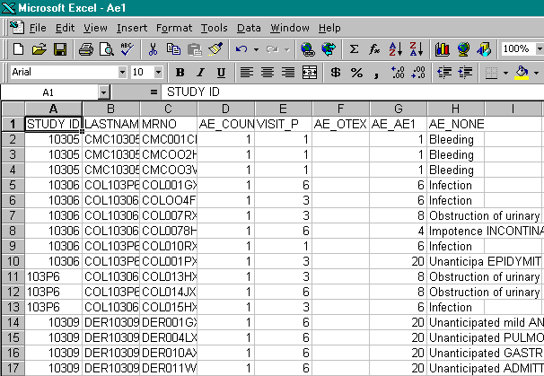
An example of a data file (shown in Excel) which will be saved in CSV (comma separated variables) format.

Note that the variable names are on line 1 and must match names in the MEDLOG databank.
{bml 10-03.bmp}

In this example the data is shown in Excel. When Excel saves this data in CSV format the result will look like this:

STUDY_ID,LASTNAME,MRNO,AE_COUNT,VISIT_P,AE_OTEX,AE_AE1,AE_NONE
10305,CMC10305,CMC001CH,1,1,,1,Bleeding
10305,CMC10305,CMC0002H,1,1,,1,Bleeding
---etc.------

The variable list is on the first line of the file. The names of the variables must match the names of variables in your databank. Variables which do not match will be ignored. You can use NotePad (or another editor) to edit the names if necessary.

If you have the variable list in a different file from the data, you should specify the “Variable list file”.

The “Error message file” is optional, but there is no harm in specifying one. Some users simply call the error file “ERRORS”.

Options for Comma/Tab/Semicolon Import:

The checkbox Disable any propagation or initialization is used to prevent the automatic assignment of values (as might be done during data entry) when a new encounter is created.

The checkbox Convert from ANSI characters to ASCII is used to convert Euro-characters and other special symbols from the ANSI character set to the ASCII character set which is otherwise assumed. This would be useful in Europe if the data came from Excel which would normally use ANSI, and the data contained non-English characters.

The separator character is normally the comma in the USA, but is more likely to be a semicolon in Europe where the comma is used a decimal point. The separator may also be a Tab character.

The Import Limitations allow you to eliminate data from the input file depending on whether the data matches or does not match patient information currently in the databank. The default is Import all data which will add new patients to the databank if the imported data does not match a patient already in the databank (on the basis of MRNO or PATKEY). If a match does occur, the encounter date (if specified) will be used to match an existing encounter for that patient. If no such encounter exists, one will be added. Thus, the default is to create new patients and encounters if no matching takes place, but otherwise to add data to any existing patients and encounters.

The other options are:
Only new patients: data which matches any existing patient will be excluded (skipped).
Only existing patients: data which does not belong to an existing patient will be excluded.
Only existing encounters: the data must belong to an existing patient, and the data must
match an existing encounter for that patient. Otherwise it is skipped.
Only new encs, old pats: the data must match an existing patient, but the encounter date must
be a new one; otherwise, the data will be excluded.
All new, even if duplicate: the data will be appended to the databank, ignoring any
existing patients. This could create duplicate patients (same MRNO) and is possible
only if the Databank Options are set to allow duplicate patients.
It is an option which is rarely needed.

#kASCII

What is ASCII?
ASCII is a program to read data from a file into MEDLOG. The data may have originated on a different computer or from another product on your computer. It is more general than the FASTLOAD program. The main requirements are that the data occur in fixed column positions. Actually, ASCII stands for American Standards Code for Computer Interchange and really defines a character set including the English language, punctuation, and some other symbols. IBM enlarged on this to include most European characters and some others.

Who should use ASCII?
ASCII is normally used by someone who is responsible for the transfer of data and understands the general operations of MEDLOG. Since ASCII can both add and change data in a databank some care must be taken before using it. Initially, a backup of your databank is recommended until you have confirmed the successful operation of the ASCII program.

Limitations
ASCII can only import files that have fixed columns for data from one patient to the next. This is because the template that is needed to import the data is made for the first patient and is assumed to apply to all other patients in the file to be imported. This restricts but does not substantially limit the use of ASCII.

Another restriction is that each patient must begin on a new line and two patients may not have data on the same line. All patients must the same number of lines of data.

The maximum amount of data that can be read for a single patient is 24K bytes. This is the equivalent of more than 300 lines of data having 30 characters per line. It is very unlikely that you would have any records with more data than this for a single patient.

In addition, ASCII permits an optional (max 24 KB) block of header information to precede the first line of the data to load. This block of information is not processed.

Since fixed columns are required, names may pose a problem if first and last are separated by only a space or a comma. It is advised that you know your data file well before you begin creating a template. A little study of exactly what you want to read in will minimize complicating the process.

Dictionary variables must already have been created for all date that you wish to import. ASCII will read in any data type except Paradox table and Notes. Due to the time-oriented nature of MEDLOG, all time-variant variables must have a corresponding date. The date file cannot contain a mixture of date formats.

If possible, it is recommended that the COMMA program be used to import data since it is easier to use.

How to use ASCII
ASCII is flexible, allowing a wide variety of data file formats. It should be easy to make files that are acceptable to ASCII from most software products. The files, which ASCII can read, will consist of one or more lines of data for each patient. Each patient must have same number of lines, and the data on each line must be in the same column for each patient. ASCII cannot read files that are comma delimited; the COMMA program does that. Each patient record must have a variable that is the medical record number (MRNO) or the patient key (PATKEY). This is the way MEDLOG knows which data belongs to whom.

Before you can read in data, you must select a template for the data. Templates are saved and can be used to routinely read data with the same format.

If you do not already have a template for the data you want to read, you must make one. This process is interactive and quite intuitive. When you use ASCII for the first time, no templates will exist, so you will be in the template creation process. Once a template is created, it can be used again at a later date on data files that have the same format.

Design a new input template
To create a template you will need to have access to the file that you want to describe. It may be on your hard disk or on a removable storage device. If it is on your hard disk, make sure that you know what folder (directory) it is in before you begin.

IMPORTANT. The data will be imported to the Current Databank. If the current databank is not the intended destination, use the Change Databank option to open the intended databank.
Figure 10-4. Create template
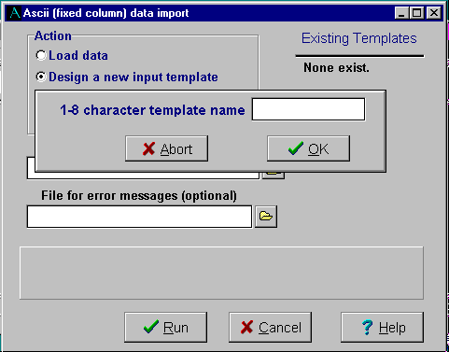
Since you need to create a new template, click on the Design a new Input template button and enter a new template name.

You will then have to enter the location of the file that you want to import.
{bml 10-07.bmp}
---------------------------------------------------------------------------------------------------------------------------------------------------------------------
Figure 10-5. Import file location
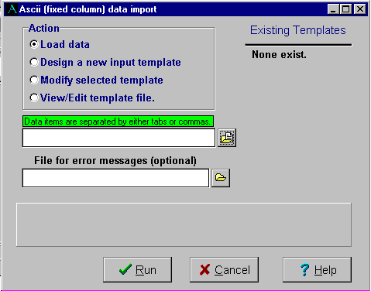
Enter the location of the file containing the data to be imported. The full path name must be provided.

Optional. You can designate a file to contain any errors generated by the importation of data.

{bml 10-08.bmp}

Template construction
The actual process of creating a template is one of using an actual data file and marking the spots where each variable to be loaded begins and ends. If the variable is time variant, then a data/time field must be identified for each such variable. Typically, the same data/time field is used with all the time-variant variables, but it is possible for a record to contain data which will be directed to more than one encounter.

Detailed instructions are not included here, because the process should be self-instructive.

Template completion
Figure 10-6. Create template
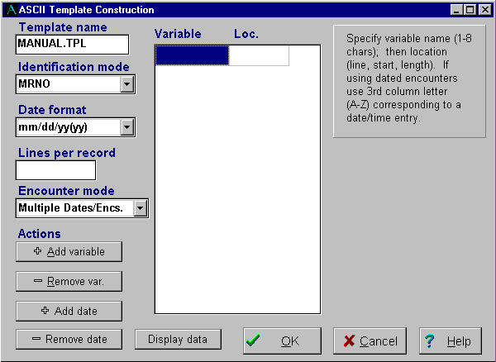
Figure 10-6 shows the resulting template specifications. It is possible to edit any specification without starting over.

(note: this example is not complete -- it does not show the variables and locations.)
{bml 10-09.bmp}

Template name
The name must be 1-8 characters with the extension .TPL.

Identification mode
This is the way ASCII will identify patients. The best method is to use the medical record number (MRNO) since MEDLOG normally prevents duplicate MRNO's. Patient keys can be used for identification but new patients cannot be added with this method. Another method is to use the patient name for identification. If the name method is used and a new patient is added to the databank, a MRNO based on the new patient key will be generated. MRNO's are considered the best patient identification method.

Date format
Select only one date format for the file.

Lines per record
Enter a number representing the number of lines for each patient’s record.

Encounter mode
If the variable that is selected is time-variant, ASCII will ask you if the template will deal with a single encounter or more than one encounter. If you indicate that the template will have more than one encounter (2 or more or encounter 0 and a dated encounter), then you must specify to which encounter each time-variant variable belongs. This is done by giving an encounter "order number" to each of the several encounters you are loading. Encounter 0 should use order number 0. The first dated encounter is number 1, and so forth. The order numbers are not necessarily the same as the patient encounter numbers, particularly when you adding date to existing patients.

Actions
Add variable, Delete variable, Add data, Remove data, and Display data.

Variable
Specify variable name (1-8 characters), then location (line, start length). If using dated encounters, use 3rd column letter (A-Z) corresponding to a date/time entry.

Once all of the elements have been completed, click on OK and the template is ready for use in importing data.

Load data

IMPORTANT. The data will be imported to the current databank as indicated in the lower left-hand corner of the main MEDLOG window. If the databank is not the intended destination, use the Change Databank option to open the intended databank

Modify selected template
Template files created by ASCII are stored in the COMMUN folder with the name xxxxxxx.tpl. You can edit the template by using the Modify selected template option on the ASCII menu. The template may also be modified by using a text editor, but the layout of the file is critical and cannot be changed.

View/Edit template file
Figure 10-7. View template
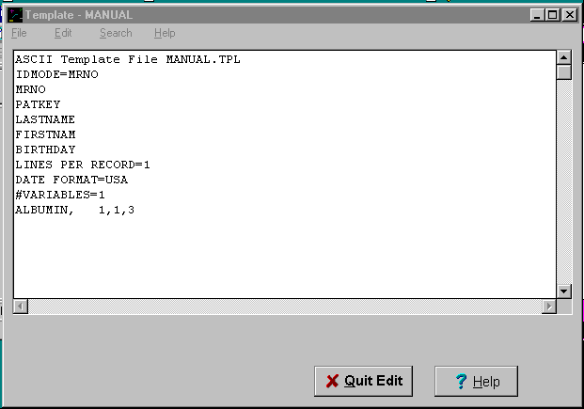
Click on the View/Edit template file button, and select a template from the drop-down list.

The template can be modified as you would with any text. Be careful that any changes follow the expected format.
{bml 10-11.bmp}

Errors
Many things can go wrong with the creating of a template that can cause ASCII to have trouble importing the data. Most of these errors are caused by specifying the wrong columns, having data that is too big for the type defined in MEDLOG, or other similar problems.

ASCII has many checks for error conditions. If you get an error message, it means that the template and data file do not match.

Because the first use of a template is always experimental, you should make sure that you have a backup of your databank before actually attempting to read data. Once you have successfully used ASCII with a template, the usual backup procedures will be adequate.

#KFASTLOAD
Figure 10-8. Fastload program
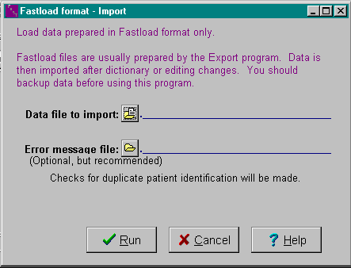
Invoke Fastload from the Setup and Import File menus.

This will open the dialog box as shown in Figure 10-8.

{bml 10-13.bmp}

Use the Windows browse techniques to select the source file. If the source file is on a Network server, invoke the Network option. Click on Run button to begin processing.

FASTLOAD is only used to import data which was made by MEDLOG databank using the fastload format in export. See Exporting Data, Chapter 11, for more information.
%PageBreak.

#$K Export File

Purpose of EXPORT
The Export File program provides for the transfer of data between databanks and to other software products. For extensive transfers between databanks see the build program.

How to Export a data file
Dialog drop-down and selection boxes are provided for selecting source data and for creating the data to be exported.

Figure 11-1. Export file program
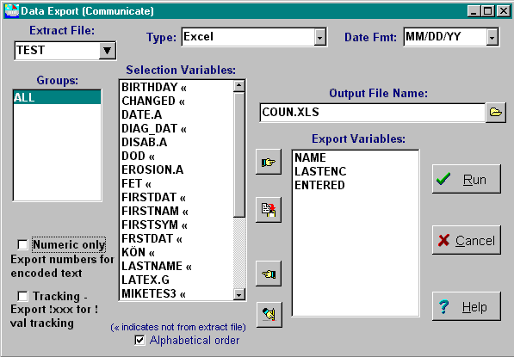
From this screen you will determine which variables will be exported and which patients will be used.

Other options will determine the format of the resulting file and its location.
{bml 11-01.bmp}

The extract file usually holds the data to be exported. You should probably not use export until you are familiar with extract files. An extract file is required before any data can be exported. It will determine which patient’s data to export (the groups in the extract file). It must also contain the names of any time-variant variables which will be exported.

Figure 11-2. Data Export
IThe extract files created for the databank will appear in the drop-down list. One extract file must be selected.
TThe type of file is typically Excel or Comma-1-file.

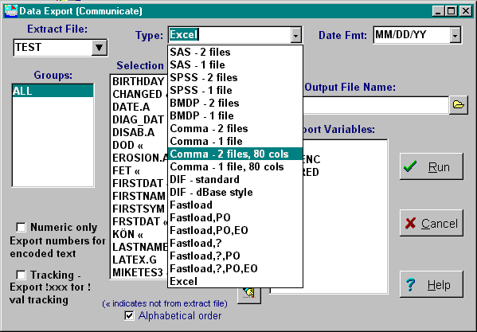
{bml 11-02.bmp}

Type
The different available export file formats will appear in the drop-down list. Select the desired file format by clicking on it.

Note: If Excel or Comma types are selected, an additional option Tracking, will appear below the Numeric only option. This is explained on page 11-4.

SAS is the Statistical Analysis System. SPSS is Statistical Programs for Social Sciences. BMDP is Biomedical Programs. There are the three main statistical packages. The two file version are used when the variable descriptions are placed in a file separate from the data. Of the three packages, SAS is most compatible with MEDLOG. Comma formats are used by many products and probably are the best general purpose method to transfer data. The 80 column formats should only be used if the receiving side cannot handle long text lines.

The DIF format is essentially obsolete and should only be used if really needed.

Fastload format is only used to prepare data which will be fed back to a MEDLOG databank (either the same or a different databank). It is the best format for this purpose. The letters following “Fastload” designate several options which are designed to prevent unintentional data changes. It “?” appears, it indicates that missing values will overwrite a non missing value (when the file is loaded). If “PO” appears then the patient must be old (must already exist in the databank when the file is loaded). If “EO” appears then the encounter (date and time) must already exist when the file is loaded. For example, the selection of “Fastload PO,EO” would put information into the file which would prevent it from establishing new patients or new encounters when the data is later imported.

Date Fmt
The acceptable date formats will appear in the drop down list. Select the appropriate format.
Figure 11-3. Date formats and Groups
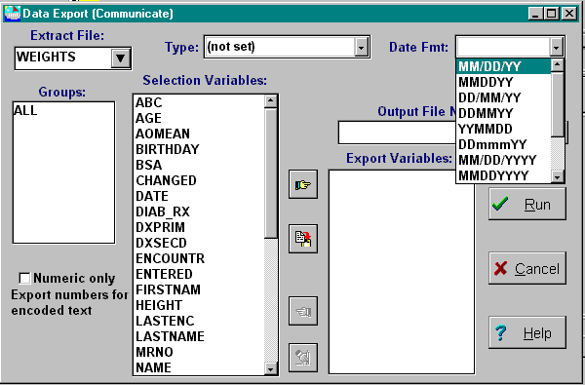
{bml 11-03.bmp}

Groups
All groups in the extract file will appear in the box. Select one or more groups.

Selection Variables
To select variables, click the name to highlight it. Holding the Ctrl key down will allow several variables to be selected at once. Move the selected variables to the Export Variables list by clicking on the Move Right button.

All of the variables on the Extracted/Builtin list can be selected and moved to the Export Variables list by clicking on the Dump button. Variables are moved in the order in which they are selected.

If you want to start fresh, you can start move all of the variables back to the Extracted/builtin list by clicking on the Erase button.

You can also de-select variables by clicking on them and then clicking on the Move Left button.

Output File Name
The complete path and name of the file to be created should be entered.

Numeric only
If this option is selected, the numeric value associated with encoded variables is exported.

Tracking
This option only appears if Excel or Comma export types are selected. If the option is available, selecting it will export the text comment rather than just the default exclamation point (!).
%PageBreak.

#$K Letter

Purpose of LETTER
The LETTER program lets you abstract and summarize data for the individual patient. It has features to selectively include and format data as well as text from other sources. Although the name implies its application for form letters, the LETTER program has numerous clinical applications such as the preparation of a patient summary to be studied prior to a treatment session. The LETTER program can also be used for some other tasks such as printing mailing labels.

Who should use LETTER
LETTER should be used by anyone who wants to produce a form letter or abstract data for individual patients. It does not change any data in the databank.

When to Use LETTER
The LETTER program requires that a letter file be designed prior to its use. LETTER has an editor which is suitable and similar other editors in MEDLOG.

Data for the LETTER program comes directly form the entry files, so letters may be produced as soon as the data is put in your databank. It is not necessary to run CREATE or EXTRACT first.

How to Use Letter
When you use the LETTER program, the first thing you must do is to choose a letter file from the Available letters list. Or, you can design a new letter by clicking the New button.
Figure 12-1. Letter program
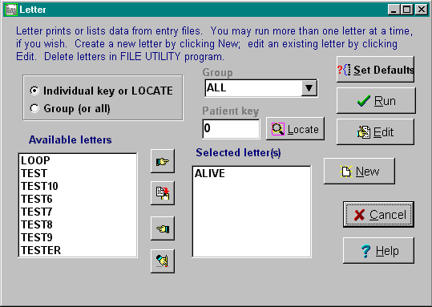
Select either individuals, or groups of patients.

{bml 12-01.bmp}

After a patient or group of patients is selected and one or more letters are selected, click on the Run button. The letter file is read and further actions will depend on its contents. If the letter file does not contain any output directives or contains the ASK function, you will be prompted for the output destination. Letter will run to completion whereupon you may another patient.

How the LETTER program works
In the discussion that follows, it is assumed that the program output is directed to a printer. In practice, output may go to any combination of printer, file, or screen.

The page parameters determine the general output appearance. The defaults are:
Length of a page 60 lines
Top lines left blank 5 lines
Width of a line 70 characters
Left margin (included in width) 8 character
Indentation for new paragraphs 0 characters

These parameters may be changed with the Set Defaults button, or set in the letter file. They may even be changed during the processing of a letter by special letter functions.

Within the page dimensions, the program output flows as if being dictated to a typist. Lines are automatically split so that no line will exceed the width specification. Multiple blank spaces are ignored except two spaces are recognized after a period or colon. A completely blank line indicates the start of a new paragraph.

The letter file normally contains a considerable amount of text data which is transferred verbatim to the printer. In fact, everything goes directly to the printer with two exceptions:

The vertical bar character “|” forces a new line. The bar is not printed.
The left and right brackets [ ] indicate special processing. They may indicate that the value of a variable should be inserted at that point. There are several other possibilities that will be discussed in detail later. The brackets, themselves, are never printed.

Letter Specifications
The letter file is divided into two parts: The preamble and the letter body. The preamble consists of assignment statements and functions to set page parameters.

A line containing only the command line !letter and beginning in column 1 separates the preamble and the body. This command line is required even if there is no preamble.

The body of a letter consists of text which will be formatted according to the page dimensions and special items enclosed in brackets [ ]

Brackets are used to:
- Insert a variable's value or a computed value.
- Conditionally include or exclude a portion of the file.
- Choose portions of the file to include from a list.
- Include letter material from another file.
- Process functions that can set page parameters or produce text output.
The five different uses of brackets are described in detail below.

Inserting Variables or Computed Values
format: [variable]
[(expression)]
In the first instance, variable must be the name of a built-in variable, a variable in the databank dictionary, or a variable defined in the preamble. If the variable is time variant, a suffix must be used. A list of permissible suffixes is on page 12-10 and 12-11. These include most of the suffixes that can be used in the EXTRACT program.

If the variable has a text value (file encoded text, numeric encoded or regular text), the capitalization of the value can be controlled. If the variable sex has two values, male and female, then:
[SEX] will produce MALE or FEMALE.
[sex] will produce male or female
[Sex] will produce Male or Female.

In the last case, the first letter of each word will be capitalized. This is very useful with names and addresses.

If the variable has a numeric value, it will be automatically formatted unless a width and decimal point are specified.

[score,5,1] means print variable SCORE with a width of 5 characters, one to the right of the decimal point. Either the width specification, the decimal specification, or both may be omitted

[score, ,1] means print with one digit showing to the right of a decimal point. The width will not contain any blank padding. If the variable name is followed by blanks but has no width or decimal specification, the number of spaces between and including the brackets will determine the result width. For example, [Address ] and [Address,12] will produce identical results.

A negative width specification causes the value to be centered in that width. Computed expressions are surrounded by parenthesis.
Example: [((DATE.L - BIRTHDAY) /365.25)]

If special formatting is required for a computed expression then the FORMAT function described later can be used.

A computed expression may be arbitrarily complex and may use all of the functions described in the COMPUTE program, Chapter 19, except the memory functions LAG, CUM, ZERO, etc. These memory functions would have no purpose in LETTER. The ASK function can be used in numeric expressions.

Computed expressions may use values from table variables: TABLE(var,elem) will return the numeric value of element elem for variable var.

Conditional Output
format: [+test ... ]
[-test ... ]

Conditional processing is used to include or exclude a portion of the file depending on the value of a variable or computed expression. In the positive case (+) the remainder of the material within braces which follows the test, is included if the test is positive. The negative case is similar except the inclusion takes place if the test is negative, zero or missing.
Example: [+WBC The white blood count was [WBC].]
Here a positive value of WBC causes a complete sentence to be included. Note that brackets may be included within other brackets.

If the test is a computed quantity, it must be enclosed by parenthesis.
Example: [+(A.LR > A.FR) Quantity A increased.]
The blanks immediately following the test are ignored in the output.

Multiple Choice Output
format: [#TEST!TEXT0!TEXT1!TEXT2!...!TEXTN]

Here the TEST is evaluated and used to control the selection of text0, text1, etc. If test is 0 then text0 is used; if TEST is n then textn is used. If TEST is missing or if there is no corresponding choice to make, then the last alternative is chosen.

In the examples below, assume these values. sex=0 wt=150 age=24

[#sex!his!her]
produces his.

[#(Sex+1)!220 is overweight!180 is overweight]
produces 180 is overweight

[#Sex![+(wt>220)[wt] is heavy.]!
[+(wt>180)[wt]is heavy.]]
produces nothing because the chosen portion is a conditional that was not satisfied.

Note that the separator symbol may be an exclamation mark, a vertical bar or any other symbol that can separate the alternatives. The symbol that follows the test, becomes the separator symbol.

Including Text Files
format: [$filename]

When a bracketed expression for a file is processed, the processing of the current file is temporarily suspended and input is switched to the new file. filename should be a 1-8 character name that corresponds to a file with a .txt extension in the LETTERS subdirectory.

The letter-text file can contain anything found in a letter file except it cannot have a preamble (soon to be explained) and does not have the !LETTER line.

Included text files may include other text files, up to a depth of 20 files.
Example: [#sex|[$malefile]|[$femalefi]|]
Here a different file for males and females will be used. Also note the extra vertical bar separator. It will cause no file to be included in case sex is undefined.
Function Processing
format: [&func1(),func2(),...]
This construction is used to process some special functions that are exclusive to the LETTER program. The commas separating the functions are optional.
The functions are:
ASK(prompt) Get input from keyboard
ASSIGN See Advanced Topics, page 12-14
CARDINIT See Advanced Topics, page 12-19
CARDIN See Advanced Topics, page 12-19
CARDSORT See Advanced Topics, page 12-19
CARDOUT See Advanced Topics, page 12-19
COMPARE See Advanced Topics, page 12-18
DATE(x) Format x as a date
FILE(filename) Direct output to a file
FORMAT(x,w,d) Format value of x in width w, d decimal places
HEADING See Advanced Topics
HOURS(x) Format value of x into hours:minutes.
IMAGE(var, elem, width, height) Format an image from a table variable. Width and height are in centimeter (25 = one inch)
INDENT(n) Indentation for new paragraphs. Default is 0
LANDSCAPE() Landscape paper orientation. Use in preamble
LENGTH(n) Page length. Default is 60
LINE(n) Move down to line n
MARGIN(n) Left page margin. Default is 8
MISSING(n) When n=1, display ! (tracking) missing values
NEWLINE() Begin a new line
NEWPAGE() Begin a new page
NOTES(n) When n=1, note lines do not “wrap”
ORDINAL(n) Value is st, nd, rd or th depending on n
PRINT() Direct output to the printer
replace(s,”xy”) Replaces all instances of character x with y in string s.
PRINTSTR(string) See PRINTSTR function in REPORT
SCREEN() Direct output to the screen
SETGROUP(groupname) See Advanced Topics
SETLINE(n) See Advanced Topics
SETPAT(key) See Advanced Topics
SPACES(n) Insert n blank spaces in text
Substr(s,j,n) Substring of S, starting in position j for n characters
TAB(n) Tab to column n
TABLE(var, elem) Value of element elem for variable var
TIME(x) Format x as a time of day
TOP(n) Lines to skip at top of page. Default is 5
TRIM(s) Remove any blanks from the start and end of s.
WIDTH(n) The page width. Default is 70
These functions take effect as they are processed in the letter output. If, for example, the page margin is changed, it would take effect on the next line.

Most of these functions can be placed in the preamble to set the letter dimensions before any real output begins.

Built-in Variables
The Built-in variables available in LETTER are NAME, LASTNAME, FIRSTNAM, MINITIAL, MRNO, PATKEY, BIRTHDAY, STATUS, DATE, TIME, ENCOUNTR, CHANGED, ENTERED and LASTENC. In Scandinavia MRNO is replaced by IDNO, SCANDNUM, and SCANDSEX.

In addition, the variables _DATE_, _TIME_, _TODAY_, _GROUP_, _GROUPTITLE_, _PAGE_ AND _LINE_ can be used. _DATE_ is today's date. _TIME_ is the time of day when LETTER is run. _TODAY_ is like _DATE_, except it has a numeric value that you can use to calculate differences between dates. Example:
It has been [(_TODAY_ - DATE.L)] days since your last visit.

The variables _PAGE_ and _LINE_ represent the current page and line number.

The variables _WORK1_ through _WORK9_ are used with the ASSIGN function. See Advanced Topic ASSIGN on page 12-12 for more information.

The Preamble
The preamble is used to define expressions that are subsequently employed in the body of the letter.

For example, the personal pronouns he and she may be needed in many places in the letter. It would be possible to use the expression [#sex|HE|SHE] wherever this occurs, but it would be easier to define it in the preamble.
Example:
[heshe]=[#sex|HE|SHE]
!letter
When this patient was first seen [HEshe] seemed very anxious.[Heshe] later appeared more relaxed.

The names used in the preamble will take precedent over your dictionary names, but not the built-in variables. Note that capitalization rules apply to variables defined in the preamble, but only if the definition uses capital letters; i.e., capitalization rules are actually de-capitalization rules that assume that the value is composed of all capital letters.

The preamble may also include functions that are not assigned to any name and are processed immediately.
Example:
[&LENGTH(50), TOP(5)]
[&PRINT()]
!letter

Numeric quantities can also be computed in the preamble. The numeric expression should be enclosed in parenthesis (not brackets) to distinguish it from a text result.

The next example computes tab settings in the preamble (T1 through T5) and uses them in the letter body:
[CWIDTH] = (MIN(15,45/NUMENC))
[T1] = [&TAB(5)]
[T2] = [&TAB(5+CWIDTH)]
[T3] = [&TAB(5+2*CWIDTH)]
[T4] = [&TAB(5+3*CWIDTH)]
[T5] = [&TAB(5+4*CWIDTH)]
!letter
[T1][X.1][T2][X.2][T3][X.3][T4][X.4][T5][X.5]
[T1][Y.1][T2][Y.2][t3][Y.3][T4][Y.4][T5][Y.5]
Some functions are used only in the preamble. PRINT(), SCREEN(), and fILE(filename) are used to direct the letter output to the printer, the screen or a file.

The functions to control the page - dimensions, INDENT(n), LENGTH(n), MARGIN(n) and WIDTH(n) are typically put in the preamble, but they can be changed within the letter too.

Using data from various encounters
One of the advantages of LETTER is its ability to pull data from any encounter and combine it with data from other encounters. The technique, which will be familiar to any one who has used MEDLOG for analysis, is to append a “suffix” to the variable name. The suffix determines which encounter to use, or what to calculate. The suffix is used only with time-variant variables.

Suffixes
There are two types of suffixes that you can append to a time-variant variable:

Data from specific encounter
Append the encounter number to the variable. Example: BP.2 is the value of BP on the second encounter. The encounter number can range from 0-999.

Special suffixes
Following is a list of the special suffixes. Another method to reference encounter values is through the ENCVAL function described on page 12-10.
.F value on the first encounter (0 or 1)
.l value on the last encounter
.FP and .LP first and last positive value
.FR and .LR first and last recorded value (same as .1R)
.S smallest value
.G greatest (largest) value
.SP and .GP smallest and greatest positive value
.A average value
.T total of all encounter values
.AP and .TP average and total of the positive values
.DFP and .DLP date of the first and last positive value
.DFR and .DLR date of the first and last recorded value
.DS and .DG date of the smallest and greatest value
.DSP and .DGP date of the smallest and greatest positive value
.#S encounter number of the smallest value
.#G encounter number of the largest value
.#FP and .#LP encounter number of the first and last positive value
.#SP and .#GP encounter number of the smallest and largest positive value
.#FR and .#LR encounter number of the first and last recorded value
.#SR and .#GR encounter number of the smallest and greatest recorded value
.C? Count of the number of times the value was missing
.C! Count of alternative missing values. (Included in .C?)
.CR Count of the number recorded values
.C1 Count of number of times the value was 1
.C2-.C9 Like .C1 except the value is 2, 3, . . ., 9.
.1R 1st recorded value
.2R-.9R 2nd through 9th recorded value
.1P First positive value. Same as .FP
.2P-.9P 2nd through 9th positive value
.1L last value (value on last encounter) .2L next to the last value
.3L-.9L 3rd through the 9th from the end
.1LR last recorded value
.2LR next to the last recorded value
.3LR-.9LR 3rd to the 9th recorded values from the last
.Xxx data from the previously referenced encounter.

EXTRACT, Chapter 22, gives a more detailed explanation of most of the special suffixes. The suffixes .2L, .2LR, .3L, etc. are unique to the LETTER program. They are very useful in obtaining the most recent data for patient summaries.

An explanation of the suffix .xxx is in EXTRACT, Chapter 22.

The function ENCVAL can be used to “compute” which encounter is to be used with a variable. Here is an example of obtaining the value of weight at the middle encounter.
ENCVAL(ENCOUNTR.L/2, WEIGHT)

The first argument is the encounter number and the second argument is the variable. encval may be used in function processing.
[&ENCVAL(Weight.#G-1, Weight)]
will print the weight at the encounter that precedes the greatest weight.

Encval can also be used at any location where a numeric function can be used - provided the variable is numeric.

When encval is used for text values, the result will be capitalized according to the way the variable name is written. If the variable is written with all capitals, the result of ENCVAL will be all capitals.
Example letter:

[&PRINT(), TOP(8), MARGIN(10), WIDTH(60)]
!LETTER
[&TAB(50)][_DATE_]

[Firstnam] [Lastname]|[Street]|[City], [STATE] [ZIP]

Dear [Title] [Lastname]:

Your regular checkup is overdue. Your last visit was [date.l].

Please call 417-9132 and schedule an appointment as soon as possible.
[+((_TODAY_ - DATE.l) > 730) || because it is now more than two years since your last exam, I recommend that a blood chemistry analysis be made. You should not eat prior to your morning appointment.]

Sincerely, |||| Marion Winters, M.D.

Example output from LETTER program:

7/14/01

William Anders
123 Main
Harrison, CA 91711

Dear Mr. Anders:

Your regular checkup is overdue. Your last visit was 3/11/00.

Please call 417-9132 and schedule an appointment as soon as possible.

Sincerely,

Marion Winters, M.D.

Advanced Topics

*REPEAT
You may construct a letter with some portion that is repeated for a specified number of times. For example, you may want your letter to list all white blood counts and the corresponding dates. This is illustrated in the example below.

The portion of a letter to be repeated is enclosed in braces and begins with the *REPEAT function. The *REPEAT function has three arguments which are evaluated before the repetition begins. The first argument sets a built-in variable called _INDEX_ with a starting value. The second argument is a test value that stops the repetition when _INDEX_ exceeds the test value. The third argument is an increment that is added to _INDEX_ at the finish of each repetition.

Example: !letter
White blood counts:
[*Repeat(1,encountr.L,1)
[+(ENCVAL(_index_,WBC)) [DATE.X] [WBC.X]|]]
!end

In the example above, the repetition continues until _INDEX_ reaches the encounter number of the last encounter (ENCOUNTR.L). The repeated portion begins with a test of the value ENCVAL(_INDEX_,WBC) to see if WBC has been recorded at this encounter. If it has, then the date and value will be printed. Note that DATE.X and WBC.X will refer to the encounter used in the ENCVAL function since that is the last reference to a specific encounter.

TABLE
The table function can be used as a text function like [&TABLE(hospital,Address)] or as a computation function like (100+TABLE(drug,cost)).

Capitalization rules apply to text values of table elements. The capitalization is determined by the case of the element name.

The TABLE function has an optional 3rd argument that may be used to access table values directly - without regard to the value of the variable that is used to identify the table. For example [&TABLE(injury.999,site,_INDEX_)] could be used in a repeat construction to print out the entire contents of a table. The suffix 999 used on the table variable INJURY has no effect since _INDEX_ will determine the table entry, not the value of INJURY.

The first argument to TABLE can be the name of the table instead of the name of a table variable. To do this, enclose the table name in quotes.

BREAK
The special function BREAK is used to terminate a repeat construct early. It is useful for stopping the repetition when the exact number of repetitions cannot be known to the REPEAT function. The argument of BREAK is evaluated, and if it is positive the current repetition will be the last. If the argument is not positive BREAK will have no effect.

Here is an example of using repetition to print all the entries of a table. Note that the BREAK function is used to see if another table entry exists or not. Table variable TABVAR requires a suffix (it’s time-variant) so 1 is used, but it has no effect.

!letter
[*repeat(1,9999,1)
[_index_] = [&table(tabvar.1,Name,_index_)]
[&break(table(tabvar.1,medlog_index,_index_+1)=?)]
|]

!OPTION
A letter may begin with a single !OPTION line. Currently there are two options that may be placed on this line.

SETPAT(key)
This selects the patient with the specified key and avoids the prompt for patient key that is normally asked. It is most useful for letters that do not really apply to a patient, as in the example above. This example would be improved by adding !option setpat(0) to the start of the letter.

SETGROUP(name)
This selects a group of patients to use and avoids the prompt for a group name. It is useful if the same group is always used.

ASSIGN
The assign function is used to set a value for working variable. Such variables can be helpful for setting column positions, doing totals, etc. Each letter may use a maximum of 10 different working variables. You may choose any 1-12 character name for your working variables, but you should not use the name of any dictionary variable or any of the built-in variables that begin and end with underscores. These variables may be then used wherever a numeric value is required.

The assign function is typically used with a *REPEAT function and the SETLINE functions. See example under SETLINE where working variable COLUMN is used.

SETLINE
The LETTER program normally prints its output in a left to right fashion, one line at a time. The SETLINE function lets you “hold” lines in memory; place output anywhere on the stored lines then; release the lines for printing.

The hold processes is begun with a [&SETLINE(n)] construct where n is a positive number, usually 1. All output is then held until a [&SETLINE(0)] is issued.

Following is an example which produces “3-up” labels. The lines are numbered for reference only.
1. !option setgroup(ALL)
2. [&length(0),width(90),margin(1),top(0)]
3. !letter
4. [&assign(column=1) setline(1)]
5. [*repeat(0,10000,1)
6. [+(column>60) [&assign(column=1) setline(0)]]
7. [&margin(column) setline(1)]
8. [Name]|[Address]|[City], [State] [Zip]|||
9. [&assign(column=column+28)]
10. [&break(setpat(-1)=-1)]
11. ]
12. [&setline(0)]

Line 1. Group ALL is requested in order to create mailing labels for all patients.
Line 2. The page length is set to zero that will cause continuous printing.
Line 4. The working variable column is given an initial value of 1. Later, column will be used to move the margin for each patient. At this point the SETLINE(1) function tells the LETTER program to hold all subsequent lines.
Line 5. The REPEAT function is used to make an infinite looping action. It will be stopped by the BREAK function on line 10.
Line 6. A test is made on variable column that is used to keep track of the column position. If the position is beyond 60, reset it and release the held lines with the SETLINE(0).
Line 7. The margin is moved and the output line position is set to the first of the “held” lines.
Line 8. This is where the label is formatted.
Line 9. A new value is computed for column which will then be used (in line 7) for a new margin. The margin will move over 28 columns.
Line 10. The BREAK function is used to terminate the REPEAT loop when all the patients have been processed. The SETPAT function causes the next patient to be loaded and returns the patient key. If no more patients exist, it returns a -1 that is tested in the BREAK function.
Line 11 merely defines the end of the REPEAT loop. Control will return to line 6.
Line 12 is used to release the last lines of output that are still being held.

One refinement that can be made to this label program is to “squeeze” out any blank lines that might occur in the middle of the label. Consider line 7 with several address fields:
[Name]|[Add1]|[add2]|[Add3]|[City], [STATE] [ZIP]||

If Add3 is not used, a blank line would occur before City. This can be handled as follows:
[Name]|[+ADD1 [Add1]|][+Add2 [Add2]|]
[+Add3 [Add3]|]|[City], [STATE] [ZIP]||
[-Add1 |][-Add2 |][-Add3 |]

This skips the blank lines, then adds the blank lines at the end of the label.

SETPAT
This function may be used on the !OPTION line, especially to avoid an inappropriate request for a particular patient.

It can also be used with a REPEAT loop to process several patients in the same “letter”. The example under SETLINE shows good use of SETPAT for making labels.

The argument to the SETPAT function is the key of the patient. A key of -1 is used to indicate that the next key in a group is to be used.

The return value of SETPAT is the key of the patient. It returns a -1 if a request is made for the next patient in a group and the group is exhausted.

Special Print Fonts
The function can be used to change the printer fonts and other printer characteristics. It is easiest to define some “printer variables” in the preamble, then use them in the body of the letter.

The argument to PRINTSTR is a string with these parts: effect:size,font
For example PRINTSTR(“I:12,COURIER”) would set the printer to Italic, 12 point and Courier font face.

The first letter in the argument string is the effect: I=Italic, R=Regular, B=Bold, U=underline. If all you want to do is switch to bold, you do not need to specify the size or font. Example: PRINTSTR(“B”) Likewise, you can leave off the font if you only want to change the size.

Underline (U) can be combined with I, R or B. You can also combine bold and italic.
If you have an invalid font name, the font result is unpredictable. Common fonts are Courier,
Times Roman, Arial and MS Linedraw.

It is common practice to “define” the font effects in the preamble. Example:

[bold]=[&printstr("B")]
[reg]=[&printstr("R")]
[_on]=[&printstr("U")]
[_off]=[&printstr("R")]
[small]=[&printstr("R:10,Courier")]
[big]=[&printstr("R:14,Courier")]
!LETTER
----- body of the letter ---

If you place [bold] in your letter, bold face printing will occur until you come to [reg] which switches back to regular printing.

[_on] will turn on underlining while [_off] will turn it off.

For small print (10 points) use [small]. To set to 14 points characters/inch use [big].

ASK(prompt)
The ASK function can be used for text e.g.:[&ASK(“Enter dosing instructions”)] construction, or for numeric, e.g. (_TODAY_+ASK(“additional days”)). When used for text, multiple lines may be entered by ending all but the last line with a backslash (\) or a plus sign (+). New line characters (|) may be put into the response.

Comments
You may imbed comments in your letter. To do so begin with [; and end your comment with a ] which matches the beginning bracket. Comments cannot be split across lines; use multiple comments instead. Remember that blanks that precede or follow the comment are part of the letter and may be significant. It is always safe to add comments immediately following a right bracket.

Comments will have no effect on the program output. Their only purpose is to aid you when you later want to modify your letter.
Example: [+(_index_=1)[;do this only once]...

HEADING
Some letters produce a variable number of output lines which cause page breaks to occur at various places. To have a heading appear whenever a page break happens, use the HEADING function. Once the HEADING function is used, it will cause a heading to appear at each subsequent new page. The HEADING function can also appear in the prolog if you want it to be used on the initial page of the letter. A second use of the HEADING function replaces the heading that was previously set.

The heading function can have a literal string as its argument:
[&HEADING(------continued------)]
or it may use more complex constructions:
[&HEADING([&TAB(45)][Lastname],[Firstnam])]

The heading is printed after the top of page spacing that may be changed with the TOP function and is automatically followed by a line feed.

The argument of the HEADING function is not evaluated until it is used. This unique property allows you to specify the heading in the preamble and have a page number appear properly. Example:
[&HEADING([&TAB(60)]page [_page_])]

SUBSTR
The SUBSTR function is used to obtain a portion of a larger piece of text. The larger piece of text may be a text variable or an expression enclosed in braces. SUBSTR has three arguments: the text string, the starting position, and the length to obtain. For example: [ &SUBSTR(OCC_CAT,2,3)]
will print three characters from the value of variable OCC_CAT beginning in the 2nd character position. If the requested length is too great, the result will only be as long as the text string permits. If the starting position is beyond the end of the string, the result is the null string.

COMPARE
The COMPARE function is used to compare two strings to see if they are equal or if one is greater (alphabetically) then the other. The result of COMPARE(A,B)is numeric: 0 when A and B are equal (leading or trailing blanks are discarded), a positive number if A>B and a negative number if A<B.
Example: [+(COMPARE(DRUG1,DRUG2)=0) both same.]
will print “Both same” if the two drug variables have the same text values.

IMAGE

The IMAGE function will display the graphical image contained in a table variable.
Example: [&image(photo,”tumor”,50,0)]

The first augment is the variable name and the second argument must be an image element name. The third and fourth arguments are the width and height. The graphic will be positioned at the current text position (where the left bracket begins) and the height and width of the display are specified in centimeters (one inch is approximately 25 centimeters). After the image is displayed, the text cursor will be positioned at the right edge of the graphic. The graphic does not cause any line spacing, so you must leave blank space under the graphic position. This allows the graphic to be placed with text to the left or right of it. However, if you are not careful, text and the graphic could be placed on top of one another (allowed, but not usually desirable).

If the height parameter is zero, or more than needed (considering the aspect ration of the graphic itself), it is ignored. Unless you want to shorten the image, set height to zero..

CARDINIT, CARDIN, CARDSORT, CARDOUT
These four functions provide a means to organize, combine and sort data within a letter. The method uses the metaphor of index cards (you know, the 3"x5" recipe cards). Data will be put on the cards and the cards may be sorted. Then the data may be used from the cards. Each card has a “name tag” which we call its index. Each card holds text information that is initially set to all blanks (empty card). The length of the index, the maximum length of text on each card and the number of cards you can use are set with the CARDINIT function. The next line establishes 200 index cards with a text length of 50 characters and an index length of 15 characters
[&CARDINIT(15,50,200)]

The CARDINIT function must be used before CARDIN or the other card functions are used. Only one set of cards can be active at a given time, so a second use of CARDINIT would dispose of the first set of index cards and make another.

Data is put on the index cards with the CARDIN function. It has four arguments:
1. The name of the card index (which card).
2. A numeric value for sorting purposes (priority).
3. The position on the card to place the value.
4. The text value to put on the card.
The priority is not mandatory and you can just put a zero if the sorting is not important.
Example: [&CARDIN(DRUG,0,COLUMN,DOSE)]

In this example the various doses if drugs are being recorded on separate cards for each drug name. The variable COLUMN is calculated previously and increases as each dose is added.

The function CARDSORT merely sorts the cards in order according to the value of the priority. Note: the priority is set the first time CARDIN makes a card. Subsequent access by CARDIN does not change the priority. CARDSORT returns the number of cards in use. It can be used to control a REPEAT loop. See the more complete example that follows.

The function CARDOUT is used to retrieve data from a card. It has three arguments:
1. The “order number” of the card.
2. The starting position to read.
3. The number of characters to obtain.

The “order number” tells which card to read. The cards are numbered 1, 2, 3, ... Originally the order number corresponds to the order in which the cards were created. After use of CARDSORT, the order numbers are rearranged to that number 1 has the highest (largest) priority.

If the starting position is negative, CARDOUT will return the index name of the card.

Following is an example that combines all the card functions to produce a list of adverse reactions with an “+” under the column which represents the encounter where the adverse reaction occurred. Each patient may have up to 20 different adverse reactions, but never more than 3 at a single encounter. The adverse reactions are entered in file encoded text variables REACT1, REACT2 and REACT3. The patients may have a maximum of 12 encounters.

[&CARDINIT(25,36,20)]
[*Repeat(1,lastenc,1)
[-ENCVAL(DATE,_index_)]
[&CARDIN(REACT1.X,0,_index_*3-2," + "),
CARDIN(REACT2.X,0,_index_*3-2," + "),
CARDIN(REACT3.X,0,_index_*3-2," + ")]
]
Reaction 1 2 3 . . . . 11 12||
[*Repeat(1,CARDSORT(),1)
[&CARDOUT(_index_,-1,25)],tab(26),
CARDOUT(_index_,1,36)]
]

This will produce a letter something like

Reaction 1 2 3 . . . . 11 12
Nosebleed + + +
Nausea + + + + +
Dry mouth +
Dizziness + + + +

Note that this example used CARDSORT only to determine the number of cards in use and produces a letter using MEDLOG data in a format that can be designed.
%PageBreak.

#$K Report

The Purpose of REPORT
The REPORT program produces listings and summaries of MEDLOG data in a format that you design. It can also perform sorting and calculations such as totals and percentages.

Who should use REPORT
REPORT should be used by anyone who wants to construct a custom report using data from all patients or the data in an extraction file.

When to use REPORT
The REPORT program requires that a report template be designed prior to its use. This is done with the REPORT program or any suitable text editor.

Usually, the data used to produce a report comes from an extraction file. This allows you to use the power of GROUP and EXTRACT to select the appropriate data and patients. If the report specifies that no extraction file is to be used, then all data will come from the entry files using all patients and all of their encounters. For larger databases, the report process will run much faster if an extraction file is used.

How to use Report
Figure 13-1. Main MEDLOG menu
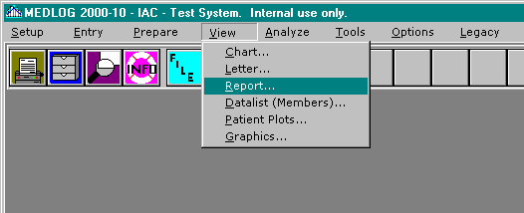
Invoke the Report program from the View menu on the main menu.

{bml 13-01.bmp}

Existing reports
When you invoke REPORT you will be asked to supply the name of the report you wish to run. Generally speaking, that is all there is to do to run a report.

The report file will contain the template for the report, the name of the extraction file to use, the printer characteristics, the patient group name, and any other relevant specifications. Some of the report specifications may be prompted for after you specify the report file name. This will only happen if the report file so directs.

The remainder of this chapter is devoted to the design of reports and the capabilities of the REPORT program.
Figure 13-2. Report program
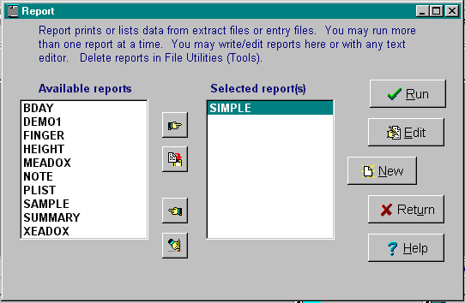
{bml 13-02.bmp}

Create a new report
Before you become immersed in the details of REPORT, it might be a good idea to see just how easy it is to do a simple report. Following is a listing of a simple report file as it looked when it was created with the New option of the Report program.

Figure 13-3. Simple report
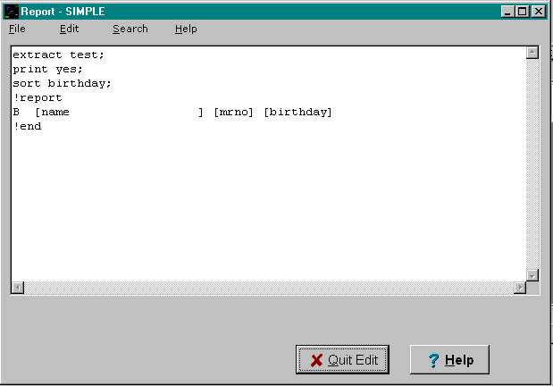
{bml 13-03.bmp}

The first line identifies the extract file to be used. The second line instructs the report to be printed as it is processed. The third line sorts the extraction file on the patients' birthdays. The fourth line instructs the report template to begin here. The fifth line shows the layout of the report.

The report begins with a “B” to indicate this is a bodyline, a line that is repeated for each observation in the extraction file. The square brackets [ ] mark where the variable information will go. The names are placed inside the brackets. The final line is optional, and indicates the end of the report specification.

The results of the report are shown in Figure 13-4.

Figure 13-4 Output from simple report.
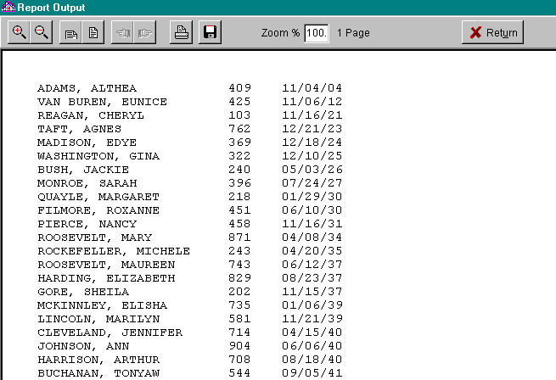
{bml 13-04.bmp}

There are a few things that should be mentioned about the preceding example. First, several defaults were taken: the extraction file contained only one group, 60 lines per page are printed, and variables are left justified (aligned with left edge flush). Also, the screen echoes what is printed. These and other controls can be changed to suit your report needs.

Designing a Report Template
The report template describes the general appearance and function of a report. This template serves a function very similar to that of a form in the FORM data entry program. The situation is a little more complex in the REPORT program, since we want to have summaries, headings, etc.

The report template follows the !report line in the report file. Each line describes a line that will appear in the report. Some lines may appear only at the start of the report (introduction lines), some only at the top of each page (heading lines) or bottom of each page (footing lines). You may print lines for each observation in the extraction file (bodylines) or only for summarization when a sorted variable takes on a different value (sort levels).
The first character on the line indicates the type of line. This character does not become part of the printed report. The line types are:
Symbol Meaning
I Introduction: these lines are printed at the start of a report and before any other lines are processed.

H Heading: these lines are printed at the top of each page.

B Body: these lines are printed each time an observation is read in the extraction file. Some people call these “detail” lines. If no extraction file is used the body lines are printed for each encounter.

1,2,3,4,5 Sort levels: these lines are printed only when the corresponding sort variables change value

F Footing: these lines are printed at the bottom of each page

C Conclusion: these lines are printed at the conclusion of the report after all data is read.

Each line following the !reportstatement must begin with one of the letters or numbers listed above. The rest of the line can contain literal text (characters which will appear exactly as written) or brackets [ ] containing variable names. The brackets will not appear on the report, but their space will be occupied by the value of the indicated variable. Figure 13-5 is a slightly more complex report specification that involves calculation. The output is shown in Figure 13-6.
Figure 13-5. Patient height summary.
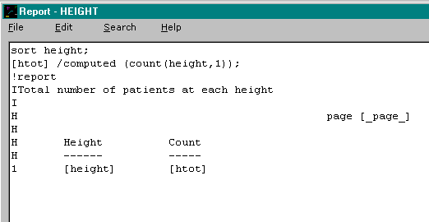
{bml 13-05.bmp}

Figure 13-6. Output of patient height summary.
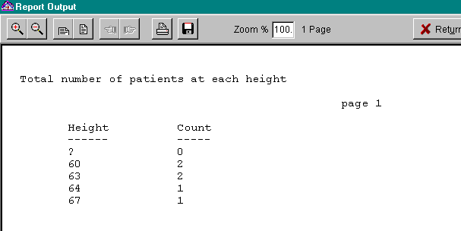

{bml 13-06.bmp}

In this example, we are not interested in the detail for each patient, only the summary for each of the various patient heights. Therefore, the report specification does not contain any body lines (lines beginning with a “B”). The first two lines are (I)ntroduction lines and the next three lines are (H)eading lines that will appear at the top of each page. The sort level 1 line will be repeated each time the sorted variable (in this case height) takes on a new value. On this line are two variables, height and htot. The first variable is in the extraction file and needs no further specification. The second variable, htot is computed in the report. Its specification is on a line that precedes the report template. That line, Beginning with [htot] declares htot to be computed and uses the count function to perform the work. Since computed variables will be discussed in more detail later, you only need to know now that htot was computed by a statement preceding the !report line.

What you should now know is:
- Report templates are composed of different types of lines, each specified by a letter or number in column one.
- The first column of the template does not become part of the printed report.
Sort level lines (1-5) are printed only when the corresponding sort variable changes value. They are used to provide summarization of observations. For a complete description of sort level line, see the Technical Details section.
- Sort level lines often contain computed quantities. The computation is specified in statements that precede the template.
- Some special variables exist which you do not need to compute. In this example, _page_ is such a variable. It has the value of the current page number of the report.

Creating Report Specification Files
Report specification files are given names with one to forty characters. In the computer system they are suffixed with RPT. For example, a report named weeklysum will have a file name of \MED\xxx\REPORTS\WEEKLYSUM.RPT where xxx is your databank ID. If you use report to write your report specifications it will automatically generate the correct file name conventions. If you use your own editor, then you must remember the RPT suffix and to put the file in the REPORTS folder. Note: old versions of MEDLOG used the at-sign @ as a prefix for report names. For compatibility, these files are still recognized.

The REPORT program can accept specification lines containing up to 200 characters. A line may be split into two specification lines by ending the first half with a backslash “\” character. The next line will be then be “glued” to the previous line. Up to six specification lines may be glued together.

Do I need an Extract File before Running a Report?
If you want to use all your data, including data entered since you last ran CREATE, you can do without an extraction file in your report. To do this, you must specify extract none; on a line which precedes your report template. The data going into REPORT will include all patients and all of their encounters (including encounter 0), unless you use a SELECT control statement to eliminate some data. This may be useful if you need a quick report on all patients, but it will take longer to run than if you use an extraction file, particularly for large databanks.

Usually you will want to run a report on a subset of your patients. The best way to do this is to use an extraction file. Since the EXTRACT program lets you specify a patient group, you can utilize the full power of COMPUTE and GROUPS in choosing the patients to use in your report. Also, you can use EXTRACT's ability to reduce a time-variant variable to a single report value. Remember, however, that EXTRACT will only examine data that is in the transpose file. That means that data entered since the last time the CREATE program was run will not be used.

If you do not specify an extraction file, REPORT will assume that you want to use the same extraction file you last used. As you will see later, there is a convenient way to prompt for the extraction file name instead of making it a constant in the specifications.

Variables on Report Templates
The report template will contain one or more variables, enclosed by square brackets [ ]. It does not matter if you use upper or lower case letters for variable names. Several types of variables are allowed:

- Variables that are in the extraction file being processed.

- Variables which are defined in the statements preceding the report template. These may be computed variables or renamed variables.

- Variables that are built into the REPORT program.

- Time invariant variables, including invariant text variables.

- Any variables defined in the dictionary, if the extraction file used the “by encounter” option, or if no extraction file is used (extract none).

The built-in variables are:
_PAGE_ Current page numberof the report.
_LINE_ Current line number of the report page.
_DATE_ Today's date
_TIME_ The current time of day.
_LENGTH_ The page length
_TOP_ Number of lines in the top margin.
_BOTTOM_ Number of lines in the bottom margin.
BREAK_LEVEL Current break level.
OBSERVATIONS Number of observations in the extraction file.
GROUP_TITLE Title of the group used for the report.
GROUP_NAME Name of the group used for the report.
PATKEY Patient key.
MRNO Medical record number.
IDNO Identification number (Scandinavia only).
NAME Last name, first name and middle initial.
FIRSTNAM First name.
LASTNAME Last name.
MINITIAL Middle initial.
BIRTHDAY Patient's date of birth.
STATUS Patient status number.
NUMENC Number of encounters of patient.
LASTENC Date of last encounter.
ENTERED Date patient established in databank.
CHANGED Date patient data last changed.
FIRSTDATE Date of first encounter.

General Specifications of a Report
A report is described by the report template (beginning with the !report line) and the control statements which precede it. Each of these statements should end with a semicolon. Only one statement can be put on a line. Any characters following the semicolon will be treated as a comment.

The statements can be broken down into two types: Specifications controlling the entire report and Specifications of the individual fields (places on the report template where data is displayed). Each of these two categories will be presented in detail, after which a few report examples will be given.

Report Controls
You may use upper or lower case in any function or report command. The words in italics should be replaced by the appropriate choice for your reports. If you want to be prompted for any item in italics, use $ask in place of the italicized name. For example, the line GROUP $ask; will cause the REPORT program to prompt for the group name when the report is run. $ask can have an optional text argument that will become the prompt on the screen.
Example: SPOOL $ASK("supply 1-8 char name");
EXTRACT NONE;
Specifies which extraction file to use. The default is the most recently used extraction file. If none is the extraction file name, then no extraction file will be used and all patient data will be processed from the entry files.
- GROUP gggggggg
Specifies which group to use if the extraction file contains more than one group. The default is the first group in the extraction file.

- SELECT expression
Specifies that only patients or encounters which have a positive value for expression will be used in the report. The expression may be a complicated computed quantity.
Example: SELECT SEX=1 & AGE>30.

- SHOW “text”
The text will be displayed on the screen before the report is run. This is useful for supplying operator instructions. If several lines of text are needed, use more than one SHOW command. The quote marks are required.

- SPOOL filename
Specifies an output file name (1-7 characters). A file containing your report will be written to the disk drive. The name will b prefixed with a percent sign % and have the extension of PRT. If you use SPOOL, but omit the filename, then a spool file will be created using the same name as your report file. For example, if your report is called MONTHLY then the file name for your default spool file is %MONTHLY.PRT in the PRINT folder.

- LENGTH nnn
Number of lines to print on a page. The default is 66.

- TOP nnn
Number of lines to skip at the top of the page. The default is 3.

- BOTTOM nnn
Number of lines to skip at the bottom of each printed page. The default is 3. Note that the defaults: length=66, top=3, and bottom=3 will result in 60 printable lines per page.

- FORMFEED yes/no
If your printer cannot use the formfeed character for a new page, use no to cause slower line spacing instead. The default is yes. Note: this function has no effect in Windows, only DOS.

- DISPLAY yes/no
Echo the printed report on the screen? The default is yes.

- PRINT yes/no
Should the report be sent immediately to the printer? The default is no.

- INIT "initialization"
Used to initialize the printer and set printer options that are specific to your printer. See discussion in “Technical Details” later in this chapter.

- LANDSCAPE yes/no
Used to put the printer into landscape mode. Default is no (portrait mode).

- SORT var1, var2, ...
This statement will cause the data to be sorted on the variables specified. Most reports will need to have a SORT statement since it is essential for any summarization of data. Up to 5 variables may be specified and these will be called the sort levels. Sorting may be in ascending order (the default) or in descending order. To specify descending order, put a minus sign after the variable name. You may also put a plus sign to indicate ascending order, although it is not required. Here is an example which sorts the data by diagnostic code, then within diagnostic code, by date last seen (most recent first), then by patient's last name:
SORT diagnos,date.l-,lastname
There is a close relationship between the sort statement and the sort levels on the report template. For example, if a sort template line begins with “2”, then it is printed only when the 2nd sort variable changes value. Consider an everyday example of a telephone directory. If we wanted to produce a listing of each last name in the phone book and how many persons shared that last name, we would print a summary line only when a new last name is encountered. If this concept is not clear yet, perhaps it will be when you study the examples. For a complete explanation of sort levels, see the Technical Details section.
One statement may be placed on a line. Each statement should be followed by a semicolon. Any characters following the semicolon will be treated as a comment. Example:
SORT zipcode,lastname; sort on zipcode first
If you want to put comment lines in between your statement lines, begin the line with a semicolon. Everything else on that line will be ignored by the REPORT program.

Report Fields
The spaces on the report template delineated by square brackets are sometimes called the report fields. They are replaced by the value of the variable named within the brackets. If there are no additional specifications for the variable, it will be displayed according to its type. Date variables will be displayed in the standard date format for your databank. Numeric variables will be displayed in formats suited to their values, left justified.

Since the purpose of a report is not just to list data, but to present the data in the most readable fashion, there are ways to control the formatting of data.

The field statements are used to describe computations, substitutions, and formatting of the variables used in the report template. These statements may be mixed with the control statements described earlier, but it may make thing easier to visualize if you put the control statements first in your report file, followed by the field statements.

The field statements begin with a square bracket [, followed by the name of a variable, followed by a closing square bracket ]. A field statement may contain several parts and is terminated by a semicolon. It is not necessary to have a field statement for all variables appearing in a report, only those which are computed or require additional formatting instruction. It is also possible to have variables defined in field statements that are used in other field statements, but never appear in the report template.

Here is how a field statement might look:
[lastname] right missing("-unknown-");
This statement says that the value of LASTNAME should be right justified and, if it is missing, then -UNKNOWN- should appear in its place.

Field Specifications
Following are all of the field specifications (which follow the bracketed variable name):

- =VARNAME
Causes a name substitution. If the name on the report template is x then the field statement [x]=diagnos.1; would cause the value of diagnos.1 to appear on the report where x had been specified. This is useful if the actual variable name is too long to fit on the report template in the space allocated for its display.
If you specify a name substitution, it must immediately follow the field name (in the square brackets). Other field specifications may appear in any order.

- LEFT
Causes the value to be left justified in the report. This is the default.

- RIGHT
Causes the value to be right justified.

- CENTERED
Causes the value to be centered in the space reserved by the brackets.

- FORMAT (tw.d)
Controls explicitly how a value is to be displayed. The Type of the variable is T which can have one of these letters:
D = Date
T = Time
N = Numeric (the default)
A = Alphabetic
U = Upper case alphabetic
L = Lower case alphabetic
C = Capitalized alphabetic

The width of the field is specified by W. It modifies the width allowed for the data. The resulting data width will be the lessor of the field format or the width of the brackets on the report template. Instead of a number for W you can put the letter V which specifies a variable or adjustable field width, i.e. using only the spaces that the variable's value requires. The adjusted width can effectively extend the right bracket on the report template.

For numeric variables, the number of decimal places to the right of the decimal point can be specified by D.

Following are some examples of formats and their effects:
variable value format displayed on report
88 FORMAT(N8.4) 88.0000
88 FORMAT(8.2) 88.00
SMITH FORMAT(CV) Smith
SMITH-ANDERSON FORMAT(L10) smith-ande
- PREFIX,SUFFIX,FIXED,NEWPAGE,NOLINE,CHANGED,PRINTSTR.
These are discussed later under Advanced Field Specifications.

- MISSING("text")
When the variable has a missing value, the text specified will be printed instead of the usual question mark.

- COMPUTED(expression)
Specifies that the displayed value is to be computed according to the expression given. To avoid too much detail at this time, only two compute functions will be mentioned now. The remainder are discussed in Advanced Field Specifications.

- SUM(exp1,exp2,...,expn)
Returns the sum of the values of variables or expressions exp1, exp2, etc. It ignores missing values. Example:
[score]=COMPUTED(sum(parta,partb));

- TOAL(variable,sort_level)
Returns the total of all values of the variables specified at the indicated sort level. This is a very powerful concept that requires some discussion. Suppose that you have a report which is sorted on treatment year "treatyr" then on diagnostic code "diagnos", and you wish to see a breakdown showing the percentage of each diagnosis, for each year. You will need to have the total for each year, TOTAL(VAR,1) and the subtotals within each year, TOTAL(VAR,2). See Figure 13-7 for an example.

- NODISPLAY
Suppresses the display of this field. It is useful if you are computing a quantity that you do not want to show in your report.

Two Sort Levels
The example in Figure 13-7 illustrates the important interplay between sort variables, the compute statement functions and the report template sort level lines. It will be discussed line by line
Figure 13-7. Diagnostic summary sample report
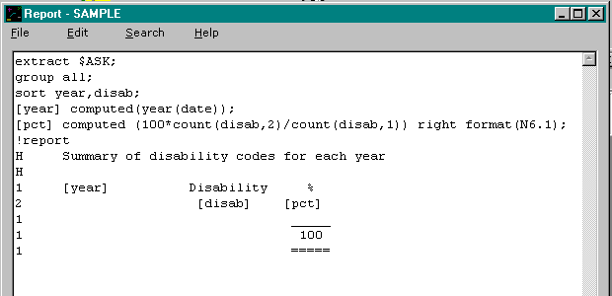
{bml 13-07.bmp}

1. EXTRACT $ASK. The extraction file name will be prompted at the time the report is run.
2. GROUP ALL. The group within that extraction file will be prompted at the time the report is run.
3. SORT YEAR,DISAB data will be sorted on year, and then within year on the diagnostic codes. If the years are 1980-1988, then all the observations for 1980 will be processed first and they will be sorted by the value of the variable diagnos.
4. PCT COMPUTED(100=COUNT(DISAB.2)/COUNT(DISAB.1)) RIGHT FORMAT(N6.1) The variable pct is computed. It uses the function count to count up the number of non-missing values of the diagnosis. It is the ratio of the number of identical diagnostic codes (sort level 2), divided by the number of diagnostics code for the entire year (sort level 1), multiplied by 100 to get a percentage. The result is then formatted to have one digit after the decimal point. The option right is used to cause right justification (alignment on right most column).
5. !REPORT. This line signals the beginning of the report template.
6. H The first header line provides a title for the page.
- H The second header line provides some blank space for readability.
8. 1 This line is printed each time the year (sort level 1) changes value. Here it displays the year and provides a heading for the diagnostic code values appearing in the sort level 2 line
9. 2 The sort level 2 line is printed each time a new diagnostic code is encountered. This line displays the diagnostic code and the computed percentage which it represents for that year.
10. 1 Another sort level 1 line is used to provide an underline for the percentages. The next two lines are similar.

Figure 13-8 shows how the output from the Simple Diagnosis Summary will appear.
Figure 13-8. Simple diagnostic summary
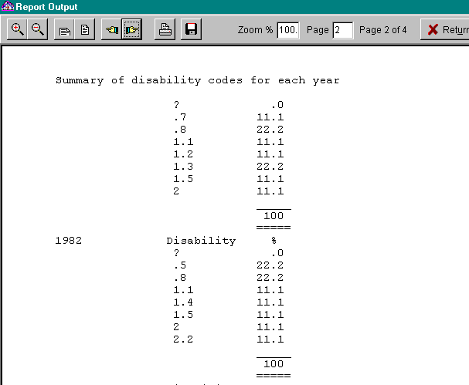{bml 13-08.bmp}

Advanced Field Specifications
The field specifications that were not described earlier are:

- ENCODED ("text0\\ text1\\ ... \\textn")
This is used to substitute a text value for a numeric value. It is similar to the use of an encoded numeric variable in the dictionary. It can be used to assign new encodings to computed quantities. Example:
[x] computed(age.f > 18) encoded("youth\\adult");
. If age.f is over 18, then the computed value of age.f > 18 is 1, otherwise it is 0. The encoded specification will assign the word YOUTH for the value 0 and the word ADULT for the value 1. Thus, patients over 18 will be displayed as ADULT and the others will be displayed as YOUTH.

- PREFIX ("text")
Used to attach one or more characters to the front of a displayed value. The most common use is to put a dollar sign in front of a number. This would be done with prefix("$").

- SUFFIX ("text")
Works like PREFIX except the characters are appended to the end of the variable's value.

- TABLE (variable, "element")
The field is assigned the value of the specified table element. The element type may be text, date or numeric.

- IMAGE (width, height)
This is required to display an image (from a table variable) in the report. The width and height are in centimeters (25 per inch). This statement should be used with the TABLE statement above, unless the table variable contains only one element. If, for example, a field with the IMAGE attribute were placed on a “B” (body) line of a report, there must be sufficient “B” lines following it to allow the image to be displayed without overwriting some other portion of the report. Likewise, sufficient horizontal space on the line must also be allowed; the width between the field brackets is ignored. If the height parameter is set to 0, the height will be determined by the aspect ratio of the stored image. In most cases, you will want to set height to zero.

- FIXED
Used to force the alignment of a value to agree with the report template. This is most frequently used when other fields on the same line have specified that a variable number of spaces should be used, and you want this item to be aligned in a certain column. Consider, for example, this partial report specification:
...[Lastname] format(CV);
[firstnam] format(CV);
[birthday] FIXED;
!report
B [lastname], [firstnam] [birthday]
Here the variables LASTNAME and FIRSTNAM have formats which specify a variable number of character positions. The effect of these is to cause the last name and the first name to be separated by a comma and a single space, regardless of their character length. This would cause birthday to be positioned in different columns, depending on the length of the name. The FIXED option will override this and cause the birthday to appear on the report in a fixed location, as described in the report template.
- NEWPAGE
A new page is automatically begun for a report when the current page is full. Sometimes, you may want to cause a new page to begin at a specific event, perhaps after each subtotal or other change. To do this you must create a dummy variable whose value will not be printed, but which will control the eject to a new page. When a line contains a variable with the newpage option, it will cause a new page to begin if the value of the variable is 1. If it is any other value, the variable will have no effect on the report. Here is a partial report specification which causes a new page to begin for each year in a report:
SOrt year,diagnos;
[new] computed(1) newpage;
!report
- [new]
- 1 Beginning a new year on a new page

- NOLINE
This option has the effect of suppressing the output of a line if the variable has the value 1. Any other value will let the line be printed, but the value of the variable is never displayed. It is useful in suppressing body lines that contain missing data. This is a partial example which illustrates that use:
[nono] computed(nummiss(diagnos)) noline;
!report
H
B [diagnos] [lastname] [doctor] [nono]
If diagnos is missing then the function nummiss will return 1 (the number of missing values). The noline option will cause the body line containing it to be skipped when this happens. If diagnos has a recorded value, then nono will have the value of zero and the body line will be printed. The field [nono]on the body line will not have any space assigned to it on the line. The nummiss function is listed in Compute Functions below, and described in Chapter 19

- CHANGED (sort_level)
This option has the effect of suppressing the output of the variable unless the specified sort level experiences a change of value.

- PRINTSTR("string")
This special option is used to send a sequence of characters to the printer for such purposes as doing underlining or bold printing. This option follow the same rules as for the INIT statement that is described in the Technical Details section of this chapter. Figure 13-9 lists a longer example of a report specification that uses both INIT and PRINTSTR.

Compute Functions in REPORT, the Complete List
There are many functions to use when computing a new value for a report. Most of these will be familiar to you if you have used the COMPUTE program in MEDLOG. Many of the functions can have expressions as arguments. This means that the functions can be nested. If you form a computed that variable which is too complex for the REPORT program to understand, it will tell you.

The numeric operators + - / * is used to cause addition, subtraction, division and multiplication, respectively. If either operand is missing then the result of the operation is missing.

- Standard) the sine of expression.

Mathematical Functions:
- SIN(expression) the sine of expression.
- COS(expression) the cosine of expression.
- TAN(expression) the tangent of expression.
- ATAN(expression)the arctangent of expression
- SQRT(expression n) the positive square root of expression
- EXP(expression) the anti natural log of expression
- LOG(expression) the natural log of expression
- LOG10(expression) the log, base 10 of expression
- ABS(expression) the absolute value of expression
- TRUNC(expression) the integer portion of expression
Functions with variable number of arguments

Arguments with missing values are ignored:
- SUM (exp1,exp2,... expn) the sum of the non-missing value of the expressions. Example: SUM(A,B,C,D)
- MEAN (exp1,exp2,... expn) the mean of the non-missing value of the expressions.
- MIN (exp1,exp2,... expn) the minimum of the non-missing value of the expressions.
- MAX (exp1,exp2,... expn) the maximum of the non-missing value of the expressions.

Analogs of COMPUTE functions
The next set of functions are the same as the functions which are described in the chapter on the COMPUTE program. See chapter 19 for their description.
- NUMMISS (exp1,exp2,... expn) Number of missing arguments.
- NUMPOS (exp1,exp2,... expn) Number of positive arguments.
- NUMREC (exp1,exp2,... expn) Number of recorded arguments.
- LOOKUP (exp1,exp2,... expn) Use a lookup a value from a list of values.
- CLOSEST (exp1,exp2,... expn) Find the closest list value.
- PICK (exp1,exp2,... expn) Find a position in a list.
- SETMISS (expression) Set -1 value to missing.
- NOT (expression) 1 if expression is 0, 0 otherwise.
- MONTH (date_variable) the month of the date (1-12).
- YEAR (date_variable) the year of the date (4 digits).
- WEEKDAY (date_variable) the day of the week (1=Sunday).
- DAY (expression) the day of the month (1-31).
- JULIAN (expression) the day of the year (1-365).
- SASDATE (dd,mm,yy) the date value of the components.
- TABLE(var,”elem”) the value of element elem for variable var

String (text) functions
These functions can also be used in the LETTER program and in the FORM program:
- CONCAT( exp1,exp2,...) This function will concatenate the values of any number of variables,string constants or expressions..
- SUBSTR(exp, start, len) This function will convert the exp to a string, then take len character beginning at position start. The result is a text string.
- STRPICK( exp1,exp2,... expn) This like the PICK function except the arguments are converted to strings and the result is a text string.
- POS{XE “pos function (in report)”}(str,substr) returns the position in str which
Where substr matches. Returns 0 if no match. First position is 1.

Sort level functions
Several functions look similar to those in the COMPUTE program, but they behave differently. When a sort level is mentioned, there is a number 1-5 that corresponds to a sort variable. These functions are very useful when summarizing data:
- CUM(variable, sort_level) Cumulates the value of the variable starting from zero whenever a change of the sort.level variable has taken place on the previous observation.
- TOTAL(variable, sort_level) Represents the total of the variable for all observations in the current sort level. Note that TOTAL differs from CUM which changes value at each observation. TOTAL has a constant value until the sort level variable changes value.
- SMALLEST(variable, sort_level) The smallest value of the specified sort level.
- LARGEST(variable, sort_level) The largest value of the specified sort level.
- COUNT(variable, sort_level) The number of non-missing values in the specified sort level.
- AVERAGE(variable, sort_level) The average or arithmetic mean.
- SD(variable, sort_level) The standard deviation of the mean. Set to missing if less than two observations.

These functions can also specify sort level 0 that does not correspond to a sorted variable, but means all the data. Thus smallest (weight,0) would be the smallest value of the variable weight for all observations.

The example in Figure 13-5 provides a simple illustration of the application of the COUNT function.

The last function is LAG(variable)and it is also similar to the LAG function in COMPUTE. There is one important distinction, however. The lag function in COMPUTE always begins its operation anew with each patient. The LAG function in REPORT will not pay attention to any change of patient. Thus, it is always the value of the variable at the previous observation. You may use it to detect a change of patient by using the PATKEY variable.

Technical Details
Using a particular extraction file in a report does not change MEDLOG's memory of which extraction file was last referenced. For example, if you extract a file called test and subsequently run a report calling for extraction file monthly, the analysis programs will think your last extraction file used was test.

Field specification lines can be broken into two or more text editor lines. Up to 6 lines can be “glued” together by ending all but the final fragment with a backslash \ character. For example:
[x]=age.g\
centered missing("-?-")\
format(N5.2);
and
[x]=age.g centered missing("-?-") format(N5.2);
are equivalent.

Initialization of the printer (INIT) and commands to the printer (PRINTSTR) currently are used to change fonts and printing effects. The argument has the form: effect:size,font.
For example, PRINTSTR(“I:12,COURIER”) would set the printer to Italic, 12 point and Courier font face.

The first letter in the argument string is the effect: I=Italic, R=Regular, B=Bold, U=underline. If all you want to do is switch to bold, you do not need to specify the size or font. Example: PRINTSTR(“B”) Likewise, you can leave off the font if you only want to change the size.

Underline (U) can be combined with I, R or B. You can also combine bold and italic.
If you have an invalid font name, the font result is unpredictable. Common fonts are Courier,
Times Roman, Arial and MS Linedraw.

Here is an example of printer initialization command:
INIT "R:14"; This will set the printer to 14 point font size.

The maximum length of a printed line is 200 characters. The control characters in INIT or PRINTSTR are not included in the length limitation.

You may initialize fields with the $ask feature. Such fields may be used like constants in your report. Here is an example:
[maxyr] $ask("Maximum age");
select (age<maxyr & sex=1);

A More Complex Example
Figure 13-9 lists a report specification that illustrates many special features. Here are some of them:
- Prompts are made for the extraction file, the spool file and the group to use. The extraction file is given a default name.
- The data is sorted in descending order on encountr. This will cause the most recent encounters to be displayed first.
- The field [hdr] is used to cause page headings to be given to all but the first page.
- FIRSTNAM and LASTNAME are given a “V” format to cause them to be placed next to each other on the printout.
- Several variables are prefixed with dollar signs.
- The field [skip] is used to skip to a new page if only a few lines are left on the page when a new name is encountered.
- One field has no name [] . It is linked to the corresponding field on the report template that has no name also. If several unnamed fields exist, they are associated by the order in which they appear.

Copying Reports and Modifying Reports
Because all of the information that controls a report is stored in an ASCII file (a report file), it is easy to use the usual Windows functions such as Explorer to copy and rename report files. You can also copy and rename reports in the FILE/TEXT/TABLE UTILITY program.

Another advantage to using an ASCII file to store the report specifications is that they are easy to print out. Contrast this with some other products on the market which store the report specifications in “hidden” files that can only be inspected by interactively editing the report template. While such report generators may be a little easier to learn, they do not provide the flexibility of the MEDLOG report files.

Figure 13-9. A more complex report specification


 
 




 
□ 
 
 
 
 
 
 
 
 
 
 
 








 

  

  
    
      
 
   

 
 

Figure 13-10. Output from a more complex example

09/12/88
Billing Summary for Westwood Clinic
___________________________________________________________________
Patient #39 Sidney Abraham 992169

Enc Date Cost Cumul.
3 09/10/83 $23.00 $23.00
2 08/22/83 $19.00 $42.00
1 08/20/83 $14.00 $56.00
----------
Total Billing $56.00

___________________________________________________________________
Patient #67 Sylvia Albertson 178676

Enc Date Cost Cumul.
3 10/01/80 $20.40 $20.40
2 09/11/80 $20.60 $41.00
1 08/04/80 $18.60 $59.60
-----------
Total Billing $59.60

.
******* repeated for many patients ***********

======
Grand total $593.50

Simple Patient Listing
One report that you are likely to need is a list of all patients who are involved in a particular study. The report in Figure 13-11 demonstrates how to do such a simple report.

Figure 13-11 Simple Patient Listing

{bml 13-11.bmp}

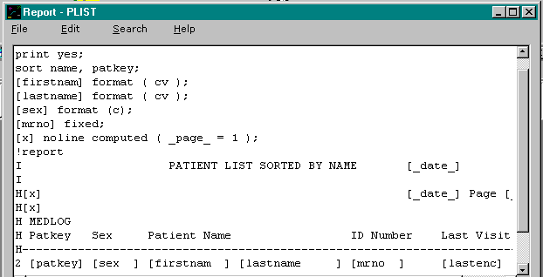
If you are inexperienced with the REPORT program, you should copy this report and run it. It will give you a useful list of patients and it will familiarize you with the report process. Here is a line by line account of the report above:

0. (not shown) contains EXTRACT NONE; This causes all entry files to be used.
1. The report will be printed as it is created.
2. The data is sorted by name and then by patkey. Line 16 which begins with a “2” will cause a line to be printed whenever the 2nd sort variable (patkey) has a new value. This extra sort level is necessary if two patients might have the same name.
3-4. The first name and last name will be capitalized characters of variable length.
5. The field SEX will be capitalized.
6. The medical record number will appear in a fixed position on the report.
This “fixed” attribute is needed to keep things lined up after the variable width name fields.
7. The attribute NOLINE will cause this field to suppress the header lines on page 1.
8. The !report line separates the control and field statements from the report template.
9-10. Introduction lines; used at the start of the report only.
11. The first heading line has the report title, today's date and a page number.
12 The 2nd heading line is a blank line. Note: [x] field will suppress this line on first page.
13-15 More heading lines.
16 The sort level two line will be repeated for each patient.
17. The last line (not shown) contains !END. and is optional.

Using Note Variables in a Report:
Note variables are handled differently from other variables in REPORT. The value of a note variable may be a few characters or dozens of lines of text. In order to handle such a range, the lines containing note variables may be “repeated” until the note is fully processed. For example, the report template line containing the encounter date and a note variable might look like:

B [DATE ] [COMMENT ]

The output may look like:

10/24/91 Patient appeared in good spirits and was able to answer all questions without difficulty. His memory is much improved and his daughter has remarked how much better he seems.

Notice that the variable DATE only appears on the first line, but COMMENT uses as many lines as it needs. It is not permitted to have more than one note variable on a line. You may, however, put them on different lines.

Summary of REPORT
EXTRACT filename or NONE;
GROUP name;
SELECT expression;
SPOOL filename;
LENGTH number, default 66
TOP number; default 3
BOTTOM number; default 3
FORMFEED yes/no; default yes
DISPLAY yes/no; default yes
PRINT yes/no; default no
SHOW " string";
INIT " string";
LANDSCAPE yes/no; default no
SORT var1,var2...; optional + - after variable names.
[var] = varname
LEFT
RIGHT
CENTERED
MISSING("text")
PREFIX("text")
SUFFIX("text")
FORMAT(tw.d) t=D,T,N,A,U,L or C w=width or V d=decimal place.
FIXED
NEWPAGE
NOLINE
NODISPLAY
CHANGED
PRINTSTR
TABLE (variable, element)
IMAGE (widthcm, heightcm)
COMPUTED(expression) expressions use +, -, / and * and these functions:
SIN, COS, TAN, ATAN, SQRT, LOG, LOG10, ABS, SUM, MEAN,
NUMREC, NUMMISS, NUMPOS, MIN, MAX, CLOSEST, PICK, NOT,
STRPICK,SUBSTR,STRPICK,ENCODED,NUMERIC,POS,
SETMISS, MONTH, YEAR, WEEKDAY, DAY, SASDATE, JULIAN,
CUM, SMALLEST, LARGEST, COUNT, LAG and TABLE.

The built-in variables are:_PAGE_, _LINE_, _LENGTH_, _DATE_, _TIME_, _TOP_, _BOTTOM_, OBSERVATIONS, GROUP_NAME, GROUP_TITLE, BREAK_LEVEL, MRNO, IDNO, NAME, FIRSTNAM, LASTNAME, PATKEY, MINITIAL, BIRTHDAY, STATUS, NUMENC, LASTENC, FIRSTDATE, ENTERED and CHANGED.

The start of the report template is signaled by a line beginning with !REPORT .
%PageBreak.

#$K Datalist (Members)

Purpose of datalist
The DATALIST program lets you list the values of selected variables for all the patients represented in a group. You can choose extracted variables, time-invariant variables (including text variables), and certain special variables such as NAME, BIRTHDAY, and NUMENC (number of encounters established).

DATALIST should be used by anyone requiring a listing of extracted and time-invariant data for patients represented in a group.

When to Use DATALIST
The group for which you want a data listing must be in an extraction file, so you must run EXTRACT before using DATALIST.

How to use DATALIST
Figure 14-1. Datalist
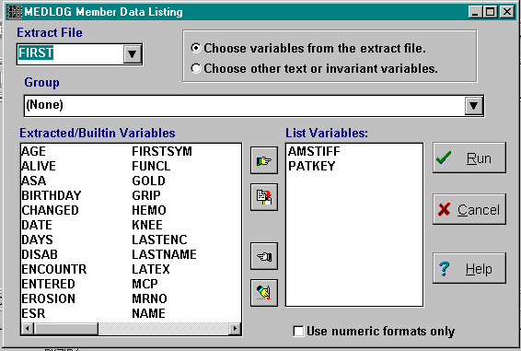
When you invoke DATALIST, you will see the last extract file you used. If this is your first use of DATALIST, choose an extract file.

Extracted/Builtin Variables
Figure 14-2. Group selection
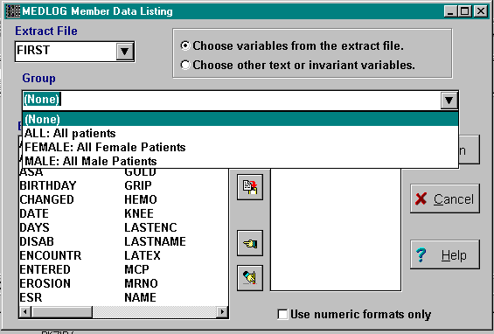
After an extraction file is chosen, select a group from the Group drop-down list.

Next, the names of the variables in the extraction file are listed in the Extracted/Builtin Variables box. You must choose the names of the variables you want to view.
{bml 14-02.bmp}

When you select a variable, it moves to the List Variables box. The order in which you choose the variables will determine their order in the output file. Select variables by clicking the Move Right button. You can select and move all of the variables by clicking on the Select All button.

In addition to the extracted variables, the built-in variables listed below can also be chosen.
NAME patient's full name
LASTNAME Patient's last name
MRNO Patient's medical record number
BIRTHDAY Patient's birth date
STATUS user defined - from the patient base record
NUMENC Number of dated encounters
LASTENC Date of last encounter
CHANGED Date patient's record last changed
ENTERED Date patient established

If you change your mind about a variable you have selected, you can click on the variable on the Extracted/Builtin Variables list and then use the Move Left button to move the variable back to the original list.

You can also use the Clear All button to move all of the variables back to the Extracted/Builtin Variables list.

There is an option to display the numeric values of encoded variables. If you want to see the numeric values, you must check on the Use numeric format only box. See Figure 14-2.

Click on the Run button when you are done making all of your selections.

Text/Invariant Vars
The other option for DATALIST is to display text or time-invariant variables that are not in the extraction file. If you click on the Choose other text or invariant variables button, the selection list will change as shown in Figure 14-3.
Figure 14-3. Text or Invariant variables
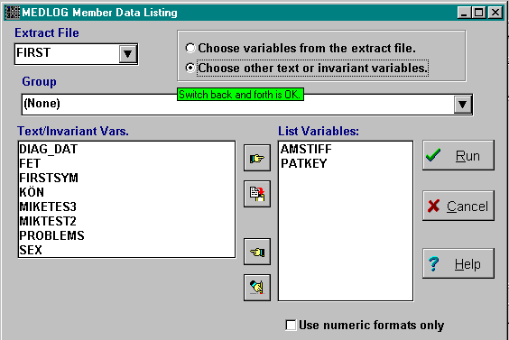
{bml 14-03.bmp}

You may move back and forth between the extracted/builtin variables and the text/invariant variables until you have made all the selections you want. Then, click on the Run button.

DATALIST will now produce a listing of the selected data. If you have selected quite a few variables, the listing will require several lines for each observation. When more than one line is required, a blank line separates observations.

Figure 14-4. DATALIST output.

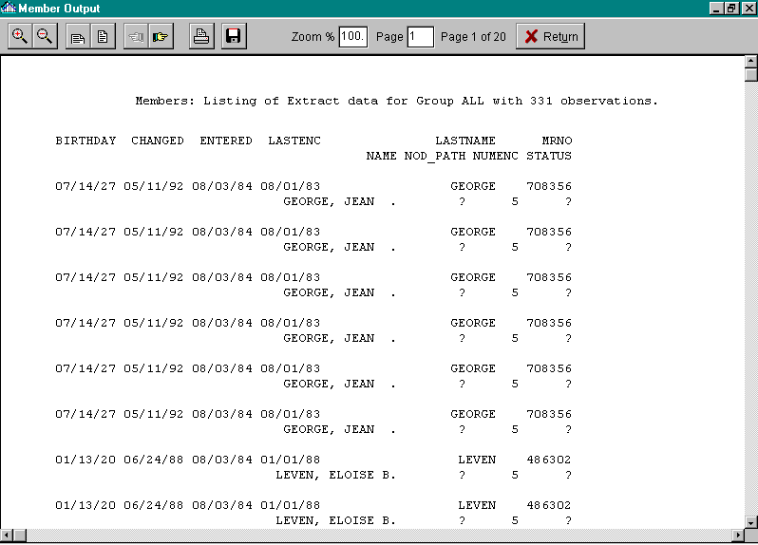

%PageBreak.

#$K PatPlot (Patient Time Plots)

Purpose of PATPLOT
PATPLOT displays in graphical form the change of a variable over time. Up to seven variables can be displayed simultaneously. For plots of averages of groups of patients, see the WHISKER program.

Who should use PATPLOT
PATPLOT should be used by anyone who is interested in the relationship between time (or encounters) and the values of time-variant variables. It is a useful companion to the CHART program.

When to use PATPLOT
You should use PATPLOT to look for trends, such as the effect of a number of treatments on the severity of back pain. Several variables can be displayed which can show the effect one variable has on another.

You do not need to extract data before running PATPLOT.

How to use PATPLOT
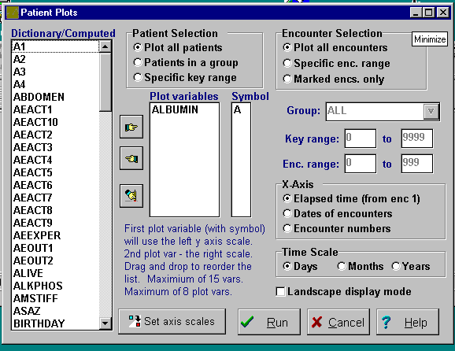
You must choose which variables to plot, which patients to display and which encounters to display.

PATPLOT also has options regarding the type and scale of the X axis (the time axis).

The color and line style of the plot are automatically set, but you may set the symbol used for the point values.
{bml 15-01.bmp}

Group
If you choose to plot patients in a group you must choose one group from the drop down-list.

Plot Variables
The variables to plot are selected from the drop down list. Use the “hand” buttons or double click to make a selection.

Plot Symbol
When you choose a plot variable, a plot symbol will be assigned to that variable. You can edit the symbols to override these assignments.

Key and Enc. Ranges
If you are plotting patients by a range of keys, the lowest and highest key numbers can be set. Plotting would then begin with the patient whose key matches the lowest key in the range. Likewise, if you are plotting, for each patient, a range of encounters, the lowest and highest encounter numbers can be set. Encounters that fall outside the range will not be plotted.

X-Axis
Three options are available:
- Elapsed time: the time between the date of encounter 1 and any subsequent encounter will be the X axis.
- Dates of encounters: the actual encounter dates will be shown on the X axis.
- Encounter numbers: the encounter numbers will be used for the X axis.

Time Scale
If elapsed time is used for the x axis, the axis scale can be set to Days, Months, or Years

Landscape display mode
The default mode is portrait. If landscape is selected, the graph is displayed and printed horizontally.

Set axis scales
Clicking on the Set axis scales button will open the dialog box and allow x and y axis scales to be set manually instead of using the default automatic scaling process.
Figure 15-2. Set plot scales
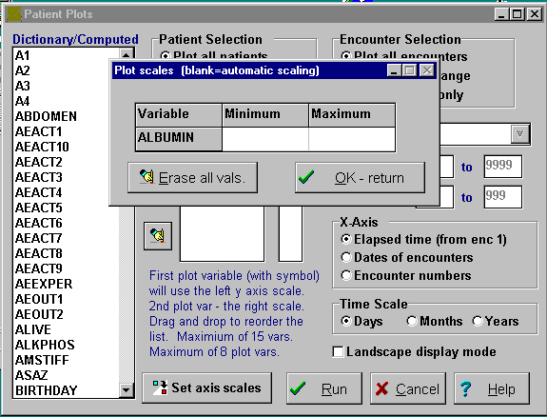
{bml 15-02.bmp}

Variable selection
Up to 15 variables can be selected. However, a maximum of 8 can be plotted; the remaining variables will only have a range listed. The first variable on the list will determine the left Y axis scale. The second variable on the list will determine the scale displayed on the right. Other variables will not have a scale displayed.

You may supply the range of values to plot for each variable. This is useful if you are producing many individual plots and want the scales to be the same for each plot. If you don't supply a range, the scale will be chosen automatically for each patient.

Patient selection
Remember that one plot will be made for each patient. Plotting all patients requires no explanation. Plotting a group allows for the selection or only certain encounters of interest (the marked encounters of a group).

If specific key range was selected, you should supply the range of patient keys to plot. If patients in a group is selected, you must choose the group from the list.

See Figure 15-3 for a plot of two variables.
--------------------------------------------------------------------------------------------------------------------
Figure 15-3. Plot output for two variables.

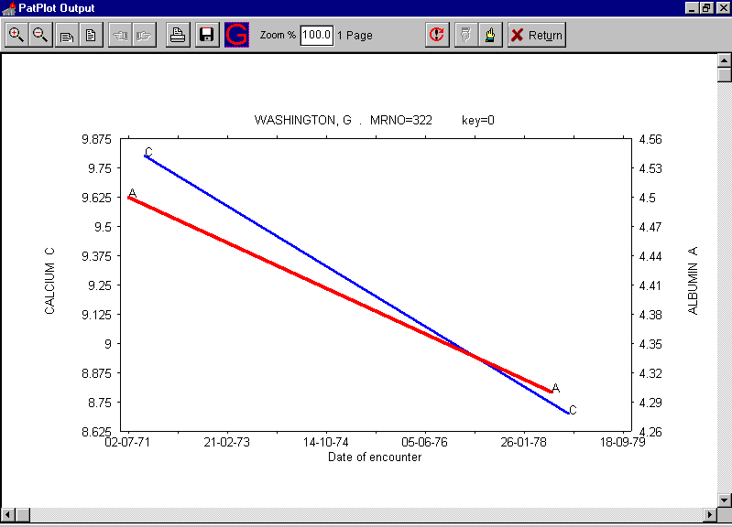
{bml 15-03.bmp}

After viewing a plot, you may proceed to the next plot or previous plot by pressing either the page forward or page reverse buttons.
{bmc BPrev.bmp}{bmc BNext.bmp}

You may abort the plotting sequence or change any of the criteria by clicking on the Return button which will return you to the Patient Plot program.
{bmc BReturn.bmp}
%PageBreak.

#$K Databank Contents

Purpose of CONTENTS
CONTENTS lets you list information in and about MEDLOG system files - the dictionary file, panels file, group file, etc.

Who should use CONTENTS
CONTENTS should be used by anyone requiring information about the status and contents of MEDLOG files.

When to use CONTENTS
You can use CONTENTS at any time after a databank has been established.

How to use CONTENTS
From the main menu, choose Tools, then Databank Contents. The CONTENTS program is also found under the Help.

Figure 16-1. Contents options selection
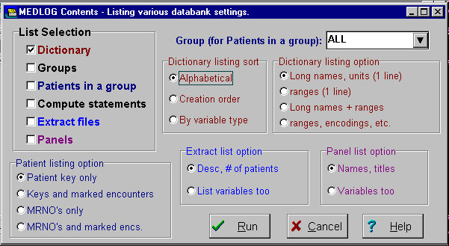
{bml 16-02.bmp}

One or more of the following list selections must be checked. If more than one selection is made, the output listing will contain the results of the each selection, in order.

Dictionary - list the variables in this databank’s dictionary.
Groups - list all the groups and their current sizes.
Patients in a group - list the patients in a specific group.
Compute statements - list all the statements for computed variables
Extract files -list all extract files and their sizes.
Panels - list the names (and variables) of panels used with ENTER or CHART.

Note that most list selection have other choices which appear in color coded boxes. If, for example, you selected Panels, you will notice there is a box (lower right side of screen) which has some Panel list options. These should be self explanatory.

An example of the first screen for a dictionary listing with an alphabetic sort option is shown below.

Figure 16-2. Dictionary listing
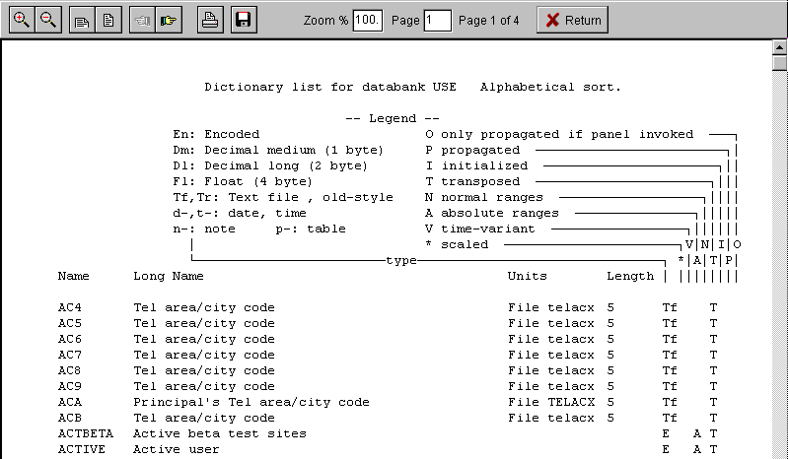
{bml 16-03.bmp}

As indicated by the legend at the top of figure 16-2, the variable attributes are displayed in 10 columns at the far right of the screen. Most of the attributes are of a yes/no nature and are indicted by the appearance of the designated character in that column. The designations for variable types are:
- Dm=decimal medium
- Dl=decimal long
- En=encoded
- Fl=float
- Tr=text-regular (old style, no longer used)
- Tf=text-file encoded, now just called text
- d=date
- n=note
- t=time
- p=table

Groups

The listing of groups is straightforward. The group name is listed along with the group title. If the group is formed (ready to use) the number of patients/encounters will also be shown. Any source groups will also be listed.

Note that the groups option can be set to list the complete specifications the groups.

Compute Statements, Patients in a Group, etc.:

These require no further explanation.

%PageBreak.

#$K QC Tools

Purpose of QC TOOLS
QC Tools provides an overview of the databank, and several special functions which are aimed at uncovering any inconsistencies or omissions. For example, it can detect if a variable has been defined in the dictionary, but never used on a data entry form. This may or may not be an error.

Who should use QC Tools
QC Tools should be used by anyone requiring information about the status and contents of the databank.

When to use QC Tools
You can use QC Tools at any time after a databank has been established. It is particularly useful when checking the consistency of the entry forms with the dictionary.

How to use QC Tools
Figure 17-1. QC Tools actions
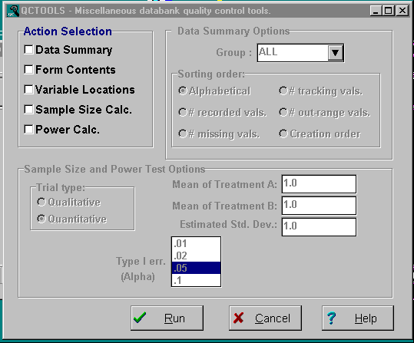
{bml 17-01.bmp}

Action Selection
One or more of the action selections must be checked. If several are chosen, the output will contain pages for each selection, one after the other.

Data Summary
If this action is selected, the dialog box to the right of the selection will become active and provides options to select a patient group and to set the sort order. Following is an example of a Data Summary.

Figure 17-2. Data summary
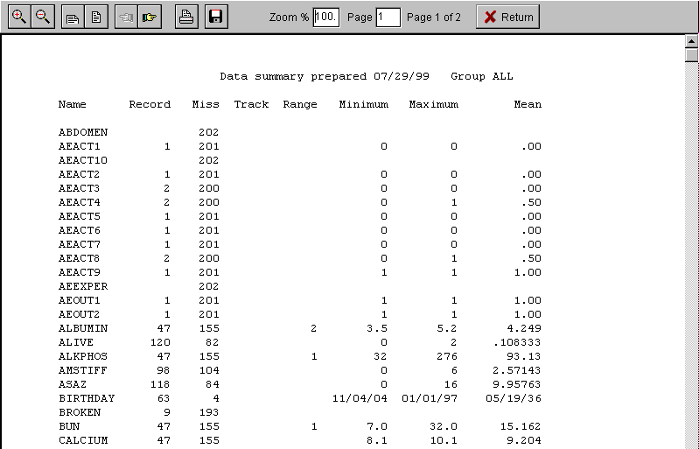
{bml 17-02.bmp}

You will notice the information provided allows you to make a visual determination of the validity of information entered for each variable. Under the “Recorded” column you will see the count of recorded values for each variable. The next column shows the number of missing values. Not that recorded+missing will equal the number of patients in the databank for time-invariant variables and will equal the total number of encounters for time-variant variables. The next column counts the current number of “missing tracking” values. These were entered with the ! value. The range column is for the count of recorded values which lie above or below the normal range set for the variable.

Form Contents
This action has no options. It simply prints the name of the forms and all variables with the line numbers where the variables were used. In the example below, form !ABC has only one variable named BROKEN which is used on line 3 of that form.

Figure 17-3. Form summary
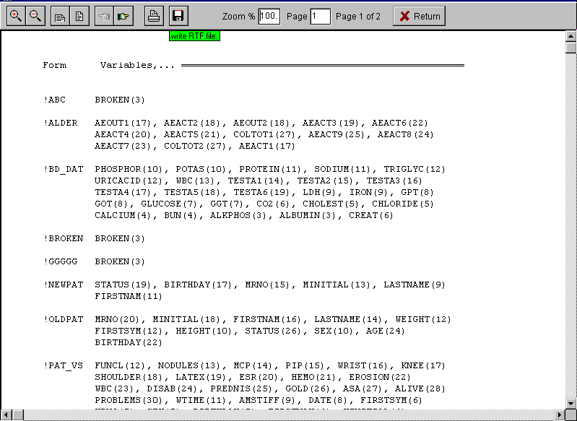
{bml 17-03.bmp}

Variable Summary
This listing is of all variables and the forms and lines on which they are used.

Figure 17-4. Variable summary
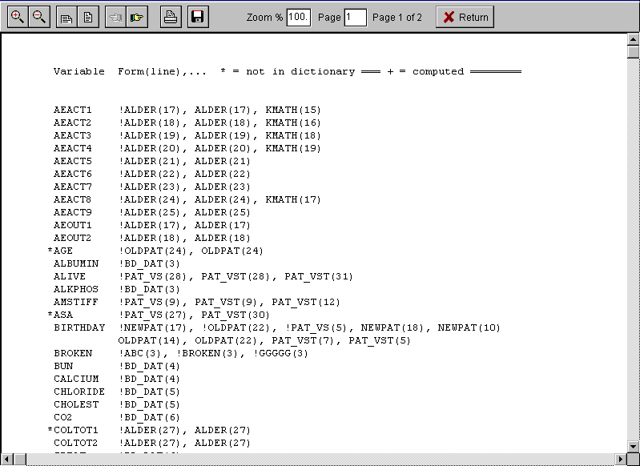
{bml 17-04.bmp}

Sample Size and Power Test Option
A Sample size calculation does not use any information from your databank, it merely makes a statistical calculation which may be helpful to you in considering the amount of data which would be needed to produce statistically significant results. The Power Calculation is similar, but working from the opposite side of the equation.

The quantitative trial type corresponds to the Chi-Square test, while the qualitative trial type corresponds to a Student’s t-test. Either type requires hat you specify the Power (probability that you will find a positive result if it exists) and the Type I error level (probability that you may make a false claim of success). Typical levels are .90 power and .05 for Type I errors.

Either test requires that you say something about the expected outcomes. For a qualitative trial you must estimate the percentages which will fall into the two categories. For example, the treated category may expect a 80% recovery rate which the untreated category may expect a 50% recovery rate. For a quantitative trial you must estimate the mean value of the two categories and also supply a value for the standard distribution (sd) of the data.

Figure 17-5. Sample size or power menu
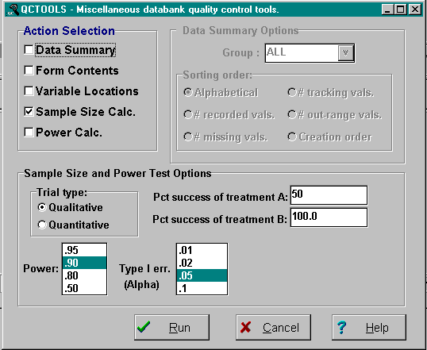
{bml 17-05.bmp}

Figure 17-6. Sample size and power calculation report
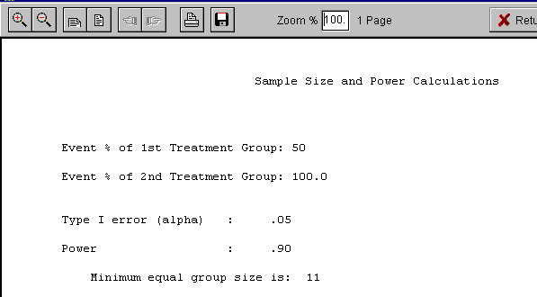

%PageBreak.

#$K Create (Transpose)

Purpose of Create
The CREATE program reads the current contents of the entry files produced by the FORM- and ENTER programs and creates a transpose file containing essentially the same data, put arranged for fast access. The transpose file is used for data analysis and data retrieval activities.

Who should use create
CREATE should be used by anyone who produces reports and performs data analyses. If several persons perform these functions, the responsibility for using CREATE should be coordinated. When CREATE is run, new data are put in the transpose file so that the modified data might not be consistent with analyses in progress.

When to Use CREATE
In most cases, data are collected and entered into MEDLOG on a more or less continuous basis. In order to “freeze” the data and organize them into a more efficient form for analysis, the CREATE program transfers data for all or some or all variables into the transpose file. The transpose file is the data source for the GROUP and SELECT programs , and for the data extraction program, EXTRACT. Thus, statistical analysis and many reporting activities use the data in the transpose file.

If MEDLOG activities require analyses that are fully up to date, then CREATE must be used frequently, perhaps as often as every few days. If, on the other hand, extensive analyses which will take weeks to complete is being conducted, CREATE should not be used during that period, so that all analyses will be based on the same data.

The amount of time CREATE takes to complete its job may influence how often it is used. The time it takes to run CREATE is a product of the size of the databank (total number of encounters), the number of variables being transposed, and the speed of your machine. Small files may be processed in seconds, while large files might require ten minutes. If the databank is very large, (over 10,000 encounters), interference can be minimized by scheduling the use of CREATE when the demand for computer usage is low.

Creation of a new transpose file is usually followed by use of two other programs, COMPUTE and SELECT. One of COMPUTE's functions is to calculate the values of previously defined derived variables. SELECT forms the membership lists for groups whose definitions have been stored. Also, the EXTRACT program is usually run to update the analysis files. All of these programs can be run at one time, and require no intervention or familiarity with their use.

How to Use CREATE
When Transpose (Create) is invoked, a menu with three choices appears. See Figure 18-2.
Figure 18-1. Create (Transpose) program
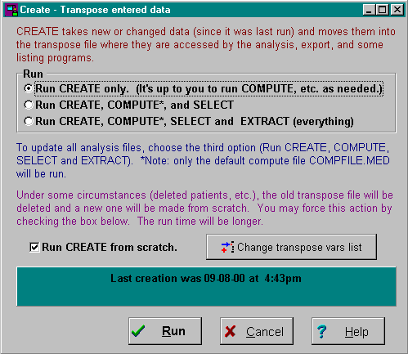
1. Run CREATE only.

2. Run CREATE, COMPUTE and SELECT is used for routine updating of files. It combines three steps that could be run separately.

3. Run CREATE, COMPUTE, SELECT and EXTRACT (default). This updates all relevant files.

{bml 18-01.bmp}

Normally, only a small portion of the data has changes since the last time CREATE ran. The program makes uses of this fact and avoids doing a lot of work by checking only data for patients who had changes or additions. This is the norm, but you may force a complete reconstruction of the transpose file by checking the option Run create from scratch. A longer run time can then be expected.

As CREATE runs, it shows a progress bar. When CREATE is finished, a window will appear displaying the number of patients (including any deleted patients), the number of deleted patients, the total number of encounters, and the number of variables in the transpose file. If you have also run the other updating programs, their output will also be shown and may be printed.

Eight built-in variables are always put into the transpose file:
PATKEY patient's system key
BIRTHDAY patient's birth date
STATUS patient's status
ENCOUNTR encounter number
DATE encounter date
TIME encounter time of day
ENTERED date the patient was first entered into the databank
CHANGED date the patient's record was last changed

Normally all of the variables for the databank a placed into the transpose file so that they can be used for retrieval and analysis. You may exclude variables from the transpose file if they are rarely used or are not currently needed for analysis. You would do this only for very large databanks where this would result in smaller files and faster run times in CREATE. If you want to do this, or if you want to check that no variables are currently excluded, click on the button labeled .Change transpose vars list.

For the Scandinavian countries, two additional variables are placed in the transpose file. SCANDNUM is the identity sequence number and SCANDSEX is the gender as derived from the identity number (even=female, odd=male).
%PageBreak.

#$K Compute

Purpose of COMPUTE
The COMPUTE program is used to derive new variables from existing variables. The values of the new variables are placed in the transpose file, not the entry files.

Who should use COMPUTE
COMPUTE should be used as required by anyone performing data analysis in the MEDLOG system. Also, it is sometimes necessary or helpful to compute variables used in group specifications for data retrieval.

When to use COMPUTE
COMPUTE should be used to derive new variables and calculate their values before using the SELECT and EXTRACT programs. COMPUTE will normally be run to reevaluate all computed variables following each use of CREATE. To derive new variables from variables in an extraction file, use the transform function in the EXTRACT program

How to use COMPUTE
Invoking the COMPUTE program will display the compute statements for the active databank.
Figure 19-1. Compute statements
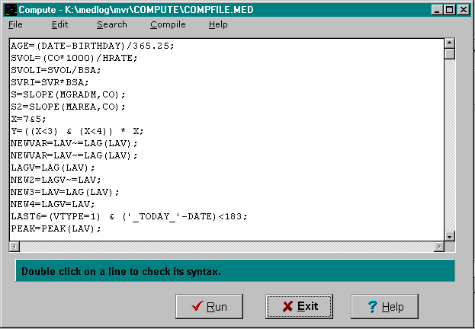
{bml 19-01.bmp}

The File menu allows you establish, change, save or print a compute file. The standard (default) compute file is named COMPFILE.MED.

The primary compute file for a databank has the name COMPFILE.MED. This file is the one the CREATE program uses to update the files. It is possible to use other files for compute statements, but this would be done only under special circumstances.

Edit options
From the Compute menu, select Edit. The following options perform the standard text editing functions. These options are essentially the same as in NotePad or WordPad. The shortcut keys
(e.g. Ctrl-C is copy) are the same too.

Search options
The Search menu is used to help in finding, changing, and moving the cursor to variables in the compute statements.

Compile options
The Compile program provides for checking the statement syntax (Compile Only) or executing the statements which is the same thing as clicking on the Run button.

Specifying a Compute Statement
A compute statement defines a new variable in terms of existing variables. The existing variables can themselves be computed variables.

Here are three examples of compute statements:
AGE = (DATE - BIRTHDAY)/365.25;
SUR_AREA = 10^(.425*LOG10(WEIGHT) +.725*LOG10(HEIGHT))-2.144.;

CREAT_CLCL=(UR_CREAT*VOL_24HR/1440)/SR_CREAT)*1.73/SUR_AREA;

The three new variables defined by the preceding statements are:
age;
sur-area (body surface area);
creat_cl (creatinine clearance).

The equal sign following the variable name indicates that the variable will be assigned the value of the mathematical expression to the right of the equal sign.

The names of computed variables cannot exceed 8 characters in length and must conform to the same restrictions as those imposed on variable names in the dictionary - see the DEFINE program, Chapter 4, for details. Note that one of the variables in the definition of creat_cl is sur_area, itself a computed variable. In a case like this, the compute statements must be executed in the appropriate order - see “Execution of compute statements” below.

A computed variable cannot have the same name as an entry dictionary variable that is in the transpose file. COMPUTE will return the message “Variable cannot be reassigned” when the name on the left of the equal sign is that of an entry variable.

Note: dates can be used as constants in compute statements if they are enclosed in single quote marks, as in '10/16/82'. Today's date, obtained from the computer's clock, is specified as a date constant by the characters '_TODAY_' (you must use the single quote marks here too). Example:
AGETODAY = ('_TODAY_'-BIRTHDAY)/365.25;

Long names and units for a computed variable can be specified. These items must be enclosed in square brackets ([ ]) immediately following the variable names and separated by a backslash (\). Example:
AGE[AGE AT ENCOUNTER\YEARS] = (DATE-BIRTHDAY)/365.25;

The various symbols used in compute expressions, and the operations they denote, are:

= equal sign assignment
+ plus sign addition symbols
- minus sign subtraction
* asterisk sign multiplication
/ slash sign division
^ carat sign exponentiation

Note that minus sign (-) can be used with a single quantity to change its sign, as in y = -x. All the other symbols are used between two quantities. Note also that the equals sign is used in a different sense in the relational expressions discussed below.

Parentheses should be used to improve readability and to ensure that calculations are done in the right order. If you use parentheses, the expressions within the parentheses are evaluated in order of depth, starting with the innermost (deepest) pair of parentheses. Parentheses can be nested to any depth; (((x+y)*z))/b is an example of nesting to a depth of 3. Unless otherwise changed by parentheses, the order of evaluation in a compute statement is:

1. ^ exponentiation
2. *,/ multiplication, division
3. +, - addition, subtraction

Operations with equal precedence are performed from left to right. Thus the expression 3+x*y^z/2-a is evaluated in the order indicated by (3+(((x*(y^z))/2))-a (Remember that the expression within the innermost set of parentheses is evaluated first, and so on). It's generally a good idea to use parentheses to avoid errors and to make clear the order of calculation.

A compute statement can contain up to 123 characters including embedded blanks, which is long enough for most purposes. Very complex statements can be broken apart into 2 or more statements, as in the example of SUR_AREA and CREAT_CL.

MEDLOG provides over 30 functions for use in compute statements. These functions include all the common mathematical functions (square root, logarithm, etc.), and several special functions - see “Functions” below for a complete listing and descriptions.

Frequently computed variables need to be assigned values on the basis of certain conditions being true or false. For example, suppose the variable backpain is coded 0, 1, 2, 3 corresponding to none, mild, moderate, severe need to be changed to the code values 1, 2, 4, 8. This can be done by using relational expressions.

Examples of relational expressions are BACKPAIN=1 and R-VISION>L_VISION. Relational expressions take the value 1 if the relation is true and the value 0 if false. The above re-coding can be accomplished by the statement
PAIN=(BACKPAIN=0) + (BACKPAIN=1)*2+(BACKPAIN=2)*4+(BACKPAIN>2)*8

It is important to use parentheses here, since without them the relational expressions are evaluated after the multiplication and additions; for example BACKPAIN=2*4 is equivalent to BACKPAIN=8.

Notice that the last term of the example compute expression is BACKPAIN>2 rather than BACKPAIN=3. This is done to ensure that the value of pain will be set to missing if the value of backpain is missing. See the discussion below on how COMPUTE handles missing values. Also, see the PICK function for an easier way to handle this problem.

The following relational symbols are available:
= equal to
~= not equal to (note: != is an alternate form of ~=)
> greater than
< less than
>= greater than or equal to
<= less than or equal to
For example, the statement
NEWVAR = (X<=50)*X + (X>50)*50

will assign to newvar the value of X if X is less than or equal to 50, and will assign it the value 50 if X is greater than 50. For this particular problem, the MIN function provides a simpler solution. Therefore, if the value of BACKPAIN is missing, the relational expression (BACKAIN=2) is false. The relational value therefore assume the value of 0 (zero).

The symbol "?" is used to denote missing values and can be used in expressions using = or ~=. The relational expression (BACKPAIN = ?) is true if the value for BACKPAIN is missing and therefore assumes the value of 1 (one).

In the case of >, <, >=, and <=, if the value of a variable in a relational expression is missing, then the expression takes the missing value. Thus, in (BACKPAIN>2), if the value of BACKPAIN is missing, so is the value of the expression.

Missing values play an important role in clinical databanks because there are usually a great many of them. COMPUTE treats missing values in computed expressions in a consistent way. In most cases, the result of a computed expression is missing if the value of any variable (or relational expression) in the expression is missing. For example, in the compute statement Y=A+B+C+D the value of Y will be set to missing if any of the values of A, B, C, or D is missing.

The exceptions to this rule are relational expressions involving = and ~=, as explained above, and the following functions of several arguments: max, min, mean, nummiss, numpos, numrec, and sum. For example, the statement Y=SUM(A,B,C,D) will assign to Y the sum of the non-missing values of A,B,C, and D. These functions are explained in the following “Functions” section.

The rationale for using the relational expression (BACKPAIN>2) in the above compute statement for PAIN can now be explained. If the value of BACKPAIN were missing, then the value of BACKPAIN>2 and consequently the value of PAIN would also be missing. If the relational expression (BACKPAIN=3) is used, then PAIN would take the value 0 if the value of BACKPAIN were missing.

Two logical operators, or (represented by the symbol |) and and (represented by the symbol &), and the function not, allow the construction of compound logical expressions. Suppose X and Y are variables or expressions. Then the expression X|Y (read X or Y) has the value 1 if either X or Y has a nonzero value. If both X and Y have the value zero (or if one is missing and the other is zero), then the value of X|Y is zero. If both X and Y have the missing value then so does X|Y.

The expression (X & Y) (read X and Y) has the value 1 if both X and Y have nonzero values. If either X or Y has the value 0 and the other is not missing, then X & Y has the value zero. If either X or Y is missing then so is (X & Y).

(Note: since & is an allowable character in a variable name, you must use a space before and after & when using it as a logical operator.)

The function NOT(X) has the value1 if X has the value zero. It is zero if X has a nonzero value, and is missing if X is missing.

If parentheses are not used to change the order, and or operations are evaluated after relational expressions. Also, and is evaluated before or. It is a good idea to use parentheses to avoid mistakes and to make the meaning of an expression clear. Example:
QUALIFY=AGE(AGE>50&WEIGHT<90) (AGE<30)NOTQUAL=NOT(QUALIFY).

Computed Variable Types
The default type of a computed variable is float. It is possible to make the type int (decimal scale factor 1), date or time when that is appropriate. If the result is a whole number (integer) then it will save storage space and it will be displayed more appropriately (without a decimal point) if the result is designated to be an integer.

An example of an integer calculation:
YEARS[INT:]=DATE-BIRTHDAY)/365.25;
results in the patient age, truncated to a whole number.

An example of a date calculation: CALLBACK[DATE:]=DATE+90;

If a long name and units are specified, they would follow the type specification:
CATEGORY[INT:disability category]=…

Execution of Compute Statements
When a compute statement is executed, COMPUTE reads the values of the variables in the expression from the transpose file, and places the computed value back in the transpose file. This operation is performed for each encounter of each patient, including encounter 0. Values of all computed variables are stored in the transpose file as 4-byte floating-point numbers (Extended Float Type).

If a variable in a compute statement is not in the transpose file, COMPUTE will return an error message. This applies to computed variables from other compute statements, as well as to variables transposed from the entry file, so the execution of computed variables must be in the correct order. COMPUTE executes compute statements in line number sequence. Use the facilities of renumbering, inserting and deleting to ensure that statements are in the appropriate order.

A computed variable is treated by MEDLOG as time-variant, even if the variables used in its definition are all time-invariant. So the values for a particular patient would, of course, be the same for all encounters. This point is relevant to the EXTRACT program, which requires you to use a suffix for all time-variant variable names.

Execution of a compute statement is not terminated by “bad” variable values. If an invalid operation, such as division by zero or taking the logarithm of a negative argument, is encountered, COMPUTE assigns the missing value to the computed variable. If some other result is required, the computed statement must be constructed correctly to return a valid value.

Invalid interpretation of missing values
There are conditions when functions such as log(x) will return a missing value for mathematically impossible operations. For example, the log(0) does not exist so that the function. log(0), returns a missing value (?) instead of an error message.

If you would like log(0) return a zero, this can easily be accomplished by several means. One example would be SUM(LOG(0), 0) which sums 0 and LOG(0) and ignores LOG(0) if it is missing.

Functions
Except for the group and table functions, the arguments of functions can be constants, variables or expressions.

Functions with one argument
In all cases, the value returned by the function is missing if the value of the argument is missing, or is invalid.

Name Value returned

sqrt(x) The square root of x.
abs(x) The absolute value of x, for example: ABS(-2.3) is 2.3
trunc(x) The integer part of x , for example: TRUNC(2.3) is 2).
exp(x) The value of e raised to the power x (inverse of log).
log(x) The natural logarithm of x.
log10(x) The common (base 10) logarithm of x.
alog10(x) The inverse of log10.
cos(x) The cosine of x (x measured in radians).
sin(x) The sine of x (x measured in radians).
tan(x) The tangent of x (x measured in radians).
atan(x) The arctangent of x (inverse of tan) result in radians.
rand(x) A pseudo-random number from the uniform distribution on the interval [0,x).
not(x) 1 if x is zero, 0 otherwise.

Functions with several arguments
Except for slope and intercept, as many arguments that can fit within the 123 character compute expression maximum length limitation can be used.

Name Value returned
lookup (x1,x2,..,y) The last argument (y) is tested to see if it equals any of the preceding arguments. If it does, the position of the first matching argument is the function value (the position of the first argument is 1, etc.). If there is no match, the function returns the missing value. For example, the value of:
LOOKUP(2,4,8,16,32,4) is 2,
where 2 represents the second argument #.

closest (x1,x2,.,y) This function is the same as the lookup function, except that the test is for the argument that is closest to being equal. The missing value is returned only if the value of the last argument is missing.

pick(x1,x2,...,y) All but the last argument are possible values of the function. The last argument (y) gives the position of the argument to be used as the function value. If the value of y is not a valid position, the missing value is returned. Example:
the value of PICK(2,3.1,4.1,1.8,2) is 3.1
where the last argument 2 represents the second value, 3.1.

max(x1,x2,...) The maximum value of the arguments, missing values excluded.

min (x1,x2,...) The minimum value of the arguments, missing values excluded.

mean(x1,x2,...) The arithmetic average of the arguments, missing values excluded.

median(x1,x2,...) The arithmetic median, missing values excluded.

order(x1,x2,...,y) Returns the yth largest value from the arguments x1,x2,etc.
Example: the value of ORDER(7.5,1.2,2.2,4.8,11.0,3) is 4.8,
because the value 4.8 is the 3rd largest value.

nummiss(x1,x2…) The number of arguments with missing values.

numpos(x1,x2,...) The number of arguments with values greater than zero.
numrec (x1,x2,...) The number of arguments with non-missing values.

sum(x1,x2,...) The sum of the arguments, missing values excluded. The missing value is returned if the values of all the arguments are missing.

slope(y,x) The slope of the least-squares straight line fit of y on x, using data from the first dated encounter up to the current encounter. slope will be missing unless there are at least 2 distinct recorded values of x.

intercept(y,x) The intercept of the straight line fit of y on x (see slope).

Functions that refer to values from previous encounters
These functions might be called memory functions, because they have the ability to “remember values of the argument from a previous encounter. Each of these functions can be used only once in a single compute statement.

Name Value returned

cum(x) The cumulative sum of the values of x, beginning at encounter 1 and ending at the encounter currently being processed. Missing values are ignored. The function value is initialized to 0 before encounter 1 is examined, so if no values have been recorded for x up to the current encounter, the value 0 is returned.

pcum(x,t) This function is like cum above, except that the cumulative sum is reset to the current value of x when t is positive pcum is the partial sum function. If t is never positive then pcum and cum will yield identical results.

first(x) The value of x at encounter 1. FIRST will return the missing value when evaluated at encounter 0.

zero(x) The value of x at encounter 0. ZERO returns the same value at all encounters, namely the value at encounter 0.

lag(x) The value of x recorded at the previous encounter. For encounters 0 and 1, lag returns the missing value.

recent(x) The value of x at the current encounter if it is recorded, otherwise the most recent recorded value of x.

peak(x) The maximum value of x, considering the current and previous encounters.

pPEAK(x,t) This function is like PEAK above, except that the peak is reset to the current value of x when t is positive.

Date functions
Five functions are available to extract certain information from dates. The argument of any of these functions should be a date type variable or a date constant.

Name Value returned

day(x) The day of the month of date x. The range is 1 to 31.

month (x) The month of date x. The range is 1 to 12, with January = 1.

year(x) The year of date x. The range is 1870 to 2049.

julian(x) The Julian day of the year of date x. The range is 1 to 366.

weekday(x) The day of the week of date x. The range is 1 to 7, with Sunday = 1.

One function exists to make the equivalent of a date variable from the components of month, day and year. The value can be used in calculations involving date variables.
sasdate(dd,mm,yy) where dd is the day, mm the month and yy the year.

Special functions

Name Value returned
table(var, elem) Returns the value of element elem for table variable var. Both var and elem must be literal names, not expressions.

If a table variable were used in a compute expression without the table function, its value would be the index into the table (index begins with 1). The table function is needed to access any of the field values. Example:
LARGE = TABLE(HOSPITAL,BEDS)>200;

group(ggg) Returns 1 if the current encounter is in group ggg. It returns 0 if it is not. If group ggg is not formed (using SELECT) or defined (using the GROUP program), then GROUP(ggg) will return the missing value. The group name, ggg, must be a valid 1-8 character name.

The GROUP function provides a method to access information about whether an encounter is selected in a MEDLOG group or not. This provides an important link between the GROUP program and the COMPUTE program.

Since computed variables can be used in the specifications of criterion groups, and group selection can be used in the computation of variables, circular definitions must be avoided to ensure that the evaluation (first SELECT then COMPUTE) is done in the correct order.

setmiss(x) If x = -1 then the missing value is returned; otherwise the value of x is returned. For example: Y=SETMISS(A-1)+1 will assign to Y the same value as A except when A is zero, in which case Y will be set to missing.

Note that when A is 0 then SETMISS(a-1) has the missing value, and the result of adding 1 to a missing value is again the missing value, according to the general rule given in the discussion on missing values, “Specifying a Compute Statement”.

Compute statement error messages
- Assignment statement does not begin with variable name. The first character of a variable name must be a letter of the alphabet.

- Extraneous characters. Something at the end of the statement is wrong.

- Invalid expression.
Example: two operators, such as * and /, appear next to each other.

- Invalid number of arguments for function. Example SIN(a,b)

- Missing equals sign. Example AGE (DATE-BIRTHDAY)/365.24

- Multiple use of cum. first, zero, lag, recent, peak, slope, intercept or group in the same statement. Only one of these is permitted in the same statement.

- Statement …….contains an error. Processing suspended. General error message.

- Unbalanced parentheses. The number of right and left parentheses must be equal.

- Unrecognized function name. Example LOGAGE = LN(X);
- Variable . . . . . cannot be reassigned. The variable name on the left of the equals sign is an entry variable name.

- Variable . xxx . . is unknown. This message appears when execution is attempted of a variable in the compute statement is not in the transpose file.

- Variable name too long. A variable name over 8 characters long was included in a compute statement.

%PageBreak.

#$K Group Specification

Purpose of GROUP
The Group Specification program is used for creating patient encounter groups by specifying criteria, Boolean operations, or by enumerating the patients to be included.

Who should use GROUP Specification
GROUP should be used by anyone with a need to define patient encounter groups for data retrieval and analysis purposes.

When to use GROUP Specification
Before running any of the statistical analysis or reporting programs, it is usually necessary to define one or more groups of patient encounters. An example is the comparison of the mean blood pressure of patients receiving one anti-hypertensive drug 6 months after the start of therapy against the mean blood pressure of patients receiving another drug. This would require the formation of groups of patients receiving the two drugs, the blood pressure measurements after the start of drug therapy, and the encounter occurring closest to 6 months after start of drug therapy. In addition there might be the need to exclude patients whose blood pressure wasn't recorded within two weeks of the 6 month reference date.

The GROUP program provides for the definition of critical time-oriented patient encounter groups.

How to use GROUP Specification
From the main menu, choose the Group Specification program under the Prepare menu.
Figure 20-1. Group program
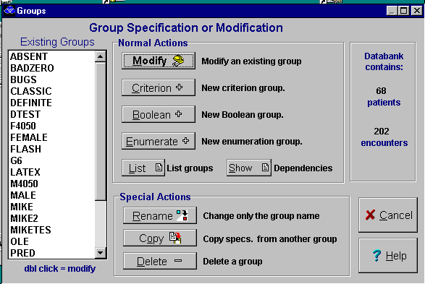
The GROUP program has 9 action buttons.

The first four choices relate to changing an existing group (Modify), or making a new group (Criterion, Boolean, Enumerate)
{bml 20-01.bmp}

Note that the number of patients and encounters in the databank are always displayed.

Definition and Use of Groups
In the MEDLOG system, a group is a list of encounters belonging to selected patients, so a more precise name would be “encounter group”. Unless there is a need to emphasize the fact that a group identifies encounters not just patients, the term "group" will be used.

Typical examples of groups are:
all encounters of all male patients or…
those encounters of male patients where aspirin was prescribed (clearly this is a subgroup of the group in the first example).

The group in the first example will include all the males in the databank. In the second example, some male patients might have no encounters in the group (aspirin wasn't prescribed for them), and such patients would not be in the second group. Patients in the group are those for whom aspirin was prescribed at one or more encounters.

When all the encounters of a class of patients are in a group, it is natural and convenient to refer to the group as a “group of patients”. The first example could be characterized as a “group of male patients”.

One important group consists of all encounters of all patients in the databank. This is the designated group All. Group All does not have to be explicitly created as it always exists and is the "group of all patients".

Groups can be thought of a set of specification which will result in the selection of certain patients (and certain encounters). The process of selection is actually performed by the SELECT program, but its operation is usually automatic. The most common type of group is the criteria group. Criteria groups employ tests to see whether a patient meets the criteria or not.

It is useful to think of criteria group definition and formation as a two-stage process. The first stage starts with a “source group” which includes all encounters of male patients (group of male patients). Then, encounters of the patients in the source group are examined to see if one or more criteria, expressed in terms of variable values, are met. The encounters where the specified criteria are met are called “occurrences”. Suppose there is just one criterion, “hematocrit less than 30%”. In this case any encounter of a male patient for which hematocrit under 30% is an occurrence.

In the second stage of group formation, certain encounters of patients represented in the source group who have had at least one occurrence are "marked". These marked encounters constitute the new group. A common option is to mark all occurrences, but other options are available. If all occurrences in our example are "marked", the new group would consist of male patients' encounters for which the hematocrit measurement was under 30%. The patients represented in the group would be males who had any encounter with hematocrit under 30%.

There are several options for marking the encounters that are to constitute the new group. One reason for marking only the occurrences that meet the criteria is that there might be a particular interest in what happens to those encounters. To examine only those values of another variable, such as hemoglobin, which are recorded when hematocrit is under 30%, the EXTRACT program allows the analysis of only marked encounters, or from all encounters of patients represented in a group.

Another reason for marking occurrences relates to the use of the group as a source for another group. Suppose, for example, that there is a need to form the group of encounters at which angina was reported and which occurred after a patient's first coronary bypass surgery. A group can be defined by the criterion “bypass = yes” and marking the occurrences. Using this group as the source group, a new group whose criterion is that angina is reported after the first marked encounter of the source group (that is, after the first surgery). We would mark the occurrences (encounters at which angina was reported) to be the encounters in the new group.

As an example of marking encounters other than event occurrences, suppose that the single criterion for a group is “kidney transplant = yes”, and that there is a need to analyze data observed after the first transplant. Specifying that all encounters after the first be marked can identify the data. Note that a patient who had a transplant, but had no encounters after the transplant, would have no encounters marked and would therefore not be represented in the new group.

Boolean groups are formed by the conceptually simple operations of union, intersection, and subtraction. The conjunctions "or”, “and”, “but not” describe these operations. The union of two groups consists of all encounters in either of those groups, and the intersection of two groups consists of encounters that are in both groups. The subtraction of group A from group B consists of encounters in group B that is not in group A. These operations permit quick specification of a group that would take somewhat longer to specify directly by criteria.

An enumeration group is specified by simply listing the patients who are represented in the group. All encounters of the listed patients are marked as being in the group.

Figure 20-2. Overview of Group specification.
1. Choose Patients to start Group ALL is the group of all
with: -(source group)- patients with all encounters.
2. Determine which encounters to test: Default is to test encounter 1 to last.
(test encounters)
3. Specify up to 8 criteria Each criteria can have time frames, etc.
4. Specify how many criteria must Normally, must be met simultaneously.
be satisfied and when
5. For each patient meeting the Default is to mark all encounters of
required criteria, specify which of qualified patients. Another common
their encounters should be identified option is to mark only the encounters
(the output encounters) where the tests were met (occurrences).

Making new groups or modifying existing groups
The first element to be completed is the Group Name. It must be from 1 to 8 characters.
Figure 20-3. Criterion specification
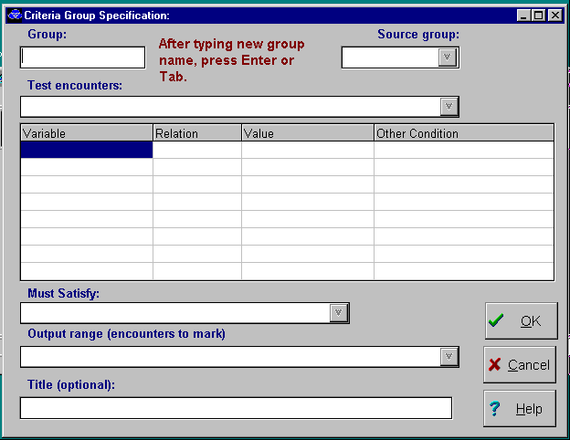
The second step is to choose is the Source Group. This is typically group ALL (all patients)
{bml 20-03.bmp}

Test encounters
Figure 20-4. Test Encounter
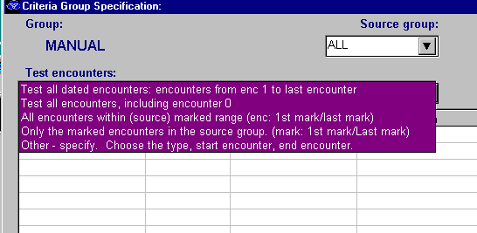
F Figure 20-4 illustrates the choices for the test encounters. The five options are discussed below.

The last choice “Other” will begin a more complex selection process.

{bml 20-04.bmp}

- Test all dated encounters. Encounters from enc. 1 to last encounter. All encounters, with the exception of encounter zero (if used) will be tested.
- Test all encounters, including encounter 0. All encounters, including the undated encounter 0 will be tested. Note: this selection will be disabled if your databank does not use encounter zero.
- All encounters within (source) marked range, (enc:1st marked/last mark). This selection is used if the source group has identified specific encounters which should be tested. For example, if a patient in the source group has his 3rd and 6th encounters marked, the, for this patient, encounters 3, 4, 5, and 6 will be tested
- Only the marked encounters in the source group. (mark: 1st mark/Last mark). This choice is similar to the one above except only the marked encounters, will be tested. In the example above, only encounters 3 and 6 will be tested.
- Other: specify. Choose the type, start encounter, end encounter. This selection requires you to specify the encounters to test in a more complex fashion. See Figure 20-5 for the range specification input.

For more detailed descriptions of the tests and examples, see the section "Advanced Discussion: Ranges and encounter types", page 20-16.

Relation
The Relation element is also selected from a drop-down list that appears by clicking on the highlighted Relation column.

Figure 20-5. Select relation element
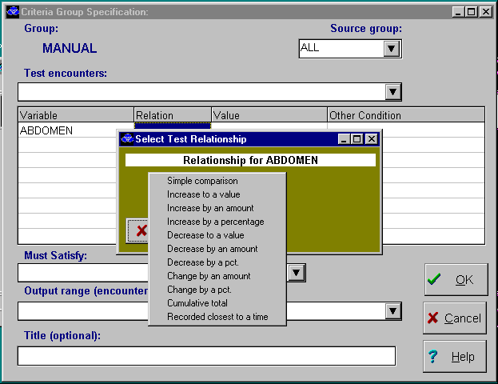
Relation options
{bml 20-05.bmp}

Test Relationships
The test relationship can be a Simple Comparison or it can be a test that depends on changes of values between encounters. The Simple Comparisons include tests for equality, greater than, etc. Explanations and examples for the more unusual and complex tests are presented at the end of this chapter.

If the test variable is TIME-INVARIANT, only simple comparisons can be used (because the value of the variable will not change between encounters).

Value
Most tests require a comparison value. Some require high/low range values. If the value is a date, be sure to enclose it in single quotes.

A legitimate Test Value must be entered in the dialog box.

Figure 20-6. Test Value
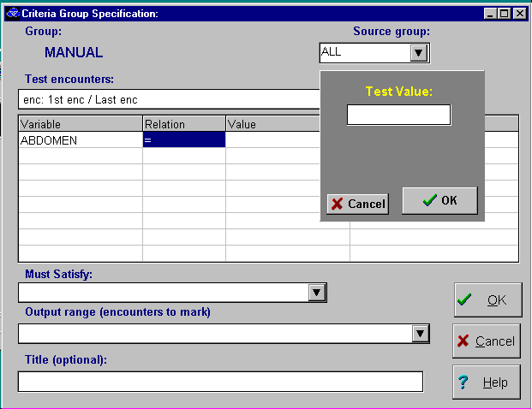
{bml 20-06.bmp}

Other Conditions
Most tests will not have any Other Conditions attached to it. The Other Conditions are used to further restrict when the test can be applied.

There are two types of conditions that may be applicable to a test.
- Since a starting time point. Encounters will not be tested if they precede the starting time point.
- Within a time frame. This applies only to certain tests. Such as Increasing by an amount. Here the time frame might be Within 2 months.

Must Satisfy
If two or more tests have been established, the Must Satisfy dialog box is used to indicate how tests are applied to determine if a patient meets the tests or not. . Figure 20-7 indicates that only one of the two tests need be satisfied in order for the patient to be in the group. If more that one test must be satisfied, you must choose whether the tests must be satisfied at the same time (same encounter), within a time range, or regardless of time (ever).

Figure 20-7. Must satisfy and Output range
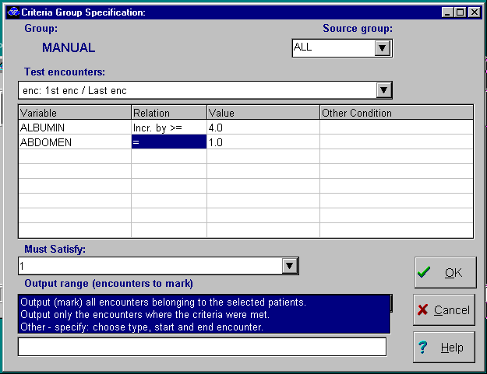
{bml 20-07.bmp}

Output range (encounters to mark)
See Figure 20-7

Once a patient has satisfied the test criteria, that patient is normally considered to be “in the group”. Within the group, a patient must have one or more encounters “marked”. If we are not concerned about marking encounters, the normal thing is to mark all the patients encounters in the output range. Another choice would be mark only the encounters where the patient met the necessary criteria to be in this group (we call that the occurrence encounters). This would allow us later to examine or analyze these encounters apart from the encounters which were not occurrences. By selecting the “Other” option, you can determine other rules for marking the patient encounters.

Title (optional)
The Title dialog box is the last item on the group specifications. The title is optional and can be up to 70 characters in length.
Click on OK to go to complete the group specification.

Modify an existing group specification.

To modify an existing Group. specification, click on the Modify button. Figure 20-8. Modify group specs
Choose a group from the list and then click on the Modify button.

You can also double click on a group to begin the modify process
{bml 20-08.bmp}

Selecting a Group will cause the specification window to appear with the current specifications.

Figure 20.9 Group Modification
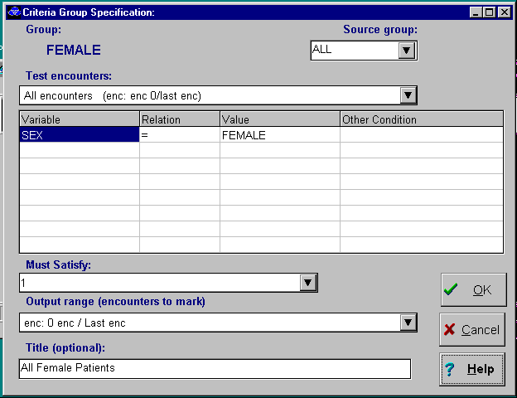

To modify any of the specifications, use the instructions already described for new groups.

{bml 20-09.bmp}

New Boolean group
The group name must be specified first.
Figure 20-10 New Boolean
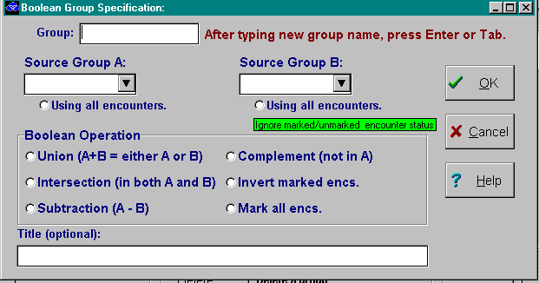
Once the Source Groups are identified, select an Operation and an optional title.

{bml 20-10.bmp}

Boolean operations:

Union
The union of two groups is the set of all encounters which belong to one (or both) of those groups. Instead of forming the union of marked encounters, you can choose to include in the new group all encounters of patients represented in either of the input groups.

Union requires two source groups; it doesn't matter which of the two groups in the union you specify first.

Note that if the “use all encounters” box is checked, the group will include marked and unmarked encounters.

Intersection

The intersection of two groups is the set of all encounters that belong to both of those groups. The procedure for specifying an intersection is exactly the same as for a union.

Subtraction

The difference between two groups: These are the encounters in A which are not in B

Complement

This uses only one source group. The result is all encounters which are not in the specified group. This is very helpful when identifying all patients who never had a certain event.

Invert markings and Mark all : rarely used Boolean functions.

New enumeration group
Figure 20-11. New enumeration group
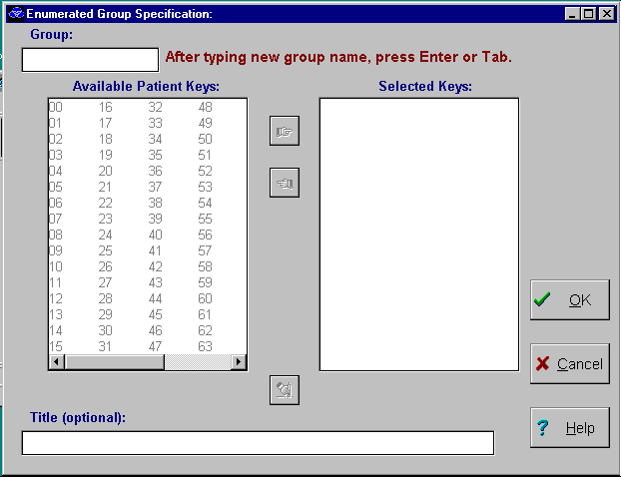
A new group name must be entered.

Specify the patient keys that will be included in the group. Select the key(s) and then use the pointer to move the key(s) to the Selected Keys box.

{bml 20-11.bmp}

List groups and their composition
This is a summary list of the groups, their titles and how many patients (and encounters) belong to the groups..
Figure 20-12. List of groups and composition
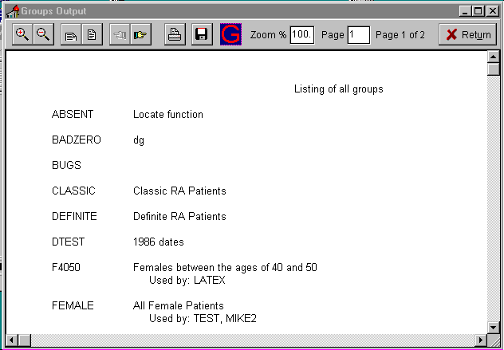
The list can be printed by clicking on print icon on the task bar
{bml 20-12.bmp}

Show Dependencies
This option will display groups and their sub-groups.

Figure 20-13. Groups and sub-groups
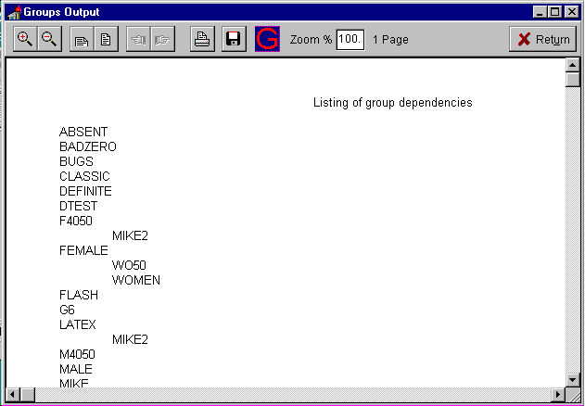
Use the scroll bar to view the entire list or click on the print button to print the list.

{bml 20-13.bmp}

Special Actions

Rename
Figure 20-14. Rename, copy, or delete
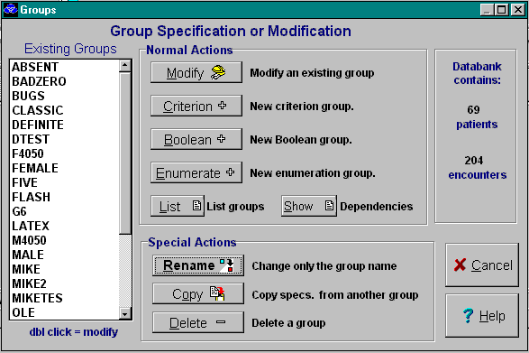
Click on the Group name to be changed.

The program will respond with a dialog box requesting the new name.

Enter the new name and click on the OK box.

{bml 20-14.bmp}

Copy
Copy specs from another group. First choose a group, then click Copy. You must then supply a new group name. Other modifications may then be made.

Delete
Select a group, then click Delete You will be warned if the group is used by another group.

Advanced Discussions

Ranges and Encounter Types

Test range
The test range defines the encounters of patients represented in the source group that will be examined to determining if the group criteria are met. These encounters are called test encounters.

Test range specification
This consists of a start encounter, an end encounter, and a test encounter type. Test encounters are inclusive of those test encounters that fall between the start encounter and the end encounter. The choices are:
- all dated encounters (all encounters except encounter zero).
- all encounters including encounter zero.
- the encounters between the first marked and the last marked encounters of the source group. This choice is not applicable to source group ALL.
- the marked encounters of the source group. This is different than choice 3 that includes all encounters lying between the first and last marked. This choice is not applicable to source group ALL.
- other - specify to make different choices for the encounters to test, choose “other” and the program will prompted for a complex specification of the test encounters. This is covered later in detail.

Criteria

At least one criterion must be specified, and up to 7 more criteria can be specified. A criterion is expressed in terms of a single variable and a test to be applied to values of that variable. Each criterion is built up from the responses to a series of prompts that are described in detail. See Figure 20-5, Criterion specification.

Test type
- If the test variable is time-invariant, only simple comparisons can be tested.
- If the test variable is time-variant, more complex tests are available.

Note that for all criteria in a group definition, the selected tests are applied only to encounters in a “test range”. The specifications are discussed in detail later.

Encounters
Encounters in the test range are called test encounters. In addition to the restriction imposed on all criteria by the test range, further restrictions can be imposed on each individual criterion by specifying a start encounter. The test for that criterion is not applied to encounters before the start encounter.

Note: If the test involves two variables such as ATEST > BTEST. a new variable C=ATEST-BTEST must be computed before the test C>0 can be used.

Test Relationships

Simple comparison
There are two general types of simple comparisons. In one type, the variable at each test encounter is numerically or alphabetically compared with a constant (the “comparison value”) to see if it satisfies a relation such as “equals”, “is greater than”, etc. An example is age=45.

In a range relationship, two comparison values, as in the example AGE IN [20,45] This statement is equivalent to AGE=20 and AGE=45.

In the other type, the variable is checked to see if any value has been recorded, or if the value is missing. An example is: WEIGHT MISSING.

Increase to a value or range
This test is for encounters where a variable has increased to or above a designated value from below that value, or has increased from below to a designated range. Examples are BUN INCR TO >= 25 and WEIGHT INCR TO [200,225]. In the second example, for the criterion to be met at a particular test encounter these conditions must hold: body weight must have been below 200 pounds at some previous test encounter, and must be >= 200 pounds and <= 225 pounds at the test encounter in question.

Increase to an amount
This test is to check whether the variable value has increased by at least a specified amount since a start encounter. It has two forms - in one the start encounter is fixed and in the other the start encounter changes as part of a sliding time frame whose specification is explained later.

In the case of a fixed start encounter, the value of the variable at the start encounter is compared with its value at each subsequent test encounter. The criterion is met at any of these subsequent test encounters at which the variable value exceeds the start value by at least the specified amount. An example is WEIGHT INCR BY >= 20.

In the case of a sliding time frame, the criterion is met at any test encounter in the current time frame at which the variable value exceeds the current start value by at least the specified amount. An example is weight incr by >= 10 in 1 month. In this example, every 1 month period in the patient's entire observation period is examined to see if body weight increased by 10 pounds or more in 1 month.

Increase by a percentage
This test is the same as “increase by an amount”, except that the increase is by a percentage instead of by an amount. An example is WEIGHT INCR BY >= 10%, which is met at a test encounter if body weight at that encounter is at least 10% higher than it was at a previous encounter.

Decrease to a value or range
This test is similar to “increase to a value”, except that the value must decrease to or below a value, or to a range, from above that value or range. In the example, BUN DECR TO <= 25, these conditions must hold for the criterion to be met at a test encounter: BUN must have been above 25 at some previous test encounter, and must be <= 25 at the encounter in question.

Decrease by an amount
This test is the same as “increase by an amount”., except that instead of checking to see if the variable value has increased, the test is to if it has decreased by at least a specified amount.

Decrease by a percentage
This test is the same as “increase by a percentage”., except that instead of checking to see if the variable value has increased by at least a specified percentage, it checks see if it has decreased by at least a specified percentage.

Change by an amount
This test is the same as “increase by an amount”., except that instead of checking to see if the variable value has increased, the check is to see if it has changed (either increased or decreased) by at least a specified amount.

Change by a percentage
This test is the same as “increase by a percentage”, except that instead of checking to see if the variable value has increased by at least a specified percentage, it is checked to see if it has changed (either increased or decreased) by at least a specified percentage.

Cumulative total
This test is useful for looking at total dosages of a drug. The test has two forms: total since some start encounter; and total in a sliding time frame (specification of a start encounter and of a time frame is explained later).

In the case of a start encounter, the values of the variable are added for each test encounter at or after the start encounter. The cumulative total at a particular test encounter is compared with a specified number or numbers to see if it satisfies a relation such as "<", ">=", or “In a range”. An example is TOTAL ADRIA >= 550. Note that in applying this test the cumulative total is initialized to 0.
In the case of a sliding time frame, the variable values are added for test encounters within the time frame. The cumulative total at a particular time in the current time frame is tested to see if it satisfies a relation such as "<", ">=", or “In a range”. An example is ASPIRIN TOTAL > 50 IN 2 WEEKS. In this example, every two week period in the patient's entire observation period is examined to see if the total aspirin dosage in two weeks exceeds 50 grams - hence the term “sliding time frame”. Sliding time frames are explained under Time reference.

Recorded closest to a time
This test specifies a starting encounter, a time offset and an optional time window, in response to a series of prompts displayed at the top of the screen. This test succeeds at a particular test encounter if 3 conditions hold:
- The variable is recorded at this encounter.
- No other encounter, where the variable is recorded, lies closer to the
desired time point.
- The encounter is in the time tolerance, if one is specified. For example, suppose there is interest in the value of blood pressure 6 months after surgery and to obtain the value observed closest to the 6 month point, provided it was observed within 1 month of that point (within 5 to 7 months after surgery).

A group is formed using a “Recorded closest to a time” criterion, with a time period of 6 months, a time window of plus or minus 1 month, and the surgery encounter as the start encounter. (The surgery encounter might be identified as the first marked encounter of the source group-see “The Meaning and Use of Groups” above.)

Marking the occurrences to be in the new group will allow us to extract the required blood pressure data.

Starting encounter
The “recorded closest to test" requires an encounter which is the reference point. For example, to find the blood pressure recorded closest to six months after the 2nd encounter, the starting encounter is encounter 2.

Time offset
The time units and a number in the range -32760 to 32760. If you omit the time offset, the test is for the encounter closest to the start encounter at which the variable is recorded. A negative number means that the search is before, rather than after, the starting encounter.

Time tolerance
If there is a tolerance to time, specify the time units and a number in the
range 1 to 32760. The width of the window is twice this amount of time. If a tolerance is omitted, no restriction is put on the closest encounter except it must be in the test range.

Elapsed time
Used only for date variables. For this test, the variable must be a time invariant date; e.g. a particular surgical procedure. The time elapsed between that date and the encounter date is compared with a specified number of time units to see if it satisfies a relation such as; “equals”, “is greater than" Examples are: CABG_DATE ELAPSED TIME > 183, and RELAPDAT ELAPSED TIME IN [61, 1221].

Test relation and value
Most of the preceding tests require a choice of a relationship and a value.

Decoded (character) values for simple comparisons. can be used. Only enough characters to uniquely identify the alternative need to be entered. Numerical code value for encoded variables can also be used. For date variables, the date format MM/DD/YY (or whatever date format you have chosen) can be used, but they must be enclosed in quotes to distinguish it from a number.

There are several tests that do not require a test value:
- Recorded.
A value has been entered for the variable at this encounter.
- Missing and Missing Special.
A value has not been entered for the variable at this encounter.
- Greatest Value.
The value of the variable at this encounter is equal to the greatest value of the variable at any of the encounters in the test range.
- Smallest Value.
The value of the variable at this encounter is equal to the smallest value of the variable at any of the encounters in the test range.

File encoded text variables can be used with any of the arithmetic relations as well as the tests for recorded or missing. The comparisons with greater or smaller relations will be made on an alphabetical basis. For example, DOC>smith is true when the value of the variable doc would be sorted below smith in a list of names.

In addition, file encoded text variables can be compared for equality to constants which include “wildcards”. For example, the wildcard character * (asterisk) will match any number of characters in the variable's value.
examples: A* will match A,abc,a123 or anything beginning with A.
M*Y will match MY, MARY, MERRY or anything beginning with M
and ending with Y.

The other wildcard character “?” (question mark) will match any single character in the variables value.
examples: A? will match AS, AT but will not match ABC or just A.
A?Y will match MAY, M5Y but will not match MY or MARY.

More than one wildcard may appear in the constant.
examples: ?ARR? will match LARRY or CARRE.
O?? 842 will match O12842 or OXY842.
*A*Y will match HARRY, MARTY or DAY
m??* will match anything beginning with M and having at least 3 characters.

Encounter Types
Following are definitions of encounter types. Note that in specifying a criteria group, and there is a reference to encounter types, the referral is always to encounters of patients represented in the source group.

- Encounters.
All encounters of patients represented in the source group, without any qualification or restriction. In the display of group specifications, the class of all encounters is denoted by the abbreviation ALL.

- Marked encounters
Encounters that are marked in the source group. Recall that a group is a set of patient encounters (and thus is an “encounter group”), and that a patient is said to be represented in a group if any of his encounters is in the group. Frequently a patient represented in a group will have encounters that are not in the group. It's important to note that in the definition of a criteria group, all the encounters of the patients represented in the source group are available for testing to see if the criteria are met, not just their marked encounters. A marked encounter of the source group, e.g. a surgery encounter, can be used to define a point in time for the purpose of selecting which encounters are to be tested. For example, to test only encounters of patients represented in the source group that occurred 5 to 7 months after first coronary bypass surgery.

Another area where the concept of marked encounters is important is the extraction of data for analysis. The EXTRACT program can extract data from all encounters of patients represented in a group, or from their marked encounters only. In the display of group specifications, marked encounters are denoted by the abbreviation MARK.

- Occurrence encounters
In the specification of a criteria group, the satisfaction of one or more criteria, perhaps within a time constraint, defines an occurrence. Test encounters (see below) at which the event occurs are called occurrence encounters, or simply occurrences.

In the display of group specifications, occurrences are denoted by the abbreviation OCC.

- Recorded encounters
The type Recorded is relevant only in the context of a single criterion. In that context, encounters for which values of the criterion variable has been recorded are Recorded encounters.

In the display of group specifications, recorded encounters are denoted by the abbreviation REC.

- Test encounters
Test encounters are those encounters of patients represented in the source group that have been examined to see if the criteria are met. The test range defines test encounters.

Test range: Special Specifications
The test range consists of a starting encounter, an ending encounter and the type of encounter to be tested.

Start encounter
Figure 20-15. Test range specification
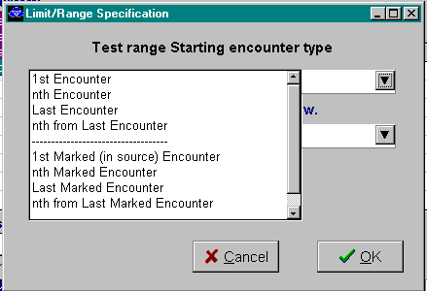
{bml 20-15.bmp}

No encounter dated earlier than the start encounter can be a test encounter. A start encounter is specified by first designating a particular encounter (called the unmodified start encounter) and then by optionally adding or subtracting a modifying number of encounters and/or amount of time. For example, the first marked encounter could be designated as the unmodified start encounter, and then add 3 months.

The start encounter is then the first encounter dated no earlier than 3 months after the first marked encounter. If the choice is not to add or subtract encounters or time, the start encounter is the same as the unmodified start encounter. Note that GROUP will not allow any modifications to encounter 0. The unmodified start encounter involving Last, requires counting in the reverse order. Encounters are counted from the last encounter in the following sequence; last, 1st from last, 2nd from last, etc.
To enter an encounter number for the unmodified start encounter, and the encounter with that number of the type specified in the next response does not exist for a particular patient, then the test range is empty for that patient. This result is not affected by any modifications made in subsequent responses, specifically, by the subtraction of a number of encounters and/or an amount of time.

If 1st Marked (in source) Encounter is specified as the start, then if the first marked encounter for a patient is encounter 0, which will be the patient's start encounter. In this case any time modifications specified in subsequent responses will be ignored because encounter 0 cannot be modified.

If Last Encounter is specified and the patient has only encounter 0, then encounter 0 will be used as the start encounter.

If Last Marked Encounter is specified and the only marked encounter is encounter 0, then it will be used as the start encounter. Any time modifications to encounter 0 are ignored because encounter 0 cannot be modified.

If nth from Last Marked Encounter is specified and a patient has at least one but fewer than n+1 dated encounters of the type specified, then the patient's unmodified start encounter is the first dated encounter of the specified type. If a patient has no dated encounters of the specified type, then the test range is empty for that patient, and this result is not affected by any modifications made in subsequent responses.

Time modification
Time frame modification is optional.

The following time units can be modified: days, weeks, months, years, hours or minutes. For internal comparisons, the units of months and years will be rounded up to make an integral number of days.

Figure 20-16. Time frame modification
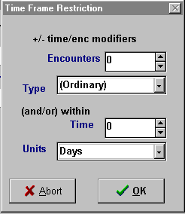
{bml 20-16.bmp}

End Encounter
No encounter dated later than the end encounter can be a test encounter. If encounter 0 is specified as the end encounter, no dated encounter can be a test encounter unless the start encounter is also encounter 0.

The procedure for specifying the end encounter is exactly the same as that for the start encounter. The end encounter can be specified without regard to the start encounter specifications. In particular, the type of the unmodified end encounter does not have to be the same as that of the unmodified start encounter and the types of any modifying encounters do not have to match either

If the start encounter is modified, the end encounter does not have to be modified, and vice-versa.

If an encounter number is specified for the unmodified end encounter, and the encounter with the number of the specified type does not exist for a particular patient, then the unmodified end encounter for that patient is the last dated encounter of the specified type.
If the patient has no dated encounters of the specified type, then the end encounter is encounter 0. In the latter case any modifications are ignored, and the test range for the patient is empty unless the start encounter is also encounter 0.

If 1st Marked (in source) Encounter is specified as the unmodified end encounter, then if the first marked encounter for a patient is encounter 0, that will be the patient's end encounter. In this case any modifications specified will be ignored.

If Last Encounter is specified for the unmodified end encounter and a patient has no dated encounters of the specified type, then the patient's end encounter is encounter 0 if encounter 0 is of the specified type. Otherwise the test range is empty and this result is not affected by any modifications. If the end encounter is encounter 0 then any modifications are ignored.

If nth from Last Marked Encounter is specified for the unmodified end encounter and a patient has fewer than n+1 dated encounters of the specified type, then the test range is empty for that patient. This result is not affected by any modifications.

Note that $2^{\text{nd}}$ from last encounter will be displayed as LAST-2 ENC.

Interpretation of modified start and end encounters
The effect of modifying a start or end encounter by adding or subtracting a number of encounters and/or a time period requires some explanation. The following sequence of encounters will be used to illustrate the various kinds of modifications.

Encounter
number 1 2 3 4 5 6 7

Encounter
Date 1/13/90 3/2/90 7/21/90 11/6/90 2/14/91 6/12/91 10/15/91

Marked $1^{\text{st}}$ $2^{\text{nd}}$ $3^{\text{rd}}$
encounters

In the case of addition or subtraction of a number of encounters alone, the effect is straightforward. If "k" encounters of a certain type are added, the start (or end) encounter is the "kth" encounter of that type subsequent to the unmodified start (or end) encounter.

If a patient has fewer than "k" encounters of the specified type subsequent to the unmodified encounter, then for that patient:
the start encounter does not exist and the test range is empty, or
the end encounter is the last encounter.

- Example 1a: 1st MARK + 2 ENC gives encounter 5 as the start (or end) encounter (2 encounters subsequent to encounter 3, the first marked encounter).
- Example 1b: 4TH enc + 2 mark results in a nonexistent start encounter and thus an empty test range. In the case of an end encounter, this specification gives the last encounter, encounter 7, as the end encounter. (There is only 1 marked encounter subsequent to encounter 4.)

- Similarly, if encounters of a certain type are subtracted, the start (or end) encounter is the "kth" dated encounter of that type prior to the unmodified start (or end) encounter. If a patient has fewer than k dated encounters of the specified type prior to the unmodified encounter, then for that patient 1) the start encounter is the first encounter, or 2) the end encounter does not exist and the test range is empty.

- Example 2a: LAST-2 ENC-3 MARK gives encounter 4 as the start (or end) encounter (2 encounters prior to encounter 6, the last marked encounter).

- Example 2b: 1st-2 ENC -3 MARK gives the first encounter, encounter 1, as the start encounter. This specification results in a nonexistent end encounter, and thus an empty test range. (The last-2 encounter is encounter 5, and there are the only 2 marked encounters prior to encounter 5.)

- The effect of addition or subtraction of a time period depends on whether a start or an end encounter is being modified. First take the case of a start encounter. Adding or subtracting a period of time to or from the date of the unmodified start encounter establishes a starting date. The start encounter is the first encounter on or after that date. If a patient has no such encounter, then the start encounter does not exist and the test range is empty for that patient.

- Example 3: 1ST MARK + 3 MONTHS gives encounter 4 as the start encounter. (10/20/90 is 3 months after 7/21/90, the date of the first marked encounter. The first encounter on or after 10/20/90 is encounter 4.) In the case of an end encounter, adding or subtracting a period of time to or from the date of the unmodified end encounter establishes an ending date. The end encounter is the last encounter on or before that date. If a patient has no such encounter, then the end encounter does not exist and the test range is empty for that patient.

- Example 4: LAST MARK +1 YEAR gives encounter 2 as the end encounter. (6/12/90 is 1 year before 6/12/91, the date of the last marked encounter. The last encounter on or before 6/12/90 is encounter 2.)

When adding (or subtracting) both "k" encounters of a certain type and m time units, the general rule is that both modifications must be satisfied. What this means depends on whether a start encounter or an end encounter is being modified. First consider a start encounter. Applying the general rule, the start encounter cannot be earlier than the "kth" encounter of the specified type subsequent to (or prior to) the unmodified start encounter, and cannot be earlier than the date established by adding (or subtracting) the "m" time units. Hence the start encounter must be the later of the 2 encounters obtained by separately adding (or subtracting) 1) the "k" encounters, and 2) the "m" time units.
- Example 5: 1ST MARK + 2 ENC & 4 MONTHS gives encounter 5 as the start encounter. In Example 1a, encounter 5 was to be the start encounter if 2 is added to the first marked encounter, and in Example 3 encounter 4 was found to be the start encounter if 3 months was added to the first marked encounter. Since encounter 5 is later than encounter 4, it is the start encounter if both encounters and 3 months are added.

Similarly, the general rule requires that, in the case of an end encounter, it cannot be later than the $k^{\text{th}}$ encounter of the designated type subsequent to (or prior to) the unmodified end encounter, and cannot be later than the date established by adding (or subtracting) the time units. Hence the end encounter is the earlier of the 2 encounters obtained by separately adding (or subtracting) 1) the k encounters, and 2) the m time units.
- Example 6: LAST MARK - 2 ENC & 1 YEAR gives encounter 2 as the end encounter.

In Example 2a, encounter 4 is identified as the end encounter when 2 encounters from the last marked encounter are subtracted.

In Example 4 encounter 2 is identified as the end encounter when 1 year from the last marked encounter is subtracted. . Encounter 2 is the earlier of these 2 encounters, so it is the end encounter if both 2 encounters and 1 year are subtracted.

Output range: Special Specifications
The output range determines which encounters belonging to patients who have at least one occurrence of the event are to be “marked” as being in the new group. The output range specification consists of a start encounter, and an end encounter and an encounter type. The actual construction of the output range parallels the construction of the test range. Encounters to be marked are those of the output encounter type that fall between the start encounter and the end encounter inclusive.

“Wild Card” Tests
The criteria groups can now use “array” variables in tests. Array variables are variables that are identical except that their names end with different numbers. For example, DRUG1, DRUG2, DRUG3, DRUG4, could be an array of four drugs variables. If DRUG* is used as the name of a variable in a criterion, this would apply the test to all four drug variables. If any of the four satisfied the criterion, the criterion would be met.

More than one array variable can be used in a criteria group, but remember that each criterion is processed in sequence. A group with two criteria DRUG*=ASPIRIN and DOSE*>20 (2 satisfied simultaneously) would identify encounters where ASPIRIN was given and the dose of some drug was greater then 20. This is probably not what is wanted. The solution to this problem will require more tedious group specifications or the use of a computed quantity prior to using GROUP.
%PageBreak.

#$KSelect (Group Formation)

Purpose of SELECT
The SELECT program identifies and stores lists of patient encounters according to the group definitions specified by the GROUP program. SELECT examines the data in the transpose file when forming criteria groups. The group of all patients (group All) exists at all times, so it is not necessary to use GROUP or SELECT for group ALL.

Who should use SELECT
SELECT should be used by anyone performing data analyses in the MEDLOG system.

When to use SELECT
SELECT should be used to form encounter groups before using the EXTRACT program. When the CREATE updates the transpose file, it normally runs the COMPUte and SELECT programs at the same time. If you elect not to run them at that time, you must do so later by invoking them from the Prepare menu column..

The Select program
Figure 21-1. Select program
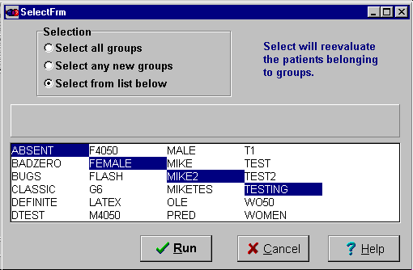
There are three options:

1.Select all groups

2. Select any new groups

3. Select from list below

{bml 21-01.bmp}

If a group acts as a source for another group, the group must be formed in the right order. If SELECT is used to form all the groups in the group definition file, it will automatically form them in the right order.

Select all groups
Click on the Select all groups button and all of the groups listed in the dialog box will be processed when the Run button is clicked.

Select any new groups
All groups which have been newly changed will be processed. Since the GROuP program normally runs SELECT when changes are made, it is now unusual to choose this option. It is left in for compatibility with older versions.

Select from list below
Click on the group in the dialog box to select it. If you want to pick more than one group, move the cursor over the first group, hold down the Ctrl (Control) key and click on the Groups you want to select.

Run select
Click the Run button and the program will display the results as shown in Figure 21-2.
Figure 21-2. Select results
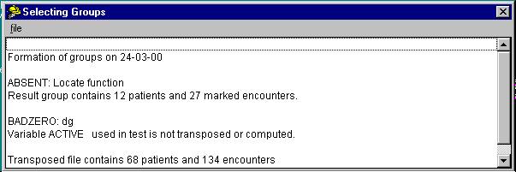
{bml 21-02.bmp}

As it runs, SELECT displays progress messages. When it is finished, you can print the results by going to the top menu under File where you will see a Print item.

Note that the transpose file counts do not include deleted patients or patients with no encounters.

If any of the groups selected have an error condition a message is displayed with the selected group. See also the error messages at the end of this chapter.

Error Messages
- Circular definition in groups. Two groups name each other as source groups, or include each other in Boolean specifications.

- Group . XXX . is required, and must be selected first. A group named as source, or in a Boolean definition, has not yet been formed (selected).

- Variable . VVV. used in test is not transposed or computed. A criterion test variable cannot be found. Perhaps the variable was deleted or the group specification is in error. %PageBreak.

#$KExtract (Data)

Purpose of EXTRACT
The EXTRACT program provides for the extraction of values for selected variables used in statistical analysis and listing programs. It is also used for exporting data and for some types of reports.

A single extract file can contain data for up to 8 groups. In general, an extract file is a working subset of your databank that allows data to be viewed from different perspectives.

This program also includes the capability of computing new variables from the extracted data values. This function was formerly in a separate program called Transform. See the last section in this chapter for instructions and descriptions.

Who should use EXTRACT
EXTRACT should be used by anyone who wants to analyze data in a MEDLOG databank.

When to use EXTRACT
Before running any of the statistical analysis programs, EXTRACT must be run to extract the required data and put it into a named file. Up to 2000 extract files may be saved. These extract files may be updated automatically when the CREATE program is run.

How to use EXTRACT
Invoke EXTRACT from the Prepare menu items on the main MEDLOG menu. A dialog box as shown in figure 22-1 will appear.
Figure 22-1. Extract program
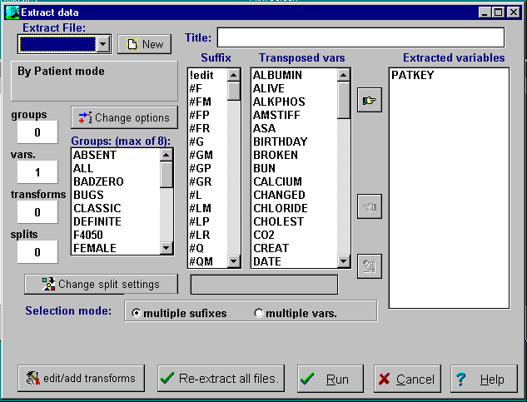
{bml 22-01.bmp}

The program will open the name of the last extract file you used. If this is the first time, the name will be blank and you will be expected to create a new file. The steps to create a new extract file are described below.

Click on the New button which is just to the left of the extract file name field. The dialog box as shown in Figure 22-2 will appear.
Figure 22-2. New extract file
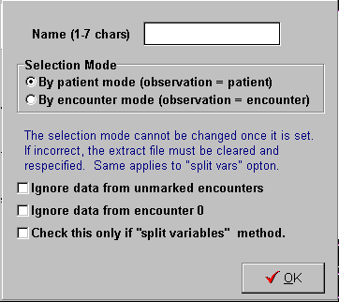
{bml 22-01.bmp}

1. Enter a 1 to 7 character name for the extract file.
2. Select the: By patient mode, or By encounter mode. Note that the mode cannot be modified later.
3. Any of the options may be selected. For instructions on using Split variables see the advanced topic section later in this chapter.

Selection mode
EXTRACT formats data in the extraction file as a series of rectangular tables, one for each of the selected groups. The columns of the tables correspond to extracted variables. The rows of the tables correspond to “cases” or “observations” for the purpose of reporting or statistical analysis. What constitutes a case depends on the extraction methodyou choose.

By patient mode (observation = patient)
This method results in one observation or record for each patient in a group. Since a patient's record may contain multiple values of a time-variant variable, such a variable must have an associated selection suffix which yields a single value for a patient - for example, the greatest value recorded for that patient. These selection suffixes are explained later.

An example of the tabular format for this extraction method is shown below. There are 5 patients in the group and 3 variables: patkey, sex, and bp_diast.g. The variable sex is time-invariant and bp_diast.g denotes the greatest value of the time-variant variable for diastolic blood pressure. The variable patkey (the system patient key) is always included in the extraction file. The question mark in the blood pressure column indicates a missing value (that patient had no recorded values for BP_DIAST)
.
PATKEY SEX BP_DIAST.G
5 0 89
7 0 95
15 1 ?
16 0 105
24 1 97

By encounter mode (observation = encounter)
In this extraction method, each row of a table corresponds to a single patient encounter, so you don't have to attach a selection suffix to time-variant variables
(and you are not permitted to do so). Here is an example of the tabular format for
this method:
PATKEY ENCOUNTR DATE SEX BP_DIAST
5 1 2/17/89 0 86
5 2 7/23/90 0 89
7 1 4/22/88 0 93
7 2 5/30/88 0 95
7 3 1/19/89 0 92
15 1 1/28/91 1 ?
16 1 11/24/90 0 105
16 2 11/29/90 0 103
encountr and date are built-in variables representing the encounter data. They are automatically included in the extraction file when the “by encounter” method is used.

Encounter restrictions
After the “by patient” or “by encounter” mode is selected, some additional restrictions may be placed on the extraction process. The restriction options are:

Ignore data from unmarked encounters
The marked encounters of a group are those which are identified or “marked” by the group specifications. Recall that in the MEDLOG system groups are comprised of selected patient encounters. A patient is said to be represented in a group if any of his encounters are “marked” for group inclusion. Marked encounters might be those at which a certain event occurred - surgery, for example. These concepts are explained
in detail in the Group program. Only marked encounters are considered in data extraction.

Ignore data from encounter zero.
If your databank uses encounter zero, you can choose whether the extracted data should include values from encounter zero or not. If your databank does not use encounter zero, this option will not be enabled.

Group specification
EXTRACT displays the list of available groups. At least one group must be selected by clicking on it and lighting it up. To select more than one group, hold down the Ctrl key and click on the group. Up to 8 groups may be chosen. To delete a group, hold down the Ctrl key and click on the previously selected group that is highlighted. The group named ALL is the pre-defined group of all patients.

If the group name appears in dim colors, the group cannot be chosen since it has not yet been “formed” with the SELECT program.

Selecting Variables
An extract file may contain anywhere from two to over a thousand “variables”. Here the term variable is the same as a MEDLOG defined/computed variable if the “By encounter” mode has been selected. Otherwise the term variable is more complex and may consist of the name of a defined/computed variable followed by a suffix. Note: newer versions of MEDLOG allow more than 900 variables.

To select one variable from the Transposed var list, click on the variable to “light it up” and then click on the {bml BMoveR.bmp} button to move the variable to the Extracted variables list. To delete variables from the list, “light it up” and use the Move Left button to move it back to the transposed list. You can also use the Move All button to move all of the variables in the transposed list to the extracted variables list.

You can move more than variable by clicking on the multiple vars radio button and then select several variables by holding down the ctrl key while clicking on the variable and “lighting it up”. Complete the moves by clicking on the Move Right button.

Suffixes (time variant data extracted with the By Patient mode)
When data is extracted so that one observation (record) is associated with one patient, the question arises “what to do with variables that change over time?” Should we look at the first value, the average value, or the greatest value? The answer will depend on the way you want to look at the data for each patient. The various suffixes allow you many ways to look at time variant data.

Suffixes are applicable only to the “By Patient” extraction mode. Suffixes are appended to the variable name by adding a period followed by an option, as for example, bp_dIAST.g that denotes the greatest value of diastolic blood pressure recorded for a patient.

In the following descriptions, note that if the restriction “ignore data from unmarked encounters” has been selected, then all references to encounters should, unless explicitly indicated to the contrary, be interpreted as references to marked encounters.

Suffix selection
Select single variable suffixes by “lighting up” the suffix n the Suffix list.

Multiple suffixes can be created by clicking on the multiple suffixes radio button, holding down the ctrl key, and then clicking on the suffixes. You can also click on !edit on the top of the suffix list and then enter one or more suffixes. Commas in the edit box must separate multiple suffixes.

Value options
Eight basic options are available for use with time-variant variables (“by patient” method):
- .F = first
The value of the variable at a patient's first encounter. The first encounter is encounter 0 if it has been specified that encounter 0 is to be used in extractions. Otherwise encounter 1 is the first encounter record.
- .L = last
- The value of the variable at a patient's last encounter.
- .S = smallest
The smallest value of the variable recorded for a patient.
- .G = greatest
The greatest value of the variable recorded for a patient.
- .A = average
The average of the values of the variable recorded for a patient.
- .I = intercept
The intercept computed from the least squares regression of the variable on time, using an individual patient's data. Time is measured in days from the date of the patient's first dated encounter. Encounter 0, which is undated, is never used in this computation.
- .B = slope
The slope computed from the least squares regression of the variable on time, using an individual patient's data (see “I = intercept” above).

- .X = same encounter
Used to extract the value of a variable at an encounter that is determined by a previous extracted variable. For example, if BP.G is extracted for the greatest blood pressure, and then HRATE.X is extracted, then HRATE.X will be the value of HRATE at the same encounter that BP has its greatest value.

If the smallest and largest values of BP are needed and also want the corresponding value of HRATE, there will be a problem using HRATE.X twice. To solve this problem, add one or two extra characters following the X to make the name unique. In this example we might use HRATE.XS and HRATE.XG

HRATE.X is determined by the variable (without an “X” suffix) that precedes it in the extraction list. In this case the list could be in this order: BP.G, HRATE.XG, BP.S, HRATE.XS: The suffixes XS and XG are used to differentiate the smallest and greatest and to avoid two extracted variables with the same name.

Several X type variables may be extracted in sequence. In this case, all would refer to the previous (non “X”) extracted variable. For example, BP.FR, HRATE.XFR, TEMP.XFR, TIME.XFR counter where BP had its first recorded value. The choice of letters following the X is arbitrary and used only to distinguish multiple uses of the X suffix.
In the case of “first” and “last”, the selected value is designated in the extraction file as “missing” for a particular patient if it was not recorded at the relevant encounter or if that encounter does not exist for the patient.

In the case of “smallest”, “greatest”, and “average”, the selected value is designated as “missing” for a particular patient if no values have been recorded for the variable for that patient (values recorded at encounter 0 are considered only if encounter 0 is specifically marked for use).

In the case of “intercept” and “slope”, the selected value is designated as “missing” for a particular patient if fewer than 2 values have been recorded for the variable on different dates for that patient. For these options, encounter 0 values are never considered.

These value options are available only for time-variant variables (and “by patient” extraction method only) - time-invariant variables can have only one value for a given patient. EXTRACT will display an error message if an attempt is made to use a value suffix with a time-invariant variable name, or with any variable name if the “by encounter” extraction method is being used. On the other hand, time-variant variables must specify, using the “by patient” extraction method, either a value suffix or one of the other suffixes described under “Miscellaneous options” below. This is required to allow the extraction of a single value from the possibly multiple values of the variable observed for a given patient.

Value option modifiers
A second letter or symbol can be added to the basic option suffixes to restrict the options to particular kinds of encounters or values.
- ._R = recorded
This modifier restricts attention to encounters at which a value was recorded for the variable. For example, the suffix “FR” (first recorded) specifies the first value of the variable among values recorded at a patient's encounters. Note that “recorded” is implicit in the “smallest”, “greatest”, “average”, “intercept”, and “slope” options, so adding “R” to those options will not affect the result.
- ._P = positive
This modifier restricts attention to encounters at which the variable value is greater than zero. Thus ADRIAMCN.FP denotes the amount of a patient's first adriamycin dosage. This option cannot be used with “intercept”, “slope”, or specific numbers; e.g. AGE.2P is invalid.
- ._M = marked
This restricts attention to marked encounters. Thus .FM gives the value of the variable at a patient's first marked encounter. If only marked encounters are used in data extraction - see “Restrictions on encounters” above, adding M to the value options will have no additional effect. If encounter 0 is not used in extractions, then FM refers to the first dated, marked encounter.

Encounter number override
By preceding a 1 or 2 letter value option with the symbol #, encounter number rather than the value can be extracted. This option is not often used. The # symbol cannot be used with the average, intercept, or slope functions, since these quantities are not associated with a particular encounter. For example, ADFIAMCN.#FP denotes the encounter number of a patient's first adriamycin dosage. “Encounter number” here refers to the number assigned by the system to the encounter. Thus #FM displays the system encounter number of a patient's first marked encounter, irrespective of which time-variant variable is attached to it. So does #F if restrictions are placed by marking encounters (see “Restrictions on encounters” above). If encounter 0 is not to be used in extractions, then #FM displays the system encounter number of the patient's first dated marked encounter.

Encounter date override
By proceeding a 1 or 2 letter value option with the letter D the encounter date rather than the value can be extracted. The letter cannot be used with the average, intercept, or slope options. For example, BP_DIAST.DG denotes that the date of a patient's encounter where the greatest value of diastolic blood pressure was reached. If encounter 0 is specified for use in extractions, and if the other part of the option selects encounter 0 for a particular patient, the encounter date will be missing for that patient.

Time invariant variable options
Two elapsed-time options are available for use with time-invariant dates. These are exceptions to the rule that time-invariant variables cannot use a suffix. They make sense to use only with date type variables.

Time elapsed to first encounter
This option gives the time in days from a time-invariant date to the date of a patient's first dated encounter (encounter 0, which is undated, is never considered in this context). An example is SURG_DAT.EF. If the value of SURG_DAT were 1/1/80, and the date of encounter 1 (the first dated encounter) were 3/31/80, then the value of SURG_DAT.EF would be 89 (days). Note that if that only marked encounters are to be considered (see “Restrictions on encounters” above), EF refers to time elapsed to a patient first dated marked encounter.

Time elapsed to last encounter
The EL option displays the time in days from a time-invariant date to the date of a patient's last dated encounter.

By adding M to EF or EL, extraction is restricted to marked encounters. Thus EFM displays the time elapsed to a patient's first dated marked encounter. If only marked encounters are used in data extraction (see “Restrictions on encounters” above), adding M to these options would have no additional effect.

Table Variables
Table variables require the use of the COMPUTE program to reference the numeric elements of a table. For example, the table variable HOSPITAL may have elements BEDS and CATSCAN, both numeric quantities. To determine if a patient was ever admitted to a hospital with a CAT-scan machine, a new variable must be computed:
HOSPCAT=TABLE(HOSPITAL,CATSCAN)
Then HOSPCAT.G can be extracted for the desired answer.

If a reference is made directly to a table variable in EXTRACT, the index number of the table entry will be extracted. Thus HOSPITAL is the index of the hospital that was recorded for a patient on the first encounter.

Miscellaneous options
Like the value options, the following options are available only for time-variant variables and extraction methods 1 and 3 only.

Counts
The suffix Cn, where n is a number between 0 and 9 inclusive, denotes the number (or “count”) of a patient's encounters at which the value of the variable is n. For example, if HEADACHE is coded 0, 1, 2, 3 for absent, mild, moderate, severe, then HEADACHE.C3 will give the number of encounters at which severe headache was reported for a patient.

Other count suffixes are C?, denoting the number of a patient's encounters at which no value was recorded for the variable, CR, denoting the number of a patient's encounters at which a value was recorded for the variable, CP, denoting the number of a patient's encounters at which a value greater than zero was recorded, and CM, denoting the number of marked encounters for a patient. The count of number of alternate missing values is C!. The alternate missing values are also counted in C?. Encounter 0 is considered in these counts only if you specified that it is to be used in extractions.

If only marked encounters are specified for consideration, these counts are computed for marked encounters only.

Total
The suffix T denotes the total of the variable values recorded for a patient. For example, ADRIAMCN.T gives the total dosage of adriamycin recorded for a patient. Recall that if you specified that only marked encounters be considered, the total is computed over marked encounters only. The suffix TM denotes the total of the variable values recorded for a patient at marked encounters. Values at encounter 0 are included in the total only if you specified that encounter 0 is to be used in extractions.

The total is not initialized to 0, so it will be missing if there are no recorded values for the variable.

Specific encounters
The suffix n, where n is a number from 0 to 999 inclusive, denotes the variable value for a patient at encounter n. The number n refers to the system encounter number, whether or not you specified that only marked encounters be considered. A specific encounter designation overrides any restrictions on encounters you have specified (see “Restrictions on encounters” above). Note: numbers greater than 9 do not appear in the suffix list box; choose “edit” in the list box and then type the suffix numbers, separated by commas.

The suffix NM, where N is a number from 1 to 99 inclusive, denotes the variable value for a patient at the nth marked encounter. Thus bp_diast.2m will give the value of diastolic blood pressure at the second marked encounter which, for example, might be system encounter number 5. If encounter 0 is marked, then 1M denotes encounter 0 if you specified that encounter 0 is to be used in extractions. Otherwise, 1M denotes the first dated marked encounter.

The suffix nR, where n is a number from 1 to 9, denotes the nth recorded value of the variable for a patient. Option 1R is equivalent to the option FR (first recorded). Note that encounter 0 will be examined to see if the variable is recorded, if you specified that encounter 0 is to be used in extractions.

Value Encounters
The suffix #Vn, where n is a number between 0 and 9 inclusive, denotes the encounter number where the variable has the value n. number (or “count”) of a patient's encounters at which the value of the variable is n. For example, if HEADACHE is coded 0, 1, 2, 3 for absent, mild, moderate, severe, then HEADACHE.#V3 will give the number of the encounter where a headache of value 3 (severe) was first reported for a patient.

By itself HEADACHE.#V3 is probably not of much utility. It is usually used in conjunction with the .X suffix to extract values that were recorded at the same encounter. For example, if HEADACHE.#V3 is followed by ASPIRIN.X3, We will know how much aspirin a patient took when a severe headache first occurred.

The #Vn suffix is often used in clinical trials to identify a type of encounter. For example, if VISTYPE is an encoded variable where the value 4 is used for a 12 month follow up, then VISTYPE.#V4 will identify the 12 month follow up encounter. Values of variables corresponding to the 12-month encounter can be extracted with the X suffix. This is especially useful if the trial does not have fixed number and sequence of encounters which is the same for all patients.

SPLIT VARIABLES

Multiple observations per patient (“Split by patient'“ method)
In some applications we want to analyze all instances of a given event (for example, fracture), even though some patients may have several events. In other words, the unit of observation is an event rather than a patient. MEDLOG can accomplish this by means of the “split variable” extraction option. Suppose we have defined several variables named fractr_1, fractr_2,fractr_3 etc., whose values are coded fracture sites. Some patients have no fractures while some may have two or three. If we think of the values of these variables as values of a generic variable fracture, then we can think of splitting the recorded instances of fracture for a single patient into several observations - hence the term “split variable”. An example of the tabular format produced by the Datalist program appears on Figure 22-3.

Before the split we have:
PATKEY FRACTR_1 FRACTR_2 FRACTR_3
0 890 ? ?
1 536 538 ?
2 744 ? ?
3 67 ? ?
4 150 476 485

Figure 22-3. Split variable example
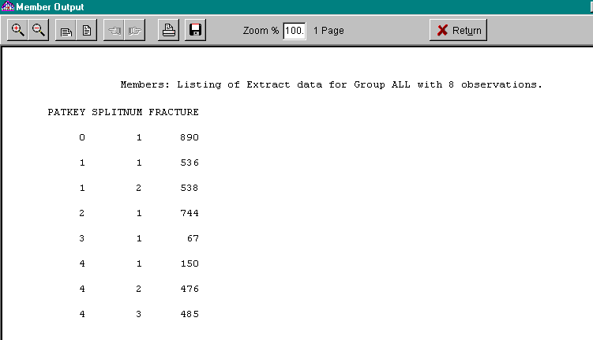
{bml 22-03.bmp}

The values of FRACTURE are instances of a fracture site code. The variable SPLITNUM is automatically generated by EXTRACT, and indicates which of the original variables (FRACTR_1,FRACTR_2,FRACTR_3) corresponds to the observation. This correspondence would probably not be of much interest in the example we have been discussing, but may be important when the original variables have a meaningful identity. For example, if L_KNEE and R_KNEE are indices of arthritis activity in the left and right knee respectively, we might want to distinguish the two in an analysis even though we are treating all knees as individual observations.

Note that if an individual patient has no values recorded for any of the split variables, then no observation for that patient is generated.

Up to 20 split variables may be specified (i.e. each patient or encounter may generate up to 20 observations).

To utilize split variables, first make sure the option “Split vars” was selected. This option appears in the box just below the extract file name. If this has not been done, click on the “Change options” button and make this selection. Next, click on the button “Change splits”. The dialog shown in figure 22.4 will appear. To establish the first split variable, click on the New button. This will open the split variable specification dialog box. See Figure 22-2 which must have the split variables box checked in order to specify split variables..

Figure 22-4. Split variables (By-patient mode)
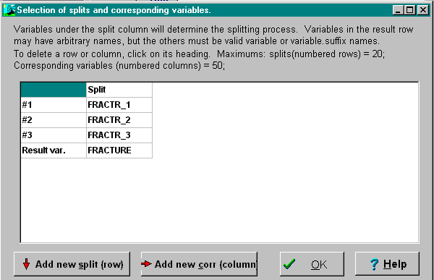
{bml 22-06.bmp}

Enter the split variables as shown on Figure 22-4 (you must type these). After you have entered the desired split variables, enter the Result var which is the new “generic” variable. A value suffix is not necessary for this name, even if the split variables are time-variant. To avoid confusion, you should not use the name of a variable in the dictionary or a computed variable.

The entry of corresponding variables, Add new corr(column), is discussed in the following section for corresponding variables.

Click on the OK button to return to the extract dialog box, where you can add other variables to your “split” extract file.

Corresponding variables (By patient method)
For example, if L_KNEE and R_KNEE are the 2 split variables (with generic name KNEE), then L_SWELL and R_SWELL might be one set of corresponding variables (with generic name SWELL), and L_PAIN and R_PAIN another set (with generic name PAIN
Figure 22-5. Entering corresponding variables
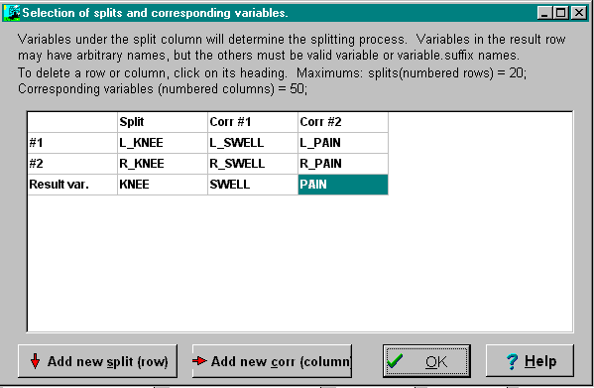
{bml 22-09.bmp}

After you have entered the result split variable (in this example KNEE), click on the Add new corr (column) to enter the first set of corresponding variables, SWELL. Repeat the process for PAIN and any other corresponding variables.

Click on the OK button when all corresponding variables have been entered. It is possible to edit the split table later.

Note that in a particular set of corresponding variables you don't have to specify a corresponding variable for every variable in the set of split variables. If you don't want to use a corresponding variable for a particular split variable (say the 4th), leave that position blank. The value of the generic corresponding variable for that set will be set to missing for observations corresponding to the 4th split variable (that is, observations with SPLITNUM = 4).

An example result of a split variable (KNEE) with corresponding variables (SWELL and PAIN) is shown below.

Figure 22-6. Corresponding split variables (By-patient mode)
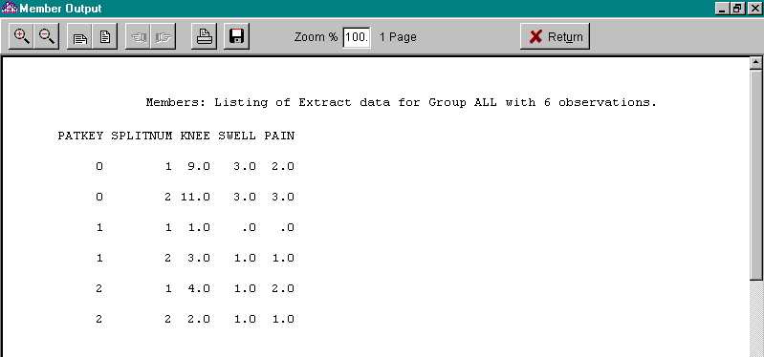
{bml 22-08.bmp}

Multiple observations per encounter. (“Split by encounter” method)
This method is similar to the Split by patient method , except the split takes place at each and every encounter. The selection of the by encounter mode is made when making a new extract file.

Split variables and corresponding variables are specified in the same way, but instead of extracting one value of a time-variant variable according to its selection suffix, one observation per encounter is generated - no variable suffix is needed (and none is allowed

Analysis Transformations

Purpose of transforming variables in an extract file.
The COMPUTE program can derive new variables from the entered data, but it cannot work on the extracted data. Another facility is required for this, and that is the function of a transformation statement.

When to use a transform statement.
Transform statements may be specified when the extract file is made, or they may be added later.

How to use a transform statement
You access a transform editor by clicking on the edit/add transforms button.

Transform statements
If a blank screen opens when the edit/add transforms button is clicked, there are no transform statements for the extract file. Otherwise, any statements created will appear as in Figure 22-6.

Figure 22-7. Transform statements
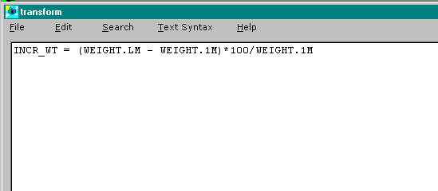
{bml 22-12.bmp}

Creating transform statements
A transform statement defines a new variable in terms of existing variables. The existing variables can themselves be transformed variables. In the example above, INCR_WT is the new transform variable and WEIGHT is an existing transposed variable in the dictionary.

A transform statement may be up to 125 characters long. Transform variable names may be up to 12 characters long. The result type of a transformation is FLOAT. To change the result type, you may add [type:] after the result variable name, just like in COMPUTE. The allowed types are: INT, TIME, DATE, TEXT and TABLE. Note that TEXT and TABLE may only be used if the result variable is so defined in the dictionary.

Transform statement construction
The construction of transform statements is essentially the same as that for compute statements. See Chapter 19 for details on compute statements.

There are, however, some compute functions which are not available for transform statements. These functions are CUM, ZERO, LAG, RECENT, PEAK, SLOPE, and INTERCEPT.

Missing value rules apply to both computed and transformed statements.

If a variable used in a transform statement is not in the extract file, transform will return an error message. Transform variables may themselves be used in the computation of other transform variables. Any variable in the extract file may be recalculated with a transform statement. An example: PATKEY = PAYKEY +1;

Like computed variables, an illegal operation as division by zero will cause transform to assign a missing value to the transformed variable.

Editing a Transform statement
The statement used to calculate a variable is saved with the extract file. This allows you to edit the statements later. It also allows the Extract program to automatically re-compute transform variables in the extract file.

The operation of the edit box is so similar to notepad that no instruction should be required. When you have completed the editing, click on the OK button to save the changes.

Applications of Transform and Compute
Compute calculates a value at each encounter in the transpose file by calculating values for all encounters of all patients. Computed variables can be used in group definitions and extract files.

Transformed variables are calculated for each observation in an extract file. Since most extract files are in the “by patient mode”, the transformed variable is typically calculated for each patient.

An example should clarify the difference. Consider the problem of determining the greatest change in body surface area that occurred in the course of each patient’s treatment. The body surface area can be calculated (estimated) at each encounter from weight and height with a simple formula using compute. The computed variable, BSA, is then used in extract to find BSA.G and BSA.S which would be the greatest and smallest values of BSA. A transform statement, BSADIF=BSA.G – BSA.S is then used to calculate the maximal change in body surface area (BSADIF).

Error Messages
Extraction group xxxxxx was eliminated. No patients were eligible. The indicated group is empty.

Invalid option. An incorrect variable suffix was entered.

No blanks allowed in name. A variable name with an embedded blank was entered.
Suffix not allowed when by encounter. A suffix was used with a time-variant variable, when using extraction method 2 or 4 (one or multiple observations per encounter).
Variable name already used. A variable name that had already been entered was entered again.

Variable is not transposed or computed. A variable was entered which is not in the transpose file.

Variable is time-invariant. Invalid suffix. A suffix was used which relates only to time-variant variables.

Variable is time-variant. Suffix required. A time-variant variable was entered without a suffix (extraction methods 1 and 3).
%PageBreak.

#$K Graphics

Purpose of GRAPHICS
GRAPHICS is used to display and edit high-resolution graphic plots from PATPLOT, BARGRAPH, FREQUENCY, SCATTER, SURVIVE, WHISKER, COXREG, and LINREG programs. Symbols, scales and labels may be changed to tailor the plot to your requirements.

Who Should Use GRAPHICS

Anyone who requires plots of higher precision than that offered by the normal text screen plot should use GRAPHICS. The program is also useful for exporting a graphic to Word or some other product.

When to Use GRAPHICS
GRAPHICS is used after generating appropriate data with one of the programs mentioned in the Purpose paragraph above. Once the data is generated, you may use GRAPHICS repeatedly, to display and manipulate the plot.

How to use GRAPHICS
Within the programs listed above, you can click on the MEDGRAF icon on the program’s menu bar to execute the program.

The program will begin by displaying the current plot.

You may also invoke this program from the main menu under the View column. In this case, you must select the appropriate file to plot by beginning with the File menu. The File menu is also used to save a plot and to set some options. It is discussed first.

Figure 23.1 Graphic File Selections

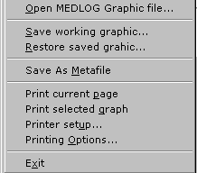

Open MEDLOG Graphic File
Click on the command line and the dialog shown in Figure 23-2 will open

Figure 23-2. Graphic files
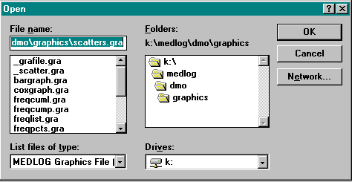
{bml 23-02.bmp}

Save working graphic
Use this selection to save the current plot so that it can be restored later for further processing.

Restore saved graphic
Use this selection to restore a plot image which was previously saved.

Save as Metafile
Metafiles are a type of graphics file which can be ready by many products, Word and Harvard Graphics, to name a couple. Use this selection to name and save the current graphic in Metafile format.

Print current page

Print selected graph
Either of these will print the current graphic on your printer (or other output device).

Printer setup
The options displayed will depend on the particular printer you are using. Figure 23-3 illustrates a typical laser printer, the HP 4050.

Figure 23-3. Printer setup
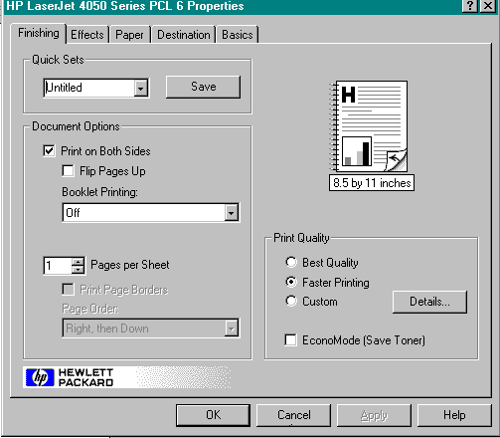
{bml 23-03.bmp}

Printing Options
Figure 23-4. Print parameters
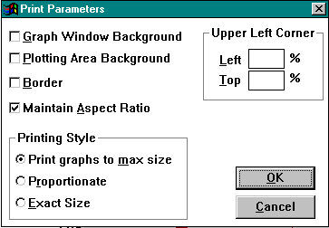
{bml 23-04.bmp}

- If the check box Graph Window Background is checked, the background color of the graph is printed, otherwise it is ignored.

- If the check box Plotting Area Background is checked, the background color of the graph is printed, otherwise it is ignored.

- If the check box Border is checked, the graph (or page) is printed with the rectangular border around it.

- If the check box Maintain Aspect Ratio is checked, the graph (or page) is printed with it’s aspect ratio preserved, otherwise the aspect ration may be changed to maximize the size of the printed image.

- The radio buttons in the Printing Style dialog box specify the manner in which the graph (or page) is to be printed.

Make the appropriate selections and enter the corresponding percentages. Click on the Ok button to complete the print parameters.

Edit Options

Copy Graph and Copy Page
Graphic images created with MEDGRAF can be exported to other applications via the “Clipboard”. Images copied to the Clipboard can be pasted to documents in other applications.

Pictures created and saved in other applications and saved in the Windows bitmap format (BMP) and Windows Metafile format(WMF) can be imported to specified locations of any graph.

Add Text Label
Click on the command line and a NEW_LABEL marker will appear on the graph.

Figure 23.5 Add Text
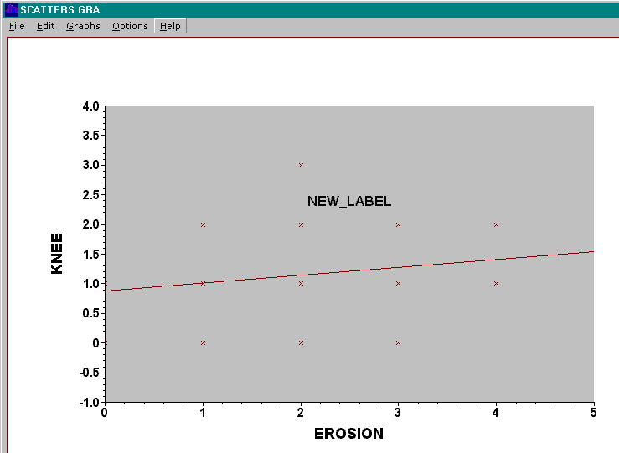
{bml 23-05.bmp}

Replace the NEW_LABEL text with the appropriate text. After entering the new text, you can drag and drop the label anywhere on the graph.

Graph

Graph Parameters
This dialog box allows the user to change the position, size, and color of the various elements of the graph. The details will depend on whether you are changing the attributes of a line, a label , an axis , the border, etc.
Figure 23-6. Graph parameters
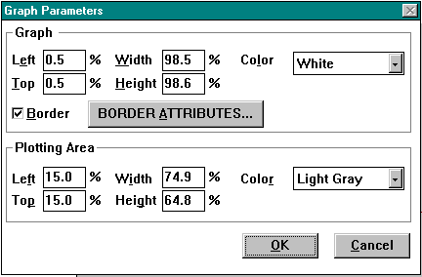
{bml 23-06.bmp}
- Left, Top, Width and Height edit controls allow the user to specify new position and size of the graph (relative to the graph window) and of the plotting area (relative to the graph window).
- The Color drop-down lists specify the graph window background color and the color of the graph’s plotting area.
- If the Border check box is checked, the graph will have a border around it.
- If Border checked, the BORDER ATTRIBUTES button leads to another standard dialog (see LINE PARAMETERS) that allows the user to specify the thickness, color, and style of the border line.

Fill Page
Clicking on this command line will cause the graph to fill the monitor viewing area.

Delete Graph
Clicking on this command line delete the graph currently displayed. This has no real function in MEDLOG, because choosing another graphic will clear the current graph anyway.

Options menu
The two options available have no real function in MEDLOG.
%PageBreak.

#$K Bargraph (Comparing Percentages)

Purpose of BARGRAPH
BARGRAPH provides a graphical means of comparing the percentages of an event, such
as diastolic blood pressure >=100, in two or more groups. It also computes a chi-square test (or Fisher exact test ) for equality of percentages between groups.

Who should use BARGRAPH
BARGRAPH should be used by anyone who wants to compare graphically and statistically the percentages of an event.

When to use BARGRAPH
You should use BARGRAPH when you want to compute percentages of an event in different groups, display them graphically, and perform a statistical test for equality of the true (population) percentages. Since BARGRAPH obtains data from the extraction file, you must run EXTRACT before using BARGRAPH.

How to use bargraph
Figure 24-1. Bargraph program
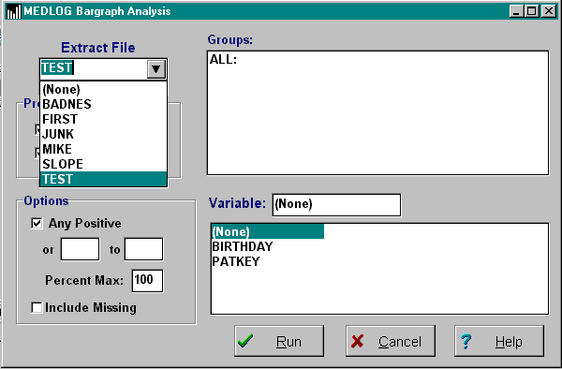
Choose an extract file, then the groups (each group makes a bar in the bargraph)

Choose one or both of the procedures: Plot Bargraph, or Chi-Square.

Choose the variable to display.
{bml 24-01.bmp}

Technical note: The Chi-square test used in BARGRAPH is the same one that is used in CROSSTABS.

Groups
A list of groups in the extraction file is displayed and you are asked to choose the groups to be used in the comparison. You will select groups by holding down the Ctrl key and as you click on the desired groups.

Variable
One variable in the extract file will be used for the test to determine whether an event occurs or not. Choose a variable from the supplied list. It your extract file does not contain the desired variable, go to the EXTRACT program and add that variable first

Options
You must determine what constitutes an event. The choices are:

Any Positive
If the variable has a positive value (a numerical value greater than zero), the event occurred.

Value Range
If you supply a range of values (min and max), any number at the endpoints or in between will be an event.

Normally, the graph will be scaled 0-100 automatically. You can override this action by supplying the percentage scale (0 to max) to use.

Percent Max
Enter a whole number between 1 and 99. In the example shown in Figure 24-2, the
maximum as set to 40.

In calculating the percentages, you can exclude missing values if you wish

Include Missing
Click this box to include in the denominator the total number of records containing the specified variable. You would do this if a missing value were an indicator that an event did not take place.

To exclude missing values from the percentage calculations, leave this box unchecked.

After all of the selections have been made, Click on the Run button to produce the bar graph shown in Figure 24-2, and the chi-square analysis, shown in Figure 24-3.

Bargraph
The bargraph is displayed first. To view the chi-square analysis, scroll down the display.
Figure 24-2. Bargraph output.
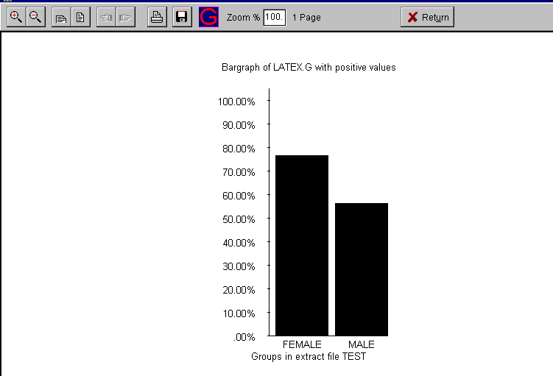
{bml 24-02.bmp}

Chi-square
The chi-square statistics display the number of observations in each group for which the event occurred, the total number of observations, including or excluding missing values, as specified in the "Include Missing Option", and the percentages of event occurrences. Also displayed are the value of the chi-square statistic for the test of equality of percentages, the number of degrees of freedom, (number of groups -1), and the p-value for the test. If only 2 groups are being compared, the test is a corrected chi-square test. If the total number of observations is less than 100, the Fisher exact test is also displayed (see Armitage, Chapter 4, Section 4.8)

Figure 24-3. Bargraph statistical output
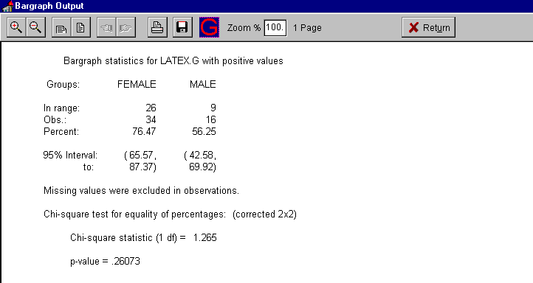
{bml 24-03.bmp}

Note. These tests assume that the groups being compared are mutually exclusive. For example, it would not be valid to form subsets of female patients over 20 years old, over 40 years old, and over 60 years old, and use the chi-square test to test the equality of percentage of patients with congestive heart failure in these 3 groups.
%PageBreak.

#$K Crosstabs (Contingency Tables)

Purpose of CROSSTABS
CROSSTABS constructs cross-classifications of two variables, displays them in contingency table format, and computes tests of association between the variables. The variables can be categorical, or measurement variables with ranges divided into intervals. Instead of two variables, one variable can be tabulated for several different groups; in this case the test is for the equality of distributions of the variable across groups. For certain tables a trend analysis will be performed.

Who should use CROSSTABS
CROSSTABS should be used by anyone who wants to analyze the association between two categorical variables (or measurement variables divided into category variables).

When to use CROSSTABS
You should use CROSSTABS when you want to summarize the relationship between two categorical variables (or measurement variables converted into categorical variables); for example, disease stage by clinical examination vs. stage by pathological examination in breast cancer patients.

You can convert measurement variables (such as blood pressure) into categorical variables by dividing the range into intervals. However, if you want to look at the dependence of a measurement variable on another variable, linear regression (the SCATTER program) may be more useful than contingency table analysis.

Since CROSSTABS obtains data from an extraction file, you must have an existing extraction file or run EXTRACT before using CROSSTABS.

How to use CROSSTABS
Figure 25-1. Crosstabs program
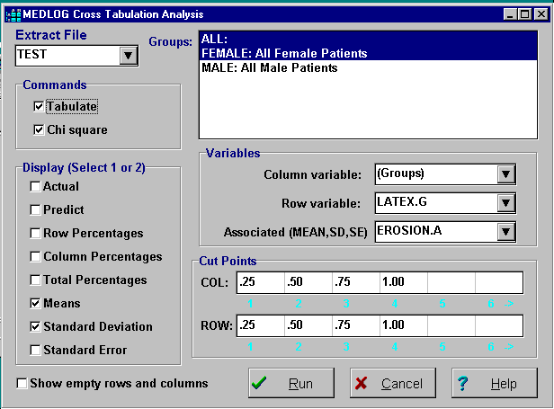
{bml 25-01.bmp}

After an Extract File is selected, CROSSTABS displays the Groups in the extract file. You may then either select a variable for the columns or set the column variable to “(Groups)” and choose two or more groups. Of course, the extract file must have more than one group for the “(Groups)” method to be used. If groups are used for the columns, the composition of the groups should be mutually exclusive. That is, no patients should be represented in more than one group.

Cut points
Cut points may be assigned to rows and columns (unless the columns are groups). Cut points can be values or percentages of the maximum value (e.g., 25%, 50%, or 75%). If, for example, the variable AGE is selected and the cut-points of 28 and 39 are specified, then AGE will be divided into 3 categories: less than 28; between 28 and 39; and over 39. For a date variable, cut-points can be entered in date format. The default cut-points, obtained by pressing the Enter key alone, are the integers 1-19. This is appropriate for most encoded variables.

Display options
Finally you must specify the items of information to be displayed in the cells of the cross-tabulation. The defaults are to display the observed (actual) and the expected (predict) cell counts, but you may choose other options from this list:

- Actual - the observed number of cases in each cell. (default)
- Predict - “expected” cell counts computed under the hypothesis of independence of the row and column classifications
- Row percentages - cell counts as percentages of row totals.
- Column percentages - cell counts as percentages of column totals
- Total Percentages - cell counts as percentages of the total number of cases. Note that the total excludes cases for which the row or column variable is missing.
- Means - the cell means of the recorded values of a variable (name to be specified).
- Standard Deviation - the cell standard deviations of the recorded values of a variable (name to be specified).
- Standard Error - the cell standard error value for the number of recorded observations of a variable - the cell counts of the non-missing values of a variable (name to be specified).
If you specify any of the last three options you must supply the name of a variable for this calculation. It could be the row (or column) variable, or a different variable. The latter option can be useful in exploratory work, by indicating if the variable is associated with one or both of the row and column classifications. For example, if the row and column variables were obesity and age, you might want to look at mean blood pressure in the cells of the table. Note that the legend of selected options is indicated in the top left corner of the table.

When all selections have been entered, click on the Run button.

Figure 25-2. Cross tabulation table
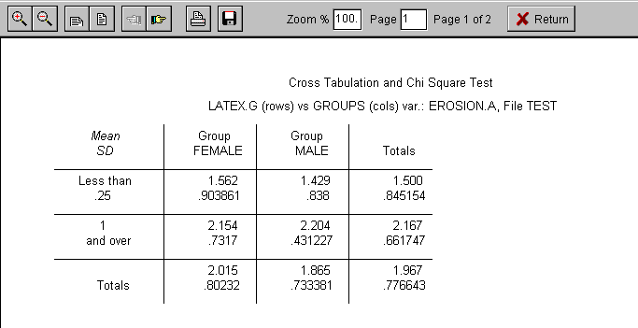
{bml 25-02.bmp}

Note: encoded variables are decoded for row and column; labels are displayed in date format for date type variables; empty rows or columns will not, by default, appear in the display of the table

The chi-square test is an approximation, and may not be reliable if the table is relatively sparse.

CROSSTABS displays the following warning:
Over 20% of cells have expected frequencies less than 5 and/or one or more cells have expected frequencies less than 1. Interpret p-value with caution. Consider pooling row and/or columns.

Test of Association
To view the results of the test of association between row and column variables, Figure 25-3, scroll down the page. This test is a chi-square test corrected for continuity in the case of a 2 x 2 table. In the case of a 2 x 2 table with fewer than 100 observations, the Fisher exact test is also displayed. For 2xn or nx2 tabulations where n > 2 tables, a trend analysis statistic is also computed.

Figure 25-3. Chi-square test of association
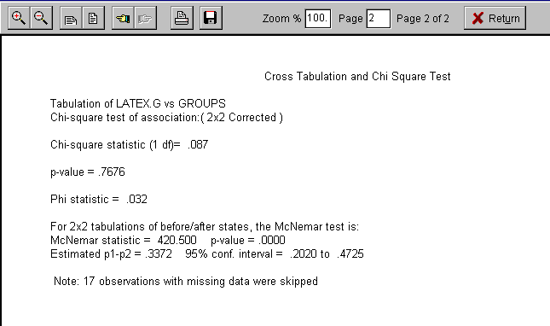
{bml 25-03.bmp}

The statistics shown in Figure 25-3 will help you interpret the cross tabulation. The chi-square value and degrees of freedom are used to compute the p-value. The p-value is the probability that there is no dependence between the row and column variables.

The Phi statistic (for 2x2 tables) or the Cramer's V statistic is a measure of the amount of dependence (or interaction) between the row and column variables. It ranges from 0.0 (no dependence) to 1.0 (total dependence). It can help you compare different tabulations.

If your data represents a breakdown of a time variable (such as year of diagnosis, age first seen, etc.) with a variable having two categories, the trend analysis will help you measure the effect of the trend (S statistic) and its associated p-value. The S statistic has a range of -1 to +1 with positive values denoting an increasing trend.
%PageBreak.

#$K Correlation Analysis

Purpose of CORRELATE
CORRELATE computes product-moment correlation coefficients between pairs of variables, and t-tests of the hypothesis that a true correlation is zero. For an explanation of correlation analysis, see Armitage, or Snedecor and Cochran.

Who should use CORRELATE
CORRELATE should be used to assess the existence and closeness of linear relationships between pairs of variables.

When to use CORRELATE
Use CORRELATE to compute measures of the closeness to a straight line of relationships between pairs of quantitative variables, and/or significance tests of the existence of a linear relationship. In general, linear regression analysis (the SCATTER program) provides more information about a linear relationship between two variables than does the correlation coefficient. Note that interpreting the value of a correlation coefficient is difficult if the patient group involved was selected on the basis of the values of one of the variables being analyzed (see Armitage⁴). If the variables are categorical rather than quantitative, a more appropriate test is found in the NONPAR , Chapter 31. Since CORRELATE obtains data from an extraction file, EXTRACT must be run before using CORRELATE.

How to use CORRELATE
Figure 26-1. Correlation analysis program
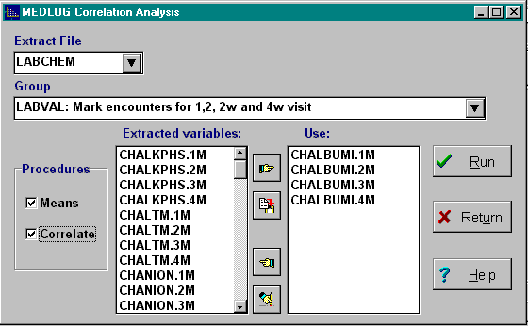
First choose an extract file.

Then, select a group.

Then, choose between 2 and 20 variables.
{bml 26-01.bmp}

Procedures

Means
This option will list the means standard deviation, skew and kurtosis of the data which your are correlating.
Figure 26-2. Correlation (Means)
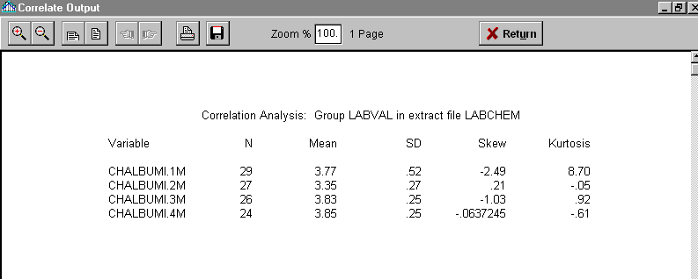
{bml 26-02.bmp}

Correlate
This will produce a correlation matrix in upper triangular form If Means is also checked, it will appear first at the top of the screen. Scroll down the screen to display the correlation matrix

If the number of variables requires more than a single screen width for the display, matrix is displayed on several pages.

Figure 26-3. Correlation matrix
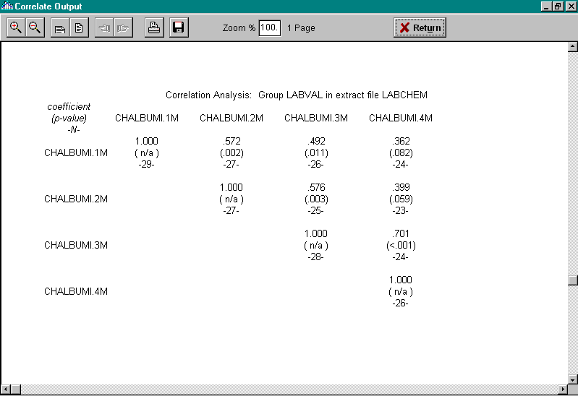
{bml 26-03.bmp}

For each pair of variables, a column of three numbers is displayed on three rows.
- The first number is the sample correlation coefficient.
- The second (in parentheses) is the p-value for the t-test that the true correlation is zero.
- The third is the number of pairs of values used to compute the correlation. It excludes any pairs of values for which either value of the pair is missing. The t-test for zero correlation is equivalent to the test that the slope coefficient is zero in linear regression analysis3.

The correlation for a particular pair of variables is computed only from the non-missing value pairs for the two variables.

Restrictions:
- A correlation coefficient cannot be computed for a pair of variables unless each variable has at least 2 distinct, non-missing values.
- A p-value cannot be computed unless there are at least 3 non-missing value pairs and the computed correlation coefficient is not equal to 1 or -1.
- Quantities that cannot be computed are indicated by n/a (not available).

Technical note
The correlation coefficients obtained from CORRELATION are identical to those obtainable from the SCATTER program. The coefficients are known as Person correlation coefficient and the Product-Moment Coefficient. A correlation of 1.0 is a perfect positive relationship and -1.0 is a perfect inverse relationship. Values greater than .5 (either positive or negative) indicate a very strong linear relationship. The graphical output of SCATTER allows the examination of the relationship between two variables in more detail.
%PageBreak.

#$K Frequency Distributions

Purpose of FREQUENCY
FREQUENCY computes frequency distributions and relative frequency distributions of a selected variable in up to 4 groups. It displays histograms of these distributions, and the frequency counts and percentages in the class intervals. FREQUENCY also displays plots and listings of the cumulative counts and percentages.

Who should use FREQUENCY
FREQUENCY should be used by anyone who wants a graphical display of the distribution of a variable in one or more groups.

When to use Frequency
Use FREQUENCY to visually compare the observed distribution of a variable in several groups (or look at the distribution in a single group). Since FREQUENCY obtains data from the extraction file, EXTRACT must be run before using FREQUENCY.

How to use FREQUENCY
Figure 27-1. Frequency distributions
Choose an extract file from the drop down list.

Then select one more groups. A maximum of four groups is allowed.

A single variable must be selected from the list.
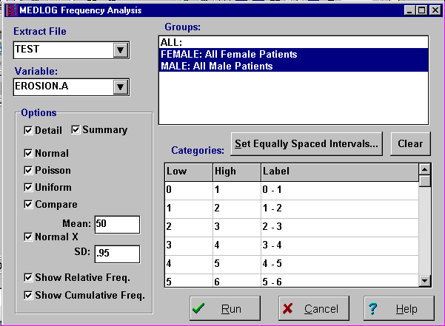
{bml 27-01.bmp}

Recommendation: Use Frequency for variables with more than two possible values. For a variable with only two values, Bargraph is a more appropriate program.

Editing the Frequency Table
The default display setting is “Set Equally Spaced Intervals”. See Figure 27-3 to see what the analysis will look like using the default setting.
Figure 27-2. Edit frequency table
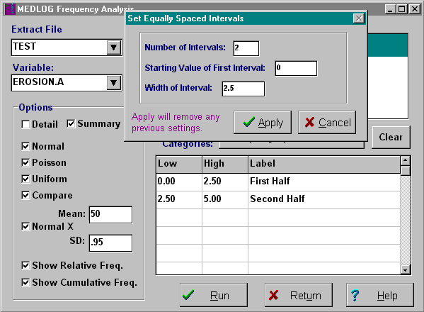
If you want to change the intervals and want to use equally spaced intervals, click on the Set Equally Spaced Intervals button..

Also, note that the labels can be modified by replacing the numeric labels with text.
{bml 27-02.bmp}

You can customize the display by replacing the values in the dialog box.
LOW: the low value of the frequency category to be displayed.
HIGH: the high value of the frequency category to be displayed.
LABEL: the label for the variable frequency category.

To divide the frequency table into a different number of categories, edit the frequency table to have unequal intervals A maximum of 50 intervals may be specified.

Intervals do not have to follow any numeric order; e.g., the largest numbers can belong to the first interval. Overlapping intervals are permitted, but a warning message will be displayed. An observation will be displayed and will be assigned to the first interval to which it can belong.

Figure 27-3 on the next page illustrates the default output, prior to editing the intervals.

Figure 27-3. Frequency table, lines 1-24.
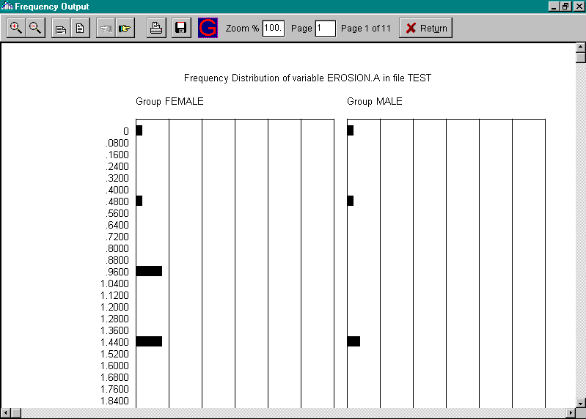
{bml 27-03.bmp}

In Figures 27-4 and 27-5, the number of intervals has been reduced to two and character labels have replaced the numeric labels.
Figure 27-4. Edited frequency table
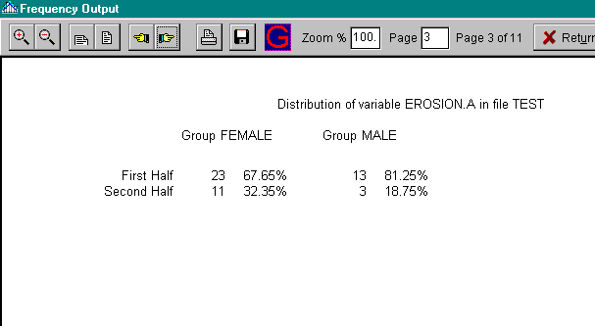
{bml 27-04.bmp}

Figure 27-5. Edited Frequency Table (graphic)
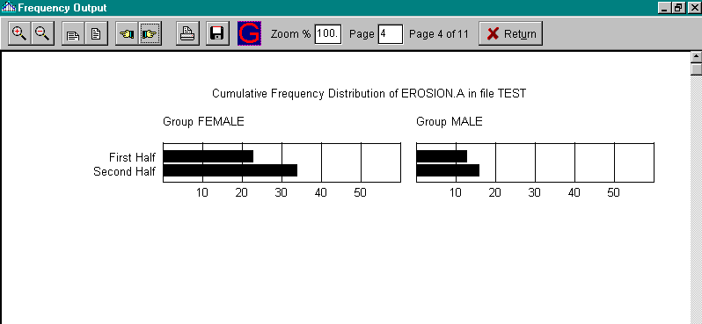
{bml 27-05.bmp}

Options

The options available for processing Frequencies can be selected individually or all at the same time. The options fall into three output categories, Distribution, Test, and Frequency output.

Display:
- Detail - complete breakdown of unique values in a single group. If more than one group is selected, only the first will be displayed.
- Summary - Absolute, relative and cumulative distributions of 1 to 4 groups.
Tests:
- Normal - compare the distribution to a normal curve
- Poisson - compare the distribution to a Poisson distribution
- Uniform - compare the distribution to a uniform(random) distribution
- Compare - Use K-S to compare 2 group distributions for (shape) equality
- Normal X - compare the distribution to a given (mean, sd) normal distribution
Frequency:
- Relative - relative frequency distribution,
- Cumulative

Test for normal distribution in a Group
Figure 27-6. Test for normal distribution
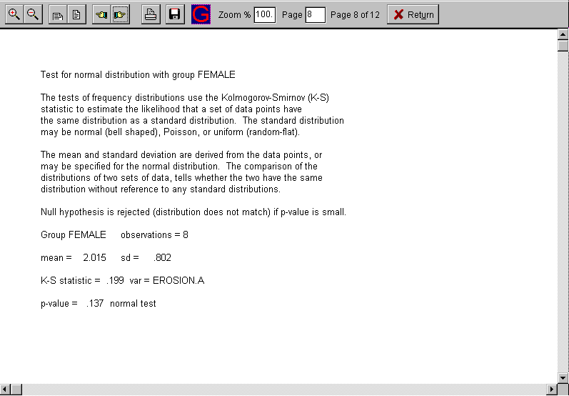
{bml 27-06.bmp}

%PageBreak.

#$K Means (Descriptive Statistics)

Purpose of MEANS
MEANS computes arithmetic means, standard deviations, minimums and maximums, t-tests, and one-way analysis of variance.

Who should use MEANS
MEANS should be used by anyone who wants to compute basic descriptive statistics and hypothesis tests on means.

When to use MEANS
Use MEANS to compare the means of a variable:
in two or more groups,
to test whether a mean is equal to zero, or
to compute the descriptive statistics of means, standard deviations, etc.
If data is categorical or does not otherwise fit the assumptions of a normal distribution, consider using the NONPAR program for the comparison of group means.

Since MEANS obtains data from an extraction file, there must be an existing EXTRACT file or one must be created.

How to use MEANS
After the extract file, groups, and variables have been selected, at least one procedure must be selected. The selection will depend on whether only one, two, or more than two groups have been selected. Some analysis options only apply to comparing more than two groups (e.g. 1 way analysis of variance) and/or two groups.

Figure 28-1. Means Analysis
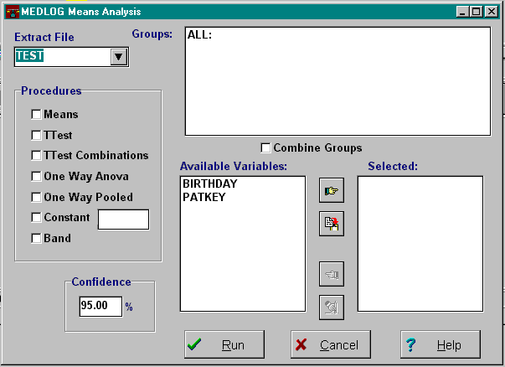
{bml 28-01.bmp}

Procedures:

Means
Can be run with one or more groups. It displays SD, SE, etc. only.

This is the simplest option since the information received will be included in the output from any of the other options. The display will show the number of recorded values (N), the mean value, the standard deviation (S.D.), standard error of the mean (S.E.), the minimum value, the maximum value, and the number of missing values (?) and missing-tracking values (!).
Figure 28-2. Means Analysis
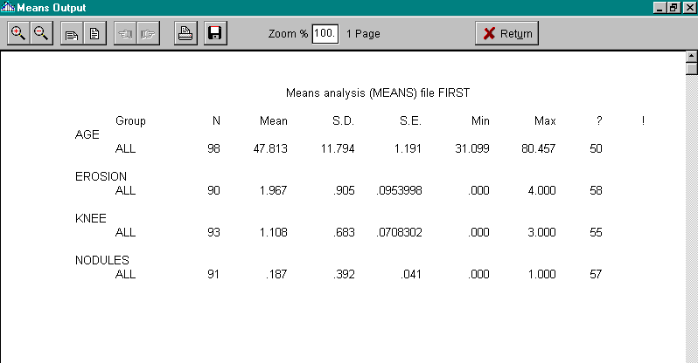
{bml 28-02.bmp}

T tests
Must be run with two or more groups
Performs on every pair of groups using pooled variance of pairs (3 on more groups)

In this test, each pair of groups will have the t-test applied. Only data from the pair of groups being compared will be used in the t-test calculations. This will yield p-values that will agree with those calculated when only two groups were chosen initially.
Figure 28-3. T-Test
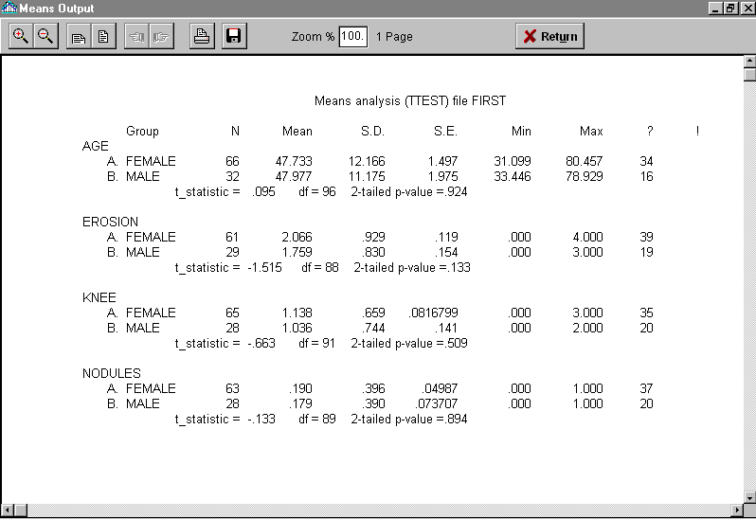
{bml 28-03.bmp}

T-test combination
Must be run with three or more groups.
Compares group means (2 groups only)

This is the classic test for the equality of means for two groups that are assumed to be normally distributed and have the same variance. In fact, this test works quite well under conditions less than ideal. For more information on the appropriateness of the t-test see Armitage, chapter 7, section 7.3 and Miller, chapter 2.

One Way Anova
Must be run with three or more groups.

The analysis of variance provides a test of the equality of the means of a variable in the selected groups (see Armitage, chapter 7). Note that this procedure assumes that the groups being compared are mutually exclusive. For example, it would not be valid to form subsets of female patients over 20 years old, over 40 years old, and over 60 years old, and test the equality of mean blood pressure in those three groups.

One Way Anova pooled
Must be run with three or more groups.
Pair-wise t-tests pooling all variances.

The pair wise t-test is based on the assumption that the variances are equal in the 2 groups. (Note that the variance estimate used is the pooled estimate computed in the 1-way analysis of variance.) If equality of variances is not a reasonable assumption, then another approach is indicated. See Armitage, chapter 4, section 4.6, for a discussion of alternative testing methods.

Constant
Can be run with one more groups. T-tests comparing each mean to a constant

In this test, the group mean is compared to a constant (usually 0). The usual application of such a test is to analyze pairs of observations in the same patients. Suppose you have two blood pressure measurements on each patient in a group, taken before and after a certain drug treatment. To test whether the drug therapy changes mean blood pressure, you can use TRANSFORM to define a new variable. The difference between the pre- and post-treatment blood pressure readings is used by MEANS to test whether the mean of the new variable is equal to zero (see Armitage, chapter 4, section 4.6 - “aired Case”).

Band
Can be run with one or more groups. If the Band option is NOT selected for use with any of the other procedure, the corresponding reports will provide only the Standard Error of the Mean (S.E.).

If the Band option is selected, the analysis reports will provide a Standard Error of the Mean and a Confidence Interval level. The Confidence Interval level is based on the percentage level entered in the Confidence data input box. See figure 28-4.

Figure 28-4. Band (Confidence intervals)
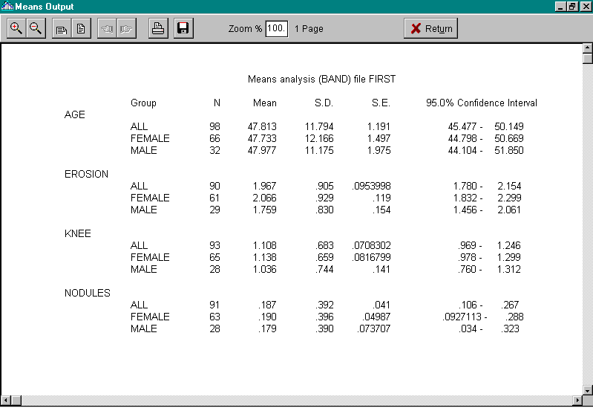
{bml 28-04.bmp}

Definitions:
Column heading Explanation
Group The identifying name of the group. (“Combined” refers to all the displayed groups combined.)
N The number of non-missing variable values for the group.
Mean The arithmetic average of the non-missing variable values.
S.D. The standard deviation of the non-missing variable values.
S.E. The “standard error” of the mean
Min The minimum of the non-missing variable values.
Max The maximum of the non-missing variable values.
? The number of missing variable values. See figure 28.3.
! The number of missing-tracking values (included in ? too) See fig. 28.3.

Other items
F-statistic The value of the F-statistic
df Degrees of freedom (between, within)
p-value p-value of the F-test
MS between Mean squares between groups
MS within Mean squares within groups (the pooled estimate of variance)
%PageBreak.

#$K Scatter (Plotting and Regression)

Purpose of SCATTER
SCATTER is a linear regression program for one independent variable. It provides scatter plots, the usual regression statistics, plots of residuals, and confidence intervals for predicted values. See Armitage, chapter 5, for information on the rationale and uses of linear regression analysis.

Who should use SCATTER
SCATTER should be used by anyone who wants to produce scatter plots and regression analyses.

When to use SCATTER
Linear regression is used to examine the relationship between two quantitative variables, when the relationship is thought to be approximately linear. You should look at the scatter plot to see if the linearity assumption seems reasonable. If it does not, it may be possible to apply a transformation to one or both variables to make the relation more linear (see chapter 11 of Armitage). Another possibility is to try polynomial regression (see Armitage, chapter 10, section 10.3). The LINREG program in the advanced regression option can be used for this.

Since SCATTER obtains data from an extraction file, you must have an existing extraction file or run EXTRACT before using SCATTER.

How to use SCATTER
Figure 29-1. Scatter program
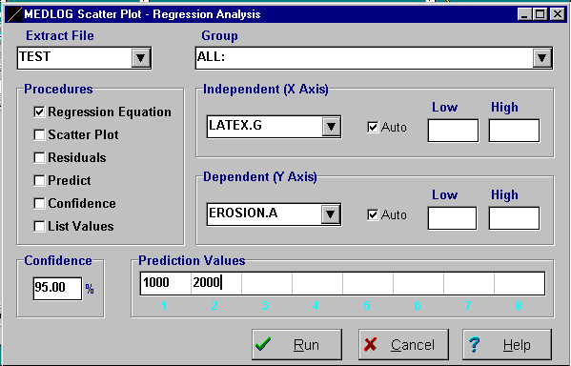
{bml 29-01.bmp}

Extract file and Group
After an extract file is chosen, a list of the groups will be displayed. Choose one group.

Axes
An Independent (X Axis) variable and a Dependent (Y Axis) variable must be selected.

Scale
If you choose the Auto option, SCATTER will use the minimum and maximum values of the dependent and independent variables to calculate axis scales that will allow all the data to be plotted.

If Auto is not selected, you must supply the Low and High ranges of values to be shown on the axis. Note that some data points may not be shown on the plot if you specify your own axes.

When data points are displayed, a number indicated how many observations fall at that location. If only one data point falls at a particular position on the screen (within the resolution determined by the screen rows and columns), it is denoted by the digit “1”. If two or more data points fall at the same screen position, the number of points is indicated by digits 2 through 9 or letters A through Z. The letter A denotes 10 points, B denotes 11, and so forth, Z denotes 35, and finally an asterisk (*) denotes more than 35 points.

When the plot is displayed, a high resolution graphics plot may be generated by clicking on the “G” icon. The high resolution plot may be manipulated as described in the GRAPHICS program chapter.

Confidence
Enter the mathematical confidence level that you want used in the regression analysis. The level may be set between 75 and 99.9.

Prediction Values
This is a tabulation of predicted values which will be computed from the values of the independent variable which you supply. Up to 8 values may be supplied for a given run.

Note that in the linear regression model, Y = a + bX, Y is referred to as the dependent variable and Y as the independent variable. On a scatter plot, the dependent variable is shown on the vertical axis and the independent variable on the horizontal axis

Once the selections are complete, it's usually a good idea to look at the plot before examining the regression analysis calculations. The Scatter Plot gives you a visual idea of the relationship between the variables, and might suggest that a transformation of one or both variables is desirable.

Procedures
Figure 29-2. Regression equation
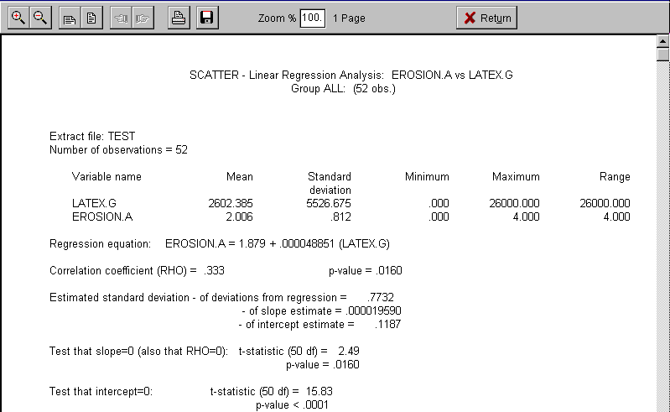
{bml 29-02.bmp}

Note that the first item on the screen, the number of observations, excludes any cases for which the value of either the dependent or the independent variable is missing. The important items to examine on this screen are the regression equation, the correlation coefficient and the p-value for slope=0.

Scatter Plot
Plots the occurrences of the values and produces a best fit (least squares) line.
Figure 29-3. Scatter Plot
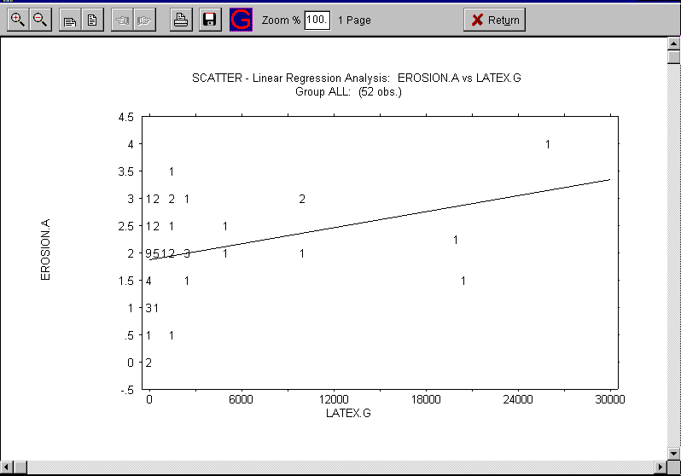
{bml 29-03.bmp}

Plot residuals against X
This option produces a plot of the residuals, Y - (a + bX), against the independent variable, X. Residual plots are useful for highlighting non-linearity of the relationship, and dependence of the variance of Y on the value of X.
Figure 29-4. Residuals
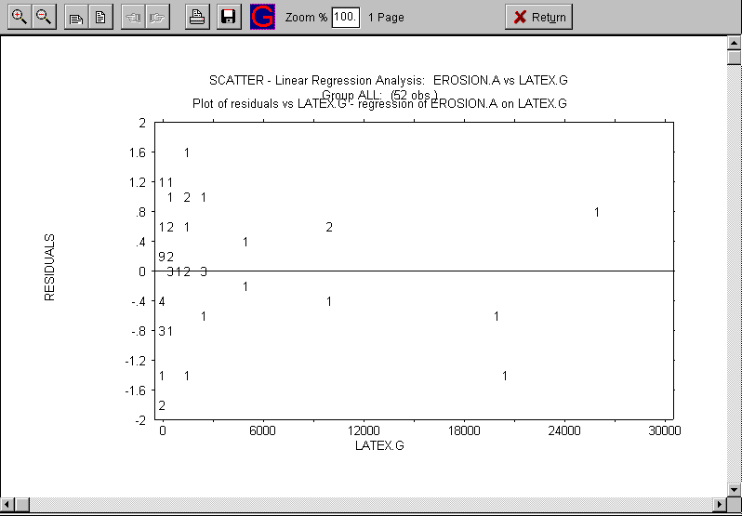
{bml 29-04.bmp}

Predict

This option calculates predicted values of Y for particular values of X, according to the estimated regression equation, Y = a + bX. It also calculates confidence intervals for the predicted mean value of Y and for an individual value of Y for a given value of X (see Armitage, chapter 4).

You can enter up to 8 values of X for which you want predicted values and confidence intervals. Then you must specify the percent confidence coefficient (a number between 75 and 99.9) for the confidence intervals. A common choice is 95.

Figure 29-5 shows an example of the display of predicted values and confidence intervals
Figure 29-5. Predict
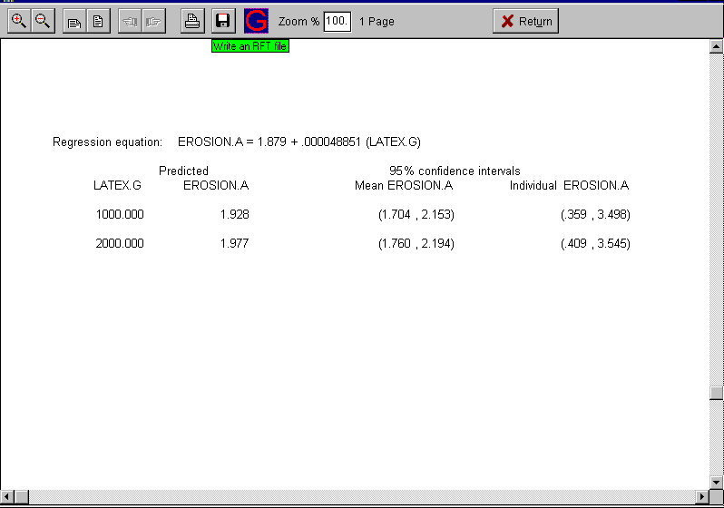
{bml 29-05.bmp}

Confidence
This display lists the variable intervals and the calculated confidence bands.
Figure 29-6. Confidence level
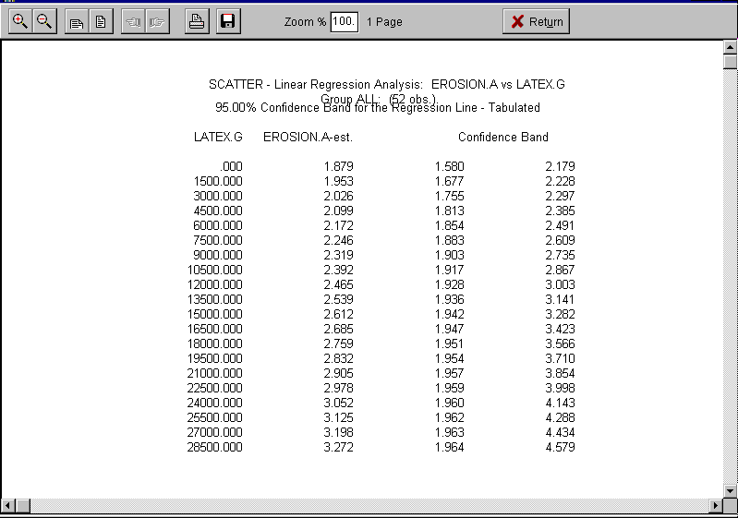
{bml 29-06.bmp}

List
This option produces a list of the X and Y values used to compute the estimated regression equation, Y = a + bX, and for each X value shows the “predicted” Y value. The predicted Y value for a particular value of X is just the quantity a + bX, where a and b are the estimated intercept and slope respectively. Also displayed are the residuals, which are the differences between the actual and predicted values of Y; that is, Y - (a + bX.
%PageBreak.

#$K Survive (Kaplan-Meyer & Life Tables)

Purpose of SURVIVE
SURVIVE computes Kaplan-Meier estimates of survival curves for censored data, and performs hypothesis tests of the equality of two survival curves. It provides a method for analyzing times to an event such as death or relapse, in situations where the data for some patients are censored - that is, observation ends before the event has occurred.

SURVIVE also produces life tables that present survival data in interval steps.

Who should use SURVIVE
SURVIVE should be used by anyone analyzing censored survival data.

When to use SURVIVE
When you have data available on time to an event (such as death) from some starting point (such as disease onset), an analysis of these times is more sensitive than simply examining the proportions of deaths in one or more groups. Also, incomplete (censored) observations can be taken into account with survival analysis techniques. The validity of these survival analysis methods rests on two assumptions:

- Censored patients have the same chance of survival after the time of censoring as non-censored patients. This may not be the case, for example, for patients lost to follow-up because of illness.

- Survival probabilities are reasonably constant for patients entering the study at different calendar times. This would not be the case if advances in therapy had improved chances of survival over the course of patient intake.

Before using SURVIVE, you must extract the data required for the analysis--see chapter 22. You must extract values of a variable representing the event, and the values of 1 or 2 variables representing the time to the event or time to censoring. This is discussed in an example at the end of this chapter.

How to use SURVIVE
The Extract File selected determines the variables available for analysis. In survival analysis literature, the endpoint event is often referred to generically as “death”, but it might in fact be something other than death relapse, heart attack, treatment failure, etc.

The Groups available in the extract file are displayed in the dialog box. If you plan to use the Mantel-Haenszel analysis, you must select two groups. The Kaplan-Meier procedure requires at least one group but can use two groups.
Figure 30-1. Survive program
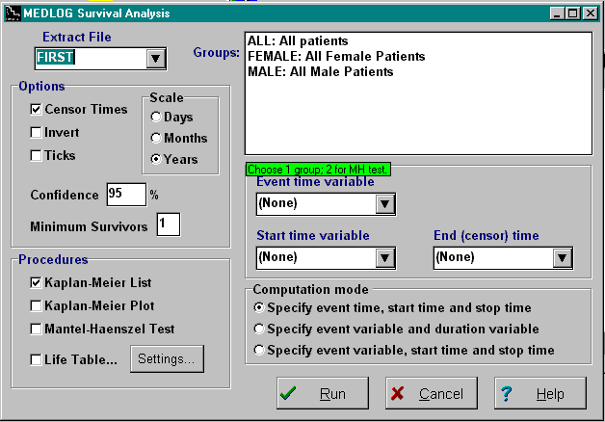
{bml 30-01.bmp}

You must select an Event time variable representing occurrence of the event. The event can be represented by a single value or a range of values. Depending on the computation mode chosen, you will also specify variables for the start and end times, or a variable for duration.

The computation of the survival probabilities and standard deviations, and of the log-rank (Mantel-Haenszel) test for equality of survival curves, is explained in Friedman, Furberg, and DeMets. See also Armitage

OPTIONS

Censor Times
Show censored times in the Kaplan-Meier listing. When this option is selected, events that may have taken place past the censor time are indicated.

Invert
The usual survival plot expresses the probability of surviving at various elapsed times. Another way to view the same data is to express the probability of the event (death occurring). This probability is: pfailure = 1 - psurvival. The graph will begin at zero and work upward.

Ticks
This will cause tick marks will appear on the graphics plot of the survival curve. The tics represent censored data.

Scale
You may choose “D” for days, “M” for months or “Y” for years. If your survival time is derived from the difference of two date variables, the calculation is adjusted to reflect your choice of time scale. If you have supplied a single variable, SURVIVE will assume that it is already scaled correctly. In this case the setting only affects the plot labeling.

Confidence
If set to a value between 75 and 99, a dotted line will appear above and below the survival curve to indicate the confidence interval.

Minimum Survivors
The plot line of the survival probability will stop when this number of surviving
patients is reached. The default is 0.

Procedures

Kaplan-Meier List
Figure 30-2. Kaplan-Meier Survival List (if more than 1 group, only the first is listed).
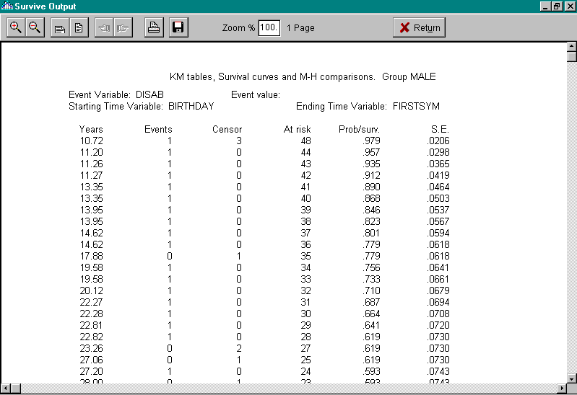
{bml 30-02.bmp}

Kaplan-Meier Plot
The plot will display up to eight survival curves (groups) in a single plot. The curves are distinguished by color or line style and a legend is shown.
Figure 30-3. Survival Plot, 2 Groups
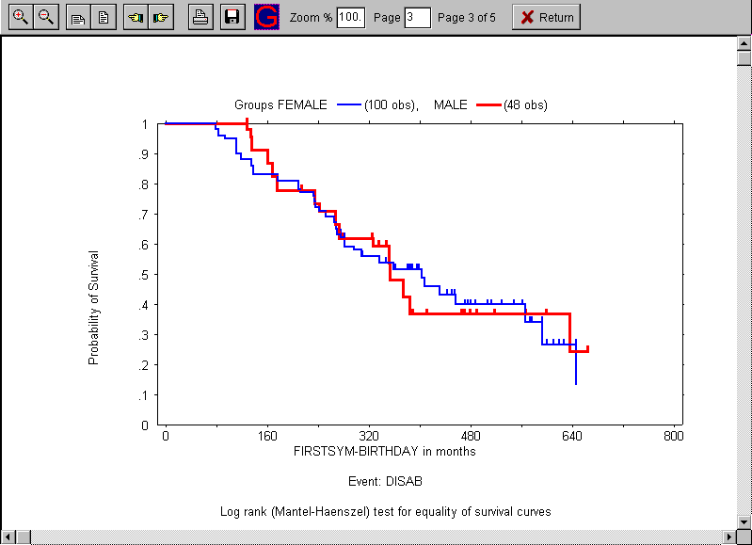
{bml 30-03.bmp}
Note: One of the options is the provision for Ticks on the graph to indicate the censoring times. The ticks can be seen on the plot above as small vertical marks on the line.

Mantel-Haenszel Test
When you use this procedure, SURVIVE requires that you to choose two groups to compare. The procedure performs a log-rank test for the equality of the two survival curves as shown in Figure 30-4.

The display of observed and expected number of events in the two groups is calculated under the hypothesis of equality of the true survival curves. The divergence of the observed and expected numbers of events gives an indication of how closely the data agree with that hypothesis.

Note: The number of events may be less than the sum of the events in the two groups being compared. This is because the log-rank test will discard events in one group which occur later than the last time point in the other group. In other words, the follow-up period of both groups must be the same.

Figure 30-4. Mantel-Haenzel Log Rank Test
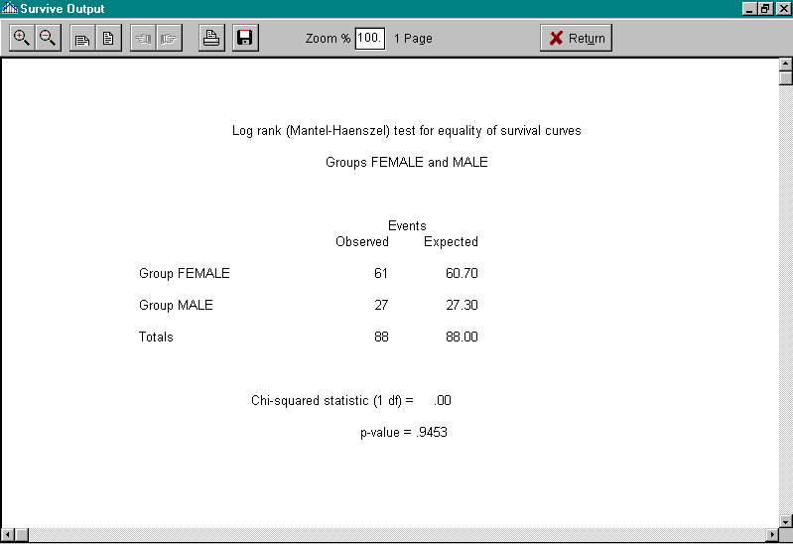
{bml 30-04.bmp}

Life Table analysis
This method of looking at survival data summarizes the survival time in intervals that you specify. This type of display, shown in figure 30-5 may be useful for standard reports or comparisons with existing tables.

The first thing you must decide is the number of intervals to use in the life table. The like table specifications are set by clicking on the Life Table Settings icon (See figure 30-1). A maximum of 21 time intervals is allowed. Reports requiring a larger number of intervals can be produced by running SURVIVE a second time with different intervals. The intervals do not need to be the same width and they may contain gaps, but this would be unusual. Initially, they can also be set up with equidistant intervals. The program menu provides for these options.

Life Table Settings
Figure 30-5. Life Table Settings
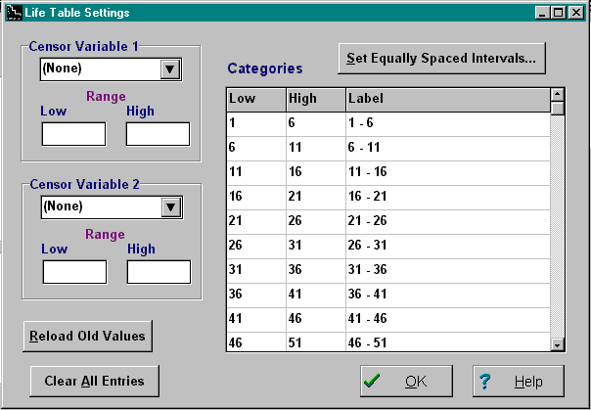

{bml 30-05.bmp}

The life table can divide censored data into one, two or three types:

The first category of censoring, withdrawal for time, is automatic. These are the patients who are still being followed in the study.

You can specify 2 other variables that indicate other reasons for withdrawal. Such reasons might be unrelated death or lost to follow-up due to patient moving. The survival statistics are not affected by specifying the optional withdrawal variables.

The last step in the production of a life table is to choose the group for the analysis. The output is shown in Figure 30-6. The last column is the standard error of the cumulative survival rate. Adding and subtracting twice this amount to the cumulative survival rate will give the 95% confidence interval.
Figure 30-6. Life Table analysis, page 1
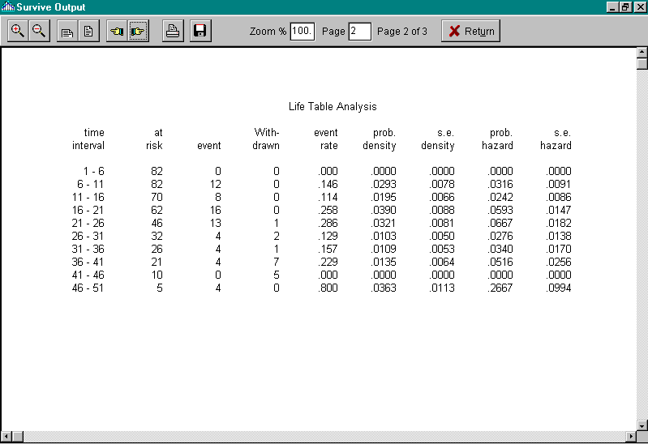
{bml 30-07.bmp}

The life table output also includes a second and third page (not shown) which is a summary of the events and censoring. If you run the life table portion of SURVIVE a second time without returning to the main menu, you will see that the intervals are remembered, and you have a chance to change them if you wish.

Application
A typical application of SURVIVE requires the proper use of the GROUP and EXTRACT programs. The GROUP program can identify the patients and the encounters when the event occurs or does not occur; the EXTRACT program finds the first date, last date and date of event.

Here is a simple example:

The variable health represents the health status of a patient and health=3 indicates relapse. We are considering survival time to be the interval from the first encounter to the relapse encounter, or last encounter if no relapse occurred.

In this case, the group program is only used to identify the patients to plot. This could be group ALL, which already exists. The EXTRACT program is used make one observation for each patient in the group. The variables will be: health.#V3, DATE.X, DATE.1 and DATE.L.

The variable health.#V3 is only used to identify the encounter where health first has the value 3. The next variable, DATE.X is the date from this encounter (it will be missing if a patient never had a HEALTh value of 3). The remaining variables are the dates of the first encounter and last encounter, respectively.

In the SURVIVE program, choose the first computational mode (event time, start time, stop time). The variable selections will be: event time =DATE.X; start time =DATE.1; and stop time =DATE.L.
%PageBreak.

#$K Non-Parametric Statistics (NonPar)

Purpose of NONPAR
NONPAR computes medians, percentiles, and a variety of non-parametric statistics, including the sign, signed rank, Wilcoxon, and Kruskal-Wallis tests, Kendall's tau, and Spearman's rho. See Armitage, chapter 13, and Hollander and Wolfe for explanations of these methods.

Who should use NONPAR
NONPAR should be used by anyone who wants to compute medians and percentiles, or to use the non-parametric counterparts of t-tests, analysis of variance, or correlation analysis.

When to use NONPAR
Use NONPAR when you want to compare the mean of a variable across two or more groups, to test whether a mean is equal to zero, or to examine the relationship between two variables, and you don't want to use the standard parametric (“normal theory”) procedures, such as the t-test. Although normal theory procedures are reasonably reliable if the distributions of the variables are not markedly non-normal, non-parametric methods may be preferable if there is obvious non-normality (distant outliners, for example), or if the sample sizes are quite small and little is known about the distributions. Non-parametric methods are also relevant if the observations are based on rankings rather than measurements (ratings of disease severity, for example).

Non-parametric methods avoid the assumption of a particular distribution form, such as the normal, but they are not assumption-free. For example, in testing for the equality of two means, the Wilcoxon test assumes that the two distributions are the same under the null hypothesis; that assumption is obviously violated by inequality of variances. Another assumption is that the distributions being analyzed are continuous rather than discrete, so that theoretically ties cannot occur. In practice, these methods are usually reliable if there are ties in the data, but if the possible values for the data are very limited the number of ties is likely to be substantial, and another approach may be preferable (see Snedecor and Cochran, page 132).

Since NONPAR obtains data from an extraction file, you must have an extraction file or run EXTRACT before using NONPAR

How to use NONPAR (Non-parametric)
Figure 31-1. Non Parametric Analysis
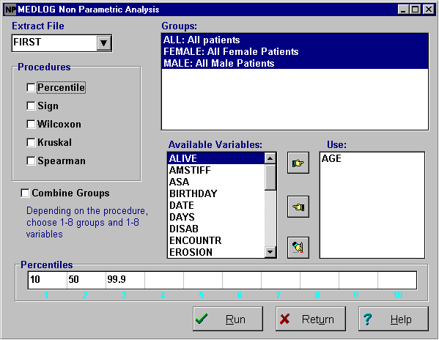
First, choose an extract file

Depending on the procedures you want to run, you must choose several variables or several groups.
{bml 31-01.bmp}

Procedures
The p-values displayed for hypothesis tests are in most cases “large-sample” approximations (the exception is the sign test, for which exact p-values are computed for samples of less than 40 observations). Though these approximations are usually adequate, you may want to refer to tables, such as those in Hollander and Moore, to get p-values for small samples. In some cases NONPAR does not give p-values for very small samples because the approximation is not considered reliable; in such cases you should get a p-value from a table.

Since NONPAR holds data in memory for analysis computations, there are limits on the number of observations that can be handled. For percentiles, the sign and signed rank tests, and the Wilcoxon test, the limit is 12,500 non-missing observations in total for all groups and variables. For the Kruskal-Wallis test, the limit is 10,000 non-missing observations for a single variable across all groups. For correlation, the limit is 5,000 non-missing observations for each pair of variables in a single group. A message is displayed if any of these limits is reached.

If there are too few observations to allow computation of a particular analysis, NONPAR will display “n/a” instead of the statistic in question, or will display an appropriate message.

Percentiles
This option gives you minimums, medians, maximums, and other percentiles for the currently selected groups and variables. (The meaning of the term percentile is explained below.) NONPAR first prompts you to enter a list of percentages. Each percentage must be a number between 0 and 100 inclusive, and may contain a decimal part (for example, 33.3). You can enter up to ten percentages, separated by commas or spaces.

NONPAR presents the percentiles in a tabular format, one variable at a time. The table for a particular variable has one row for each requested percentile and one column for each group. Note that “minimum” is the zero percentile, “median” is the 50th percentile, and “maximum” is the 100th percentile.

The following example illustrates the meaning of percentiles. If the 25th percentile of ages in a population is 17.631 years, then 25% of all ages are less than that number, and 75 percent of ages are greater.
In a sample data set we often can't find a number that divides the data in the required proportions, we use the following definition of percentiles. Let X1, X2, . . . , Xn be the ordered observations from smallest to largest. Then by definition the percentile corresponding to the percentage
P(I) = 100*(i - .5)/n Sum(X1)

For example, suppose there are 20 ordered observations, of which the 5th is 18 and the 6th is 23. Then
P5 = 100(5 - .5)/20 = 22.5%
P6 = 100(6 - .5)/20 = 27.5%
Thus the 22.5 percentile is 18 and the 27.5 percentile is 23. Percentiles for percentages between those corresponding to the observations are found by linear interpolation. To get the 25th percentile in our example data, we note that 25 is midway between 22.5 and 27.5, so the required percentile is midway between 18 and 23, namely 20.5. A percentile for a percentage less than that corresponding to X1, the smallest observation, is by definition set equal to X1 (a conservative extrapolation). In particular, the zero percentile is always the minimum value in the data set. Similarly, percentiles for percentages greater than that corresponding to Xn, the largest observation, are set equal to Xn, so the 100th percentile is always the maximum value in the data set.
Figure 31-2. Percentiles
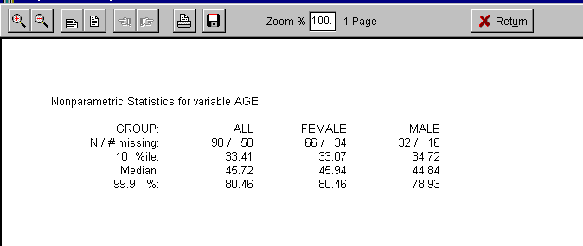
{bml 31-02.bmp}

Sign
The sign test and signed rank test procedure is used to test whether the distribution of a specified variable is symmetric about zero (which implies that the mean and median are zero). To test the null hypothesis, NONPAR computes the sign test and the Wilcoxon signed rank test. These non-parametric tests are analogous to the parametric one-sample t-test (see chapter 28, the MEANS program

Figure 31-3. Sign test and sign rank test
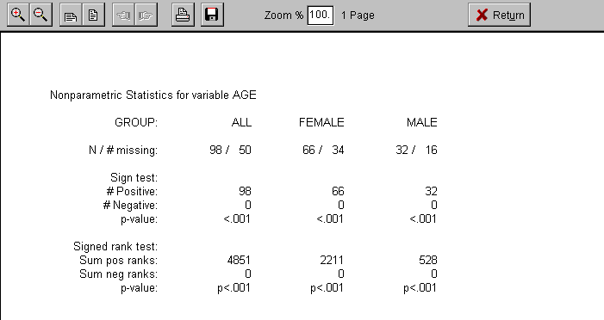
{bml 31-03.bmp}

The usual application of these tests is to compare pairs of measurements in the same patients. Suppose you have two weight measurements on each patient in a group, taken before and after a weight reduction therapy. To test the efficacy of the therapy, you could use transform feature of EXTRACT to compute a new variable WT_CHANGE as the difference between the pre- and post-treatment weights, and then use NONPAR to test whether the mean of the new variable is equal to zero.

Wilcoxon
This procedure is used to test whether the distribution of a specified variable in one group is the same as its distribution in another group (which implies that the means (and medians) of the two distributions are equal). NONPAR computes the Wilcoxon test (also called the Mann-Whitney U test) for each selected variable and each pair of selected groups. The Wilcoxon test is analogous to the parametric two-sample t-test (see chapter 28, the MEANS program).

Figure 31-4. Wilcoxon test
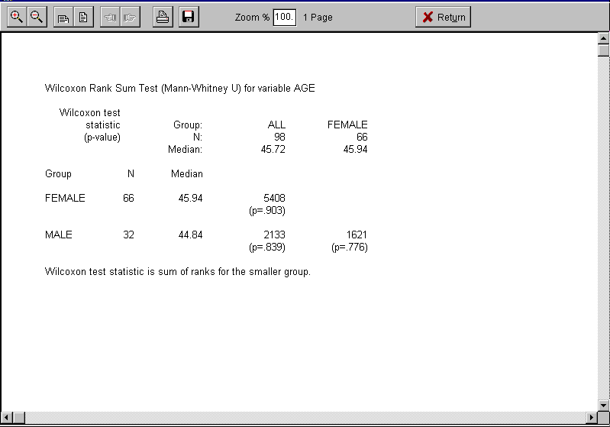
{bml 31-04.bmp}

Kruskal-Wallis
The Kruskal-Wallis test is the non-parametric counterpart of the F-test in one-way analysis of variance (see chapter 28 --- MEANS program). The procedure tests the hypothesis that the distributions of a selected variable are the same in all the selected groups, which implies that the means (and medians) are equal in all groups. If only two groups are currently selected, the Kruskal-Wallis test is equivalent to the Wilcoxon.

Figure 31-5. Kruskal-Wallis test
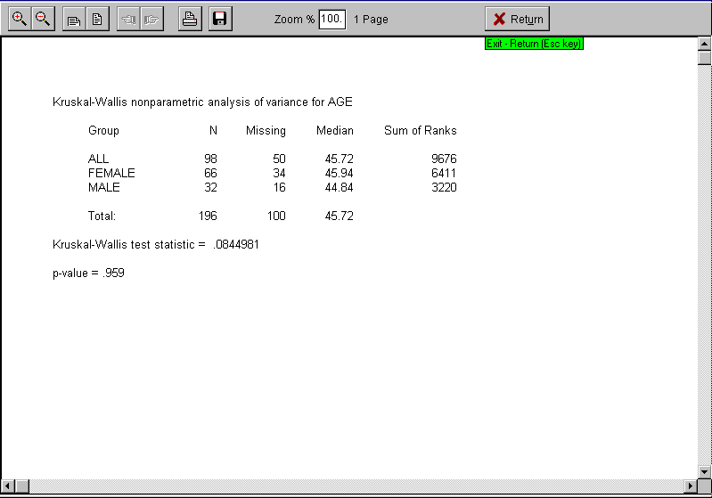
{bml 31-05.bmp}

Spearman
This option computes the values of Spearman's rho and Kendall's tau, which are non-parametric counterparts of the product-moment correlation coefficient (see chapter 26 --- the CORRELATE program). Both quantities are measures of the closeness of association between two variables and, like the product-moment coefficient, can take values between -1 and 1. NONPAR computes both non-parametric coefficients for each pair of selected variables in each selected group. NONPAR also computes tests of the hypothesis that two variables are independently distributed, which implies that their true correlation is zero - these tests are analogous to the t-test of the hypothesis that a product-moment correlation is zero.

Figure 31-6. Non-parametric correlation
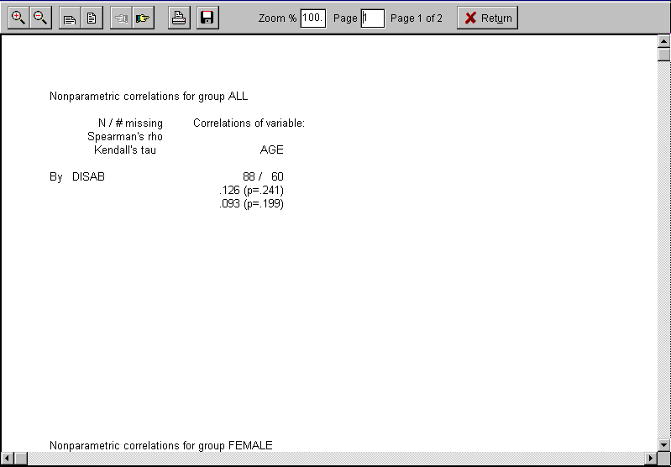
{bml 31-06.bmp}

Combine Groups
If you have selected two or more groups and have not selected group ALL (all patients), NONPAR will produce the statistics for the combination of all selected groups. This option is meaningful only if the groups you have selected are mutually exclusive (that is, if no patient is represented in more than one group).

When click on the Run button, NONPAR will compute statistics for each group separately and for all groups combined. (The Wilcoxon and Kruskal-Wallis procedures do not use all groups combined.)

Figure 31-7. Combined groups.
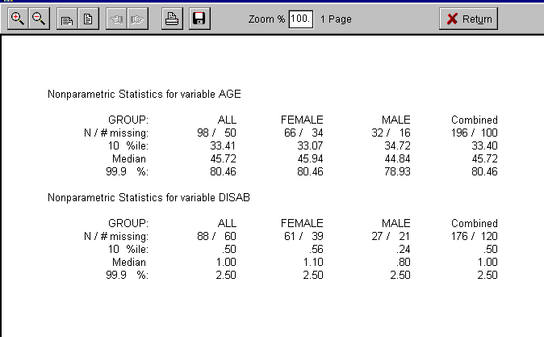
%PageBreak.

#$K Whisker Plot

Purpose of WHISKER PLOT
WHISKER PLOT displays in graphical form the summary of data for groups of patients.

Who should use WHISKER PLOT
WHISKER PLOT should be used by anyone who is interested in the relationship between time and variables changes.

When to use WHISKER PLOT
You should use WHISKER PLOT to look for trends, such as the effect of a number of treatments on the severity of back pain. The two plot methods (box plot and standard error) also indicate the reliability of the results.

You need to extract data before running WHISKER PLOT.

How to use WHISKER PLOT
When you invoke WHISKER PLOT, you are provided with a choice of two plotting methods, each of which will be discussed separately:
1. Box quartiles Box-Whisker plot, Tukey style.
2. SE-means. Standard Error and Means
Figure 32-1. Whisker Plot program
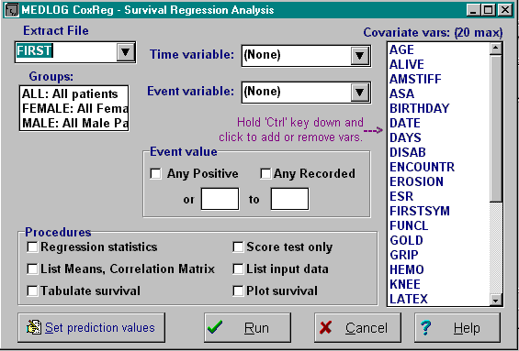
{bml 32-01.bmp}

Required selections

Extract file
An extract file containing the data to be analyzed must be prepared. The variables selected will appear as the Available Variables.

Groups
One or more groups must be selected.

Plot variables
A variable from the Available Variables drop down list must be selected and moved to the Plot variable box.

All of the other options have defaults that can be changed depending on the analysis desired.

Box Quartiles (Whisker Plot)
Figure 32-2. Box Quartiles Whisker Plot
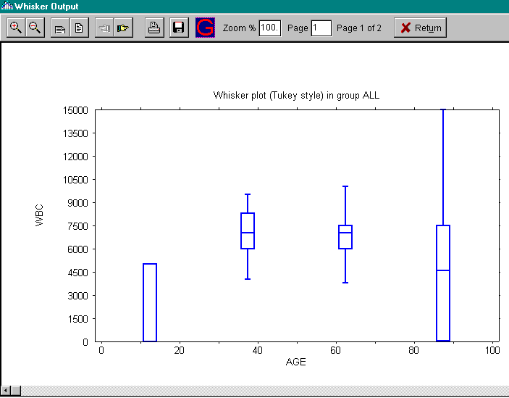
{bml 32-02.bmp}

In the box plot, the center line of the box represents the median valueNote: The top of the bottom and top of the box represent the upper and lower quartiles, respectively. The whiskers are for the minimum and maximum values, but are to limited to1.5 times the Inter-Quartile Range (IQR), which is the size of the box
Figure 32-3. Numerical tabulation of Whisker Plot
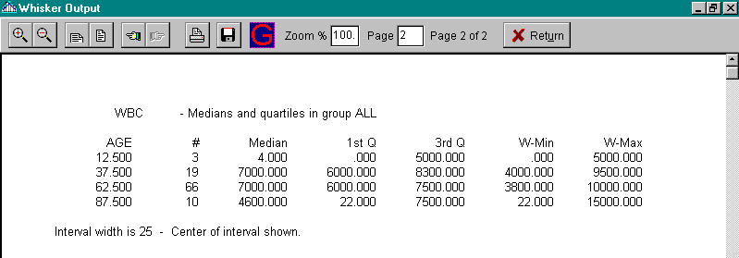
{bml 32-03.bmp}

SE-means
Figure 32-4. Means and SE Whisker Plot
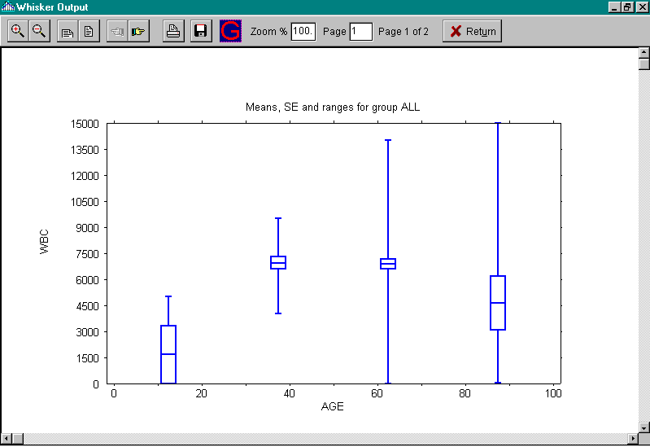

Here the middle of the box is the mean, the top and bottom of the box is the mean +/- the standard error of the mean. The whiskers represent the mean +/- the standard deviation. The whiskers are truncated if the values fall outside the plot range.
{bml 32-04.bmp}
Figure 32-5. Numerical tabulation of Whisker Plot
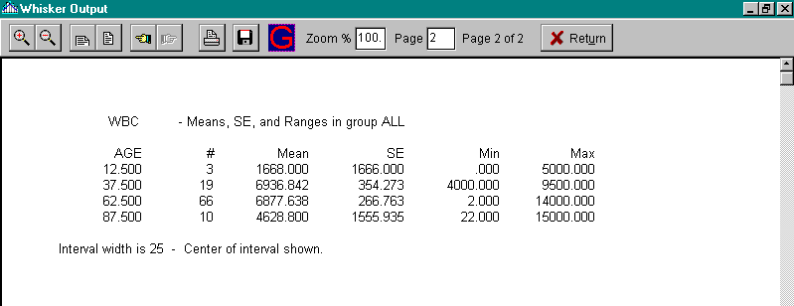
{bml 32-05.bmp}

Plotting SE-mean
The first decision is whether to use encounters for the horizontal axis or to use the time elapsed since the first plotted encounter. If time is chosen, each patient's first plot value will be averaged at time zero. This would be useful, for example, for plotting changes in body weight in a weight reduction program. The encounter scale may be more appropriate where specific treatments or medications are given on a schedule.

If an elapsed time axis is used, it is important to understand how the values will be assigned to the averaged values. If, for example, the time increment is set to one month, then all values from the encounter date of the first selected encounter up to 1/2 month will be displayed at time 0. Values corresponding to elapsed time of .5 to 1.5 are displayed at Time = 1 month. The pattern would continue through the 30th month. Figure 32-4 illustrates this method.

The next step is to specify the variable to plot. Only one variable is displayed on a plot Unless you are plotting group ALL, you may choose to plot all encounters or only the marked encounters in the group. Normally, you would choose for all encounters.

If you are using time for the horizontal scale, you may choose a time increment. This allows you to have several plots with the same time scale. The default is automatic scaling.

The computer will then analyze the data and produce the plot of the means. The mean values are represented by solid boxes. The Standard Error (SE) is indicated by a vertical line above and below the solid boxes. When an average is only a single value, a lightly shaded box is displayed.
%PageBreak.

#$K Cox Regression

Purpose of COXREG
COXREG is a program for Cox's proportional hazards regression analysis of censored survival data, with up to 20 covariates. In the Cox regression model we assume that the hazard function (“Force of mortality” in actuarial terminology) has the form

H(t) = exp(b₁x₁ + b₂x₂+....b_{k}x_{k})

where t is time and the x_{i} are the covariates, and the function H and the b_{i} are unknown. COXREG calculates estimates of H and the b_{i}, and from these provides estimates of survival curves for specified values of the covariates. COXREG also provides tests of significance of the covariates. The books by Cox and Oates and Lee contain extensive material on the Cox model.

When to use COXREG
Cox covariate adjusted survival analysis is used to estimate the survival function of an event, breast cancer relapse, for example, in terms of several covariates such as age and node pathology. For each time (t), a survival function gives the probability of the event not occurring in the time interval of length (t) that begins at some defined starting point, such as time of diagnosis. In most applications there will be some censored observations; that is, some patients will not have suffered the event at the time of last observation.

This method of survival analysis assumes that the Cox model is an adequate description of the dependence of the survival function on the covariates. Cox and Oates (section 7.8), discuss approaches to assessing the adequacy of the model. See also the comments under “ Tabulate and plot survival function” below.

Since COXREG obtains data from an extraction file, you must have an extraction file or run EXTRACT before using LOGREG.

How to use CoxReg
Figure 33-1. Main MEDLOG menu
When you click on Regression, a sub menu with three choices appears.

Click on Cox Regression to open the program window, Figure 33-2.
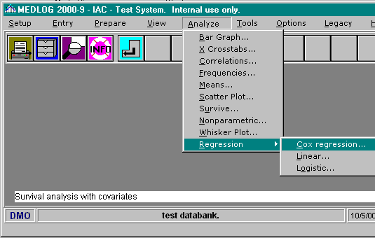
{bml 33-01.bmp}

Figure 33-2. Cox Regression program
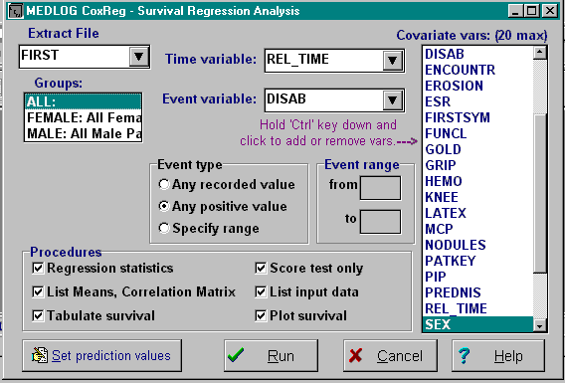
{bml 33-02.bmp}

Groups
COXREG displays the groups for the selected extract file. You must select one or more groups.

If you want to make the groups one of the covariates, you would first compute a new variables (see the compute program, Chapter 19) In this example the groups consist of patients in different strata, such as disease stages. Variable S1 will indicate if the patient is in the stage 1 group or not.
S1 = (group(STAGE1))
The variable s1 assumes the value of 1 for patients in the group, STAGE1, and has the value 0 for patients in any other group. If all the disease stage groups are included in the analysis, you can use the disease stage indicator variables as covariates in order to assess the influence of disease stage on survival. Note that if you include k groups, you must use only k-1 indicator variables. Including all k indicator variables will cause the computation to fail.

Note that COXREG uses all the observations in the groups you specify, and that those groups must be mutually exclusive (have no common observations) for the analysis to be valid.

Time Variable
The next selection is Time variable. This variable represents the time to survival or time to censoring. It will usually be derived from other variables using the transform capability of the EXTRACT program. For example, we might compute the time to relapse or censoring with the statement:
REL_TIME = MIN(DATE.L, REL_DATE) - DIAG_DAT
where DATE.L is the date the patient was last observed and thus is the censoring date if there was no relapse. REL_DATE is the date of relapse that is missing if there was no relapse, and DIAG_DAT is the date of diagnosis. The MIN function will equal DATE.L if REL_DATE is missing, and will otherwise equal REL_DATE. In this example, REL_TIME is expressed in days, since it is a difference of date type variables. For example, the statement
REL_TIME = REL_TIME/30.5
will convert REL_TIME to month units.

Event variable
The event of interest in survival analysis is frequently death, but it could be some other happening such as relapse, heart attack, or treatment failure.

Event type
The choices are: Any recorded value, Any positive value, or Specify a range (from/to).

If, for example, the event variable is coded 0=NO, 1=YES, then you would choose “Any positive value” for the event type. If you specify a range, the event will be considered to occur if the variable value lies between “from” and “to” inclusive

Covariate vars
You can specify from 1 to 20 covariates but you must specify at least one and it cannot be either the time or the event variable.

Run Procedures
One or more of the following procedures must be selected. A specimen of the output is also provided for each procedure.

Regression statistics
This procedure gives the values and estimated standard deviations of the individual coefficient estimates, and exhibits a test of significance for each covariate. Of more interest than the regression coefficient estimates themselves are estimates of survival probabilities derived from the regression model. These estimates are discussed below under “Tabulate and plot survival function”.

You can calculate a test of the significance of a subset of the covariates in the regression model in the following way. After running the analysis with all covariates, note the log likelihood. Then run the analysis again without the covariates to be tested, and again note the log likelihood. Multiply by 2 the absolute value of the difference between the two log likelihoods. The resulting test statistic has approximately the chi-square distribution with degrees of freedom equal to the number of deleted covariates, under the null hypothesis that the coefficients of all the deleted covariates are zero.

The above procedure assumes that the same set of observations is used in both analyses. That would not be the case if observations have been discarded in the first analysis because values of the deleted covariates are missing, and if some of those observations are included in the second analysis. One way of preventing this is to use a transformation EXTRACT to set the value of the event variable to missing if the value of any of the covariates in the first analysis is missing. The statement
EVENTVAR = EVENTVAR + 0*COV1*COV2* ... *COVk
where COV1, COV2, ... , COVk are the names of the covariates and EVENTVAR is the name of the event variable, will produce the required result.

Example:
- log likelihood with 3 covariates (A,B,and C)=-30.8727
- log likelihood with covariate A only =-31.8864

Test for significance of B and C, when A is also a covariate:
Chi-square statistic (2 df)=2 x (31.8864-30.8727)= 1.01
p > 0.5 (from chi-square table).

In this example, covariates B and C are not significant when A is present as a covariate. By deleting just one covariate, the same method can be used to obtain a test of significance for a single covariate, in the presence of the remaining covariates, this is a more reliable alternative to the test displayed by COXREG. (The latter test uses the estimated variance of the regression coefficient estimate.) Note also that if your analysis has just one covariate, the likelihood-ratio test is to be preferred to the significance test based on the estimated variance.

All of the significance tests discussed above are “large-sample” tests. This means that the reliability of the p-values they produce becomes better as the amount of data available (the sample size) becomes greater. There are no precise guides available to what constitutes an adequate sample size, but results from small numbers of observations should be viewed with some circumspection, particularly if several covariates are being used. A data set with fewer than 10 to 20 events or two to three times as many events as covariates (whichever is greater) might reasonably be considered “small”.

Another point about these tests is that they may not be very sensitive in detecting covariate effects which don't conform to the “proportional hazards” model (see the discussion under “Tabulate and plot survival function” below).

Figure 33-3. Regression statistics
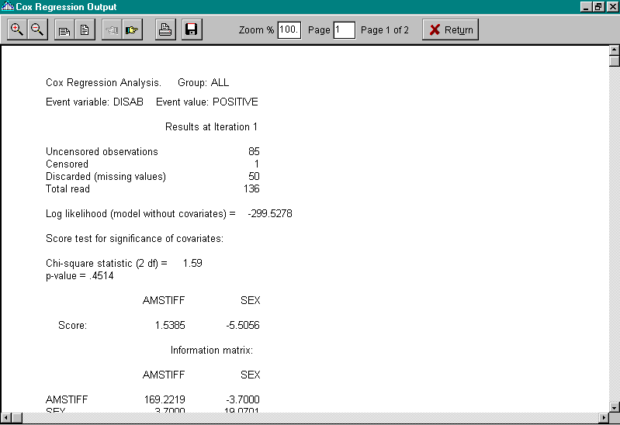
{bml 33-03.bmp}

Figure 33-4. Regression statistics, continued
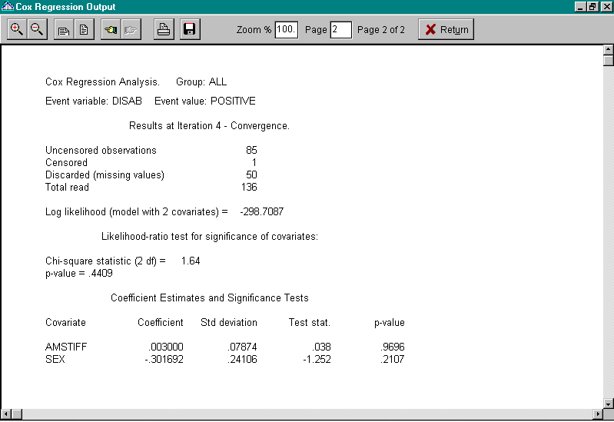
{bml 33-04.bmp}

List Means, Correlation Matrix
List means, minimums, and maximums of covariates.

These results are used in computing the score test. The information matrix is the estimated covariance matrix of the score vector. You can get a score test statistic for an individual covariate by dividing the element of the score vector corresponding to that covariate by the square root of the corresponding diagonal element of the information matrix. Refer to a table of the standard normal distribution to get a p-value.

The matrix listed here, which is derived from the covariance matrix is useful for assessing the strength of association between a pair of covariates. A high correlation between coefficients is a good indication that the corresponding covariates are themselves highly correlated. You can use the CORRELATE program to look at the correlation between covariates directly. Since high correlation among covariates can cause poor estimation results, you might want to consider deleting one or more covariates that have high correlation with others.
Figure 33-5. Covariate Means & Correlation Matrix
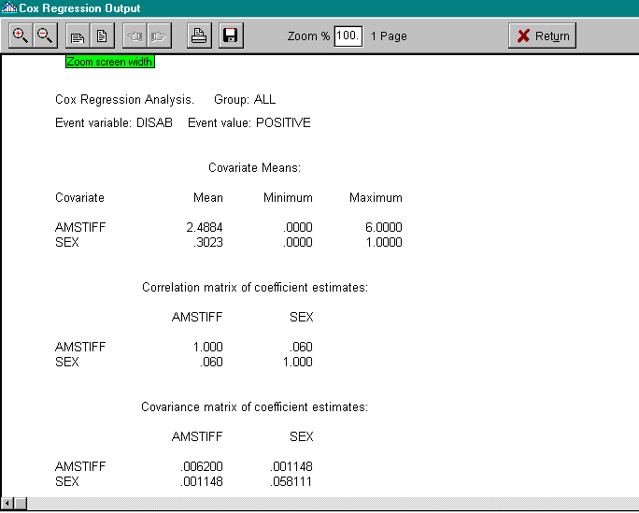
{bml 33-05.bmp}

Tabulate survival
Figure 33-6. Covariate values
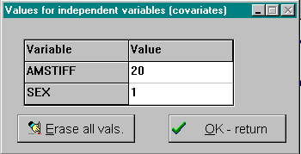
{bml 33-06.bmp}

This procedure produces a table of the times at which events were observed, the numbers of events and the numbers of patients at risk at those times, and finally the estimated survival probabilities at those times for the given set of covariate values.

The survival probability estimates are based on the results of the Cox survival analysis and on the covariate values you supply. The model used in the Cox analysis involves the rather restrictive assumption of “proportional hazards”. Roughly speaking, this means that survival curves for different sets of covariate values are assumed to have the same “shape” - two curves cannot cross, for example. A plausible example in which this assumption is not realistic would be a comparison of surgical and medical treatment for a condition, where the surgical treatment results in higher short-term mortality but lower long-term mortality when compared to the medical treatment. If you have enough data, you might be able to get a graphical check on the plausibility of the proportional hazards assumption by forming several groups based on the ranges of the covariates.

Figure 33-7. Survival probabilities
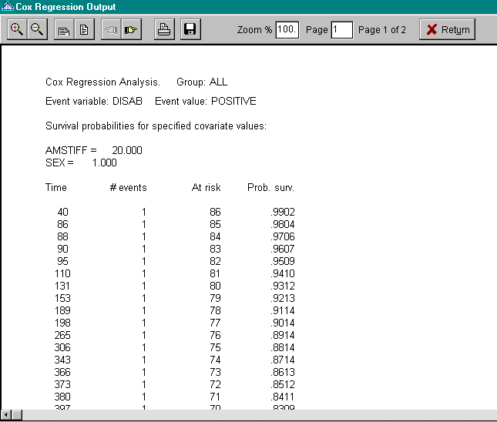
{bml 33-07.bmp}

Score test only
The score test is a test of the hypothesis that the covariates don't influence survival. It has the advantage that it is available before the full iterative computation is completed. The score test statistic is usually reasonably close to the likelihood-ratio test statistic, which is available after the iterative computation converges (see below).

The likelihood-ratio test statistic is twice the absolute value of the difference between the log likelihood at convergence and the log likelihood at iteration 1. The likelihood-ratio test is a test of the hypothesis that all the regression coefficients are zero. That is, the covariates don't influence survival.

The likelihood-ratio test is considered to be more reliable than the score test, but you may wish to stop the computation at this point - for example, if the test shows that the covariates are clearly non-significant. If the covariates are all stratum indicator variables (for example, disease stage strata), then the score test is equivalent to the log-rank (Mantel-Haenszel) test for equality of survival curves between strata.

The log likelihood test quantity shown on this screen is used by COXREG in computing the likelihood-ratio test.
Figure 33-8. Score test
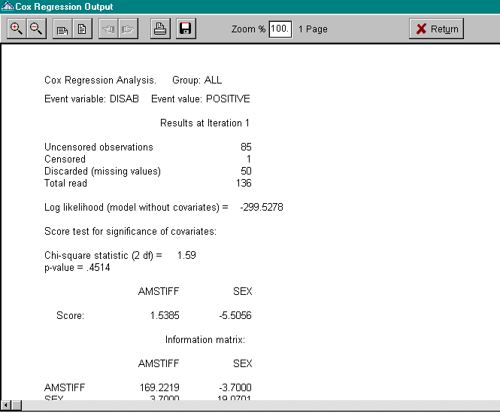
{bml 33-08.bmp}

List input data
Note that an observation is discarded if the value of the event variable, the time variable, or any of the covariates is missing.

The maximum number of observations COXREG can analyze depends on the amount of memory available on your computer.
The computation of the regression estimates is an iterative process, in which the results at each step (iteration) are used as inputs for the next iteration until (if all goes well) the series converges.
Figure 33-9. List input data

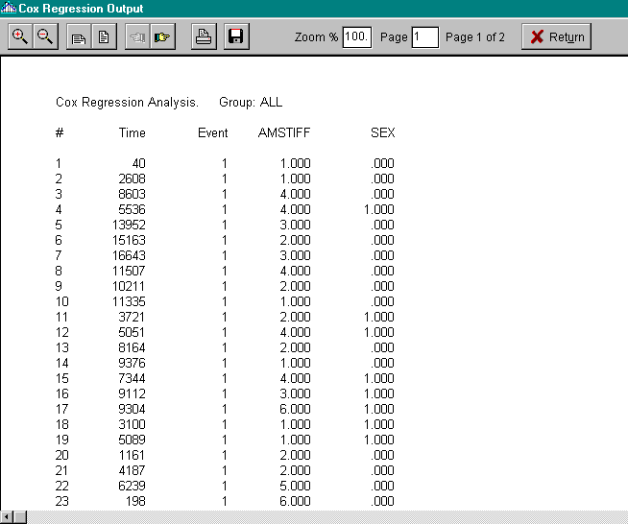
{bml 33-09.bmp}

Plot survival
This option produces a plot of the survival curve, based on the results of the Cox survival analysis and on the covariate values you supply.
Figure 33-10. Survival plot
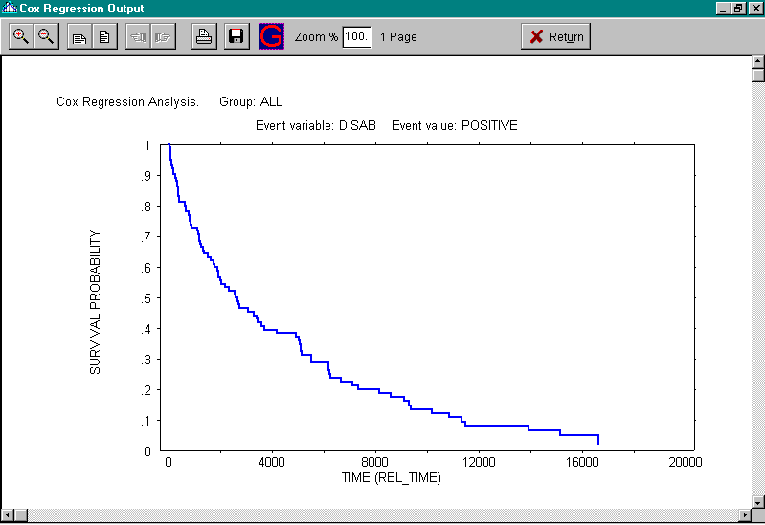 {bml 33-10.bmp}%PageBreak

#$K Multiple Linear Regression

Purpose of LINREG
LINREG is a multiple linear regression program for up to 30 explanatory variables. In multiple regression analysis we assume that the mean of a “dependent” variable is a linear function of one or more explanatory variables in symbols,
Y = a + b₁ x₁+ b₂x₂+ . . . + b_{k}x_{k}+ E
Y is the dependent variable, the x_{i} are the explanatory variables, while a and b_{i} are the regression coefficients. LINREG provides the usual regression statistics, plots of residuals, confidence intervals for predicted values, etc. See Armitage chapter 10, for information on the rationale and uses of multiple linear regression analysis.

When to use LINREG
Multiple linear regression analysis is used to estimate the linear relationship between a “dependent” quantitative variable (such as blood pressure) and several explanatory variables (such as sex, age, and body-weight). As well as the estimated regression equation, LINREG provides tests of significance of the explanatory variables. Linear regression analysis assumes that a linear model is an adequate description of the relationship between the dependent and explanatory variables. The scatter plots provided by LINREG of residuals versus fitted values, and of residuals versus transformations of variables, are useful in assessing whether the linearity assumption is reasonable (see Armitage chapter 10, section 1). For example, adding the square of an explanatory variable to the equation might help to make the relation more linear.

Since LINREG obtains data from the extraction file, you must have an extraction file or run EXTRACT before using LINREG.

How to use LINREG
After an extract file is chosen, you must select a group, the dependent variable, several independent variables, and a procedure.
Figure 34-1. Multiple Linear Regression program
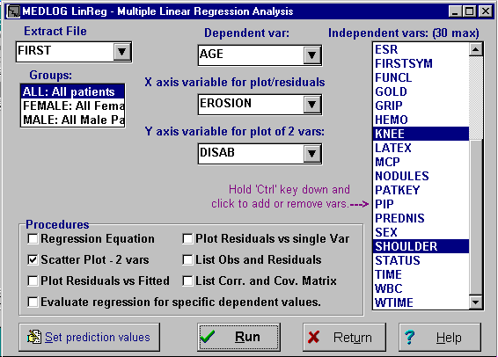
{bml 34-01.bmp}

Note that LINREG uses all the observations in the groups you specify. If you choose more than one group, the groups should be mutually exclusive (have no common observations) for the analysis to be valid.

Following is an example of using more than one group in the analysis. The groups consist of patients in different strata, such as disease stages. You have constructed, using transform statements in the EXTRACT program, indicator variables, such as
S1 = group(STAGE1);
This variable has the value 1 for patients in group STAGE1, and has the value 0 for patients in any other group. If all these disease stage groups are included in the analyses, you can use the disease stage indicator variables as explanatory variables in order to assess the influence of disease stage on the dependent variable. Note that if you include k such groups, you must use only k-1 indicator variables - including all k indicator variables would cause the computation to fail.

If you include one or more explanatory variables, you can perform an “analysis of covariance”. One question of interest in such an analysis is whether the dependent variable is influenced by the stratificationvariable (disease stage, for example) after adjusting for the effects of the additional explanatory variables (covariates). See the discussion below about testing the significance of a subset of explanatory variables. Armitage (pages 322-324) discusses the use of multiple regression techniques in the analysis of covariance.

A maximum of 30 independent variables may be selected. They may not be linear combinations or multiples of each other if the regression analysis is to succeed.

Procedures

Regression equation
Figure 34-2 is an example of results of a regression run. Note that at the right of the report, LINREG displays the number of observations used in the analysis and the number discarded because of missing values. Also, that an observation is discarded if the value of the dependent variable or of any of the explanatory variables is missing.
Figure 34-2. Regression equation
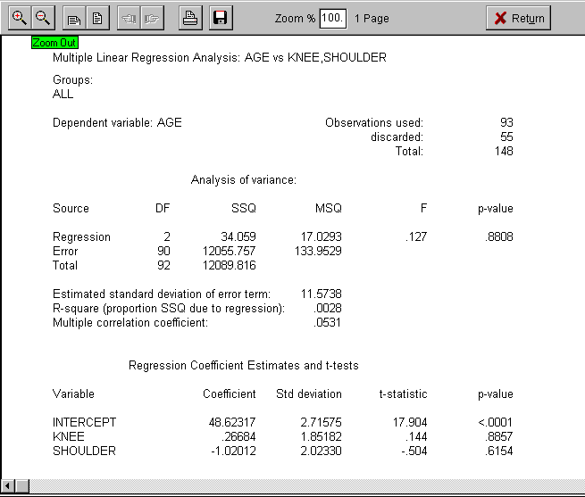
{bml 34-02.bmp}

The analysis of variance (ANOVA ) is a conventional way of displaying the results of a regression analysis (see Armitage pages 310-312). The F-test, see last two columns of the ANOVA table, tests the hypothesis that the regression coefficients of all the explanatory variables are zero. That is, the explanatory variables do not influence the dependent variable, subject to the linearity assumption.

The standard deviation of the “error” term is a measure of the variation in the dependent variable that is not attributable to the effects of the explanatory variables. The quantity R² is the proportion of the total sum of squares (SSQ) attributable to the regression; its value lies between 0 and 1. (R² is calculated by dividing the regression SSQ by the total SSQ). The square root of R² is called the multiple correlation coefficient, and like R² is a measure of how closely the linear regression equation represents the relationship between the dependent variable and the set of explanatory variables. (If there is only one explanatory variable, the multiple correlation coefficient is the same as the usual correlation coefficient of the dependent and explanatory variable, sign ignored).

If the dependent variable is an exact linear function of the explanatory variables, a message to that effect is displayed with the ANOVA table. In this case the error variance is zero and the F-test cannot be computed. One cause of linear dependence is that the number of observations used in the regression calculation is one more than the number of explanatory variables.

At the bottom of the Figure 34-2, LINREG gives the values and estimated standard deviations of the individual coefficient estimates, and exhibits a t-tests of significance of the intercept and each explanatory variable. The t-tests for a particular explanatory variable should be interpreted as a test of its effect, taking into account the influence of the remaining explanatory variables. In the case of linear dependence, this message is displayed; “The dependent variable is equal to a linear function of the variables with nonzero coefficients. T-tests cannot be computed”.

You can calculate a test of the significance of a subset of the explanatory variables in the regression model in the following way (see Armitage, pages 312-314). Suppose there are P explanatory variables in the equation, and you want to test the significance of q of them. Note the regression sum of squares (SSQ) and the error mean square (MSQ) in the analysis of variance table. Then run the analysis with p-q explanatory variables (deleting the subset of q variables from the original set of p). Subtract the regression SSQ in this new analysis from the original regression SSQ, and divide the difference by q. Dividing the resulting quantity by the error MSQ (from the original analysis) gives an F-statistic with q and n-p-1 degrees of freedom (n is the number of observations).

You can get the p-value for the test from a table of the F-distribution, which you can find in most statistics texts. Example:
n=349
Error MSQ (4 variables): 101.3
Regression SSQ (4 variables): 3687.7
Regression SSQ (2 variables): 2900.9
Difference 786.8

786.8/2 = 393.4 F= 393.4/101.3 = 3.88(2 and 344 degrees of freedom)
P < .025 (from F-distribution table).

In this example the two deleted variables are significant when the remaining two explanatory variables are present.

The preceding procedure assumes that the same set of observations is used in both analyses. That would not be the case if observations have been discarded in the first analysis because values of the deleted explanatory variables are missing, and if some of those observations are included in the second analysis. One way of preventing this is to use a transform statement in EXTRCT to set the value of the event variable to missing if the value of any of the explanatory variables in the first analysis is missing.

The statement
EVENTVAR = EVENTVAR + 0*VAR1*VAR2* ... *VARk
where VAR1, VAR2, ..., VARk are the names of the explanatory variables in the first analysis and EVENVAR is the name of the event variable, will produce the required result.

If you want to test the significance of just one explanatory variable, you don't have to follow this procedure, since the t-tests for individual explanatory variables mentioned above give exactly equivalent results.

Scatter Plot, 2 vars
When you choose this procedure, You must choose the variables for the two axes of the scatter plot. You can choose any variables from the drop-down lists, even if they are not in the current regression equation.
Figure 34-3. Two variable scatter plot
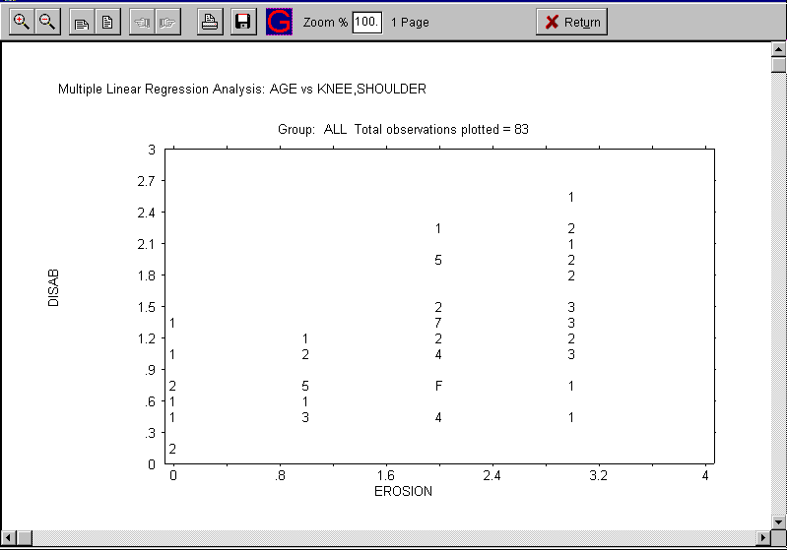
{bml 34-03.bmp}

If you choose to restrict the plot to observations in the analysis, some value-pairs may be omitted because of missing values for variables in the regression equation.

Plot Residuals vs. Fitted (values)
The fitted values from the regression analysis are the quantities

a + b₁x₁ + b₂x₂+ +b_{k}x_{k}

where a and the b_{i} are the estimated regression coefficients and the x_{i} is the explanatory variables. The residuals are the differences between the observed values of the dependent variable and the fitted values; in symbols, with y representing the dependent variable, the residuals are the quantities

y-(a+b₁x₁+b₂x₂+...b_{k}x_{k})

Because of the way the regression estimates are calculated, the residuals are not always correlated with the fitted values. However this plot may suggest that a transformation of the dependent would be useful, to reduce variance inequality, for example (see Armitage, pages 316-319 for a discussion of residual plots).

Figure 34-4. Residuals vs. Fitted Values
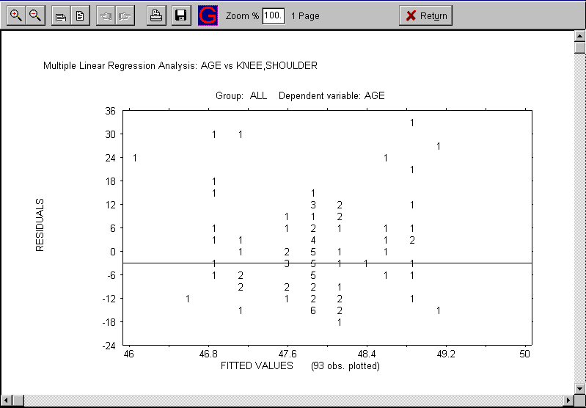
{bml 34-04.bmp}

Evaluate regression for specific dependent values
If this procedure is selected, you must first provide the independent variable values and the Confidence level.
Figure 34-5. Set prediction values
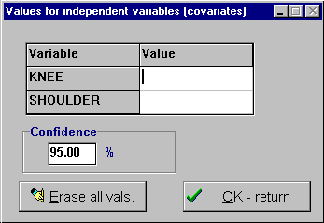
{bml 34-05.bmp}

Figure 34-6. Regression for specific dependent values
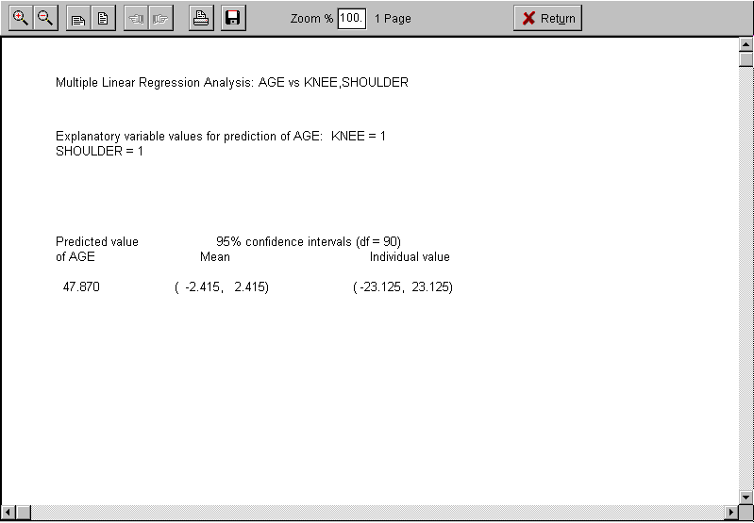
{bml 34-06.bmp}

Plot Residuals vs. single Variable
This procedure plots a variable against the residuals. These plots might suggest, for example, that another variable should be included in the equation, or that the square of a variable should be included (see Armitage, page 319).

Figure 34-7. Residual vs. Single Variable
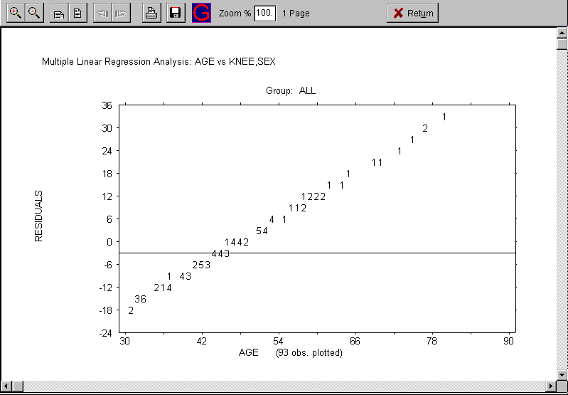
{bml 34-07.bmp}

List Obs(ervations) and Residuals
For each observation, LINREG displays the values of the explanatory and dependent variables, the fitted value, and the residual (see option 3 for an explanation of these terms).

Figure 34-8. Observations and Residuals
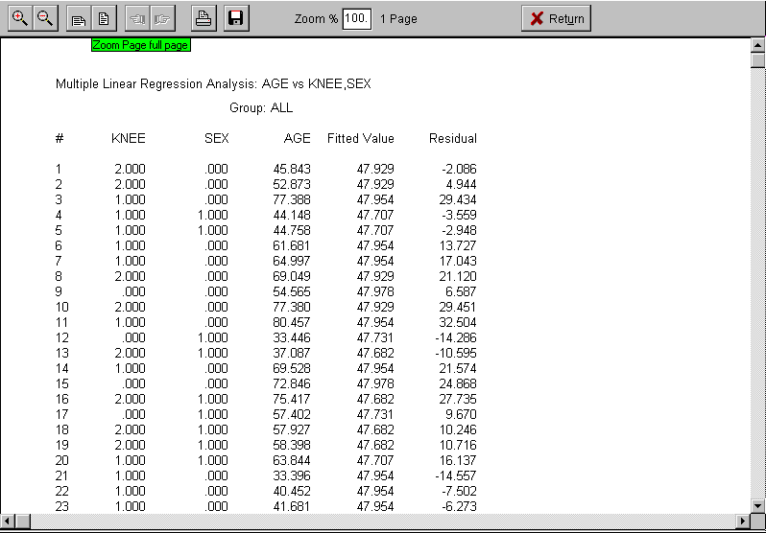
{bml 34-08.bmp}

List Corr(elation) and Cov(ariance) Matrix
This procedure produces a listing of the estimated covariance matrix of the regression coefficient estimates. See Armitage (page 323) for an application of this information.

Figure 34-9. Correlation list and Covariance matrix (page 1 of 3)
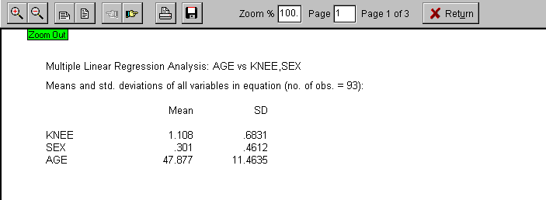
{bml 34-09.bmp}

Figure 34-10. Correlation list and Covariance matrix (page 2 of 3)
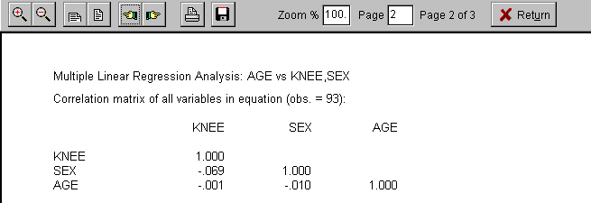

Figure 34-11. Correlation list and Covariance matrix (page 3 of 3)
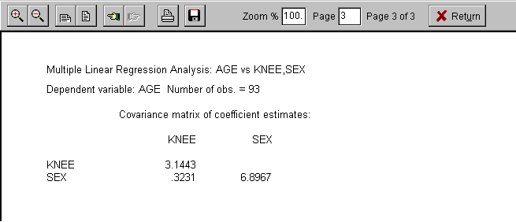
{bml 34-11.bmp}

Compute a predicted value and confidence intervals
When you choose this option, LINREG asks you for the explanatory variable values for the prediction of the dependent variable. (The predicted value is just the fitted value for that set of explanatory variable values - see option 3). You can then enter a percent confidence coefficient (a number between 75 and 99) for confidence intervals - the default is 95. Click on the Run button to complete the processing. LINREG then displays the predicted value, and confidence intervals for the predicted mean value and for an individual value of the dependent variable.

Error Messages
A computational error has occurred.
This error message should not result from a data condition; it may be due to a software or hardware error. Refer to a MEDLOG consultant for assistance.

All residuals are equal to zero.
The dependent variables is equal to a linear function of the explanatory variables, so all residuals are zero.

All values of (variable name) are equal to (number).
The regression equation cannot be computed. All values of one of the variables in the analysis are equal to the same number.

An explanatory variable is equal to a linear function of one or more other explanatory variables. The regression equation cannot be computed.

There is a linear relation between covariates (for example, $X_{1}=2X_{2}+1$). Remove variables from the analysis to eliminate the linear dependence.

Error variance zero - cannot compute intervals.
The dependent variables is equal to a linear function of the explanatory variables, so all residuals, and the error variance, are zero.

The number of observations is less than the number of explanatory variables plus one. The regression equation cannot be computed.

If there are p explanatory variables, at least p+1 observations are needed to compute the regression equation, and at least p+2 are needed to get tests of significance.
%PageBreak.

#$K Logistic Regression

Purpose of LOGREG
LOGREG is a multiple logistic regression program for up to 20 covariates (explanatory variables). In the linear logistic regression model we assume that the logic of the probability of an event is a linear function of one or more covariates. (The logic of a probability p is defined to be the natural logarithm of p/(1-p). In symbols, the model assumes that:
Log(p/(1-p) = a + b₁x₁+b₂x₂+....b_{k}x_{k} + E
where the x_{i}'s are the k covariates and a and the b_{i}'s are the coefficients of the linear function.

LOGREG provides the regression estimates, tests of significance of the covariates, confidence intervals for predicted probabilities, etc. Logistic regression is discussed by Armitage (Section 12.5), and more fully by Cox .

When to use LOGREG
Logistic regression is used to estimate the relationship between the probability of an event (such as coronary artery disease) and several covariates (such as smoking and diastolic blood pressure). This method of analysis assumes that the linear logistic model is an adequate description of the relationship between the event probability and the covariates. Cox, section 6.6, suggests approaches to assessing the adequacy of the linear logistic model.

Since LOGREG obtains data from an extraction file, you must have an extraction file or run EXTRACT before using LOGREG.

How to use LOGREG
Figure 35-1. Logistic Regression program
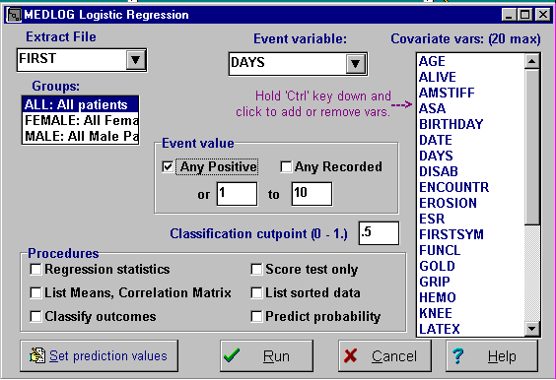

Extract File
After an extract file is selected, you may choose a group, the event variable, the event value, the covariates and one or more procedures.
{bml 35-01.bmp}

Groups
You must select one or more groups to use. Note that LOGREG uses all the observations in the groups you specify, and that those groups must be mutually exclusive (have no common observations) for the analysis to be valid.

Following is an example of using more than one group in the analysis. The groups consist of patients in different strata, such as disease stages. You have constructed, using transform statements in EXTRACT, group (disease stage) indicator variables, such as
S1 = group(STAGE1)
which has the value 1 for patients in group STAGE1, and has the value 0 for patients in any other group. If all these disease stage groups are included in the analysis, you can use the disease stage indicator variables as covariates in order to assess the influence of disease stage on the probability of the event you are analyzing.

Note that if you include k such groups, you must use only k-1 indicator variables. Including all k indicator variables that would cause the computation to fail.

Event value
Depending on the Event variable selected, one of three options can be selected to select the event:
Any positive. Any positive value will be considered to be an event.
Any recorded. Any non-missing value will be an event.
From/to. An event will be any value which satisfies the range requirement.

If, for example, the event variable is coded 0 = NO, 1 = YES, then you choose “any positive value” for the event.

Classification cutpoint(0-1.)
If the Classify Outcomes procedure is selected, a value for the cutpoint must be supplied. The value must be between 0 and 1 with the default being .5.

Procedures
The maximum number of observations LOGREG can analyze depends on the amount of memory available to the program. The memory required for n observations with k covariates is 4n(k+2) bytes. The number of observations cannot exceed 16,383.

Regression statistics
The computation of the regression estimates is an iterative process, in which the results at each step (iteration) are used as inputs for the next iteration, until (if all goes well) the series of estimates converges to an acceptable solution. See “Error Messages” at the end of this chapter for possible reasons for failure to converge.

The time taken to complete the process depends on the number of covariates and the number of observations. If you want to abort the computation, press the Escape key.

The number of iterations needed to converge to a solution depends on the nature of the data. “Reasonable” data sets generally require fewer than 10 iterations. If convergence is not achieved after 20 iterations, processing stops. Apart from failure to converge, the computation may fail due to an adverse data condition, such as too few observations. See “Error Messages” below for more information on possible causes of non-convergence and computational failure.

After convergence is obtained, LOGREG displays the log likelihood and the likelihood-ratio test - see figures 35-2 and 35-3. The likelihood-ratio test statistic is twice the absolute value of the difference between the log likelihood at convergence and the log likelihood at iteration 1. The likelihood-ratio test is also a test of the hypothesis that all the regression coefficients are zero; e.g., the covariates don't influence the probability of the event.

Figure 35-2. Regression statistics, part 1
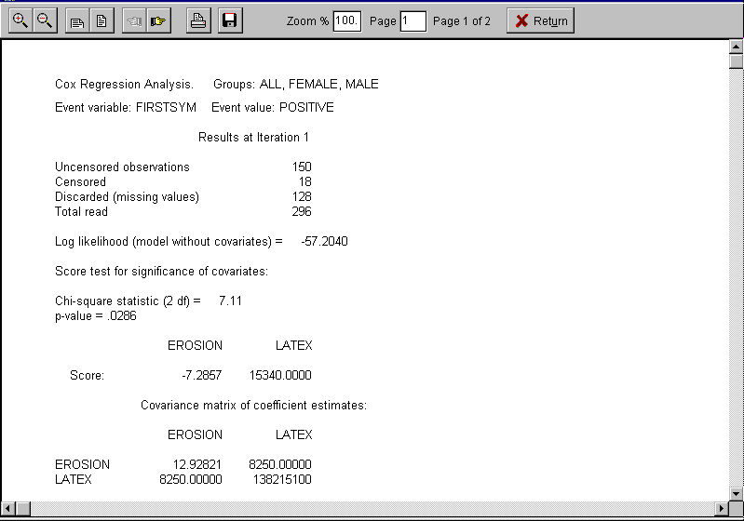
{bml 35-02.bmp}
Figure 35-3. Regression statistics, convergence
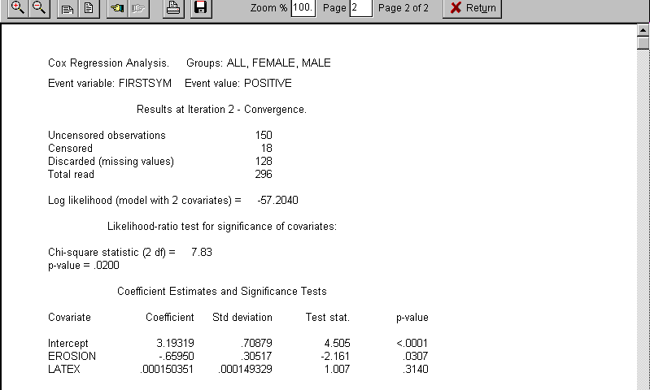
{bml 35-03.bmp}

List Means, Correlation Matrix
Figure 35-4. Means Correlation Matrix
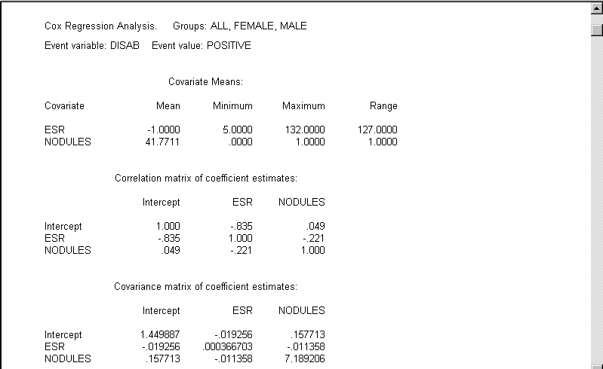
{bml 35-04.bmp}

Classify outcomes
Figure 35-5. Classification table
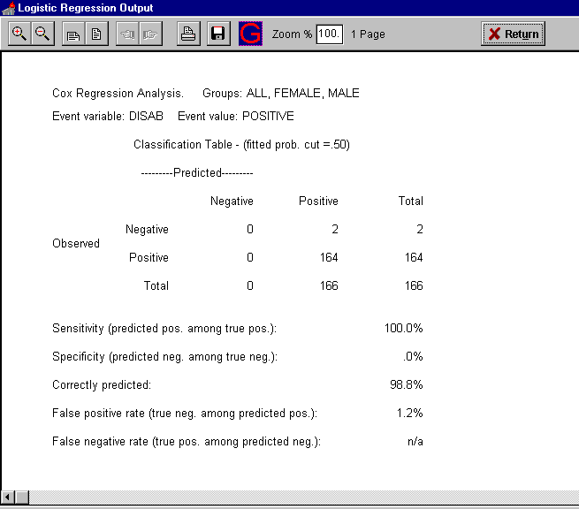
{bml 35-05.bmp}

Figure 35-5 shows a two-way classification, with observed outcomes, negative (event did not occur) and positive (event did occur), in the rows, and predicted outcomes, negative (predicted probability < cut-point) and positive (predicted probability >= cut-point), in the columns. Following the table are several quantities calculated from the table (numbers in parentheses are from the table in figure 35-5).

Sensitivity - percentage of outcomes predicted positive among observations for which the event occurred
(100 x (164/164) = 100.0%)

Specificity - percentage of outcomes predicted negative among observations for which the event did not occur
(100 x (0/2) = 0%)

Correctly predicted
(100 x (0 + 164)/100 = 98.8%)

False positive rate - percentage of observations for which the event did not occur among those with outcome predicted positive.
(100 x (2/166) = 1.2%)

False negative rate - percentage of observations for which the event occurred among those with outcome predicted negative.
(100 x (0/0) = n/a)

These quantities give some indication of the performance of a decision rule based on predicted probabilities calculated from the logistic regression equation. Note however that such a rule is likely to perform better with the data set used to construct it than with other data - in other words, these performance induces are probably optimistic.

Score test only
The score test is a test of the hypothesis that the covariates don't influence the probability of the event, and has the advantage that it is available before the full iterative computation is completed. It is usually reasonably close to the likelihood-ratio test statistic, which is available after the iterative computation converges (see Figure 35-3, Regression statistic, Iteration 1). The likelihood-ratio test is considered to be more reliable than the score test, but you may wish to stop the computation at this point. For example, if the test shows that the covariates are clearly non-significant.

If there is just one covariate whose values define an ordering of k groups of patients, then the score test is equivalent to Armitage's test for trend in proportions from group 1 to group k (see Armitage, page 363). For example, the groups might correspond to disease severity categories, and the covariate SEVERITY might take values 1 for the least severe disease category through k for the most severe category. Then we might be interested in testing whether there is a significant trend in the proportion of deaths across groups.

The log likelihood quantity shown on this display is used by LOGREG in computing the likelihood-ratio test.

Figure 35-6. Score test (Likelihood ratio test)
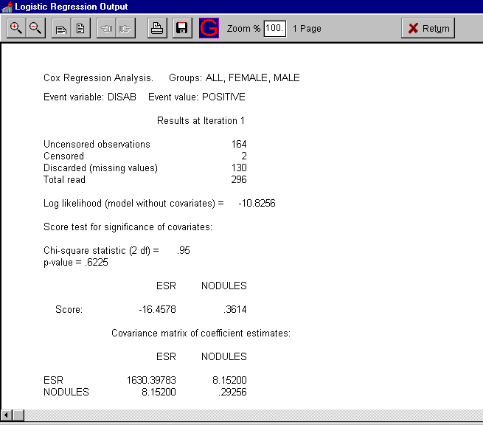
{bml 35-06.bmp}

List score vector and covariance matrix
The score vector and its estimated covariance matrix are used in computing the score test. You can get a score test statistic for an individual covariate by dividing the element of the core vector corresponding to that covariate by the square root of the corresponding diagonal element of the covariance matrix. Refer to a table of the standard normal distribution to get a p-value.

Discussion of Regression Statistics
On the final iteration, LOGREG calculates the values and estimated standard deviations of the individual coefficient estimates, and exhibits a test of significance for each covariate - see figure 35-3. Of more interest than the regression coefficient estimates themselves are estimates of the event probabilities derived from the regression equation.

You can calculate a test of the significance of a subset of the covariates in the regression model in the following way. After running the analysis with all covariates, note the log likelihood. Then run the analysis again without the covariates to be tested, and again note the log likelihood. Multiply by 2 the absolute value of the difference between the two log likelihood. The resulting test statistic has approximately the chi-square distribution with degrees of freedom equal to the number of deleted covariates, under the null hypothesis that the coefficients of all the deleted covariates are zero.

The above procedure assumes that the same set of observations is used in both analyses. That would not be the case if observations have been discarded in the first analysis due to missing values of the covariates, but not discarded in the second analysis. One way of preventing this is to use a transform statement in EXTRACT to set the value of the event variable to missing when the value of any of the covariates in the first analysis is missing.

The statement
EVENTVAR = EVENTVAR + 0*COV2* ... * COVk
where COV1, COV2, . . ., COVk are the names of the covariates in the first analysis and EVENTVAR is the name of the event variable, will produce the required result. Example:
log likelihood with 5 covariates = -112.9688
log likelihood with 2 covariates = -118.1867

Test for significance of the 3 deleted covariates:
Chi-square statistic (3 df) = 2 x (118.1867 - 112.9688) = 10.44
P < 0.25 (from chi-square table).

In this example, the three deleted covariates are significant when the two remaining covariates are present. By deleting just one covariate, the same method can be used to obtain a test of significance for a single covariate, in the presence of the remaining covariates - this is a more reliable alternative to the test displayed by LOGREG. The latter test uses the estimated variance of the regression coefficient estimate. Note also that of your analysis has just one covariate, the likelihood-ratio test is to be preferred to the significance test based on the estimated variance.

All of the significance tests discussed above are “large-sample” tests. This means that the reliability of the p-values they produce becomes better as the amount of data available (the sample size) becomes greater. There are no precise guides available to what constitutes an adequate sample size, but results from small numbers of observations should be viewed with some circumspection, particularly if several covariates are being used. A data set with fewer than 10 to 20 observations or two to three times as many observations as covariates (whichever is greater) might reasonably be considered “small”.

List sorted data
LOGREG displays the values of the covariates and the coded event variable, as well as the predicted probabilities. This list is sorted in ascending order of predicted probability.

Figure 35-7. Sorted data list
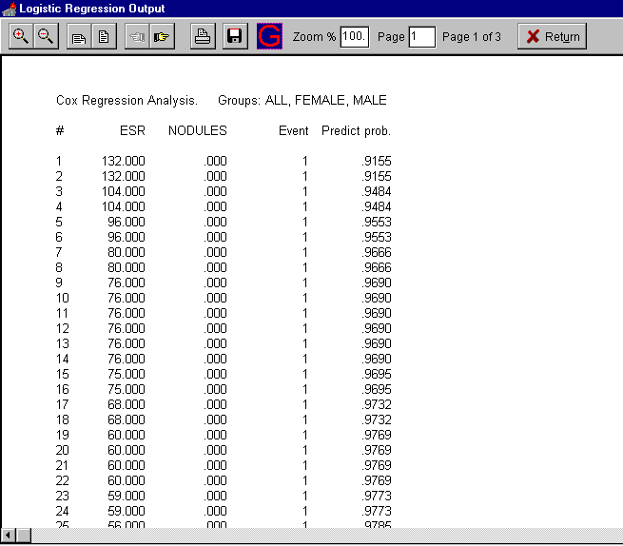
{bml 35-07.bmp}

Compute a predicted probability and confidence interval
When you choose this option, You must supply values for the covariates. (The predicted probability is the quantity obtained by plugging the covariate values you supply into the regression equation). You can set a percent confidence coefficient between 75 and 99. LOGREG will display the predicted probability and a confidence interval for the probability.

Figure 35-8. Predicted probability
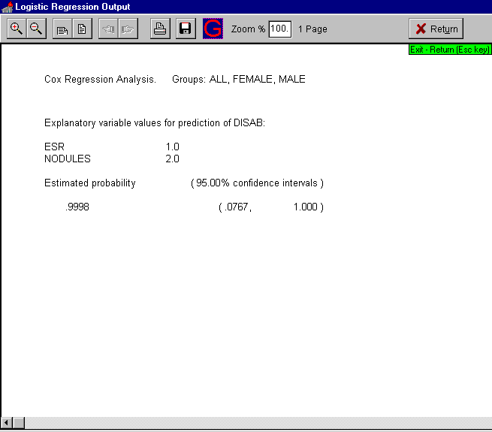
{bml 35-08.bmp}

Error Messages
A computational error has occurred which prevents further processing. Certain data conditions can cause the computation to fail. Possible causes are:

- Too few observations, with the number of covariates begin used.

- A high correlation between covariates.

- Nearly all values of a covariate are equal to the same number.

All observations are event occurrences. The regression analysis cannot be performed.

All values of (variable name) are equal to (number). The regression analysis cannot be performed. All values of a covariate are equal to the same number.

Convergence to a solution was not obtained.
See “A computational error . . .” above for possible causes of failure to converge.

The information matrix is singular, due possibly to a linear relation among the covariates. The regression analysis cannot be performed. The most likely cause of this condition is a linear relation between covariates (for example, $X_{1}=2X_{2}+1$ ).

The number of observations is not sufficient to perform the analysis.
There are fewer than 2 observations available for the analysis.

There are no event occurrences. The regression analysis cannot be performed.
%PageBreak.

#$K Copy Databank

Purpose of COPY DATABANK
The COPY DATABANK (Copier) program copies the contents of one databank to a new databank. In the process of copying the databank, the COPY DATABANK program checks the databank linkages and, if necessary, corrects any errors. Another purpose of this program is to make a copy a only a portion of the current databank. This could be useful if the databank has patients who are no longer needed or if some of the current databank should be archived.

Who should use COPY DATABANK
COPY DATABANK should be used by anyone who needs to make a copy of a databank or needs to re-establish databank record linkages caused by machine failure, etc..

How to use COPY DATABANK
Figure 36-1. Copier program
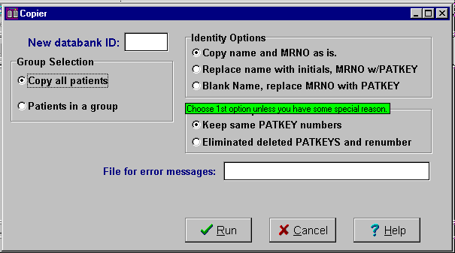
A new three letter databank ID is needed.

This is the destination databank. The source is always the current (active) databank.

{bml 36-01.bmp}

If you wish to retain the original name of the databank, create a temporary databank. After you have tested the new databank and are sure that it is correct, you can delete the original and rename he new databank with the original databank's ID. The renaming is done with simple Windows features (like explorer or “my computer”), outside of MEDLOG.

After you have entered a new three letter databank ID, you will normally use the defaults of “Copy name and MRNO as is”. The only reason to choose one of the other identity options is to remove sensitive information before sending the data to someone who is not authorized to see information such as patient names.

The PATKEY default is to keep the existing patkeys without renumbering.

If you want to remove the keys used by deleted patients, you can ask for the option to “Eliminate deleted PATKEYS an renumber”. Do not do this if you typically refer to patients by patkeys since the keys will change. Also do not use this option if you are using the missing value tracking function because it keeps track of missing data by the patkey.

Unless you chose the option to “Copy patients in a group”, all the patients will be processed. If, for example, wanted to separate the current databanks into two databanks based on two groups, you would run copier twice, once for the first group, then for the second. The original databank could then be archived or deleted (after testing the new databanks to make sure everything looks good).

Any messages and reports of errors will be displayed in a message box which may be printed. You may also specify a file for this information, but that is probably not necessary unless you are running COPY DATABANK from a command file.
%PageBreak.

#$K Merge Data

Purpose of Merge
The MERGE program can combine analysis data from two different groups, either from the same extract file or different files. This is necessary when dealing with particularly difficult specifications or when the data must come from different databanks. The MERGE program is used to prepare data for analysis. If you need to combine data from different databanks for more general purposes, use the BUILD program

Who should use Merge Data
MERGE should be used by anyone who needs create a file containing certain patients or of specific information that cannot be done with the EXTRACT program alone.

How to use Merge Data
Because the data to be merged must be in extract files, the EXTRACT program, see Chapter 22, must be first. Depending on the type of merging to be performed, you may need to run the EXTRACT program more than once. This will described in detail later.
Figure 37-1. Merge Data program
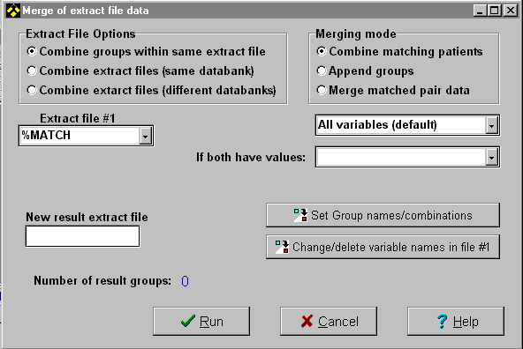
{bml 37-01.bmp}

Extract File Options

Combine groups within same extract file (option 1)
This option is used to combine data within the same extraction file. Depending on the Merging Mode, you are able to combine records (combine matching patients mode) or concatenate groups (append groups mode

Combine matching patients
For example, suppose we wanted to study data from two events in each patient's treatment course. Using the GROUP program and marking only the encounter that corresponds to the event in question may identify each the two events. The EXTRACT program could then be used to examine data that corresponds to the marked encounter for each patient. In our example let group X be the first event and group Y be the second event. Then PAIN.1M would represent pain at the first event in group X, but pain at the second event is group Y. Using the renaming facility (described later) we could rename this variable PAIN.2M in group Y, so that the combined group would contain the variables PAIN.1M and PAIN.2M. Subsequent analysis could examine the change in pain levels. It should be noted that most types of analysis can be done by marking the two events (using GROUP criteria or Boolean groups) directly. If this is not possible, the MERGE program should be the tool used.

Append groups
This option is similar to matching patients, except that no matching process is performed. If two groups with 30 and 47 patients are merged with this option, then the resulting group will have 77 patients. One of the reasons for using this option is to combine extracted data that is taken from different encounters (events) on the same patient. For example, a study of knee surgery might combine the data from both knees, if patients received two different surgical procedures at different times. In that way, patients with two procedures would count as two observations for analysis purposes. There are some statistical concerns about doing such things.

Please note that this option is very similar in function to the “split variables” option in the EXTRACT program. It will handle situations that are too complex for split variables.

Combine extract files (same databank) (option2)
This option is identical in operation to option 1, except that the groups being combined will come from different extraction files from the same databank. As with option 1, the records to be merged are determined by the Merging Mode selected.

Because this option deals with two extract files, there is a second Extract file drop-down dialog box/list and a second Change/delete variables names option.

Combine extract files (different databanks) (option 3)
This option is identical in operation to option 2, except that the extract files being appended are from different databanks.

Also, note that to select Extract file #2, click on the locator button.
Figure 37-2. Finding an extract file.
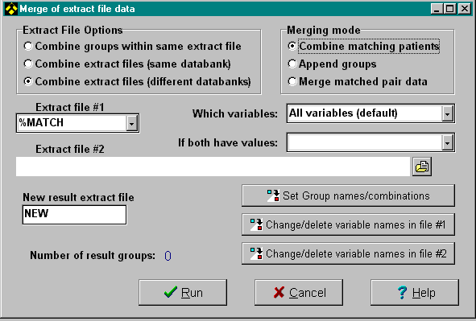
{bml 37-02.bmp}

Merge match pair data
This mode is used to compute differences in a case-control extract file see the Casematch program for more information. A computation mode must be chosen, this is illustrated at the end of this chapter.

Which Variables
When different extract files are used, you may choose to take all the variables (from either extract file) or limit the output to only the variables in one of the two extract files.

If Both Have Values
When merging data (combine matching patients) it is possible that both extract files have recorded data for the same variable. In such a case you can specify which extract file has the priority. That is, you can choose which value to keep and which will be discarded. If only one file has a recorded value, that value will always be taken regardless of the priority setting.
Renaming Variables
When extract files are combined, it is possible to rename variables. In the case of merging groups within the same extract file this is not likely to be used. However, when merging from different extract files, you may want to rename some variables in one or both of the participating extract files. One reason to do this is so that variable XXX in the first extract file will correspond to variable YYY in the second extract file. The renaming options will allow one or both variables to be renamed so that they will represent the same thing when merged.
Figure 37-3. Change/Delete variable
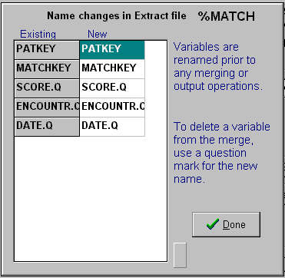
{bml 37-03.bmp}

Set Group names/combinations
When you combine extract files, you must specify which groups are to be combined. You can also keep groups that are not combined, but merely copied from the existing extract files. For example if two different extract files are used, and the first contains groups AAA and BBB, and the second contains group CCC, you could combine AAA+CCC to make a new group DDD. Along with group DDD could also include groups AAA, BBB and CCC in the resultant extract file. Remember that an extract file can contain a maximum of eight groups.
Figure 37-4. Merge extract file data
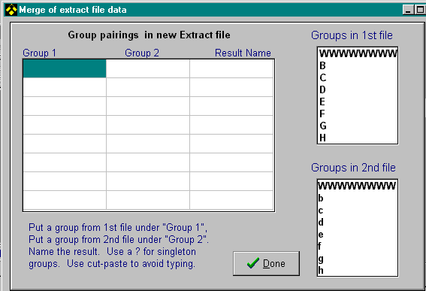
{bml 37-04.bmp}

Computation Mode (applies to match-pair extract file only).
When an extract file is produced by the CASEMATCH program, it contains two groups, one for the controls and one for the cases. The MERGE program is used to make a new group containing data that is computed from the differences between the cases and the controls. This new group can then be used in the analysis programs. The method of computing the “differences” is selected from the choices shown below.
Figure 37-5. Contrast computation
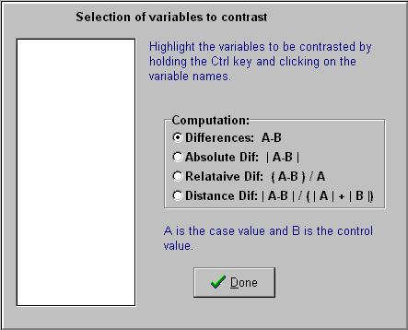
{bml 37-05.bmp}
%PageBreak.

#$K Build Databank

Purpose of BUILD DATABANK
The BUILD program allows you to take two databanks, and combine them to form a new databank. You may choose all of the patients in a databank or only those in a specified group. The two databanks may be combined by matching medical record numbers or concatenated by simple addition. Variables may be renamed or matched.

Who should use BUILD DATABANK
BUILD should be used by anyone who wishes to combine two existing databanks, forming a new one.

When to use BUILD databank
BUILD may be used anytime when you have two databanks and want to combine them. Since BUILD takes all data from the entry files, you do not have to use EXTRACT before use. However, if you are taking a specific group of patients or encounters from a databank, you will have to form these groups first.

How to use BUILD DATABANK
Figure 38-1. Build Databank program
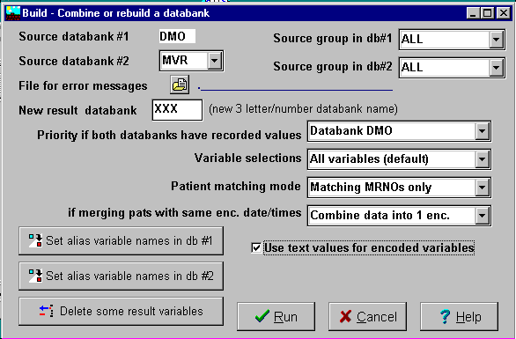
{bml 38-01.bmp}

Source Databanks
The current databank is always assumed to be the first source databank. You will be required to enter the ID for the second databank and the new destination databank. The source databanks must already have patients, and the destination must be empty.

Group selection
For each of the source databanks, you are required to select the Group to be used. Group ALL will cause all data to be used.

Error messages
If you want to save any error messages produced during the build process in a file, you can supply a file name. Any error messages will appear in a message box which can be printed.

Databank priority
The type of variable that is to go into destination databank will be determined by the source databank that has priority. One exception to this rule is that if the type of either databank's variable is a float type, the resulting type will be extended float regardless of the normal priority setting.

The other function of variable priority is to determine which databank's value will be used during match building (combining databanks based on patient medical record number). Match building allows encounters to be overlapped; the values in matching encounters are taken from variables with priority. If a matching variable is missing from either databank, and a value other than missing exists in the other databank, that value will be used.

Example: (with priority given to source databank 1)

databank 1 databank 2 Destination
23 4.56 1.23
44.432 0.01 44.432
5.55 5.55 5.55
? 2.22 2.22
? ? ?

Variable selections

All variables (default)
If you would like all variables from both databanks to be used in the destination databank, select this option. Any variable with matching names will be placed in the destination databank only once, with the type determined by variable priority as set by the databank priority.

Variables in current databank
This option selects all variables that are in the first databank and any that match from the second. All variables from the second source databank that do not match any of those in the first source databank will not be included in the destination databank. Any variable with matching names will be placed in the destination databank only once. The variable type is determined by the variable priority selected.

Vars from db #2
This option selects all variables that are in the second source databank and any that match from the first. All variables from the first databank that do not match any of those in the second will not be included in the destination databank. Any variables with matching names will be placed in the destination databank only once. The variable type is determined by variable priority selected.

Vars common to both
Variables that exist in both source databanks, and only those variables, will be placed in the destination databank. Any non-matching variables will be eliminated. Types of resulting variables are assigned according to the variable priority settings.

Vars unique (not common)
All variables that do not match name in the source databank will be used in the destination databank. All matching variables will be eliminated.

Modify variable names from first source databank
This option allows you to change the names of any variable in the first databank before matching takes place. Its purpose is to allow you to separate variables having the same name in both databanks, or to match up variables with differing names. Matching is performed after variables have been renamed.

Click on the “Set alias variable names in db #1”.

Figure 38-2. Change variable names
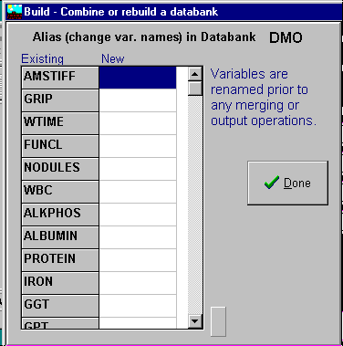
{bml 38-03.bmp}

Click on the variable name you want to change and enter the new name (alias). Click on Done when complete.

Modify variable names from second source databank
Use the same process used for the first databank.

Patient matching mode

Concatenate, no merging
This is the simplest function of BUILD. It allows you to create a databank with consists of the first source databank appended by the second. No checks will be made to see if there are duplicate patients in the source databanks.

After the build is complete, you will see the total number of patients in the newly formed destination databank the number of variables in its dictionary.

Matching MRNO's only
Matching patients will be the most common use of BUILD. This allows you to combine the two source databanks so that patients with the same Medical Record Number will have their encounters combined. The destination databank contains all encounters of each patient whose MRNO matches in both source databanks. If the encounter dates for both databanks are the same, the build may combine the encounters in either of two ways:
Method A:
Two encounters will be added to the destination databank, one from each source databank. You may specify which databank will be added first.
Method B
The encounters will be combined to form a single encounter in the destination file. The data values for any variables, which exist in both source files, will be output according to which databank has priority. For these matches, the value in the destination databank will be taken from the source databank with priority. The value in the other databank will be ignored. One exception to this rule is when value in the source databank with priority is missing. In this case the value will be taken from the other source databank.

For example, when priority is given to the first source databank:
Source 1 Source 2 Destination
1.23 5.678 1.23
1.11 ? 1.11
? 2.22 2.22

The method of dealing with identical encounters, is chosen by the “If merging pats with same enc. date/times” selection box. When encounters are not to be combined, but duplicated, you are able to specify the order in which the encounters will be placed in the resultant (destination) databank

Match MRNO's, add rest
This method is like the “Match MRNO” above, except if on match occurs, then the patient data is copied to the destination databank, regardless of which databank had this “loner.

Use text values for encoded variables
Normally, matching encoded variables are assumed to have the same encoding string (or at least the same meaning for each encoded value). If you will be matching encoded variables with different encoding strings, then select this option. This mode should only be selected if you really need it, since it will take several times longer to process a databank

Consider a variable in the first source databank which has an encoding string:
A\B\C\D\E\F
and a matching variable in the second source databank, which has an encoding string of:
F\E\D\C\B\A

If the selection box is not checked (the default), this variable's values will be incorrect from one of the databanks (the one which does not have priority). Without the option selected, the numeric values will be used as they are, disregarding the difference between the position of letters in the two encoding strings.

If the option is selected, the encoding strings are taken into account instead of numeric values. This allows the two variables above to be matched correctly, even though the positions of the letters differ. This operation will slow down processing, and thus should only be used when required.

Delete resulting variables
You may remove any variable from the destination file with this item.

By pressing on the “Delete some result variables” button, you can delete one or more variables.

Using the New Databank
When the build process is completed you will see the resulting databank specifications. BUILD only copies the databank essentials, the dictionary and the entry file data. You must copy forms, reports, etc if you want. Use Windows facilities to copy the appropriate folders and files.
Figure 38-3. Build Databank results
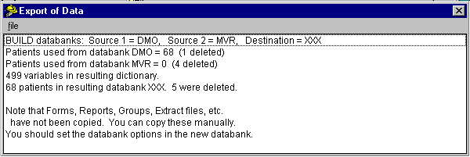
{bml 38-04.bmp}
%PageBreak.

#$K Remove Data

Purpose of REMOVE
REMOVE is designed to remove (delete) patient or encounter data and also permits the changing or insertion of encounter dates.

Who should use Remove
REMOVE should be used by (or under the direction of) the person responsible for the control and operation of the MEDLOG databank.

When to use Remove
Before you begin collecting data you may set the date format, databank description and other databank options. These may be changed at any time. After data entry has begun, REMOVE must be used to delete a patient or encounter.

How to use Remove
Figure 39-1. Remove: special deletion, insertion, or combining

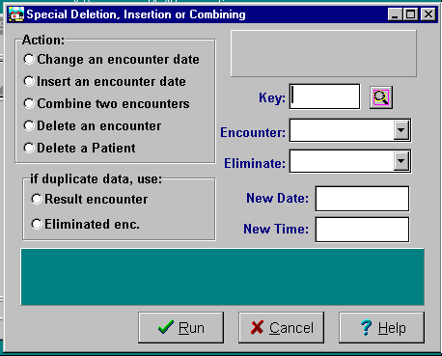
{bml 39-01.bmp}

Patient Selection
Begin by specifying a patient key. You must know the key of the patient before you use this program. There is a locate button next to the key field to help you find the desired patient.

After you supplied a patient key, REMOVE displays the name and medical record number to that you can verify that this is the correct patient.

Remove Actions

Change an encounter date
Select the encounter whose date is to be changed. Supply a new date (and time). If the date supplied changes the order of the encounters, they will be renumbered.

Insert an encounter date
FORM and ENTER normally allow you to insert encounters into the patient's file in any order. However, some databank administrators believe that this practice is a source of mistakes. Therefore they will set the databank option that prevents FORM or ENTER from inserting encounters that are dated before the last existing encounter. If this option is in effect, the REMOVE program must be used to insert a missing encounter.

Supply a new data (and time) for the inserted encounter. The values of all variables for the new encounter are set to missing (no values are propagated). Remove renumbers all encounters following the inserted encounter.

Delete an encounter
All encounters following to the deleted encounter will be renumbered.

Delete a patient
You can recover the resulting unused space in the patient file when you add a new patient by requesting a patient with medical record number 000000000 (9 zeros), and then entering the new patient's name, medical record number, etc. The space may also be recovered by copying the databank - see chapter 36.
%PageBreak.

#$K File/Text/Table Utilities
This program is described in three parts: File Utility, Text Utility, Table Utility.
Figure 40-1. Utility menu.
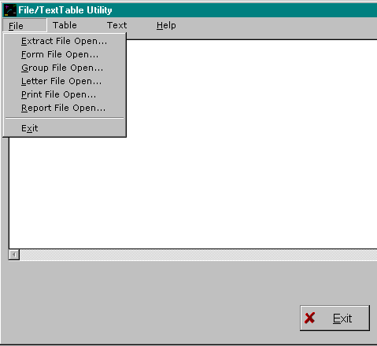
Choose File for renaming, copying, etc. various databank files, such as forms or reports.

Choose Text modify or examine the text values stored in text variables. See page 40-3.

Choose Table to examine or modify values stored in table variables.

{bml 40-01.bmp}

File Utility
After choosing File from the menu, choose one the file types you are interested in: Extract files,
Forms, Groups, Letters, Print files, or Report Files. Figure 40-2 illustrates an extract file choice.
Figure 40-2. File selection
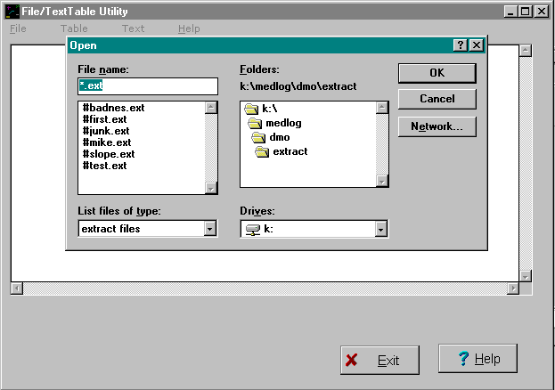
In this example, the “open extract file” selection was made. All of the extract files in the databank are displayed.

Select the file you want to view, copy or delete.

{bml 40-02.bmp}

After a file is selected, it will be displayed (if possible), and a menu will indicate other actions such as Copy, Rename or Delete.

Any of the actions in the File Utility can be performed by using Windows functions outside of MEDLOG. However, using “native” Windows functions are much more dangerous since it is possible, for example, to delete an entire folder. The File Utility limits you actions, and therefore is safer.

Text Utility
This program lets you examine all the values of text variables. You could use the Text Utility, for example, to examine all medications that have been used in your study. It also lets you change the spelling of a text value.

How to use TEXT UTILITY
After choosing Text from the menu, you are presented with two choices: “Open (Variable name)” or “Open(Storage file name)”. Remember that each text variable is assigned to an encoding file, but a single encoding file may be used for several variables.
Figure 40-3. Text variable selection
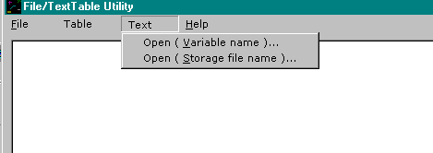
{bml 40-03.bmp}

Figure 40-4. Text variable listing or modification
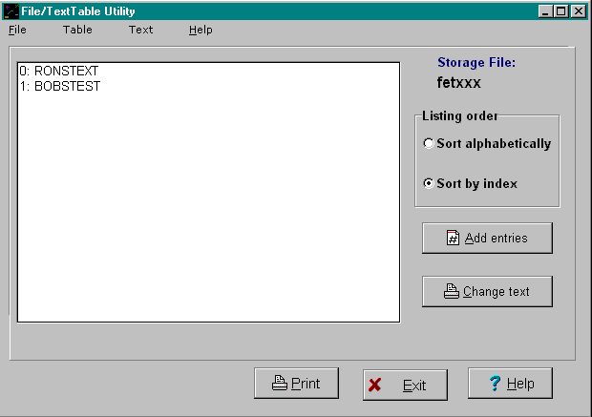
{bml 40-04.bmp}

After you have selected a variable or storage file, you may examine the text values. The values may be sorted in alphabetical order or displayed in the order they were added to the databank (index order). You may add new entries at this time or change the text of existing entries.

Be careful about changing text values: if several variables share the same encoding files, your text change may affect data for more than one variable. Also, if several patients have the same text response, changing the text value will change the text for all such patients.

It is not possible to deleted a text entry (because the index numbers cannot have gaps), but you can change it to something that looks like a deletion. A single underscore is suggested.

Table Utility
The Table Utility is similar to the Text Utility. Begin by choosing Table from the menu. Then choose whether you want select the table by the variable name or by the table storage file name.

Figure 40-5. Table variables
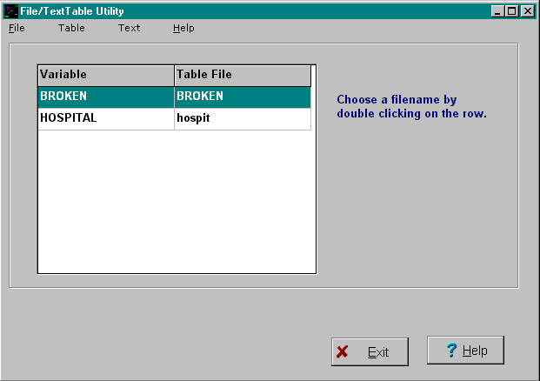
{bml 40-05.bmp}

After selecting the variable or table file, the table editor will appear as shown in figure 40-6.

Figure 40-6. Edit table variable
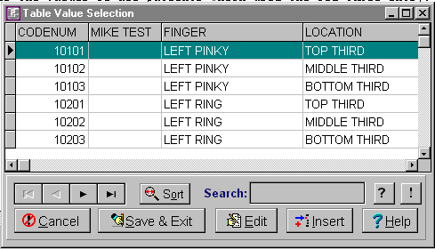
{bml 40-06.bmp}

The actions you can take with the table are the same as those available during data entry. The buttons with a question mark or exclamation mark have no function here.

You can add new entries to the table or modify existing entries. The same cautions given for modifying text values apply to table values. Your changes could affect more than one patient’s values.

To modify the structure of a table (add new elements, for example), the DEFINE program must be used.
%PageBreak.

#$K Edit Extract Data

Purpose of EDIT EXTRACT DATA
The program is used to modify values of variables in an extract file. The program uses the Excel system to the actual editing and modification. Note the EXTRACT program has capabilities to compute new variables from other extracted variables.

Who should use edit extract data
It should be used, as required, by anyone performing data analysis in the MEDLOG system.

When to use edit extract data
This program requires an extract file, so it must be run after the EXTRACT program.

There are many reasons for modifying data prior to analysis, reports or export. For example, an outlier value can be remove to see the effect this has on a statistical result. It should be used to re-define new variables and calculate their values after using the EXTRACT program. Another example would be the addition of data which is not in the MEDLOG databank, but could be combined or used with a MEDLOG analysis program.

How to use edit extract data

After the extract file is selected, the available groups will be shown.
Figure-41-1. Choose an extract file
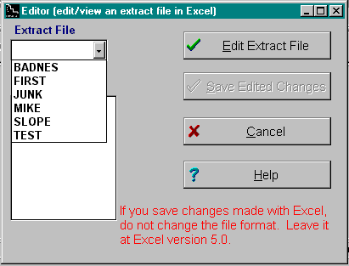
Choose an extract file.

Then choose a group to edit.

Click on Edit Extract File to invoke the Excel program.
{bmc 41-02.bmp}-----------------------------------------------------------------------------------------

Figure 41-2. Excel worksheet of Extract File
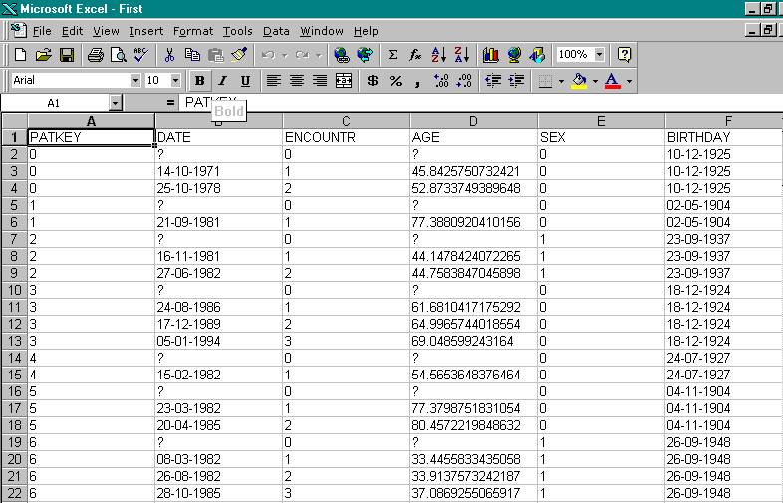
{bml 41-04.bmp}

Some familiarity with Excel is required to use its computational features. Editing is straightforward an can be done without any Excel experience.

Closing the worksheet will return you to the Edit Extract Data program where you can save the changes, by clicking on “Save edited changes”. Note that running extract again with this file will undo any changes made here.
%PageBreak.

#$K Casematch

Purpose of CASEMATCH
This is a specialized program which facilitates matched pair analysis of time-oriented data. The CASEMATCH program takes a group representing the cases and attempts to find a corresponding patient from the group representing the controls.

Who should use CASEMATCH
CASEMATCH should be to prepare for a match pair analysis of patients who are dynamically matched, based on matching criteria.

How to use CASEMATCH
Figure 42-1. Casematch program
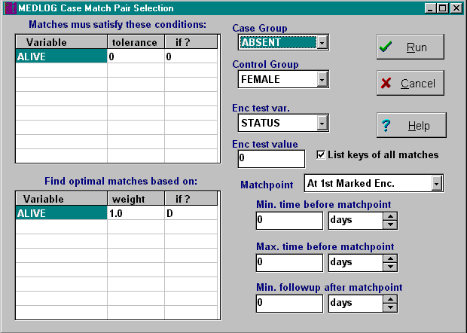
{bml 42-02.bmp}

You must select one group for the cases, and one group for the controls. For the program to operate correctly, these must be disjoint groups (no patients in common
The next step is to determine the minimal matching criteria. This is done by specifying up to eight matching variables. The tolerance sets a limit on now far apart a matched pair is allowed to be. For example, if the variable is AGE and the tolerance is 5 then matched pairs cannot have an age difference of more than 5 years.

If you have more than one matching variable, all conditions must be satisfied in order for a match to be made.

If the matching variable is missing, you may select a default value to be used for the match. This might be done, for example, if missing is the equivalent of zero. You may also specify that that a missing data item use the last recorded value from the patient’s previous encounters. It is also possible to have the program prompt you to supply a value for a missing data item, but this is seldom used.

The matching variables determine the minimal matching requirements. In order to find the best matches, you may specify optimizing criteria involving 1-8 variables. It is common for the optimizing variables to be the same as the match variables, but this is not mandatory. Each optimizing variable may be given a weighting value in order to place more importance on one variable than another. Like the matching variables, you may specify what action to take if the value of the optimizing variable is missing.

The "closeness" of the match is the square of the usual distance metric.
Dsq=sum((Case(i)-Control(i))**2) where Case and Control are the values of the optimizing variables.

If several encounters are involved in the optimizing process, the distance metric is the average of the encounters, so that the number of encounters does not bias the result. It is possible for a given case and control to match at several different encounters belonging to the control. If the closeness scores are tied, preference is given the lower encounter number of the control.

Time period
You may choose the time period over which the optimizing process will take place. The case group is assumed to have a marked event (e.g. the first surgery). The matching process can involve time at or just before the first marked encounter in the case group. The controls will consider all encounters (possibly restricted to a certain type of encounter) in order to find a qualified match encounter

The optimizing variables will be compared at or before the match point. You may set a minimum and maximum time span for this optimization process. You may also set a minimum time span following the match point in order to have sufficient follow up time for analysis purposes. Case and controls that do not have this minimum follow-up time span will be discarded.

Results
When the Run button is clicked, the program proceeds to automatically examine all data, find all possible matches, and find the "best" match by repeatedly choosing the cases that have only a single possible control, then choosing from the remaining cases the one which best matches a control. With each selection, the list of possible matches is pruned accordingly.

The final result is written to an extract file named #match#. It may be listed in MEMBERS or exported in COMMUNICATE. The final result also includes two new groups files: #CASES and #CTRLS. These groups identify the match-point encounter for the cases and the controls respectively.

Analysis usually requires that further group operations be performed to identify encounters of interest. The groups will usually use the #CASES and #CTRLS groups as source groups in order to identify the match-point encounters. The next step involves the EXTRACT program in retrieving values of various variables from the groups just formed. The extract file should have data from two groups, one for the cases and one for the controls.

The MERGE program has an option to handle the extract file described above. It uses this extract file and the #MATCH# extract file created earlier to pair the cases and controls correctly. You are then given an option to identify the variables that should be "differenced". These variables will be computed by taking the difference between the case value and the controls value. You may select from several computational method of expressing this difference. Variables not chosen will take their value from the case observation. The result is a third group in your extract file. The group name is assigned as DELTA.

Analysis of the changes can be done in the MEANS program (paired t-test on group DELTA) or in the NON-PARAMETRIC program. Or, you can export this data to another statistical package.
%PageBreak.

#$K Locate Utility (F4)

Purpose of LOCATE
The LOCATE program lets you identify patients who meet simple tests based on data stored in the databank entry files. It is most useful in choosing a patient for data entry. It may be activated in any program and may be thought of as a simple databank search tool.

How to Use LOCATE.
To use the LOCATE utility, press the F4 key. In a second or two, the LOCATE dialog will appear.

Figure 43-1. Locate program
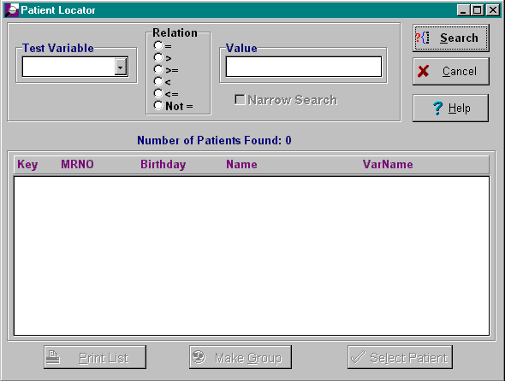
{bml 44-01.bmp}

You may identify patients using any variable in your dictionary and the built-in variables BIRTHDAY, CHANGED, DATE, ENTERED, FIRSTNAM, LASTNAME, NUMENC, STATUS, and TIME. The built-in variables appear in the selection list along with your dictionary variables.

The search will be made using data in you entry files. Therefore, it is not necessary to run CREATE in order to have LOCATE find your latest additions.

After you have picked a variable you must determine whether or not you want to test for an exact match or some other relationship. Next you will enter a value to be used in the test. If your variable is a text, variable, your test value may contain “wild cards”.

When searching a text file, either regular or file encoded, you can use special character to stand for “wild card” values. The question mark will stand for any single character. If the test value were a? it would match A1, A2, and so on. It would not match A by itself. The asterisk character will match any string of characters, including none. If the test value is an A*, it would match ANY, A1245, and A. The value *Y will match ANY, BYANMDBY and PRETTY, to name a few.

If one or more patients match your search request, their basic identification information will appear in a scrollable window.

Selecting a Patient
You should use the cursor to identify a particular patient. If you click on the Return button, you will return to the program you were using. Some programs, most importantly FORM and ENTER have a connection to LOCATE for the purpose of selecting a particular patient.

Search Results
After a search is completed, you have several options.
- Narrow the search.
The results of the current search will be used as the starting point for a new search. This, in effect, chooses patients who meet more than one test.
- Start a new search.
This discards the current search results and begins the next search fresh.
- Print the search list.
The current search results will be printed.
- Make an enumeration group.
The patient keys in the current search result will be put into an enumeration group. You must supply the group name.
%PageBreak.

$ Help(F1) and Information(F5)

#KHelp(F1)
This facility is really an on-line manual. If you in a program (not just a the main menu), you will be directed to the chapter of the manual which describes that program.

How to obtain HELP
Figure 44-1. F1 Help Key
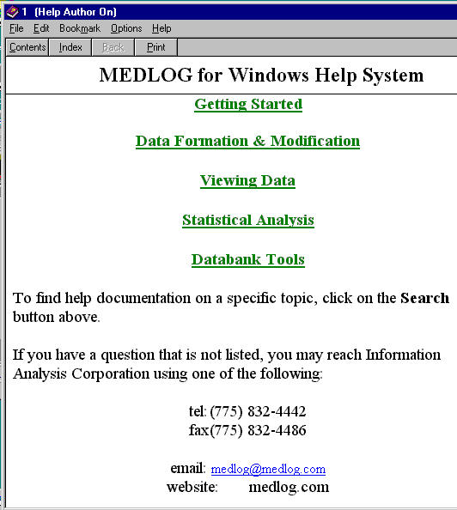
TTo see the available HELP topics, simply press the F1 key. In a second or two, the HELP menu of available help subjects will appear. Click on the appropriate topic to see more on the topic.

{bml 45-01.bmp}

Need more help?
The manual may not be sufficient to help you design a study or help you decide what analysis to perform. In such cases, there is no substitute for personalized help.

Information Analysis Corporation and its distributors are eager to help you when you are stuck. We can be reached at: telephone (775) 832-4442 or email at medlog@medlog.com
#KInformation Utility (F5)

This program is a “Hot Key” program -- it can be activated within any other MEDLOG program.
It provides information which may be useful in setting up other programs, for example, determining the units of a particular variable.

The tabs on the bottom of the window (see figure 44-2) represent the available information. Each tab is discussed separately below.
Figure 44-2. Information Utility, F5 key
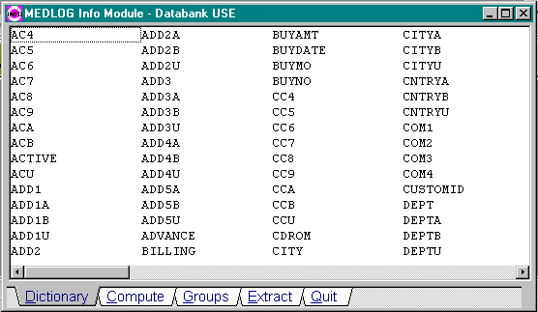
{bml 45-02.bmp}

Dictionary (shown above)
There will be many occasions when you cannot remember the name of a particular variable in your databank. You can use the CONTENTS program to test a complete dictionary listing, but that would mean leaving the program you are currently using. Instead, use this help selection to display a sorted list of all of your variables.
If you want information on a specific variable, double click on the variable, and you will be shown the variable’s specifications.
Figure 44-3. An encoded variable
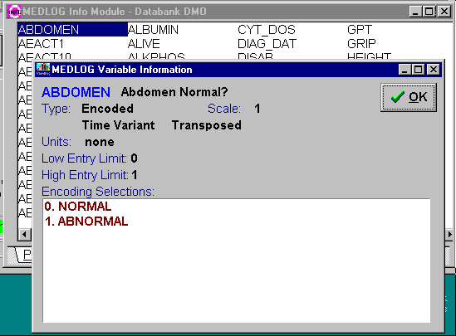
Note that the encoding table is displayed if the variable is encoded. If there are more encoding that will fit on the screen, you can scroll through the list.

{bml 45-03.bmp}

- Compute will display of all of the active compute statements.
Figure 44-4. Compute statements
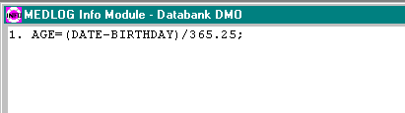
{bml 45-04.bmp}

- Selecting Groups displays information about the groups in the active databank.
Figure 44-5. Group info
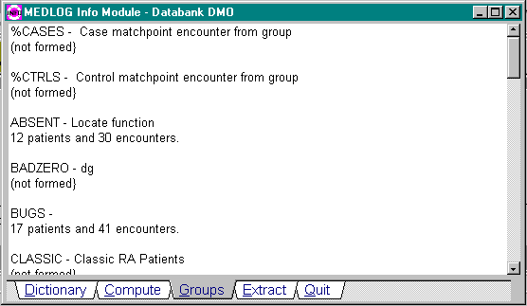
This lists the group names and titles. If a group has been formed, you will also see the number of patients and encounters in the group. It is helpful, for example, to see, without leaving the current program the group titles and contents at the same time you are displaying a set of statistics for several groups.

{bml 45-05.bmp}

- Extract files
Figure 44-6. Extract file info
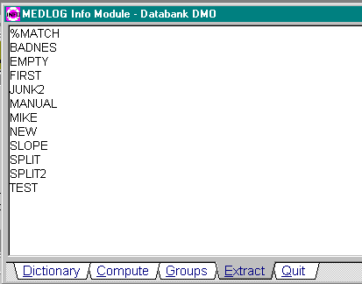
All extract files are listed.

Double click on a file to see the groups and variables in the extract file.

{bml 45-06.bmp}
%PageBreak.

#$K Edit Speedbar

Purpose of EDIT SPEEDBAR
EDIT SPEEDBAR creates shortcut icons on the main menu to speed up the selection of frequently used programs.

Who should use EDIT SPEEDBAR
The speedbar does not change anything in the databank and may be set by anyone. Note that the Speedbar is unique to the user ID for which it is set. In other words, each user may have his own speedbar.

How use EDIT SPEEDBAR

Figure 45-1. Main MEDLOG menu
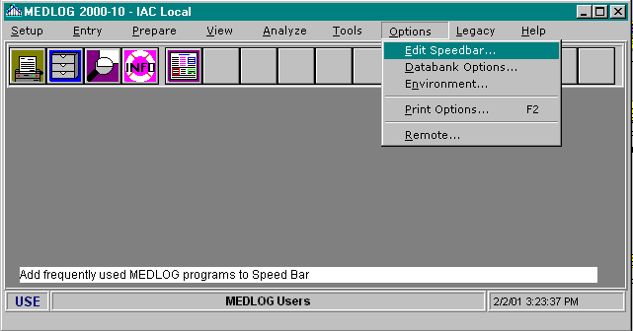
From the Options menu, select the Edit Speedbar program.

Note that there are four permanent functions on the speedbar:
Print Options = F2 key;
Command Files = F3 key; Patient Locator = F4 key; Info Utility = F5 key

{bml 46-01.bmp}

In the example above, the fifth icon represents the shortcut for FORM DATA ENTRY.

Figure 45-2. Edit Speedbar
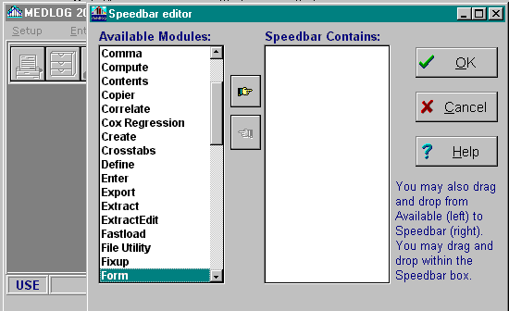
{bml 46-02.bmp}

Add programs to the speed bar by moving the name from the Available Modules to the Speedbar Contains list. A maximum of 12 programs be selected. The Speedbar list may be rearranged by drag and drop mouse actions.
%PageBreak.

#$K Print Options (F2)

Purpose of PRINT OPTIONS
PRINT OPTIONS enables users to select the printer options such as time and date stamps for printed pages. The options apply to most programs, but some like LETTER and REPORT have their own printer setup.

Who should use PRINT OPTIONS
The print options apply to the databank, so changes should be coordinated with other users of the same databank.

How use Print Options
This program may be reached in three ways: by pressing the F2 key, by selection from the main program Options menu or by clicking on the main menu icon that looks like a printer.
Make your selections and then Apply or Save the settings
Figure 46-1. Print options
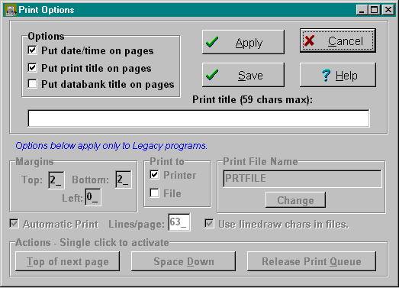
{bml 47-01.bmp}
After setting the options, click on either Apply or Save. Apply will not change the permanent settings; the new settings will be for this session only.

Many programs have an print symbol which is easy to recognize. You may also print most MEDLOG program screens by pressing Ctrl-F2. Alternatively, you can click on the system menu icon (upper left corner) and choose the print option.

The Legacy settings are used only by old versions of MEDLOG. They are no longer needed.
%PageBreak.

#$K Remote Data Transfer

Purpose of REMOTE
The REMOTE program is used for multi-site databanks. It evaluates a remote site's data files for changes and creates a summary file. At the central site REMOTE reads in these files and incorporates the changes into the central databank. During the course of a project, a remote site would send many of these “update files” in order to keep the central site current.

Who should use REMOTE
Since REMOTE is intended for use in projects where data is sent or received from another site, only someone who is in close contact with the other site should use it.

When to use REMOTE
If you are at a remote site, your use of REMOTE will depend on the volume of activity at your site, and the demands of the central site. The size of the update file generated by REMOTE depends on the number of changes that have occurred since the last file was created. If thousands of changes have occurred, the update file may become quite large. This could cause a complication if you are sending the file via diskette, and the file is larger than the diskette's capacity.

If you are at the central site, you will use REMOTE whenever you receive an update file from one of the remote sites. However, you are not required to do this immediately. If the updated data is not yet needed, you may collect several updates and read them all at once. REMOTE keeps track of the order of the update files.

How to use REMOTE
For REMOTE to work correctly, all sites must have the same databank ID and have dictionaries with identically defined variables. The dictionaries do not have to be identical, only the variables that will be transmitted. In other words, the variables that will be sent to the central site must have identical names and types as those at the remote sites. The best way to ensure this is to design the dictionary at one site (most likely the central site) and send it to all the other sites. The dictionary files are in the databank's defines directory. Once a site has a copy of the dictionary files, it may add more variables. If added variables are to be transmitted, the central site must make the identical additions.

REMOTE distinguishes patients by the medical record number. In order for REMOTE to work correctly, MRNO’s must be used. In addition, all MRNO’s must be unique. The best way to ensure this is to set the option in the VERIFY program to prevent entry of duplicate medical record numbers.

Limitations of REMOTE and Inconsistencies
REMOTE is capable of handling a very active databank. The following actions are not a problem for REMOTE:

Deleting patients
Deleting encounters
Changing an encounter date
Inserting encounters between existing encounters

However, cases may arise where REMOTE is unable to resolve what has happened since the last update file was created. These inconsistencies will only become apparent when the central site is incorporating the update file. Inconsistencies that cannot be solved arise when one of the actions listed above occurs along with some other related action after, but on the same day, an update file was prepared. For example:
- An update file is created at 10 am.
- At 11 am a new encounter is entered into the databank.
- At noon it is determined that the new encounter should be deleted from the databank.
- The next day another update file is created.

REMOTE does not know the order that the events occurred the day before, so to play it safe it will tell the central site to delete the encounter. But, since the encounter was never entered into the central site's databank, an inconsistency that the system cannot resolve will occur.

The central site will attempt to delete an encounter it does not have. This will generate an error message at the central site during the incorporation of the update file.

In this particular example no harm is done by this miscommunication, but cases may arise where data is compromised. The only safe action to take after a warning of this type is to request a complete re-transmission for the patient in question.

Remote Site

Initial Setup of REMOTE
Click on Remote on the Options menu of the main MEDLOG menu.

If REMOTE has never been used before, Figure 47-1 will appear. You will have to indicate by clicking on the appropriate radio button whether the site is the remote site or the central site. It also needs a Site ID that uniquely identifies the site. The Site ID, like the Databank ID, is three characters. All sites involved in a project must agree upon the Site ID’s. The Site ID should be different from the databank ID.
Figure 47-1. Initial use of Remote
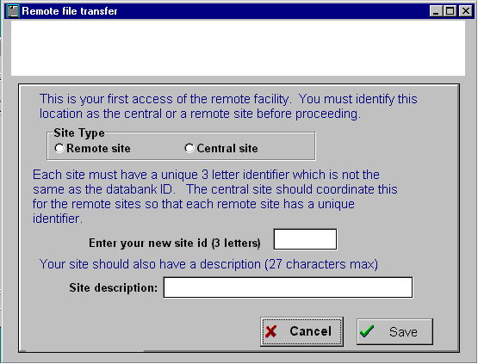
{bml 48-01.bmp}

If the site is designated the Central Site the first time Remote is used, the system will respond as shown in Figure 47-2. Click on the OK button to establish the Remote Sites ID's and descriptions. All remote sites must be identified before their transmission can be accepted by the Central Site.

Figure 47-2. Initial setup of a central site
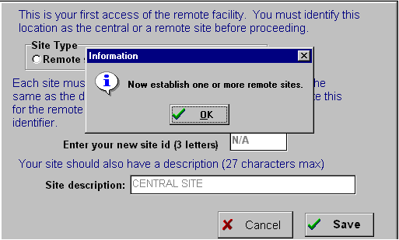
{bml 48-02.bmp}

Figure 47-3. Remote site assignments
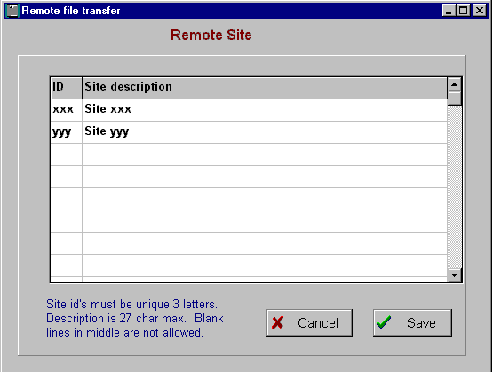
The remote site ID's must not be more than 3 characters long and should not be the same as a databank ID.

The Site description can not be more than 27 characters long
{bml 48-03.bmp}

The next steps are different for the remote and the central sites. If you are the central site skip ahead to the section titled “Central Site”.

Setup for Remote Site

Edit this site description
If the site is designated as a remote site the first time REMOTE is opened, the Site ID and Site Description must be entered as in Figure 47-1.
Figure 47-4. Remote site menu.
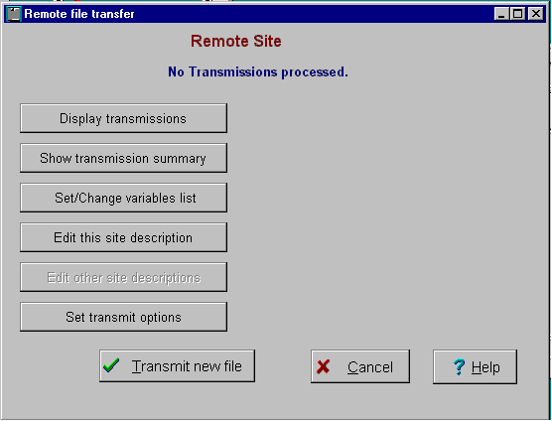
Thereafter a remote site will see this dialog.

Clicking on the Edit this site description button will allows the modification of the site ID and description.

{bml 48-04.bmp}

Preparing an Update File

Set/Change variables list
A remote site must indicate which variables will be sent to the central site. While it is typical to transmit all variables, it is not required. This allows a remote site to keep track of variables which are not of interest to the central site.
Figure 47-5. Select transmission variables
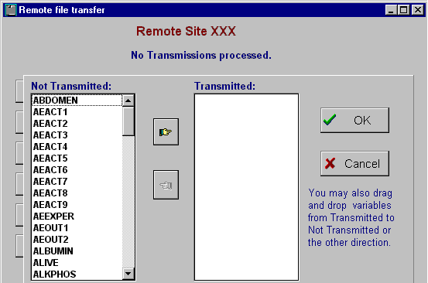
Variables can be selected individually by clicking on the variable and then clicking on the move right button.
You can also move multiple variables by dragging and dropping the variables, holding down the Control key and clicking on the desired variables and then clicking on the move right button.

{bml 48-05.bmp}

Transmission options
Clicking on the Set transmission options button will open the following dialog box, Figure 48-6. Follow the instructions for the dialog boxes to meet your transmission requirements.
Figure 47-6. Remote transmission options
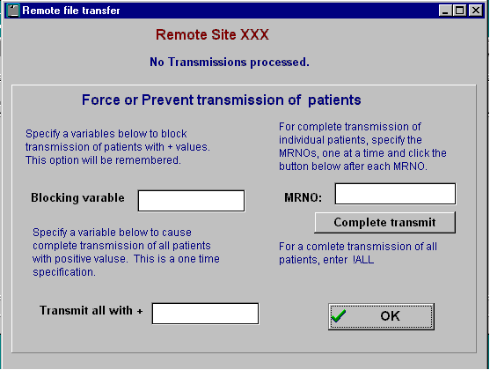
{bml 48-06.bmp}

Blocking variable
Patients will a positive value for this variable will not be transmitted.

Transmit all with +
By default, REMOTE transmits information for all patients in a databank. It may be desirable, however, to transmit from a remote only a subset of the patients. In such cases, a variable may be used to flag a patient as one to be included in remote transmissions. The name of the variable is supplied to REMOTE by selecting the “Patient Flag Variable” from the REMOTE Options/Setup menu (only available on remote sites). Enter the name of the variable. The variable must be “time invariant” and already in the dictionary. If the value of the variable is positive, the patient will be included in transmissions. If the value is negative, zero or missing, the patient will not be included.

MRNO
Complete transmission of the specified MRNO's.

Complete transmit
Specify !ALL to transmit all patient records. Warning -- this could be a lot of data. Do this only if necessary.

Transmit new file
When the available options have been set, click on the Transmit new file button, Figure 49-4, to produce the transmission.

Transmission Summary
The results of the transmission are summarized in a listing, Figure 47-7.
Figure 47-7. Transmission summary
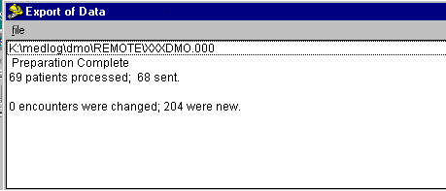
{bml 48-07.bmp}

Transmission Listing
If you want to verify that the transmission has been executed completely, you can click on the Display transmissions button, see Figure 47-4, to open a similar window that will display a Transmission list. See Figure 47-8 below.

Figure 47-8. Transmission list
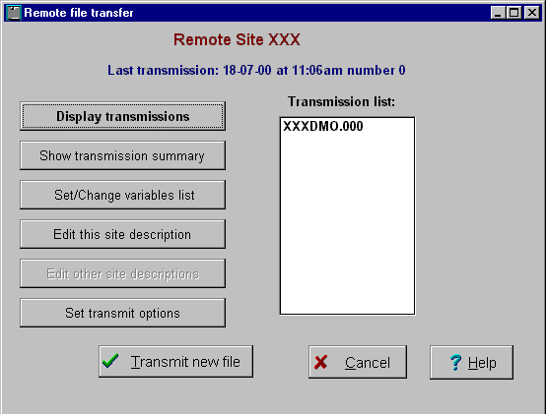
The transmission list items consist of the:
Site Id (XXX)
Databank ID(DMO)
And Sequential file # (000)

{bml 48-08.bmp}

Once the Update file is prepared, you may copy it to another directory or disk. You will most likely send the update by floppy diskette or modem with your communications software. Take note of the size of the file. If you are copying to a diskette and the file is larger than the 1.44 MB diskette capacity, you must use WinZip or similar programs, or use a large capacity disk products such as the 100MB zip cartridges. .

Once the copying is complete, the update file information is displayed again. See Figure 48-6. Press the Escape key to return to the REMOTE menu. Press the Escape key once more to return to the MEDLOG main menu. Subsequent uses of REMOTE will immediately display information about the time, date and number of the last update file.

Central Site
When Remote is invoked, only one site may be the Central Site designated by the button labeled Central site.
Figure 47-9. Central Site
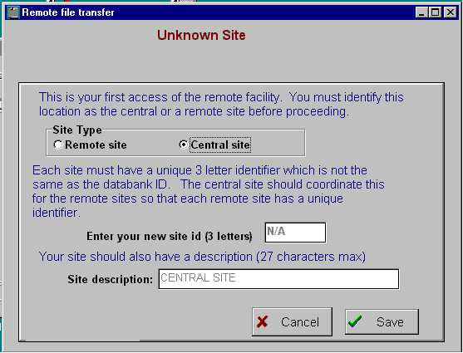

No site I.D. or description is needed for the Central Site.

Once the selection of “Central site” is made, it may not be changed to “Remote site”.
{bml 48-09.bmp}

When Remote is used the next time, the file transfer menu, Figure 47-10, will appear. The remote sites in the Site list. If no remote sites have been set, Remote will require you to identify at least the site from which you can receive data.
Figure 47-10. Receive transmission menu
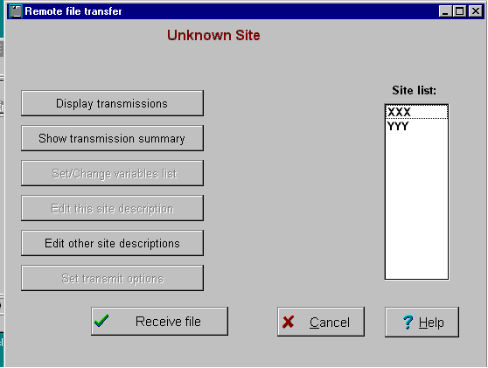
{bml 48-10.bmp}

Loading an Update File
In order to load an update file from a remote site, click on the Receive file button.

At this time, if you have identified the remote sites, the site list will appear. You can add new sites by clicking on the Edit other sites descriptions button.

Loading an Update File at the Central Site
In order to load an update file from a remote site, select the first menu option, “Incorporate Update file”.

Choose the site that sent you the update. If you have put the update file in the REMOTE folder of your databank, the program will know which file to load and will begin processing. If REMOTE does not find the update file in the REMOTE folder, it will ask you for the path to the update file. It will then copy of the file into the REMOTE folder and begin.

During the loading of the update file you will see the progress of the operation. The loading process cannot be interrupted.

If the update file is very large and you have a slow computer, the process may take quite a while. The display will give you an idea of how long it will take. In most cases, however, the process should take very little time.

Complete Transmissions
REMOTE accomplishes its task by sending and receiving only changes that have taken place. Occasionally, however, there may be instances when all information about a patient needs to be transmitted. In such cases select the “Complete Transmission” option from the REMOTE Options/Setup menu (only available on remote sites). Enter the MRNO of the patient who requires a complete transmission. When the update file is created, all of the data will be sent for these patients. In practice most users will never need this option. If it is used unnecessarily it will not harm anything, but it will make the update file larger. For an understanding of when this option is useful, see the next discussion on the limitations of REMOTE.

Technical Discussion
The way that REMOTE determines what needs to be in an update file is straightforward. If any changes to an encounter have occurred since the last update file has been sent, the entire encounter is sent. Since patients are distinguished from one another by MRNO, it is important that each patient's MRNO be unique. In addition to recording values that change, REMOTE must also keep track of the databank structure at the remote site.

The most common structural change will be the addition of a new encounter. When the central site receives information on an encounter that it does not have, it creates a new encounter for the patient. The way that it determines whether or not it has received a new encounter is by checking the encounter number. If the encounter number is one greater than the largest encounter number at the central site, the encounter is added at the end. If it is any larger, an irresolvable inconsistency warning will appear. If the encounter is equal to an existing encounter number, but is dated before the existing encounter, REMOTE will insert the new encounter before the existing encounters and renumber all the following encounters. It must be dated before the encounter with the same number; otherwise an irresolvable inconsistency warning will be generated.

Other changes that can occur to a databank are:
Deleting patients
Deleting encounters
Changing an encounter date

These are called exceptions. Exceptions are actions that do not occur often, yet need to be communicated to the central site. Unlike the update file that is created at a specific point in time, these exceptions need to be recorded as they happen. The remote site, therefore, keeps track of these exceptions in a file, REMOTE.XCP, in the REMOTE subdirectory.
%PageBreak.

#$K Technical Overview

Operating System
MEDLOG for Windows is a medical information system that is designed for use on Personal Computers using Microsoft Windows as the operating platform. MEDLOG will not run on Apple computers.

Programs and files
MEDLOG consists of several programs and several related files. The programs are activated when they are selected using the main menu taskbar. Most programs consists of two parts: the user interface where parameters are set, and the engine portion which processes the requests. By designing the system this way, changes are easier to make to the interface and the engine portion can be used by itself (with command files).

Databanks
A Databank is sometimes called a database. MEDLOG will support any number of databanks - limited only the total disk storage capacity on a single computer or on a network server. Passwords can be used for data security.

File names and subdirectories
A complete list of the file names and subdirectories is found in Chapter 54, File Organization. You may wish to review this material before proceeding. All MEDLOG programs read one or more of the MEDLOG files. The files describing variables are in the DEFINES folder. The data itself is in the ENTRY folder. Other folders hold forms, reports, compute statements, etc.

Data Dictionary
The DEFINE program creates the dictionary files and provides the capability of modifying the variables. The entries in the dictionary determine the attributes of the variables and their physical location. Some of the attributes, such as long names, can be changed at any time without affecting the data already collected. Other attributes such as size, scale, and location may affect data already collected. The system will change existing data to agree with the current contents of the dictionary.

File Linkage
Three of the data files are linked together via record pointers. patsfile contains the beginning or root records for each patient. It contains a pointer to ENCSFILE which holds a record for each encounter. The ENCSFILE records are linked together by forward and backward pointers (double linked list). Each ENCSFILE recorded can contain pointers for up to 25 DATAFILE records. Most numeric data is stored in DATAFILE.MED. Table variables are stored in Paradox files (suffixes like .PX, .X01, .Y01, etc) Text data is stored in files with suffixes .VTX. Notes are stored in files with suffixes .NTX.

The records in TEXTFILE, ENCSFILE and DATAFILE all contain a linkage back to PATSFILE. This provides a simple and effective check on file integrity

The data in DATAFILE consist of scaled integers of one or two bytes and four byte floats (IEEE Standard). The one-byte variables are unsigned integers, ranging from 0 to 253. The values 254 and 255 are reserved for missing values. The 2-byte variables have a range of –32,760 to 32, 760 in the case of integer values.

The 2 byte variables (except those for file encoded text) are “shifted up by 32,756”, so that 65,646 and 65,636 are used for missing values. Four byte float variables have a range of-1.0E37 to +1.0E37 with six places of accuracy. Dates are stored as signed two byte integers representing the number of days from 1 Jan 1960. Coded variables are stored as 1 byte values. The decimal numeric variables can have a scale factor that is a power of 10 from –7 to 7.

Data stored in the transpose file, VARIFILE have the same format, except that “shifted” 2 byte values are restored to their true values. The format for file encoded text variable is too involved to be covered thoroughly in this brief overview. Those variables are processed via index records and hash file entries.

Time-of-day variables are recorded as the number of minutes (+/-) from noon. Notes are recorded as four byte pointers into text files.

Table entries are recorded as a two-byte index for data stored in Paradox files.

Data Entry
The FORM program defers the update of the files until the last possible moment, when all of the related files can be updated at the same time. For example, if a new patient encounter is added, PATSFILE has the pointer to the last ENCSFILE record changed. ENCSFILE adds a new record which contains pointers into DATAFILE, and DATAFILE will add from 1 to 25 new records. All of these records are kept in memory until data entry for the encounter is complete. Then they are written, or rewritten, in a few milliseconds. This technique reduces the vulnerability of the files to hardware failures and allows the addition or update of an encounter to be aborted at any time up to the completion of data input.

Transposed Data
The order and format in which data are stored in the files used by the data entry programs are not well suited for the retrieval except by individual patient. Therefore, the data files are transposed by the CREATE program into a format where each record holds a single variable’s values for all patient encounters. Mapping records at the start of the transpose file, VARIFILE identifies the starting records for each variable and which patients and encounters the values belong. VARIFILE also contains a copy of the dictionary specification for all of the transposed variables.

The transpose file is used as the data source for three important MEDLOG programs: COMPUTE, SELECT, and EXTRACT. COMPUTE creates new variables by evaluating expressions containing existing variables. It allows expressions up to a maximum length of 128 characters. The operands are +, -, /, *, and ^ exponentiation). All of the usual trigonometric and arithmetic functions are included and nested parentheses of any level are allowed. Care is taken to propagate missing values. The expressions for 1500 computed variables can be stored, modified, and executed. Variables, which are computed, can be recalculated by subsequent compute statements, but the variables from the data entry files are protected from modification. Once a compute variable is created, it exists in the TRANSPOSE file just as the “raw data”.

Patient Groups
Returning now to our discussion of the programs that read the transpose file, we come to SELECT. This program is used to identify patients who satisfy certain criteria. In can further identify which of their encounters meet stated qualifications. The subset of patients meeting the criteria is called a patient group. Patient groups are stored as a set of specifications followed by a series of data bits indicating membership in the group. Each data bit corresponds to a patient encounter. For example, if the first patient has 7 encounters and the second has 3 encounters, the first 7 bits of the records for this group will represent the first patient’s encounters and the next 3 bits will represent the second patient’s encounters. If a bit is “on” then the corresponding encounter belongs to the group. A patient is said to be represented in the group if any of his encounters belong to it. The same mapping strategy used in the transpose file is used to identify who owns which data bits. In fact, the information in the first records of VARIFILE must be read in order to use the group information in most applications.

The SELECT program adds a bit map to the group files created by the GROUP program. There are three different formats for the group files. The simplest is merely a list of the patients who are in a group. The user supplies this list to GROUP. Another type of group is a Boolean group, which is formed by a Boolean operation (union, intersection, or subtraction) on one or two other groups. The most common and most important type of group specification records is one that describes criteria that the patient must meet to be represented in a group. This is a complex record containing up to 8 different tests on variables and several other conditions. For a full discussion of the possibilities, see the chapter for the GROUP program.

The SELECT program can form any or all of the groups at one time. Since one group may act as the source for another group (group x being all patients in group y meeting further qualifications), it is important that the groups be formed in the correct order. SELECT does this correctly regardless of the order the groups were originally specified.

SELECT is one of three programs that are periodically run and may take some time to complete. The first is CREATE whose running time is proportional to the number of patients and encounters stored and the number of variables being transposed. The second is COMPUTE when it is used to reconstruct all computed variables following a file transposition. Its time is proportional to the number of computed variables, the number of encounters transposed and the complexity of the compute statements. The last program is SELECT and its run time is proportional to the number of groups being formed, the number of encounters transposed, and the complexity of the group specifications. For a typical medical device study, using a modern PC, the time is only a few seconds. For a large clinical databank the time can be much more.

Data Extraction
The last major program to use the transpose file is EXTRACT. It takes a bit map of one or more groups files and uses it to read selected information from the transpose file, VARIFILE. It writes the selected and processed data to an extraction file. EXTRACT contains various options for “collapsing” the time history of a variable into a single value. For example, systolic blood pressure might be extracted as the average systolic value, or the maximum value, or the value of an encounter identified by the GROUP and SELECT programs. EXTRACT contains more than 60 options for processing time variant data. It also allows transformations to be made on extracted data using the same rules as in the COMPUTE program.

The files produced by EXTRACT can stand on their own. They contain the names of the variables extracted and their attributes. The data in an extraction file can be arranged in several different ways: by patient so that a logical record consists of all of the extracted data that belong to a single patient by encounter so that there are multiple records per patient. See Chapter 22 on the EXTRACT program for a detailed explanation.

An extraction file can contain data on up to 8 groups as EXTRACT will process up to 8 groups at one request. This is useful because we often want to compare several groups with the statistical programs. The first record in the extraction file lists the groups and their starting keys for the data records.

The statistical programs MEANS, SCATTER, SURVIVE, BARGRAPH et al take all of their data from an extraction file. Some programs like MEMBERS, REPORTS, and COMMUNICATE take information from the extraction file and from the entry files.

Technical Summary
We have not discussed all of the MEDLOG programs, but have concentrated on the file relationships and the programs that create files. A complete description of the individual programs will be found in the relevant chapters.

In conclusion, MEDLOG employs several files to gain flexibility and efficiency. The entry files are linked by relatively simple means are updated with care. The transpose file provides an efficient format for content searches, and provides a method of “freezing” the data for analysis while allowing data entry to proceed.

Computed variables can be “one shot” or can have their statements stored in the compute file for repeated use.

Groups of patients can be formed according to many conditions, including rather complex time-oriented relationships. Groups are evaluated and stored as “bit maps” which provide compactness and efficiency.

Lastly, the EXTRACT program “pulls” data for each patient in a particular group and stores it in a file that can be easily processed by any of the statistical programs. Despite the obvious complexity involved, or perhaps because of it, all of the MEDLOG programs can be used by someone without any computer programming expertise.
%PageBreak.

#$K Command Files (F3)
Note: Command files for the Windows version of MEDLOG are not compatible with the DOS version. If you have old command files (created in DOS) you must run them in the DOS version, or redo them for Windows.

In general, MEDLOG uses a "language" to describe the commands to perform. The DOS programs used a keystroke copier method.

Usually, you will make a command file by first running the program which will place the command lines in the USERXXX.INI file. When you go to the COMMAND FILE program (F3 key), you can copy portions of the USERXXX.INI file into the file you will use for your commands. In this way you will not be required to type much, and you will see how the syntax looks.

Here is an example of a command file that was copied directly from the USERXXX.INI file. Remember that XXX stands for your initials.

[SCATTER]
EXTRACT=STUDY1
DEPENDENT=SUGAR.G
INDEPENDENT=AGE.A
CONFIDENCE=99
COMMAND=EQUATION,BAND

Here, the SCATTER program will be run using the extract file study1. The dependent variable is SUGAR.G and the independent variable is AGE.A. The command specifies that the least squares regression line is calculated (equation) and that the confidence interval be calculated (band). The confidence parameter specifies that the confidence band be based on a 99% confidence interval.

A command file can contain more than one program to run. At the conclusion of one program (programs always conclude with the command line), you may begin the next. Except for the program name in brackets which must come first and the command line which must come last, the parameter lines may be in any order.

You will usually use the F3 key to invoke the command file utility. From here you can run an existing command file, modify a command file or make a new command file. If you are making a new command file, use the “in” edit box to bring in your INI file and copy the portion you want to the “out” edit box. Save your results in the “out “ box and give the command file a name.

You may use any editor to modify a command file. The command files are stored in the COMMAND folder under the databank folder. They have the extension of .CMF The lines of the command file are ASCII text lines.

This is a list of the commands for all the programs that have a command capability. Comments are enclosed in braces and are not part of the commands.

[ASCII]
DATA=filename
TEMPLATE=filename
ERRORS=filename {optional - file for error messages}
COMMAND=IMPORT

[BARGRAPH]
extract=extfile
groups=grp1, grp2,... { max of 8 groups, minimum of 2 }
var=varname { 1 must be given }
valrange=min,max { default is any positive value }
pctmax=max { value between 0 and 100; default automatic };
option=INCLUDE { include missing values in denominator } command=PLOT,CHISQ

[BUILD]
GROUP1=groupfile { default is ALL }
SOURCE2=xxx { 2nd databank ID };
GROUP2=groupfile { default is ALL };
RESULT=xxx { result databank ID }
ERRORS=filename
PRIORITY=1 or 2
VARMODE=ALL or SOURCE1 or SOURCE2 or COMMON or UNIQUE
MATCHMODE=CONCATENATE, MERGEADD, or MERGEONLY
ENCMODE=COMBINE or SEPARATE { only used with MERGE match modes }
DECODE_OPT=TEXT or NUMERIC
ALIAS1A=newname:oldname,newname:oldname,...
ALIAS1B..Z
ALIAS2A=newname:oldname,newname:oldname,...
ALIAS2B..Z
ELIMINATEA=var1,var2,...
ELIMINATEB...Z
COMMAND=BUILD or REBUILD
[CASEMATCH]
CASE_GROUP=group
CONTROL_GROUP=group
MATCHPOINT=AT_FIRST_MARKED or JUST_BEFORE
MATCH_VAR1=varname,def_val ( or D=drop, A=ask )
MATCH_VAR2...8
OPTIMIZE_VAR1=varname,def_val (or D=drop, A=ask ),weight
OPTIMIZE_VAR2...8
MIN_COMP_TIME = n units { min time from 1st visit to matchpoint can be 0 }
{ units are DAYS,WEEKS,MONTHS,QUARTERS or YEARS }
MAX_COMP_TIME = n units { max time from 1st visit to matchpoint 0 = none }
MIN_FOLLOW_TIME = n units { min time to last visit from matchpoint. Can be 0. }
FILTER=VAR(VAL);
COMMAND=RUN,LIST

[CHART]
VARS=var1,var2,... { 1 or more must be given }
VARSA= { followed by VARSB,VARSC as needed }
GROUP=grp { optional group }
PATMODE=ALL,GROUP or KEYS
ENCMODE=ALL,ENCS,LAST, or MARKED
KEYRANGE=lowkey,highkey { optional }
ENCRANGE=lowenc,highenc { single number for last n }
OPTION=HIGHLIGHT, LANDSCAPE, { optional }
COMMAND=LIST

[COMMA]
DATA=filename
VARIABLES=filename { if not specified, must be 1st line of DATA }
ERRORS=filename { optional - file for error messages }
DATEFMT=MM/DD/YY,DD/MM/YY,DDMMMYY,DDMMYY,YYMMDD,MMDDYY.
OPTIONS=TAB,COMMA,SEMICOLON,PROPAGATE
COMMAND=IMPORT
[COMMUNICATE]
extract=extfile
groups =grp1,grp2,... { default is 1st group }
vars=var1,var2,... { 1 or more must be given }
varsa=var,var,... { continuation of VARS if needed }
varsb...VARSZ=var,var { further continuations as needed, then varTA, etc. }
option=NUMERIC,TEXT,TRACKING,TAB,SEMICOLON
datefmt=MM/DD/YY,DD/MM/YY,DDMMMYY,DDMMYY,YYMMDD,MMDDYY
MM/DD/YYYY,DD/MM/YYYY,DDMMMYYYY,DDMMYYYY,
YYYYMMDD,MMDDYYYY,DD-MM-YYYY,YYYY-MM-DD.
filename=xxxx { output file name }
command=SPSS1,SPSS2,BMDP1,BMDP2,SAS1,SAS2,COMMA1,COMMA2,
COMMAS1,COMMAS2,DIF1,DIFDB,FASTLD,FASTLDP,FASTLDE,
FASTLDM,FASTLDMP,EXCEL
Notes:
COMMA1 vs. COMMA2 1= use one file, 2=use separate file for headings and specifications
DIFDB the dBase option for DIF file
COMMA vs. COMMAS unlimited line length vs. 80 column limit}
FASTLD add P=patients old; E=encounters old; M=missing overrid
options NUMERIC and TEXT apply to output of encoded variables
option TAB causes comma delimited output to use tabs instead
option SEMICOLON works like TAB,except it uses semicolons
option TRACKING causes missing tracking comments to be exported.
This works only for “by encounter” extract files. }

[CONTENTS]
patgroup=groupname { used only for PATLIST command }
Patmode=KEYS or MRNO { used only for PATLIST command }
patencs=YES or NO { used only for PATLIST }
dictsoRT=ALPHA or VTYPE or CREATION or CONTROL { DICTIONARY command }
dictmode=LONGNAMES or RANGES or ENCODINGS
dictcontrol=control_file
extmode=EXTVARS
panmode=PANVARS
command=DICTIONARY,GROUPS,FILESPACE,PATLIST,COMPUTE,EXTRACT,PANELS

[CORRELATE]
extract=extfile
group=grp
vars=var1,var2, { 2 or more must be given }
command=MEANS,TABULATE
[COXREG]
EXTRACT=extfile
GROUPS=group1,group2,...
EVENTVAR=var { required }
TIMEVAR=var { required }
COVARIATE=var1,var2, { required }
COVARIATE1, COVARIATE2, etc. { if needed }
EVENTVAL=POSITVE or RECORDED or val or val1,val2
VALUES=v1,v2,v3,... { max of 20 values. for TABULATE/PLOT }
COMMAND=SCORE,EQUATION,LIST,LISTCORR,TABULATE,PLOT

[CREATE]
OPTION=SCRATCH
COMMAND=CREATE or CREATE,COMPUTE,SELECT,EXTRACT

[DEFINE]
name=varname
longname=longname { 40 char max }
variant=YES or NO
vtype=DM,DL,FL,D,TF,T,TR,N,P,E { T=time,P=table }
length=nn { for file encoded 1<=nn<=80; old text is 1-40 }
units=units { 8 char max }
init=value { numeric initial value }
scale=xx.x { multiplier .001, 100, etc.}
abslow=value { absolute range low }
abshigh=value { absolute range high }
normlow=value { normal range low }
normhigh=value { normal range high }
encode=string { encoded values separated by backslashes }
storage=file { storage file for VTX or TABLE }
dfield=fieldname { name of default table display field }
propagate=YES or NO { time variant only }
action=0,1 or 2 { see program: to allow new values }
oldname=old varname { rename command only }
id=xxx { id of user making changes }
command=ADD,MODIFY,DELETE,RENAME,COPY { copy same as add }
[Extract]
EXTRACT=extfile { required unless EXTRACT_ALL command given }
DESC=statfile description
GROUPS=grp1,grp2,... { 8 groups max }
MODE=BY_PAT or BY_ENC, SPLITVARS { required for new files }
NSPLITS=n; { 0 unless this is split mode }
NCORRS=n; { given only when NSPLITS > 0; includes split col }
VARS=var1,var2,... { 1 or more must be given can be ALL_VARIABLES }
{ note: ALL_VARS used only with BY_ENC mode and NSPLITS=0 }
VARS1= continued to VARS99 { if needed }
CORS=corr1,corr2,... { given only when NSPLITS > 0 }
CORS1= continue to CORS50 { if needed }
TRANSVARS=n { number of transform statements }
OPTION=MARKED_ONLY, NO_ENC0 { required for new extract files }
COMMAND=UPDATE, EXTRACT, SYNTAX or EXTRACT_ALL
{ note: SYNTAX and EXTRACT_ALL ignore all other parms UPDATE uses only the EXTRACT=extfile parm }

[FREQUENCY]
extract=extfile
groups=grp1,grp2,.. { default is 1st group}
var=var { required }
mean = val { used only with NORMALX command }
sd = val
category1=val1a,val1b { defines 1st category: val1a <= x < val1b }
category2=val2a,val2b ...
label1=label-for-1st-category { default is to display val1a,val1b }
label2=...
command=SUMMARY,DETAIL,NORMAL,POISSON,UNIFORM,
NORMALX,COMPARE
{ Note: a maximum of 50 category and labels may be given. Categories and labels are only used with SUMMARY command. }

[GROUPS]
OPTION=DETAIL,SELECTED,TREE
COMMAND=LIST

[LETTER]
PRINTFILE=filename
GROUP=groupname
PATKEY=key1,key2,...
DEFAULTS=pglen;width;top;bottom;margin;indent
LETTERS=rept1, rept2,...
COMMAND=RUN or COMPILE
[LINREG]
EXTRACT=extfile
GROUPS=group1,group2,...
DEPENDENT=var { required }
INDEPENDENT=var1,var2,
INDEPENDENT1=var...
INDEPENDENT2=var...
INDEPENDENT3=var...
XAXISVAR=var
YAXISVAR=var
VALUES=v1,v2,v3,... { max of 30 values. required for PREDICT }
CONFIDENCE x { range 75 to 99.9; default is 95 }
COMMAND=EQUATION,PLOTVARS,PLOTRES,PLOTRESVAR,
LIST,LISTCORR,PREDICT

[LOGREG]
EXTRACT=extfile
GROUPS=group1,group2,...
EVENTVAR=var { required }
COVARIATE=var1,var2, { required }
COVARIATE1, COVARIATE2, etc.
COVARIATE2=var... { more vars - optional }
EVENTVAL=POSITVE or RECORDED or val or val1,val2
VALUES=v1,v2,v3,... { max of 20 values. required for CLASSIFY/PREDICT }
CONFIDENCE x { range 75 to 99.9; used with PREDICT }
CUTPOINT=x { .001 to .999 used by CLASSIFY }
COMMAND=SCORE,EQUATION,LIST,LISTCORR,CLASSIFY,PREDICT

[LOGTRACK]
FILENAME = filename
OPTION = NORESOLVED
START_DATE = date
STOP_DATE = date
COMMAND = AUDIT or TRACKING

[MEANS]
extract=extfile
groups=grp1,grp2,... { max of 8 groups, default: 1st group }
vars=var1,var2,... { 1 or more must be given }
option=COMBINE { only valid if 2 or more groups }
constant = val { default is 0.0; use with CONSTANT command }
confidence = val { default 95% for BAND }
command=MEANS,TTEST,PAIRWISE,ONEWAY,ONEPOOL,CONSTANT,BAND
{ Note: if only 1 group, only MEANS,CONSTANT,BAND are valid. If 2 groups, add 3 TTEST if or more, all commands are valid. }

[MEMBER]
extract=extfile
group=GRp
vars=var1,var2,...{ 1 or more must be given }
option=NUMERIC
command=LIST,TEXT

[MERGE]
EXT_FILE1=1st extract input file
EXT_FILE2=2nd extract input file.
RESULT_FILE=result extract file name { not used for CASEMATCH }
RESULT_GROUP1=groupname(a1,b1) or groupname(a1,?) (?,b1)...
RESULT_GROUP2=groupname(a2,b2)
RESULT_GROUP3=groupname(a3,b3)
RESULT_GROUP4=groupname(a4,b4)
RESULT_GROUP5=groupname(a5,b5)
RESULT_GROUP6=groupname(a6,b6)
RESULT_GROUP7=groupname(a7,b7)
RESULT_GROUP8=groupname(a8,b8)
PRIORITY=1 or 2 { 1 if file1 has priority in matches }
RENAME1A=old:new,old:new ... { renames for file1 }
RENAME1B=... { up to RENAME1Z as needed }
RENAME2A=old:new, ... { renames for file2 }
RENAME2B=... { up to RENAME2Z as needed }
PAIRVARA=var,var,...
PAIRVARB=... { up to PAIRVARZ as needed }
PAIRCOMP=DIFFERENCE,ABSOLUTE,RELATIVE or DISTANCE
VARIABLES=ALL or ONLY1 or ONLY2
COMMAND=MERGE APPEND or CASEMATCH

[nonpar]
extract=extfile
groups=grp1, grp2,... { max of 8 groups, default 1st group }
vars=var1,var2,... { 1 or more must be given }
option=COMBINE { only if 2 or more groups }
percentiles = val1,val2,... { maximum of 10 values }
command = PERCENTILE,SIGN,WILCOXON,KRUSKAL,SPEARMAN
{ Note: PERCENTILES only used with PERCENTILE command.
WILCOXON,KRUSKAL require 2 or more groups
SPEARMAN requires 2 or more variables. }
[PATPLOT]
GROUP=grp { optional group - default ALL }
VAR1=var1,sym1,range1 { ranges are low:high }
VAR2=var2,sym2,range2 { maximum of VAR15 }
PATMODE=ALL,GROUP,or KEYS
PLOTMODE=ELAPSED,DATES or ENCOUNTERS
ENCMODE=ALL, ENCS or MARKED
KEYRANGE=lowkey,highkey
ENCRANGE=lowenc,highenc
XRANGE=x1,x2 { default = autoscale x axis }
TIMESCALE=DAYS,MONTHS,YEARS
OPTION=LANDSCAPE { optional }
COMMAND=PLOT

[QCTOOLS]
datagroup=group
datasort=RECORDED,MISSING,ALPHA,TRACKING,RANGE or cREATION
trialtype=QUALITATIVE or QUANTITATIVE
meana=value
meanb=value
sdest=value
pcta=value
pctb=value
type1err=.01 or .02 or .05 or .1
samplesize=n
power = .95 or .90 or .80 or .50
command=FORMLIST,VARLIST,DATALIST,SAMPLESIZE,POWER

[REMOVE]
KEY=patkey
MRNO=mrno/id { as a check on KEY }
DATE=encdate { for insert encounter, or for checking }
TIME=enctime { for insert encounter, or for checking }
ENCOUNTER=encnum
ELIMINATE=encnum
OPTION=USE_REMOVED { preference to data from removed encounter }
COMMAND=DELETE_PAT,DELETE_ENC,INSERT_ENC,COMBINE,CHANGE_DATE

[REPORT]
REPORTS=rept1,rept2,...
COMMAND=RUN or COMPILE
[SCATTER]
extract=extfile
group=group
independent=var { required }
dependent=var { required }
xrange=x1,x2 { 0,0 indicates autoscale x axis }
yrange=y1,y2 { 0,0 indicates autoscale y axis }
values=v1,v2,v3,... { max of 8 values. required for PREDICT }
confidence x { range 75 to 99.9; default is 95 }
command=EQUATION,PLOT,LIST,RESIDUALS,PREDICT,BAND

[SUrvive]
extract=extfile
groups=grp1,grp2... { max of 8 groups }
event=var
eventval=val1,val2 { default: any + value; if 2 values given use range }
duration=var { variable for time duration }
startvar=var { STARTVAR, STOPVAR: n.a. with DURATION }
stopvar=var
scale = DAYS, MONTHS or YEARS
option = CENSORTIMES,INVERT,TICKS
confidence = xx.x { pct for confidence. band on plot, list. }
minsurvive = n { stop survival plot when survivors < n }
censorvar1=var { optional, used only in LIFETABLE }
censorval1=val1,val2 { two values for a range; required for CENSORVAR1 }
censorvar2=var
censorval2=val1,val2
lifepct=pct { percentage categories for life table analysis }
category1=val1a,val1b { defines 1st life table category }
category2=val2a,val2b... { maximum of 40 categories }
label1=label-for-1st-category { default is to display val1a,val1b }
label2=... { maximum of 40 categories }
command = LIST,PLOT,MHTEST,LIFETABLE
[WHISKER]
EXTRACT=file
GROUPS=grp1,grp2
VAR1=var1,range1 { ranges are low,high }
VAR2=var2,range2
PLOTMODE=ELAPSED, DATES or ENCOUNTERS, OTHER
XAXISVAR=var { only used with PLOTMODE=OTHER }
INTERVALS=n { maximum of 60 }
XRANGE=x1,x2 { default = autoscale x axis }
TIMESCALE=DAYS,MONTHS,YEARS
PLOTTYPE=MEDIANS or MEANS
OPTION=LANDSCAPE { optional }
COMMAND=PLOT

[XTABS]
extract=extfile
groups=grp1,grp2,... { 2 or more indicates groups are the columns. }
independent=var { may be "GROUPS" for group columns. }
dependent=var { required }
assoc = var { required if MEAN, SD, or SE }
xcuts=v1,v2,v3,... { max of 20 values. default 1..20 }
ycuts=v2,v2,v3,... { not applicable if 2 or more groups given }
option = SHOWALL { display empty rows/columns }
display = ACTUAL,PREDICT,ROWPCT,COLPCT,TOTPCT,
MEAN,SD,SE { max of 2 may be specified. default ACTUAL,PREDICT }
command=TABULATE,CHISQ

print_option

A program may be preceded by a print option line like PRINT_OPTION ALL.
The options allowed on PRINT_OPTION are:
all - to print all pages of output
page x - to print a single page.
page x to y - to print a range of pages.

If your command file contains several programs, you may have more than one print_option.

Each print_option will replace the effect of the previous one. A print_option line with nothing else on it will revert the print control back to the operator.
The repeat instruction allows you to run a program several times with a change of variable or other parameter.

The general format is:
repeat [program] WITH parameter = val1, val2,...valn

Example:

repeat [BARGRAPH] with var=AGE,OCCUPAT,CLASS,DISAB
extract=ACTIVE
groups=MALE,FEMALE
command=PLOT,CHISQ
%PageBreak.

Backup Data Files

When to Backup
Ideally, MEDLOG should be backed up whenever there are significant changes to any of the databanks.

Why Back Up Your Data, and How Often?
You should back up your data files on a periodic basis to prevent loss of valuable data due to power failures, hardware or software problems, or other calamities. The desirable interval between backups is determined by how the databank changes over time, how difficult and costly it is to reenter the data recorded since the last backup, and the time and effort involved in the backup process. If you have a magnetic tape backup device, we recommend that you use it at the end of each period for which data are entered. If you are using floppy disk for backup, you might decide to backup less frequently than daily if only small amounts of data are being entered. Just remember that there is always a risk of having to duplicate the effort entering the data recorded since the last backup.

We also strongly recommend that you make a backup of your data files prior to using the REMOVE program to remove records, the DEFINE program before making dictionary changes, and the ENTRY or FORM programs after add a substantial amount of data..

Performing a backup of a databank is similar to buying insurance for your automobile. You hope that you will never have to use it but, as in the case of the automobile, there are risk factors beyond your control as well as the possibility of human error. Factors beyond your control include power failures, machine malfunctions, fire damage, theft, and previously undetected software bugs. Under the heading of human error are such hazards as accidental erasure of data by operating system commands or other programs, and loss of data due to requesting an improper change to the dictionary.

Consider the cost of re-entering the lost data when deciding how much backup protection is needed. Less frequent backups are like higher deductibles on your auto insurance.

We urge you to err on the side of safety when it comes to deciding how often \to make backup copies of your databank.

The backup operations should be part of a standard operating procedures. The person who does the data entry usually performs it.

How to Back-Up Your Data
In today’s capacity and cost environment, most users will do just fine with straight copy or drag and drop routines to copy a MEDLOG databank an external storage medium. The new diskettes, zip drives and CD’s hold upwards of 100 megabytes while a very large MEDLOG databank is unlikely to exceed 100 mb.

Storage devices with larger capacities and faster backup times are available at affordable prices so there is no reason not to backup data frequently.

A backup every day is probably the most frequent any user would do. A more common frequency is weekly, and for those with intermittent activity, a backup after every session. Each backup should be maintained at least until the next backup has been recorded and the general rule is that the backup should not be destroyed or reused until three generations of backup have been produced.

In addition to some of the more frequent backups, an end of month backup can be created and saved permanently so that recovery and reconstruction for any give year, recapturing 30/31 days of activity. Again, statutory requirements and cost dictate how much and how long backups are maintained.

Critical MEDLOG files
You do not need to backup all of the files that make up the MEDLOG systems and data files because files like the transpose file can be recreated from other files.

Critical Files. The following folders are critical because they contain original information from patient encounters, laboratory results, etc. Always backup and restore these folders at the same time.

DEFINES Dictionary information
ENTRY Original patient data

Less Critical Files. These files in thee folders can be re-created, not necessarily to their original state, but close enough and not without a lot of effort.

REPORTS Report specifications
FORM Form specifications
LETTERS Letter specifications
COMMANDS Command files
GROUPS Group specifications
COMPUTE Compute expressions
EXTRACT Extraction files
REMOTE Remote transmissions

Usually not backed up:

PRINT Print files
TRANS Transpose files made by CREATE
COMMUN Communications files
GRAPHICS Graphics option files

Backup Storage
It is not enough just to make backups. They must be secured in order for them to be an effective backup. It does no good to have the backup on the desk next to the computer site and the whole place goes up in smoke. At minimum, the backup should be in a safe rated to hold magnetically recorded material. A regular safe will not safeguard diskettes from being destroyed by high heat.

Extremely sensitive information is usually secured away from the building and if the site is in a high-risk area (earthquake, flood, hurricane, and tornado) the backup may be in another city not in the same high-risk area. You might want to consult your insurance carrier if you feel that the loss of the information on your MEDLOG files is critical to the survival of your company.

Special Versions of MEDLOG

This chapter describes some variations from the “standard” version of MEDLOG.

Distribution outside of North American
Information Analysis Corporation has licensed distribution of MEDLOG in several countries. If you intend to use MEDLOG in one of the areas listed below, you should contact the distributor for sales and support.

Eastern Europe and Scandinavia

Medicinsk Datakonsult, Ole Strand AB
Dr. Ole Strand
Eriksbergvagen 180B
41 Sollentuna
SE-191 SWEDEN

Tel: 46.8 927-701
Fax: 46.8 927-703
Email: ole.strand@telia.se

Germany
Parox, GmbH
Mr. Carsten Haerle
Drechslerweg 40
DE 44000 Muenster
GERMANY

Email: carsten.haerle@parox.com

Foreign Language Features
Versions of MEDLOG used in Scandinavia utilize the special data formats (S, N, or D) which enable MEDLOG to process the patient’s national identity numbers for Sweden, Norway, and Denmark.

Checksum processing for all Scandinavian identification numbers may be disabled with an option available in the Databank options program. When checksum is disabled, any number may follow the birth date portion of the identify number. The number will always be padded to four digits with leading zeros if less than 4 digits are supplied. If no birth date is supplied, the identification number will be entirely missing. The number following the birth date may be omitted entirely. In this case, no checksum or duplication checks will be performed.

Sweden only: Patients may be entered with the formats yymmdd-nnn, yyyymmdd-nnnn, yymmdd+nnnn. If the plus sign separator is used, the patient is assumed to be over 95 years old. Patients born before 1900 may have any 4 digit sequence number, since no checksum processing will be performed. Ordinarily, checksum processing is used to validate the identity number. This may be disabled in the ENVIRONMENT program. The checksum processing can be temporarily disabled by using an (*) in the last position. The asterisk will be replaced by a zero. For example, 460321-776* becomes 460321-7760.

Norway only: The valid formats are ddmmyy nnnnn, ddmmyyy nnnn, ddmmyyyy nnnnn, ddmmyynnnnn, or ddmmyyyynnnn. Using a colon instead of a blank as the separator will temporarily disable the checksum processing. For example, 040308:12345 will not be tested for validity regardless of the EnVIRONMENT setting. Identify numbers that were not tested for validity will be displayed with the colon separator. If two digit birth years are used, then: 1900’s is assumed for sequence numbers 0-49999; 2000’s is assumed for sequence numbers 75000-9999. Sequence numbers 50000-74999 could be either 1800’s or 2000’s; MEDLOG will assume 2000’s.

Norway only: valid formats are ddmmyynnnn, ddmmyyynnnn or ddmmyyyynnnn. If the two digit years are used, then these assumptions apply: sequence numbers less than 4000 belong to the 1900’s. Otherwise years less than 37 belong to 200’s. Sequence numbers in the 4000 and 9000 range belong to 1900’s if the year is greater than 36, otherwise they belong to the 1800’s.
This is explained in more detail in the Danish government site www.cpr.dk.

For all Scandinavian countries, the identification variable is called idno. The transpose file contains three variables created by idno. scandsex is the patient gender. It is derived from the last digit of the idno. scandsex = 1 for males and 0 for females. scandnum is the entire sequence number following the minus sign. The Norwegian scandnum does not include the 5th checksum digit. birthday is also derived from idno.

For Scandinavian countries, patients deleted by the REMOVE program can be located by searching for idno = 0.

Data is maintained in the files in ASCII format. Text is translated to ANSII as Windows requires. This insures compatibility of MEDLOG data between countries and with the old DOS version. A special modified version of the MS Linedraw font is included with the MEDLOG installation. It recognizes all the western European characters, in particular the “slash O” used in Norway and Denmark.

All of the special characters needed for European alphabets are supported in MEDLOG. They can be used in variable names, and in text data. These letters can be entered from the American keyboard by holding down the Alt key while entering three digits on the numeric keypad. When the Alt key is released, the character will appear on the screen.

Network version of MEDLOG
A multi-user version of MEDLOG is available. It operates with local area network (LAN) operating systems such as Novell, NT, or Windows 2000 Servers. It allows simultaneous access to a databank by several persons. A feature known as “record locking” prevents two persons from attempting to change the same patient record at the same time

The installation and operation of the network version is the same as the single-user version with the following one exceptions:

After loading the programs onto the network drive, use the command
FLAG *.* SRW /FO to make all of the programs shareable.
(this is the Novell command). NT and Windows 2000, see your tech. staff.

The network version of MEDLOG can also function on a non-networked computer by automatically detecting the presence of the local area network. Whether MEDLOG is operating in a network mode or not can be determined from the main menu screen. The “About display” under the Help menu shows at the top of its box, whether you have a network or a single user license. If it is a network license and the network is operational, the message will display “network enabled”.

Timeout for inactivity
Your system may be set up to automatically exit MEDLOG if it waits more than 15 minutes for an input response. If this 15 minute option may be enabled when your system was installed, you cannot change it. If it is not enabled, you can set a timeout value in the Databank Options (Password section). This is done to comply with national laws concerning the confidentiality of patient data.

If a timeout is in effect, you will see a message at the bottom of the main menu. Two minutes and then one minute before the timeout, the system will beep and give a warning message. After waiting another minute, MEDLOG will close its files and force you to exit MEDLOG.

.

Installing MEDLOG for Windows

Hardware Requirements

Single User System
Computer. An IBM or compatible PC with at least a 4x86 or faster processor.
Monitor. At least a super VGA (600 x 800).
Operating System. Window 95, 98, NT, 2000, XP or Vista.
Hard drive capacity. At least 40 megabytes of available hard drive disk space is needed to load the MEDLOG system. Additional hard drive space is needed but varies according to the size of the databanks that are created.
CD ROM/Floppy drive/or Network connection. is needed to install the system. .

Network System Hardware

Workstation. An IBM compatible PC or equivalent.
Server. A network server with enough storage capacity to serve all workstations and at least 40 megabytes of available disk space. Additional space is needed for the databanks.
Monitor. Same as single user.
Workstation Operating System. Windows 95, 98, NT, 2000, XP or Vista.
Server System. Novel, NT, Windows 2000 or any network supporting standard record locking.

Software Requirements

No additional software is needed to run the MEDLOG system but the availability of Microsoft Word and Excel is recommended..

Installation Using Diskettes

The following instructions are for users installing MEDLOG for the first time.

Before starting, make sure you have all MEDLOG for Windows diskettes or an installation CD ROM and one diskette labeled "Authorization Diskette".

The installation program will begin setting up MEDLOG and a system aid called the “wizard” will guide you through the installation. There is a progress bar to indicate how things are going.

Figure 52-1. Welcome to MEDLOG
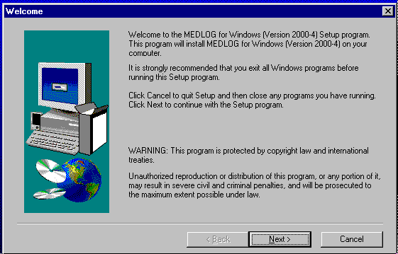
The system will welcome you and await your reply. Clicking Next > is the equivalent to pressing the Enter key and will take you to the next window, Figure 52-2.

Figure 52-2. Destination location
If you intend on installing MEDLOG for Windows on your local hard drive, and "C:\Med”, already exists, proceed by clicking Next >.

If you want to install MEDLOG anywhere but “C:\Med” you must hit the “Browse...” button at this point.

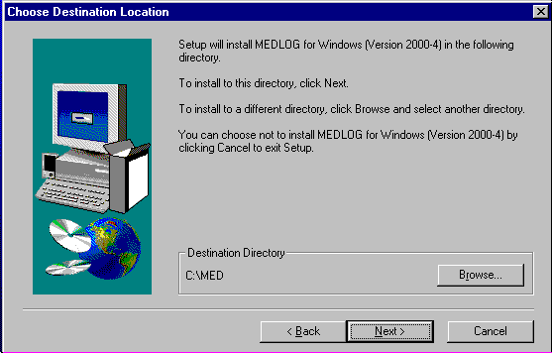

Note: If you intend on installing MEDLOG for Windows onto a Network drive, you must hit the “Browse...” button.

Figure 52-3. Select directory
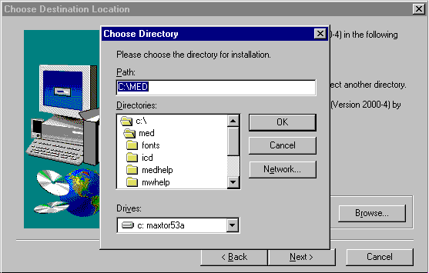
After clicking on the “Browse...” button, your screen will look like Figure 52-3. The “Path” reads C:\Med (“C:” stands for the drive MEDLOG for Windows will be installed in, “\Med” stands for the name of the folder).

Installing MEDLOG on a network

We recommend that the MEDLOG system is installed on the local PC and space is provided on the network server to hold the databanks to be created. This installation configuration appears to create a better operating performance environment than when both MEDLOG and the data are stored on the network server.

Figure 52-4. Select directory
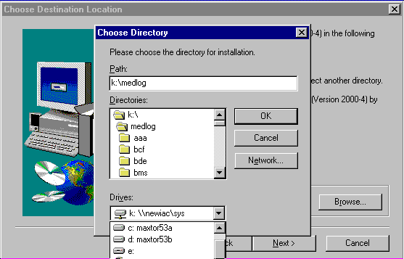
If you are going to install the MEDLOG system on a Network drive, you must change the drive you are installing to, and highlight the MEDLOG folder so that the “Path” reads "x":\Med, where "x" is changed to the letter which represents the Network drive, “Med” is the folder where MEDLOG for Windows resides. Consult your Network Administrator for more information.

After you have changed the “Path” to the correct drive and folder, click OK and then Next >, and your screen will look like Figure 52-5.
Figure 52-5. Destination location
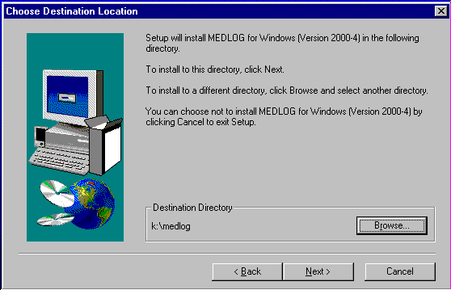
If you have been through the “Browse...” sequence, the Destination Directory will now read the correct network path.

Once you are satisfied that MEDLOG for Windows is being installed where you want it to be, click Next >.

Figure 52-6. Select program folder
YYou will be asked what name you would like for the “Program Folder”. The default is “MEDLOG for Windows.” This is not the “Path” that was just discussed, but where the icons for MEDLOG for Windows will be placed in your “Program Manager”. As long as you don’t object to the folder being called "MEDLOG for Windows" click Next >.

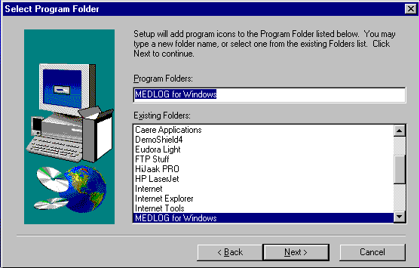

If you want to make any corrections to the installation, click on the <Back button. You can go back and change any of the information you have already put in. Make sure that the “Target Folder” is where the MEDLOG systems currently reside. Once you are happy with your entries, proceed.

You will be prompted to insert disks two, three, etc., during the installation.

When the installation is complete click Finish. You will be asked if you wish to restart your machine. We recommend that you do because MEDLOG for Windows needs to write to your win.ini file, and that can only happen when the system is rebooted.

You can now add a shortcut to your desktop for MEDLOG.

MEDLOG System Authorization

MEDLOG has an authorization routine installed to differentiate and control the different levels of use and options; e.g., single user vs. network and local vs. remote.

Every MEDLOG system is accompanied by an Authorization Diskette that contains the appropriate authorization codes. This diskette must be installed with MEDLOG or you will receive a message indicating that system use is not authorized.

Authorization Procedure.

- Install MEDLOG as previously described.
- Insert the Authorization Diskette that accompanied the MEDLOG installation diskettes.
- Use the Windows copy or drag and drop function to copy or move the file, menupz.exe from the Authorization Diskette to folder that contains the MEDLOG system. The MEDLOG system installation default folder is C:\Med.
- Store the Authorization Diskette in a safe place because you may need to re-install the menupz.exe file if you need to re-install MEDLOG on another PC, have a hard-disk failure, or erased menupz.exe inadvertently.
- There is a special program available called disable.exe which can modify the menupz.exe file and thereby disable some of the programs which appear on the main menu. This may be needed , for example, at remote site where personnel are not authorized to do data analysis. The Disable program is not part of the normal installation, but it will be sent to any requesting institution, without charge, via email. The Disable program is normally kept on a diskette for security purposes.

System Use Prior to Establishing Databanks

The MEDLOG system requires that a databank be established when the system is first opened. To delay the establishment of a databank and to allow you to see the construction of the system, we have provided a validation databank VAL. Like the Authorization Diskette, it must be copied into the folder where you installed MEDLOG, usually C:\MED.

VAL loading procedure
- Use Windows Explorer to create a folder named VAL in the MED folder.
- Use the Copy or drag and drop routines to either copy or move the contents on the diskette labeled VAL to the VAL sub-folder in the MED folder.
- When you open MEDLOG, VAL should be the only databank available.

Setting the BDE for MEDLOG
MEDLOG uses the Borland Database Engine (BDE) to access certain table information. If you are using a network or the Vista version of Windows, or if you are having any problems with table variables, follow the instructions below.

- Open Windows Explorer or use the "My Computer" icon on your Windows desktop.

- Open the IDAPI folder that is located on your C: drive.

- Click on the bdeadmin.exe icon (may be called bdecfg.exe) within the IDAPI folder. If you do no see this file, change your Windows setting to "view all file types".

Figure 52-7. Database configuration utility
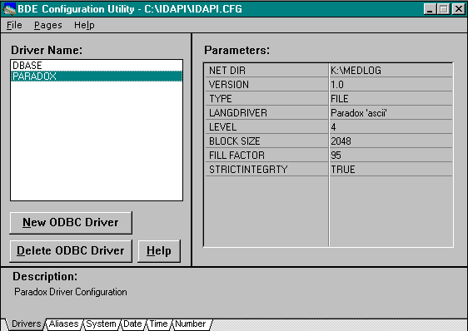
- Change the "Driver Name " to "PARADOX".
- DBASE is the default setting.

- Enter in the "NET DIR" box the appropriate drive letter and folder where MEDLOG is located on your network.

- Once you have made the changes, go to the File menu on the menu bar and click on "Save".

It is CRITICAL that you have "read, write, create" access to this folder on your network. If you make the appropriate changes to the system and you are still getting errors, the reason is because you do not have the necessary access to that folder on the network. If this is the case, you will need to contact your network administrator. All workstations that access MEDLOG must have the identical NET DIR setting.

Note that the Vista version of Windows does not allow the “NET DIR” to be the root level of the C drive. For Vista the entry for “NET DIR” may be C:\MED or something similar.

Getting started

Every time you start MEDLOG for Windows you will be asked to type in your initials.

Figure 52-8. Opening MEDLOG
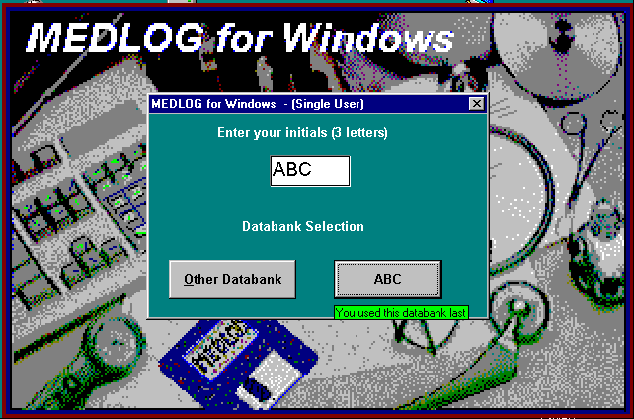

Entering your Initials
The first time you use MEDLOG for Windows, you will see a message that says, “There is no record of your previous use of MEDLOG for Windows. Confirm your initials”. If they are correct, click the They’re OK button, otherwise correct them.

MEDLOG will create an initialization file which will remember your initials, the last databank you used, and certain program options for the next time you use it. It is important to remember that MEDLOG is not asking for the three-letter identification of the databank that you wish to access. Once you have typed in your initials, you may choose a databank.

There is nothing to prevent several people from using the same initials, but we advise against it. Many of the programs “remember” what you did during your last session, according to your initials.

Frequently Asked Questions

After I installed MEDLOG for Windows I got a message that said “This Copy of MEDLOG Not Licensed.” What does this mean?

The message indicates that MEDLOG for Windows is installed in a directory (folder) that does not contain the authorization program, menupz.exe. The program, menupz.exe is issued with the system diskettes and is loaded into the folder where MEDLOG is loaded, usually the default folder, C:\med. If you search the folder where MEDLOG for Windows is installed and you do not see the program, menupz.exe, and you have the Authorization Diskette, copy menupz.exe into the folder. If you cannot find the diskette, call IAC because we are going to have to make a replacement diskette.

I know that I installed MEDLOG for Windows in the correct place, but when I try to run the system, I get a white box that says my computer “Cannot Initialize the Borland Database Engine.” What did I do wrong?

This message is issued then the system cannot find the Borland Database Engine or when the net directory cannot be accessed. To cure this problem, install MEDLOG for Windows on your local hard drive. This will create a folder named IDAPI and in the IDAPI folder will be a program named bdeadmin.exe. See Setting the BDE earlier in this chapter for detailed instructions on setting the net directory.

After I ran Uninstall, it said there were still parts there. What does this mean?

The Uninstall program has been set to remove ONLY MEDLOG for Windows and its attached programs. Since there are still files in the directory, the Uninstall program is a little confused, and is just letting you know that there are still programs in the directory.

I don’t like to use the mouse. Is there any way to avoid it?

Once you have entered MEDLOG for Windows, you can operate almost the entire system with the keyboard. You will notice that almost every menu or executable program has a letter that is underlined. If you hit Ctrl (or Alt) + that letter the menu will be opened or the program will be executed. If a sub-menu is opened, every program within the menu has a letter that is underlined can be executed but as soon as the Alt key is pressed the menu will disappear. You will have to remember the letter and press the Alt key plus the underlined letter to execute the program. Again, if you hit Ctrl (or Alt) + that letter will be able to start the program.

We have a network version of MEDLOG for Windows. Some machines have Windows 3.1 and others have Windows 98. Can we still run the system?

The 32 bit version (MEDLOG2K) can run with all recent versions of Windows. Old Windows 3.1 machines must use MEDLOGW. See the web site to obtain a copy of MEDLOGW.

I have a MAC. Can I run MEDLOG for Windows?

Only if your MAC has the options needed to run Windows..

I am running Windows XP. How do I create a shortcut to MEDLOG for Windows?

Creating a shortcut in Windows 98 or later is very simple. Right click in any open area of the Windows DESKTOP, and choose “New” from the menu presented. Then choose “Shortcut”. Click on the “Browse” button, and find the folder that medlog2k.exe is located in. Select medlog2k.exe and make sure it says so in the “Open” box. Then click OK twice, and name the shortcut MEDLOG for Windows.

Why does MEDLOG for Windows ask for my initials? Is it a password?

MEDLOG instead it creates an initialization file for each user. This is done for several reasons. First, after you use MEDLOG for Windows for the first time, the system remembers the last databank you used. This eliminates having to scroll to find the databank you are trying to access. Second, the Speed Bar (per databank) you create will be remembered. Third, all of the programs will remember the values you set the last time you used them, and they will be presented as defaults. Fourth, administrators will be able to check on who used MEDLOG when, and which databank they last used. Lastly, the initials may be linked to password access (see chapter 3, Databank Options).

MEDLOG® Storage Capacity

MEDLOG Limitations
Number of databanks on the same machine no limit
Number of patients in each databank maximum 65,530
Number of variables in each dictionary maximum 2,500
Number of additional computed variables maximum 3,000

Number of encounters per patient maximum 2,000

Total encounters for a databank no practical limit

Total bytes of text data per patient no practical limit
Total byes of text for note variables no practical limit
Number of unique text entries per encoding file maximum 65,535
Number of unique table entries maximum 65,535

Number of stored group specifications maximum 2,000
Number of command files no limit

Data Capacity
The limitations listed above are the design maximums for MEDLOG. All programs are designed to honor these limitations. Another limitation is imposed by the amount of physical disk storage on your computer. Whereas the original IBM PC had limited formatted storage capacity, the hard disk storage capacity today far exceed MEDLOG databank limitations.

MEDLOG needs less than ten megabytes for its programs. The space needed for a databank will depend on the number of patients, variables, and encounters. The CONTENTS program lets you review the file size and available disk space based on the estimates from the technical information which follow.

Each patient base record uses 84 bytes of storage, each encounter uses 96 bytes, and each data cluster uses 128 bytes. For example, entry files containing numeric data for 2,000 patients with an average of 6 encounters each and average 5 data clusters per encounter will occupy:

2,000(84 + 6(96 + 5(128))) or 9,000,000 bytes (9mb) of storage.

Transpose File Storage
A variable in the transpose file occupies storage space equal to the product of its size (1, 2, or 4 bytes) and the total number of encounters of al patients combined. In the above example, we have 12,000 encounters. If the transpose file held 299 entry variables with an average length of 1.5 bytes, the total file size would be 3,200,000 bytes.

Values of computed variables are stored in the transpose file as 4 byte, floating-point numbers. In our example with 12,000 encounters, 10 computed variables will add another 480,000 bytes to the size of the transpose file.

Other Storage Requirements
Each patient group specification requires a minimum of 384 bytes of storage, plus one bit for each encounter in the databank. A bit is one eighth of a byte. This is a very compact format with 20 groups for a databank with 12,000 encounters occupying just 30,000 bytes.

Each compute expression uses 128 bytes.

An extraction file uses 4 bytes for each extracted variable value in a floating-point format. An extraction file holding 25 variables and 4 groups with an average of 500 observations each will required about 196 kb (4bytes* 25 *2,000)

File encoded text storage requirements are too complex to express with a simple formula. Each unique text value occupies its own length and about a dozen bytes of additional storage. Occurrences of the text value are represented in the patient record in two bytes.

Table variables are stored in several related files. The actual space depends on many factors and is best judged by experience. Image (picture) elements are stored within the table in jpeg format. A single typical image might occupy 30,000 bytes.

Storing Multiple Databanks
Disk storage costs are now so low that the size of a databank is no longer the concern it once was. There is no practical limit to the number of databanks which may coexist on a machine. Each databank occupies its own folder which may be on any drive which is accessible, including a network or removable drive.

Data Bank Administration
In today’s environment of low cost storage space, the administration of the data is as important as ever. Databanks which get too large with unnecessary variables and data clutter will operate less efficiently because of the time lost in data entry, slower program run times, and increased likelihood of confusion. The number and type of variables in a databank is something which deserves careful planning.

To comply with FDA guideline 21CRF, Part 11, for new drug or medical device submissions, the administrator should use the features of MEDLOG which allow it to comply with the guideline. In particular, passwords and appropriate access privileges should be assigned to individuals who use MEDLOG. The audit trail options should be enabled for the data entry system and dictionary. If necessary, portions of the main menu may be disabled for all users by the special DISABLE.EXE program which is available on request. In addition, a log book should be maintained of changes to the databank design, changes to operational procedures, changes of equipment, etc.

Backup of data is essential to security and safety. Do not rely on others to do this for you. Test any backup procedure. See the Chapter 50 for more information.

MEDLOG File Organization

MEDLOG makes extensive use of Windows folders to organize its data into manageable sizes. The basic idea is that each databank has its own folder that is further divided by sub-folders into important storage categories. The advantage of this method is that it makes it easy to duplicate databanks using the Windows Explorer drag and drop or copy commands. It also makes it difficult to accidentally erase files, and it permits MEDLOG to share data between databanks, as will be explained later.

Each databank is in a separate folder and will have some sub-folders.

DDD (Databank folder)

Sub-folders

DEFINES
Contains the dictionary files: defnfile.med
deflfile.med
ecodfile.med
File encoded text files: nnnnnnnn.vtx
Paradox table files: nnnnnnnn.db
nnnnnnnn.px
nnnnnnnn.xnn
nnnnnnnn.ynn
dictionary audit log defaudit.med

ENTRY
Entry files: patsfile.med
encsfile.med
datafile.med
textfile.med
Notes files: nnnnnnnn.ntx

FORMS
Entry forms: nnnnnnnnnn.for*
(40 chars max) nnnnnnnnnn.rtf
Panel files: nnnnnnnnnn.pnl

REPORTS
Report specifications: @nnnnnnn.rpt*
(40 chars max) nnnnnnnnn.rpt

* = used with older MEDLOG versions, but still valid.

LETTERS
Letter specifications: nnnnnnnn.ltr
Letter text: nnnnnnnn.txt

TRANS
Transport data file: varifile.med

EXTRACT
Extraction files: #nnnnnnn.ext

COMPUTE
Computed variable specifications: compfile.med
nnnnnnnn.cmp

GROUPS
Group specifications: nnnnnnnn.grp

GRAPHICS
Graphical output files: _nnnnnnn.gra

COMMUN
Communicate program output user named

PRINT
Print files: %nnnnnnn.prt
Temporary sorting file: sortfile.tmp

COMMAND
Command files: $nnnnnnn.cmf

REMOTE
Configuration file: remote.cfg
Transmissions files: xxxyyy.nnn
Exception file: remote.xcp

In addition, each databank has three files that are not in subdirectories:
databank.cfg is a configuration file which holds various options.
audit.med is the audit trail of data changes/additions, if used.
access.med is a trail of access to a databank (date/time, operator), if used.

File Redirection
If all of your data fits comfortably on one disk drive and you do not need to share files between databanks, you do not need to be concerned with the remainder of this chapter.

File redirection is the process of letting MEDLOG obtain data from a location other than the normal location. For example, you may want to execute MEDLOG from drive C: but store the databank on drive D.

First, the databank file has to be created and then saved to the desired location. Using the Windows Explorer, you can drag and drop the databank folder into the desired location. This can even be a floppy diskette on the A: drive.

The next time you open MEDLOG after creating and storing the databank, the opening MEDLOG dialog box, Figure 54-1, will request that a databank be selected.
Figure 54-1. Select databank
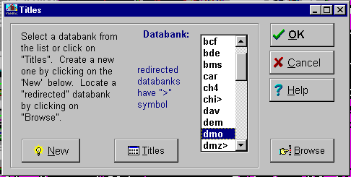
The databank drop-down list will include all recognized databanks, including previously redirected databanks marked with a greater than (>) sign
. If you want to add a databank to the list (not in the current directory) click on the Browse button. Then see figure 54-2.

Figure 54-2. Set redirect path
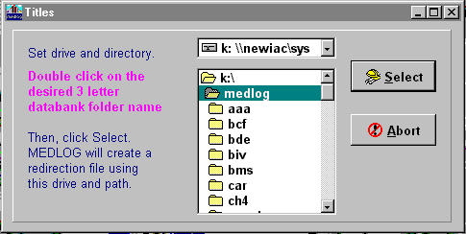
Set the drive and folder to where the desired databank resides. Clicking on Select will open the dialog box with the path to the desired databank,

Once the databank is located and used, MEDLOG will add it to the drop-down list with the > sign to indicate a redirected databank.

.

WARNING. Do not attempt to share the entry, defines, trans, or groups directories. This could commingle data which does not belong together and would likely cause file errors. If you share files, they will likely be forms (form) or reports (reports).

…INDEX

absolute range, 4-9
absolute value function, 19-7
after (field specification), 5-7
and (logical) operator, 19-5
anova, 34-3
anti log (base 10) function, 19-7
arctangent function, 19-7
ask function (in letter), 12-6, 12-16
aspect of form image, 5-9
aspect ratio (in graphics), 23-4
assign function (in letter), 12-13
assignment (in form), 5-9
audit (field specification), 5-10
audit log, 8-1
audit log file, 8-6
authorization file, 52-5
autoenter (field specification), 5-8
average (extract suffix), 22-5
average function (in report), 13-19
backup of data, 50-1
bar plots, 24-1
bargraphs, 24-1
BDE (engine), 52-7
BDEADMIN program, 52-7
BDECFG program, 52-7
before (field specification), 5-7
BMDP export format, 11-2
bmp bitmap file, 23-4
bold
in letter, 12-15
in report, 13-19
Boolean group, 20-4, 20-11
bottom statement (in report), 13-10
box quartiles, 32-2
brackets
in compute, 19-3
brackets
in form, 5-3
in letter, 12-3
in report, 13-3
break function (in letter), 12-13
built-in variable
in report, 13-8
built-in variable
date, 4-3
firstnam, 4-3
in form, 5-12
lastname, 4-3
minitial, 4-3
MRNO, 4-3
name, 4-3
time, 4-3
built-in variables
in create, 18-2
in locate, 43-1
button (in form), 5-8
by encounter mode (extract), 22-2
by patient mode (extract), 22-2
capitalization
in letter, 12-3
in report, 13-12
cardin function (in letter), 12-18
cardinit function (in letter), 12-18
cardout function (in letter), 12-18
cardsort function (in letter), 12-18
casematch, 37-5, 42-1
cases (in extract), 22-3
categorical variables, 25-1
censored observation, 30-1
central site, 47-1
change encounter date, 39-1
changed field (in report), 13-16
chi-square test, 24-1, 25-4
classification (in logreg), 35-3
closest function (in compute), 19-8
colors in forms, 5-13
combine encounters, 39-1
combining databanks, 38-1
comma delimited exports, 11-2
comma delimited imports, 10-1
command files, 49-1
comments (in letter), 12-16
compare function (in letter), 12-17
complement (Boolean group), 20-11
compute (in form), 5-8
compute operators, 19-3
compute statement
dates, 19-3
equal sign, 19-2
long name and units, 19-3
name length, 19-2
name limitations, 19-3
today's date, 19-3
compute statements, 44-4
computed
in letter, 12-3
in report, 13-12
computed variables, 19-1
concat function (in report), 13-18
conditional output (in letter), 12-4
confidence interval, 29-3, 30-3, 35-10
contents of databank, 16-1
contingency table, 25-1
continue (in form), 5-4
copy groups, 20-14
copying a databank, 36-1
correlation, 26-1
correlation matrix, 26-2
corresponding vars (in extract), 22-13
cosine function, 19-7
count function (in report), 13-19
covariance matrix, 33-6, 35-8
cox regression, 33-1
Cramer's V statistic, 25-5
create reminder, 3-3
criteria (in group), 20-15
criterion group, 20-4
cross-classifications, 25-1
crosstabs, 25-1
cum function, 19-9
cum function (in report), 13-18
cut points (in crosstabs), 25-2
data summary (qctools), 17-2
data transformation (extract), 22-15
databank, 48-1
description, 3-1
databank copying, 36-1
databank limits, 53-1
databank options, 3-1
date
constants, 19-3
variables (data entry), 6-11
date format, 2-1
date formats (in export), 11-3
date function (in letter), 12-6
date values (in group), 20-8
day function, 19-10
define variables, 4-1
delete
encounters, 39-1
files, 40-1
groups, 20-14
patients, 39-1
designing forms, 5-1
dictionary, 4-1, 48-1
dictionary audit log, 8-5, 8-8
dictionary list, 16-2, 44-3
Disable program, 3-2
display (in form), 5-9
display records (in Chart), 9-1
display statement (in report), 13-10
distribution equality, 27-4
distributors of MEDLOG, 51-1
double entry verification, 8-1
drop-down lists, 6-3
duplicate encounters, 3-3
edit a table, 40-1
edit a text file, 40-1
edit extracted data, 41-1
elapsed time (in extract), 22-8
elapsed time (in group), 20-18
encoded display, 3-3
encoded field (in report), 13-15
encoded variables (data entry), 6-11
encounter zero (in extract), 22-4
encval function (in letter), 12-10
end (in form), 5-3
endall (in form), 5-8
Enter (using panels), 7-1
enumeration group, 20-4, 20-11
environment, 2-1
error mean square, 34-4
event (in logreg), 35-1
event var. (cox model), 33-3
event, survival analysis, 30-1
examine files, 40-1
Excel, 41-1
Excel export format, 11-2
exclamation point (data entry), 6-12
exponentiation function, 19-7
exporting data, 11-1
extract
in report), 13-9
extract file, 48-3
extract file
editing, 41-1
listing, 44-5
merging, 37-1
extracting data, 22-1
extraction method, 22-3
false negative (in logreg), 35-7
false positive (in logreg), 35-7
fastload export format, 11-2
field specs (in report), 13-11
fields section (in form), 5-3
fields section of a form, 5-11
file function (in letter), 12-6
file organization, 54-1
file redirection, 54-3
first (extract suffix), 22-5
first function, 19-9
Fisher exact test, 24-3
fixed (field specification), 5-8
fixed field (in report), 13-15
fonts
in letter, 12-15
in report, 13-19
form
limits, 5-4
Form (data entry), 6-1
form design
!continue line, 5-4
!end line, 5-3
!fields line, 5-3
!form line, 5-3
!form section, 5-13
image style, 5-15
modification, 5-14
form field
after, 5-6
autoenter, 5-6
before, 5-6
begin...end, 5-6
button, 5-6
computed, 5-6
display, 5-6
fixed, 5-6
goto, 5-6
hidden, 5-6
hour, 5-6
if,,,then,,,else, 5-6
image, 5-6
noverify, 5-6
numeric, 5-6
table, 5-6
time, 5-6
form option
abortopt, 6-7
dupkey, 6-12
gotoendopt, 5-7
history, 6-3
format function (in letter), 12-6
formatted data input, 10-4
formfeed statement (in report), 13-10
forms
audit log, 8-5
designing, 5-1
forms summary (qctools), 17-3
frequency distributions, 27-1
frequency intervals, 27-2
f-statistic, 28-6, 31-6
f-test, 34-3
functions
in compute, 19-7
in form), 5-11
in letter, 12-6
in report, 13-17
goto (in form), 5-4
graphics, 23-1
greatest (extract suffix), 22-5
group
in report, 13-9
group, 48-3
dependency, 20-13
formation, 21-1
function (in compute), 19-10
in coxreg, 33-2
in letter, 12-13
listing, 44-5
listings, 16-2
modification, 20-10
specification, 20-1
hazard function, 33-1
heading function (in letter), 12-16
headings (in report), 13-5
hidden (in form), 5-8
hi-res graphics, 23-1
hot key, 1-11, 44-3, 46-1, 49-1
hour (field specification), 5-10
hours function (in letter), 12-6
ICD-9 table, 4-7
IDAPI folder, 52-7
identity format, 2-2
if ... then (in form), 5-7
image (in form), 5-6, 5-9
image element in tables, 4-14
image function (in letter), 12-6, 12-17
image storage, 53-2
image width (in report), 13-15
image, not in MEDLOGW, 4-14
importing data, 10-1
fonts, 5-13
extract, 13-7
including text (in letter), 12-5
indent function (in letter), 12-6
Information Analysis Corp., 44-2
information utility (F5), 44-1
init statement (in report), 13-10
insert an encounter, 39-1
installing MEDLOG
hardware requirements, 52-1
software requirements, 52-1
intercept (extract suffix), 22-5
intercept function, 19-9
intersection (Boolean group), 20-11
invert markings (Boolean), 20-11
italics
in letter, 12-15
in report, 13-19
jpeg images, 4-14
julian function, 19-10
Kaplan-Meier, 30-1, 30-4
Kendall's tau, 31-1
keystroke errors, 8-1
Kruskal-Wallis, 31-1
kurtosis, 26-2
lag function, 19-9
lag function (in report), 13-19
landscape mode (in letter), 12-6
landscape statement (in report), 13-10
largest function (in report), 13-18
last (extract suffix), 22-5
length function (in letter), 12-6
length of text variables, 4-11
length statement (in report), 13-9
letter
defaults, 12-2
label example, 12-14
specifications, 12-3
Letter, 12-1
life tables, 30-1, 30-7
likelihood ratio test, 35-7
line function (in letter), 12-6
line types (in report), 13-5
linear regression, 29-1
linear relationship, 26-1
link (in form), 5-10
linkage error, 6-14
linking forms, 5-4
Linreg, 34-1
list
compute stmts., 16-2
data (contents), 16-1
data (datalist), 14-1
data (in chart), 9-1
dictionary, 16-2
extract files, 16-2
groups, 16-2, 20-12
panels, 16-2
reports, 12-19
table, 40-1
text file, 40-1
listing patients (in report), 13-23
locate utility, 43-1
logarithm, base 10 function, 19-7
logical expressions, 19-5
logistic regression, 35-1
log-likelihood, 33-4, 33-9
log-rank (in survive), 30-2
log-rank test (coxreg), 33-9
lookup function, 19-7
Mann-Whitney, 31-5
Mantel-Haenszel, 30-2, 33-9
margin function (in letter), 12-6
mark all (Boolean), 20-11
marked (extract suffix), 22-7
marked encounters, 20-20
marked encounters (in extract), 22-4
matched pair analysis, 37-5, 42-1
mathematical functions, 13-17
max function, 19-8
max function (in report), 13-17
maximums, 28-1
mean function, 19-8
mean function (in report), 13-17
means plots, 32-1
means testing, 28-1
median function, 19-8
merge extract files, 37-1
message display, 5-9
metafile graphics, 23-2
min function, 19-8
min function (in report), 13-17
minumums, 28-1
missing field spec. (in report), 13-12
missing function (in letter), 12-6
missing tracking in exports, 11-2
missing value summary (qctools), 17-2
missing value tracking, 8-9
month function, 19-10
MRNO duplicates, 3-1
multiple correlation coefficient, 34-4
multiple linear regression, 34-1
must satisfy (in group), 20-9
name substitution in form, 5-4
natural logarithm function, 19-7
networks, 51-3
newline function (in letter), 12-6
newpage field (in report), 13-16
newpage function (in letter), 12-6
newpat form, 3-3, 5-2
noline field (in report), 13-16
nonparametric statistics, 31-1
normal distribution, 27-4
normal range, 4-9
beep, 3-1
not (logical) operator, 19-5
note variables (data entry), 6-11
note variables (in report), 13-24
notes function (in letter), 12-6
noverify (in form), 5-8
numeric (in form), 5-8
nummiss function, 19-8
numpos function, 19-8
numrec function, 19-8
observation (in extract), 22-3
occurrences, 20-3, 20-9, 20-20
one-way anova, 28-1, 28-5, 31-6
option line (in letter), 12-13
or (logical) operator, 19-5
order function, 19-8
ordinal function (in letter), 12-6
output range (in group), 20-9
paired t-test, 28-4
panels (in enter), 7-2
passwords, 3-2
patient identification (modification), 7-6
patient search, 43-1
patient selection
in enter, 7-4
in form, 6-2
pcum function, 19-9
peak function, 19-9
percentiles, 31-2
Person correlation, 26-3
phi statistic, 25-5
pick function, 19-8
picture storage, 4-14
plot residuals, 29-5
ploting 2 variables, 29-4
plotting date (patplot), 15-1
Poisson distribution, 27-4
pooled variance, 28-4
popup (in form), 5-9
positive (extract suffix), 22-7
power test, 17-5
ppeak function, 19-9
preamble (in letter), 12-3, 12-8
precedence, 19-3
prefixed field (in report), 13-15
print function (in letter), 12-6
print options, 46-1
print statement (in report), 13-10
printstr field (in report), 13-16
printstr function (in letter), 12-15
product moment, 26-1, 26-3, 31-7
proportional hazards model, 33-1
quality control tools, 17-1
question mark (data entry), 6-12
random number function, 19-7
range
absolute, 4-9
normal, 4-9
receiving data, 47-10
recent function, 19-9
recorded (extract suffix), 22-7
recorded closest (in group), 20-17
regression equation, 34-3
regression, linear, 29-1
regression, multiple linear, 34-1
relation test (in group), 20-7
relational expressions, 19-4
remote data transfer, 47-1
remote site, 47-1
rename
files, 40-1
groups, 20-14
repeat function (in letter), 12-12
replace function (in letter), 12-6
reports (letter program), 12-1
reports (report program), 13-1
reserved name
changed, 4-3
encountr, 4-3
entered, 4-3
idno, 4-3
lastenc, 4-3
numenc, 4-3
patkey, 4-3
scandno, 4-3
scandsex, 4-3
splitnum, 4-3
status, 4-3
residuals plot, mulreg, 34-6
residuals, plotting, 29-5
r-square, regression, 34-4
running reports, 13-2
sample size, 17-5
SAS export format, 11-2
sasdate, 19-10
scale multiplier, 6-10
Scandinavian features, 51-2
scatter plot, mulreg, 34-5
scatter plots, 29-1
score test, 33-6, 33-8
in logreg, 35-7
screen function (in letter), 12-6
select statement (in report), 13-9
sensitivity (in logreg), 35-6
setgroup function (in letter), 12-13
setline function (in letter), 12-14
setmiss function, 19-11
setpat function (in letter), 12-13, 12-15
show statement (in report), 13-9
sign test, 31-1
signed rank, 31-1
sine function, 19-7
skew, 26-2
slope (extract suffix), 22-5
slope function, 19-8
smallest (extract suffix), 22-5
smallest function (in report), 13-18
sort levels (in report), 13-5, 13-13
sort statement (in report), 13-10
sorting (in letter), 12-19
spaces function (in letter), 12-6
Spearman's rho, 31-1
special MEDLOG versions, 51-1
specificity (in logreg), 35-6
speedbar, 45-1
split variables, 22-11
spool statement (in report), 13-9
SPSS export format, 11-2
square root function, 19-7
standard deviation, 28-1
standard error, 28-2, 32-4
std. dev. function (in report), 13-19
storage capacity, 53-1
storage file (text), 4-11, 40-3
stratification (in regression), 34-2
substr function (in letter), 12-7, 12-17
substr function (in report), 13-18
subtraction (Boolean group), 20-11
suffix, variable (in extract), 22-5
suffixed field (in report), 13-15
suffixes (in letter), 12-9
sum function, 19-8
sum function (in report), 13-13, 13-17
sum of squares, 34-4
survival analysis, 30-1, 33-1
survival plot, 33-10
survival probability, 33-7
tab function (in letter), 12-7
table (in form), 5-9
table function, 19-10
in letter, 12-7, 12-12
in report, 13-18
table utility, 40-5
table variable, 4-7
data entry, 6-12
elements, 4-7
in extract, 22-8
in report, 13-15
Paradox, 4-14
tangent function, 19-7
technical overview, 48-1
test encounters (in group), 20-6
test range (in group), 20-15, 20-21
test type (in group), 20-15
text
variable
data entry, 6-11
text utility program, 40-3
text variable
permit new, 4-12
prevent new, 4-12
verify new, 4-12
tick mark (in survive), 30-3
time (field specification), 5-10
time format, 2-2
time modification (in group), 20-23
time variant, 4-4
timeout for inactivity, 51-3
today's date (data entry), 6-12
today's time (data entry), 6-12
top function (in letter), 12-7
top statement (in report), 13-10
total function (in report), 13-13, 13-18
total suffix (in extract), 22-9
transfer data, 47-1
transform variables, 22-15
transmitting data, 47-6
transposed data, 48-2
transposed data, 18-1
trend analysis, 25-5
trend plots, 32-1
t-test, 28-1, 28-4, 34-4
Tukey box plots, 32-1
underlines
in letter, 12-15
in report, 13-19
union (Boolean group), 20-11
value suffix (in extract), 22-10
variable
image type, 4-14
length, 4-11
modification, 4-15
name, 4-1
range, 4-8
text storage file, 4-11
time variant, 4-4
type
computed, 19-6
date, 4-5, 4-6
decimal long, 4-5, 4-6
decimal medium, 4-5, 4-6
encoded, 4-5, 4-6
float, 4-5, 4-6
note, 4-5, 4-7
table, 4-5, 4-7
text, 4-5, 4-6
time, 4-5, 4-6
type of, 4-5
variable suffix
in extract, 22-5
in letter, 12-9
variables summary (qctools), 17-4
view files, 40-1
weekday function, 19-10
whisker plots, 32-1
whole number function, 19-7
width function (in letter), 12-7
Wilcoxon, 31-1
wild card matches, 20-19
wild card search, 43-2
wild card tests, 20-26
Windows, 48-1
wmf metafont file, 23-4
year function, 19-10
zero function, 19-9

#
$ Systems Overview
K
MEDLOG is a registered trademark of Information Analysis Corporation.
#
K
2 There are two types of missing values: normal and tracking (requiring special attention).
Tukey, John W., Exploratory Data Analysis, 1977, Reading, MA, Addison Wesley Publishing.
Fries, James F., Time Oriented Patient Records and a Computer Databank, JAMA Vol 222, Dec. 18, 1972, pp 536-542.
#
$ Environment
K
#
K
#
$ Databank Options
K
#
K
#
$ Define Variables
K
Paradox is a trademark of Borland International, Scotts Valley, CA.
#
$ Form Designer-Editor
K
#
$ Form (Data Entry)
K
#
$ Enter (using Panels)
K
#
$
K
#
K
#
$ Chart (Patient Chart Display)
K
#
$ Import Data
K
#
K
#
k
#
K
#
$
K
#
$ Letter
K
#
$
K
#
$ Datalist (Members)
K
#
$ Patplot (Patient Time Plots)
K
#
$ Databank Contents
K
#
$ QC Tools
K
#
$ Create (Transpose)
K
#
$ Compute (Variables)
K
#
$
K
#
$
K
#
$
K
#
$
K
#
$
K
#
$
K
#
$
K
P. Armitage. Statistical Methods in Medical Research. John Wiley and Sons, 1971.
G. W. Snedecor and W. G. Cochran. Statistical Methods. Iowa State Press, sixth edition, 1967.
3 P. Armitage. Statistical Methods in Medical Research. John Wiley and Sons, 1971.
#
$
K
#
$
K
R. G. Miller. Simultaneous Statistical Inference. McGraw Hill, 1966.
#
$
K
#
$ Survive (Kaplan-Meier & Life Tables)
K
L.M. Friedman, C.D. Furberg, and D.L. DeMets. Fundamentals of Clinical Trials. John Wright/PSG Inc., 1981.
P. Armitage. Statistical Methods in Medical Research. John Wiley and Sons, 1971.
#
$ Non-Parametric Statistics
K
P. Armitage. Statistical Methods in Medical Research. John Wiley and Sons, 1971.
M. Hollander and D.A. Wolfe. Non Parametric Statistical Methods. John Wiley and Sons, 1973.
G.W. Snedecor, and W.G. Cochran. Statistical Methods. Iowa State University Press, 1967.
#
$ Whisker Plot
K
Tukey, J.W. (1977). Exploratory Data Analysis, Reading, MA: Addison-Wesley Publishing Co.
#
$ Cox Regression
K
D.R. Cox, and D. Oates. Analysis of Survival Data. Chapman and Hall, 1984.
E.T. Lee. Statistical Methods for Survival Data Analysis. Lifetime Learning Publications, 1980.
#
$ Multiple Linear Regression
K
P. Armitage. Statistical Methods in Medical Research. John Wiley and Sons, 1971.
#
$ Logistic Regression
K
P. Armitage. Statistical Methods in Medical Research. John Wiley and Sons, 1971.
D.R. Cox. Analysis of Binary Data. Chapman and Hall, 1970.
#
$ Copy Databank
K
#
$ Merge Data
K
#
$ Build Databank
K
#
$ Remove Data
K
#
$ File/Text/Table Utilties
K
#
$ Edit Extract Data
K
#
$ Casematch
K
#
$ Locate Utility
K
$ Help(F1) and Info(F5)
#
K
#
K
#
$ Edit Speedbar
K
#
$ Print Options
K
#
$ Remote Data Transfer
K
#
$ Technical Overview
K
#
$ Command Files (F3)
K

